**Implementation Report**

**Emergency Help Service**

**Introduction** :

we have built a web-App which can help people to report their emergencies with details such that authority can contact them and public can see nearby victims of emergency. We have implemented 3 Type of emergency

1. By Call Reporting

2. One Tap SOS Button

3. By Message

Web-App fetch location and emergency contact numbers. User can directly send message to their trusted emergency numbers too by single SOS Button click and adding personalised message for the same.

**Implementation** :

Let’s See implemented use-case’s database entries and it’s front end by screenshot of use-case.

**Use Case : Authentication :**

* Login

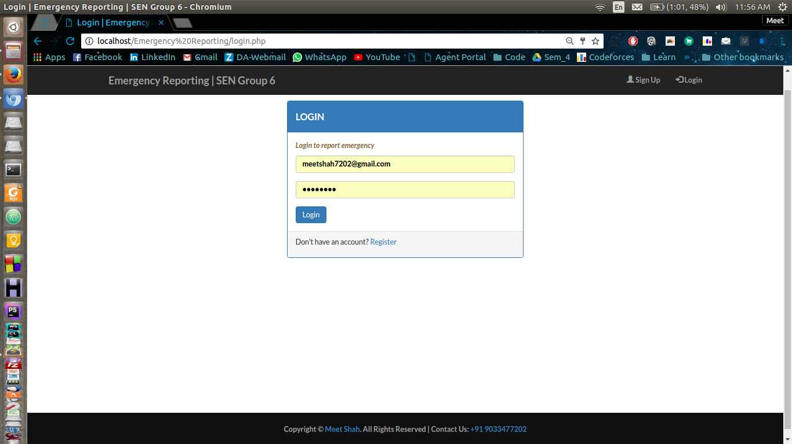

* Sign-up

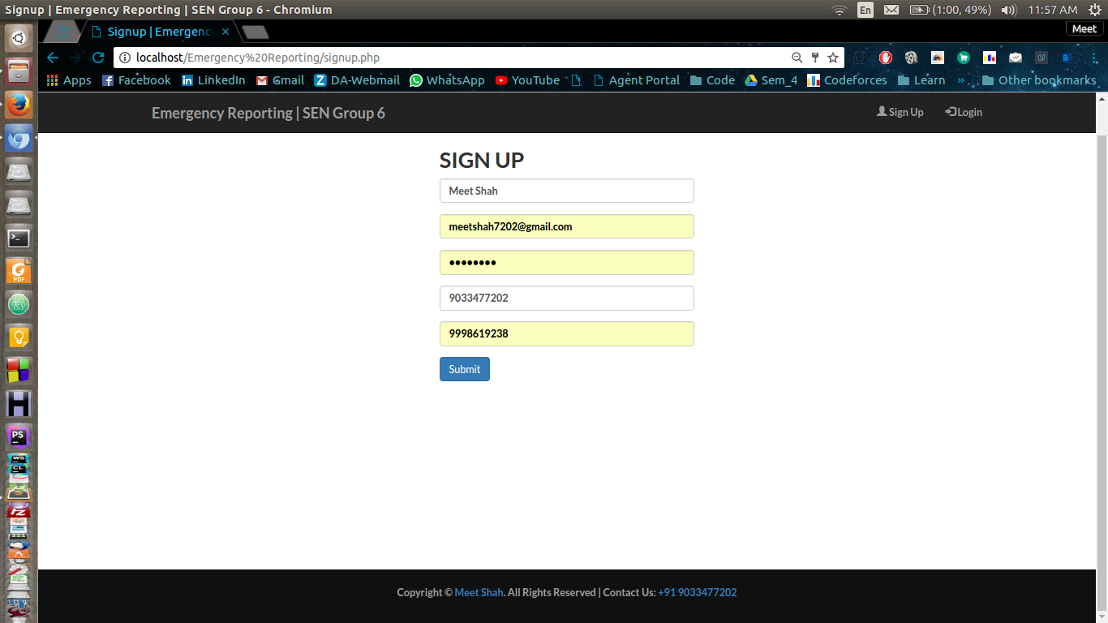

* Database of Users table

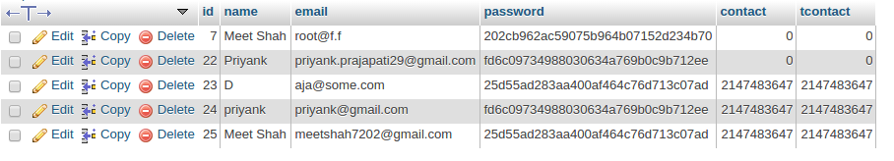

Passwords are secured via md5() method which is standard crypto notation for real world applications.

**Use Case : Report Emergency:**

* Front-end UI after Login

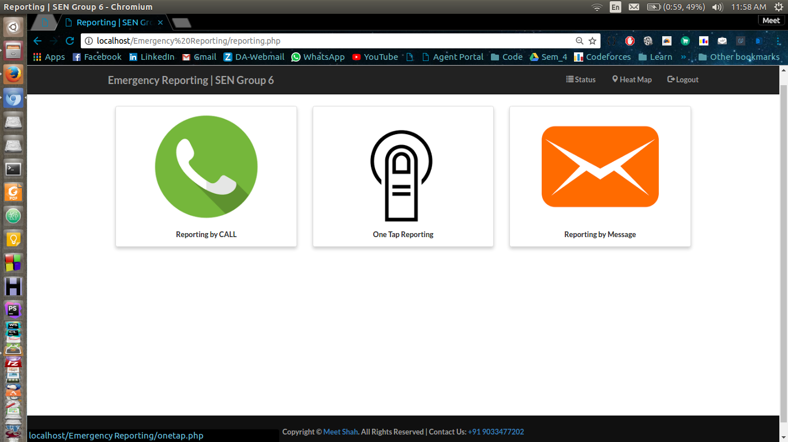

* Report by Call :

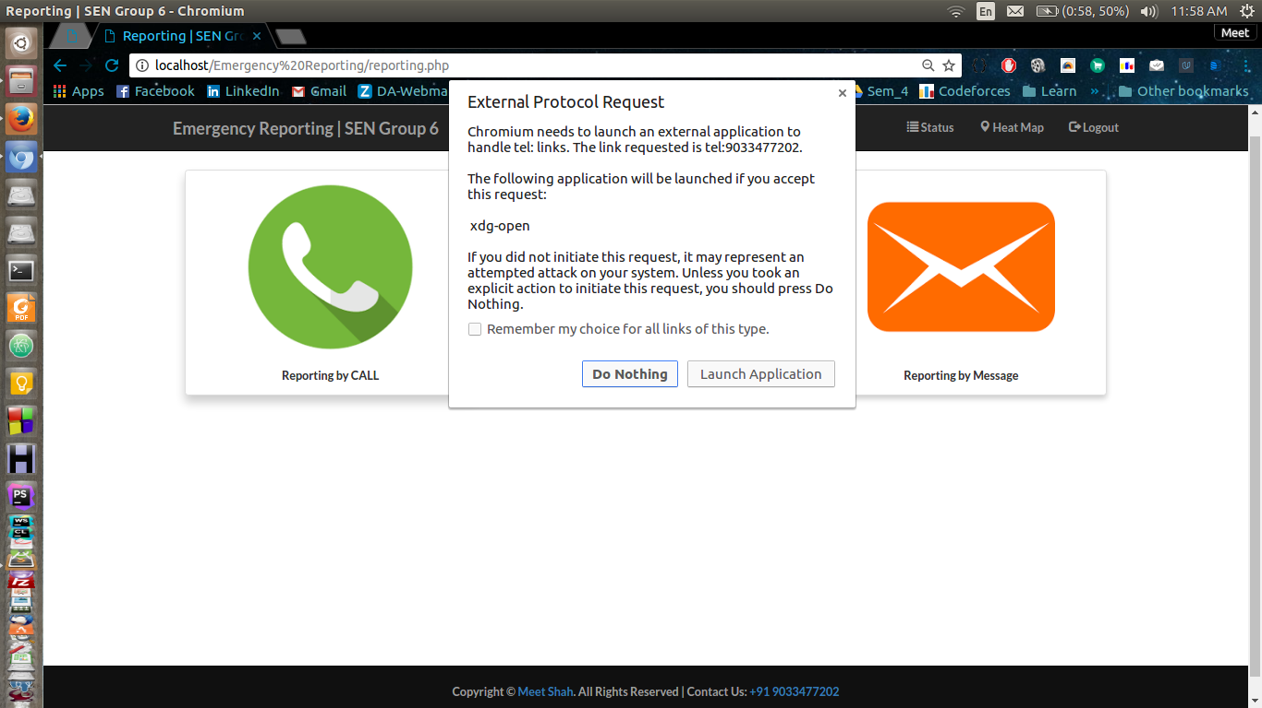

It directly calls on my mobile if GSM Module is connected with laptop. In mobile it directly calls on provided number.

* Report by One-Tap

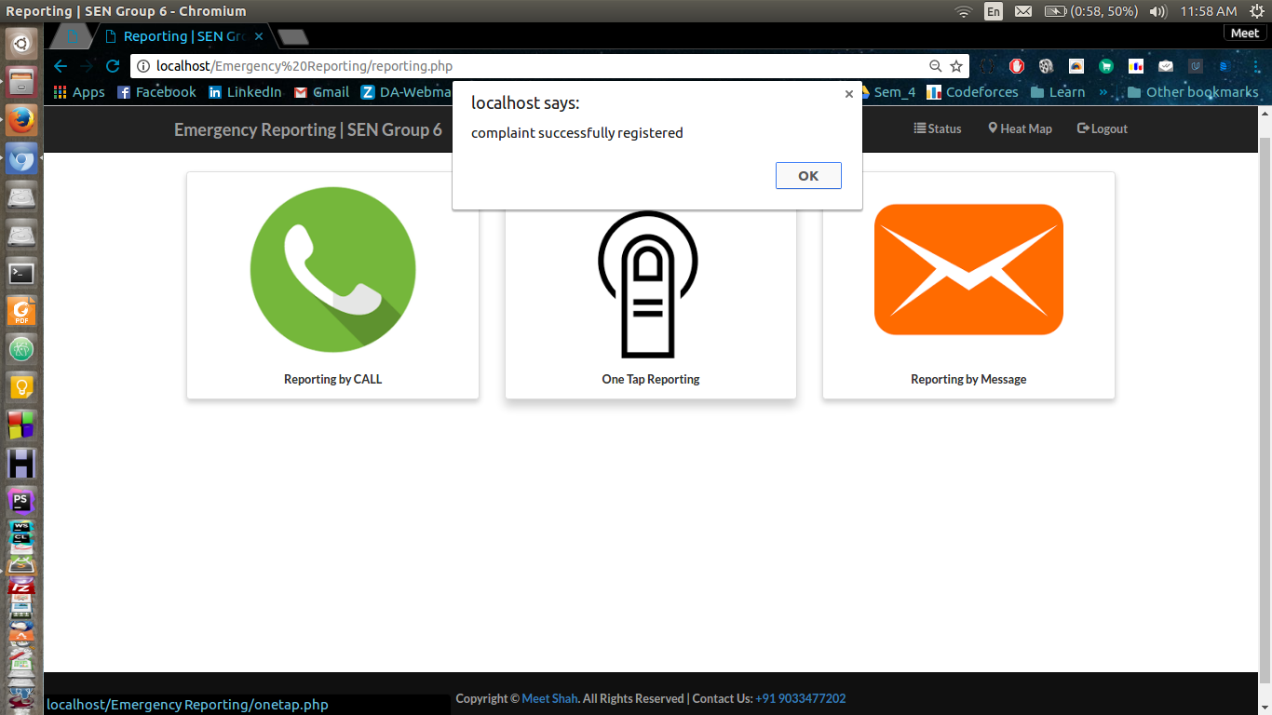

After clicking on One-Tap it directly registers complaint with associated id.

* Report by Message 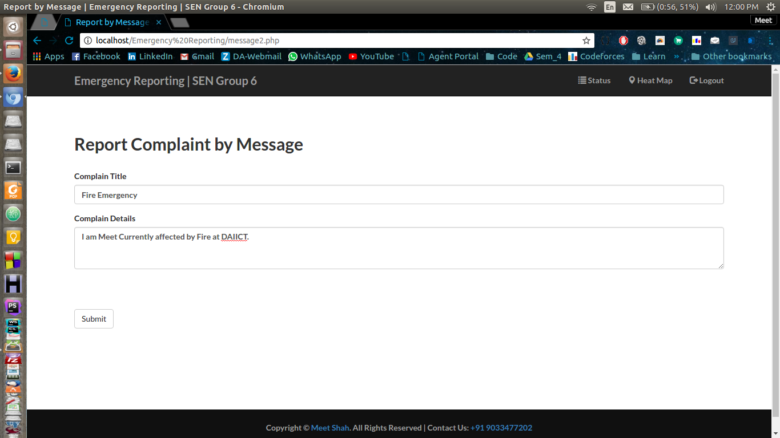

User can write details in message by this feature.

* Database of reported Emergencies associated with different users :

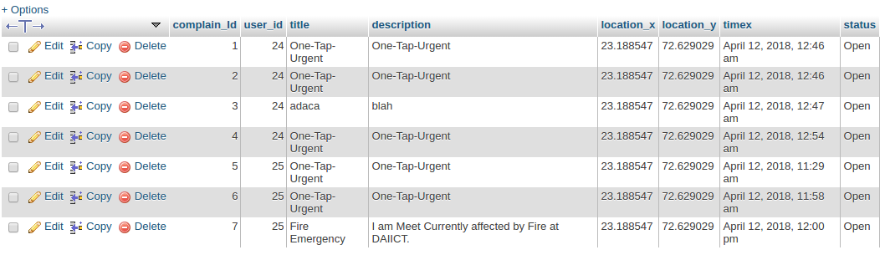

Here complaint id and user id are mapped for each emergency. Emergencies registered by one-tap have One-Tap-Urgent as title and description other have details of title and emergency details. latitude and longitude are fetched by appropriate google API. time is also fetched by API. Open Status shows it’s still alive and can see on heat-map.