**Implementation Report**

**Emergency Help Service**

**Introduction** :

we have built a web-App which can help people to report their emergencies with details such that authority can contact them and public can see nearby victims of emergency. We have implemented 3 Type of emergency

1. By Call Reporting

2. One Tap SOS Button

3. By Message

Web-App fetch location and emergency contact numbers. User can directly call higher authority, report emergency by single SOS Button click and adding also can add personalised message for the same.

**Implementation** :

Let’s See implemented use-case’s database entries and it’s front end by screenshot of use-case.

**Use Case : Authentication :**

* Login

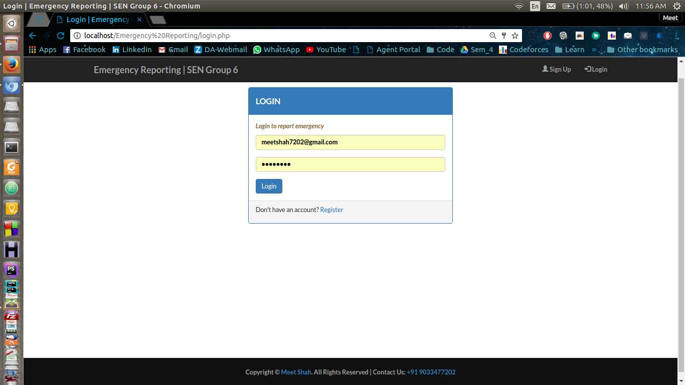

* Sign-up

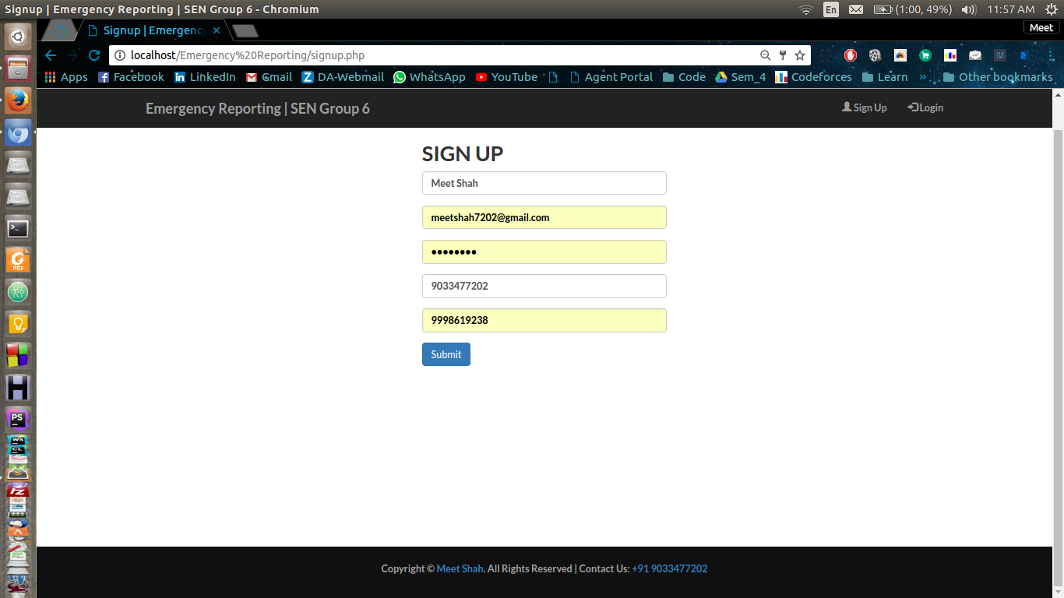

* Database of Users table

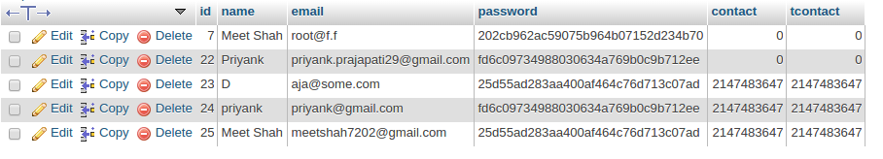

Passwords are secured via md5() method which is standard crypto notation for real world applications.

**Use Case : Report Emergency:**

* Front-end UI after Login

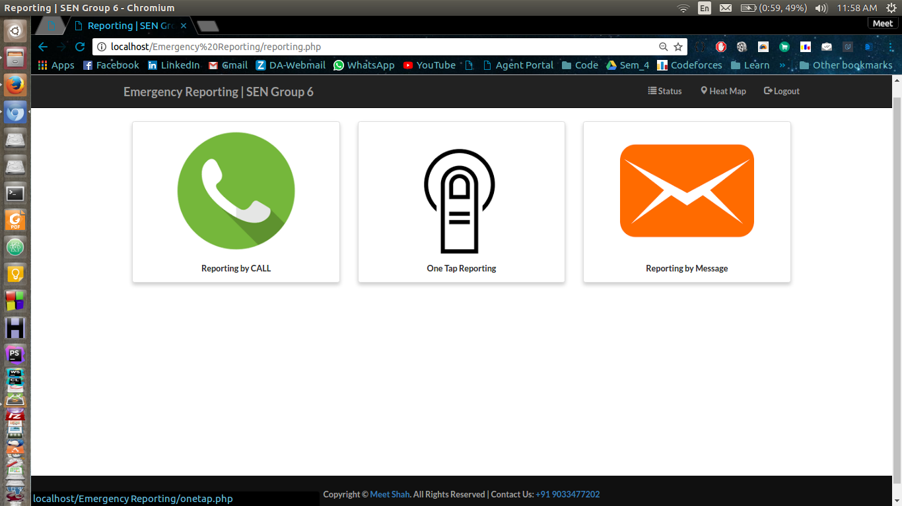

* Report by Call :

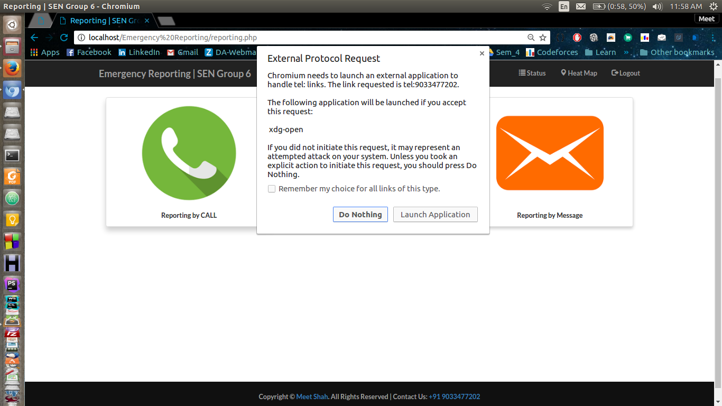

It directly calls on my mobile if GSM Module is connected with laptop. In mobile it directly calls on provided number.

* Report by One-Tap

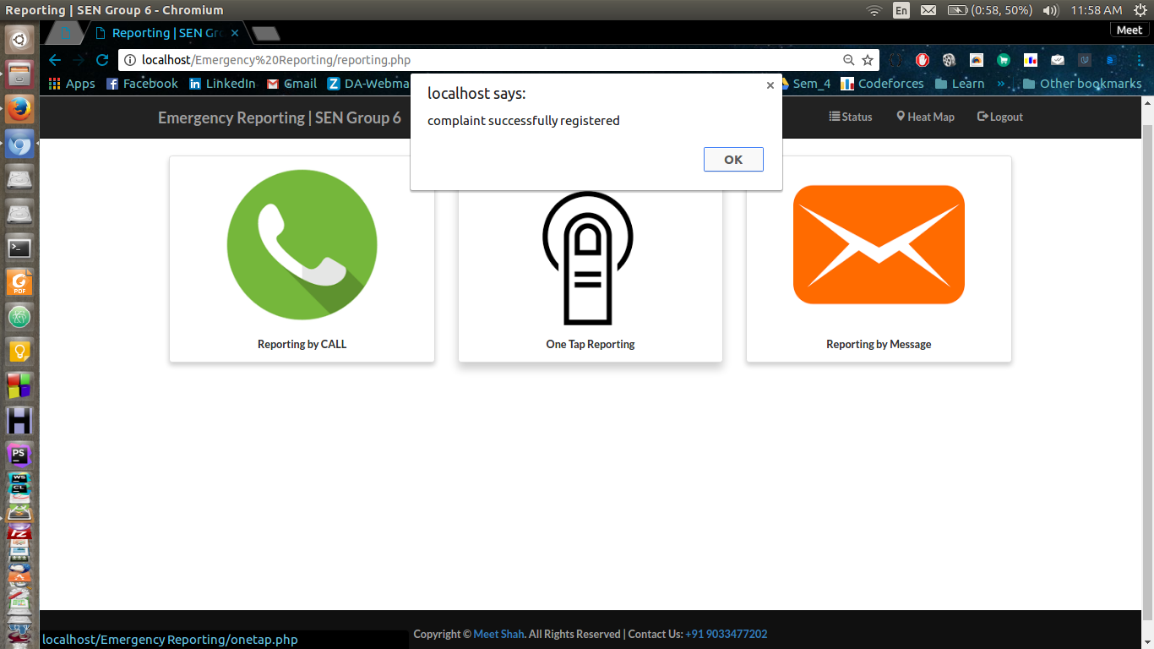

After clicking on One-Tap it directly registers complaint with associated id.

* Report by Message 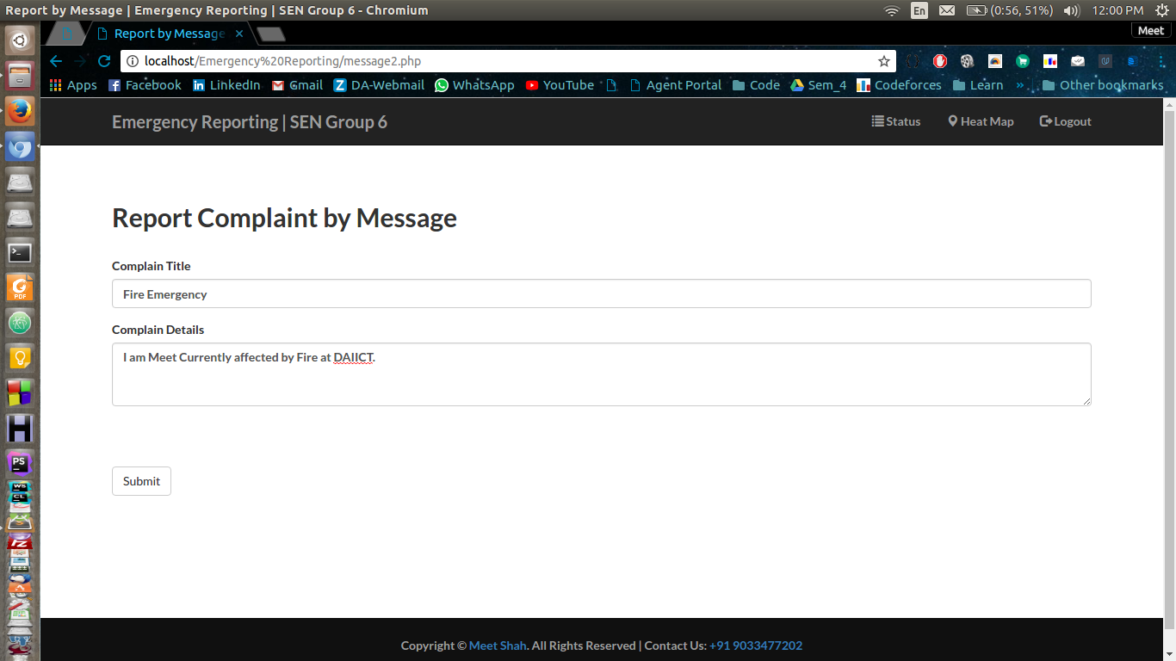

User can write details in message by this feature.

* Database of reported Emergencies associated with different users :

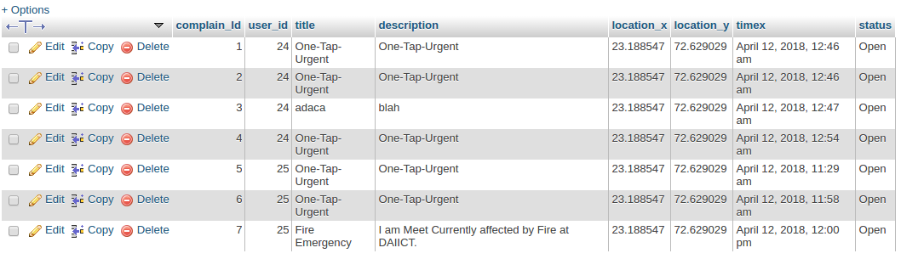

Here complaint id and user id are mapped for each emergency. Emergencies registered by one-tap have One-Tap-Urgent as title and description other have details of title and emergency details. latitude and longitude are fetched by appropriate google API. time is also fetched by API. Open Status shows it’s still alive and can see on heat-map.

**Use Case : Emergency Status:**

* Status page of User

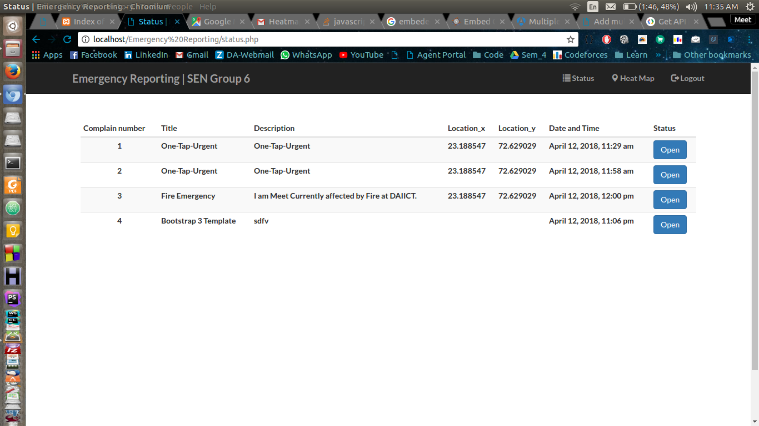

* Heat Map of Nearby Emergencies :

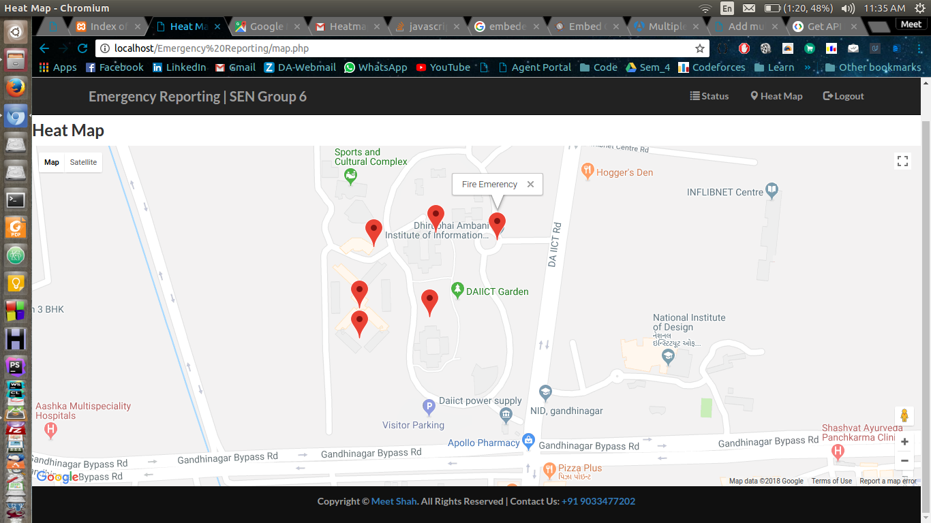

**Conclusion :**

We have implemented all core functionalities on Back-end and Front-end both by using MySQL as database and PHP as back-end language. HTML,CSS and JS are used in front-end part.

All Core Features listed in our Class model are implemented.

List of Implemented Features are,

* Authentication ( Login, Signup)
* Report Emergency (by Call, by One-tap Button, by detailed message)
* View Status ( View Own Emergency Status, Heat map of nearby location)

Steps to Run Software are given in README File.

**Appendix:**

***SQL Code :***

-- phpMyAdmin SQL Dump  
-- version 4.0.10deb1  
-- http://www.phpmyadmin.net  
--  
-- Host: localhost  
-- Generation Time: Apr 12, 2018 at 01:04 PM  
-- Server version: 5.5.54-0ubuntu0.14.04.1  
-- PHP Version: 5.5.9-1ubuntu4.21  
  
SET SQL_MODE = "NO_AUTO_VALUE_ON_ZERO";  
SET time_zone = "+00:00";  
  
  
/*!40101 SET @OLD_CHARACTER_SET_CLIENT=@@CHARACTER_SET_CLIENT */;  
/*!40101 SET @OLD_CHARACTER_SET_RESULTS=@@CHARACTER_SET_RESULTS */;  
/*!40101 SET @OLD_COLLATION_CONNECTION=@@COLLATION_CONNECTION */;  
/*!40101 SET NAMES utf8 */;  
  
--  
-- Database: `ER2`  
--  
  
-- --------------------------------------------------------  
  
--  
-- Table structure for table `complaints`  
--  
  
CREATE TABLE IF NOT EXISTS `complaints` (  
 `complain_Id` int(15) NOT NULL AUTO_INCREMENT,  
 `user_id` int(50) NOT NULL,  
 `title` varchar(256) NOT NULL,  
 `description` varchar(700) NOT NULL,  
 `location_x` varchar(100) NOT NULL,  
 `location_y` varchar(100) NOT NULL,  
 `timex` varchar(255) NOT NULL,  
 `status` enum('Open','Close') NOT NULL,  
 PRIMARY KEY (`complain_Id`)  
) ENGINE=MyISAM DEFAULT CHARSET=latin1 AUTO_INCREMENT=8 ;  
  
--  
-- Dumping data for table `complaints`  
--  
  
INSERT INTO `complaints` (`complain_Id`, `user_id`, `title`, `description`, `location_x`, `location_y`, `timex`, `status`) VALUES  
(1, 24, 'One-Tap-Urgent', 'One-Tap-Urgent', '23.188547', '72.629029', 'April 12, 2018, 12:46 am', 'Open'),  
(2, 24, 'One-Tap-Urgent', 'One-Tap-Urgent', '23.188547', '72.629029', 'April 12, 2018, 12:46 am', 'Open'),  
(3, 24, 'adaca', 'blah', '23.188547', '72.629029', 'April 12, 2018, 12:47 am', 'Open'),  
(4, 24, 'One-Tap-Urgent', 'One-Tap-Urgent', '23.188547', '72.629029', 'April 12, 2018, 12:54 am', 'Open'),  
(5, 25, 'One-Tap-Urgent', 'One-Tap-Urgent', '23.188547', '72.629029', 'April 12, 2018, 11:29 am', 'Open'),  
(6, 25, 'One-Tap-Urgent', 'One-Tap-Urgent', '23.188547', '72.629029', 'April 12, 2018, 11:58 am', 'Open'),  
(7, 25, 'Fire Emergency', 'I am Meet Currently affected by Fire at DAIICT.', '23.188547', '72.629029', 'April 12, 2018, 12:00 pm', 'Open');  
  
-- --------------------------------------------------------  
  
--  
-- Table structure for table `users`  
--  
  
CREATE TABLE IF NOT EXISTS `users` (  
 `id` int(11) NOT NULL AUTO_INCREMENT,  
 `name` varchar(255) NOT NULL,  
 `email` varchar(255) NOT NULL,  
 `password` varchar(255) NOT NULL,  
 `contact` int(10) NOT NULL,  
 `tcontact` int(10) NOT NULL,  
 PRIMARY KEY (`id`)  
) ENGINE=InnoDB DEFAULT CHARSET=latin1 AUTO_INCREMENT=26 ;  
  
--  
-- Dumping data for table `users`  
--  
  
INSERT INTO `users` (`id`, `name`, `email`, `password`, `contact`, `tcontact`) VALUES  
(7, 'Meet Shah', 'root@f.f', '202cb962ac59075b964b07152d234b70', 0, 0),  
(22, 'Priyank', 'priyank.prajapati29@gmail.com', 'fd6c09734988030634a769b0c9b712ee', 0, 0),  
(23, 'D', 'aja@some.com', '25d55ad283aa400af464c76d713c07ad', 2147483647, 2147483647),  
(24, 'priyank', 'priyank@gmail.com', 'fd6c09734988030634a769b0c9b712ee', 2147483647, 2147483647),  
(25, 'Meet Shah', 'meetshah7202@gmail.com', '25d55ad283aa400af464c76d713c07ad', 2147483647, 2147483647);

**Project Source Code :**

*-> PFA Emergency Reporting Folder*

**Steps to Run**

1. In Localhost import provided database file Database_File.sql
2. Open 'Emergency Reporting/includes/common.php' change id and password according to your localhost's id and password.
3. You can run our Web-App at 'http://localhost/Emergency%20Reporting/'