**Interaction Diagram**

**Emergency Help Service**

***Authentication***

**Interaction Model**

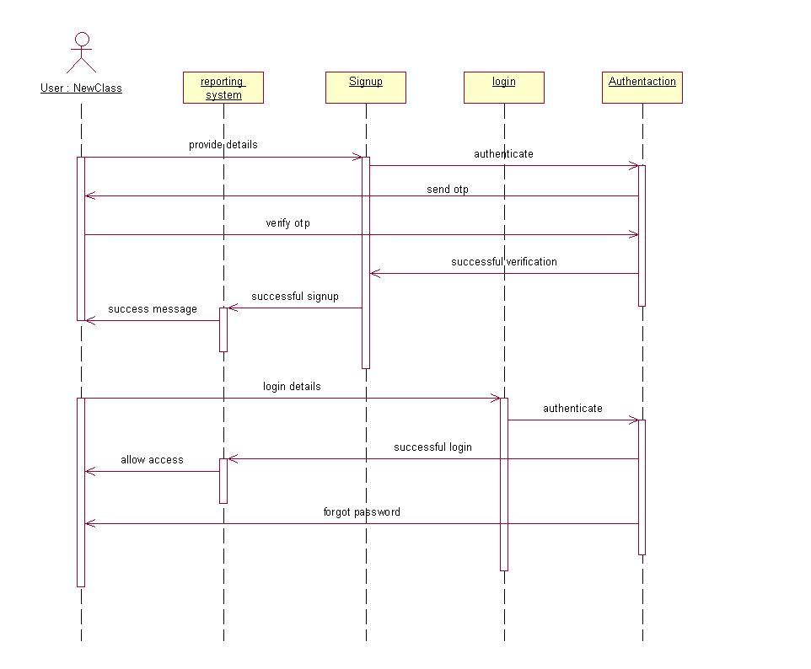

**Collaboration Model**

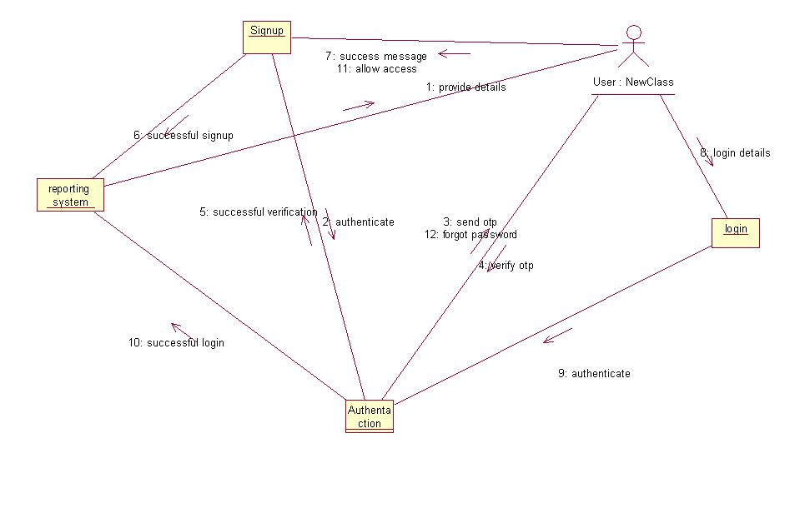

***One Tap Emergency Reporting***

* **Interaction Model**

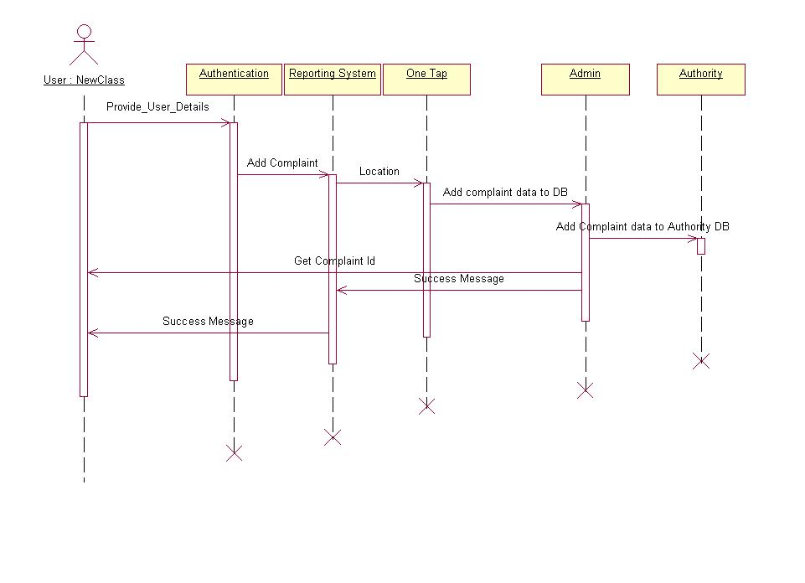

* **Collaboration Model**

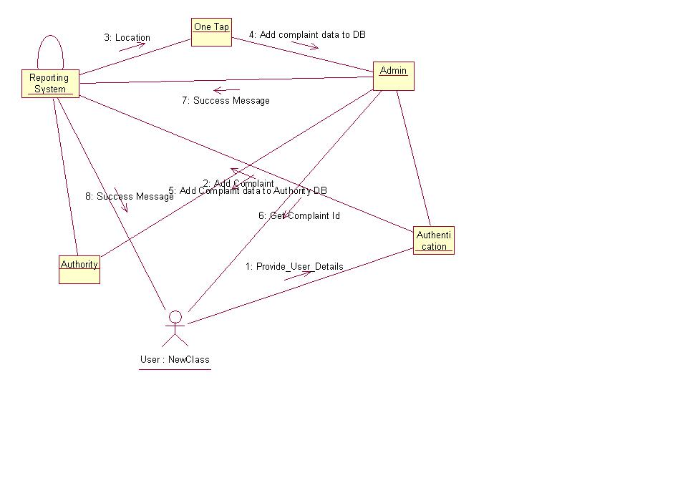

***View Emergency Details***

* **Interaction Model**

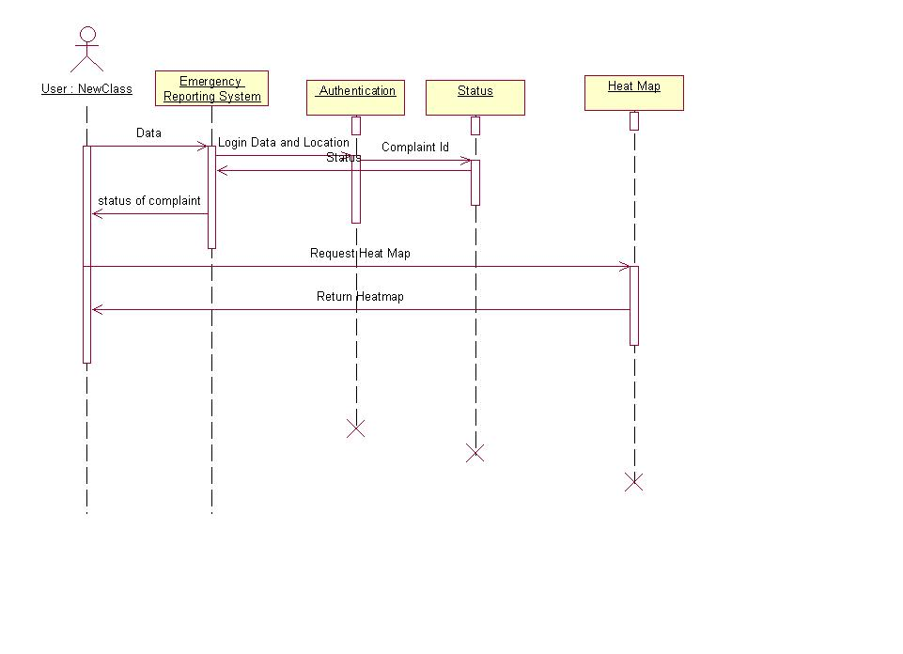

* **Collaboration Model**

