**Class Modeling**

**Emergency Help Service**

***Initial Nouns :***

|  |  |  |
| --- | --- | --- |
| 1 | Emergency | Type |
| 2 | Help | Association |
| 3 | System | General |
| 4 | Service | General |
| 5 | Introduction | Vague |
| 6 | World | Vague |
| 7 | Gadgets | General |
| 8 | Solutions | General |
| 9 | Imitation | General |
| 10 | challenge | Vague |
| 11 | digitalization | Vague |
| 12 | boom | Vague |
| 13 | culture | General |
| 14 | accessibility | Association |
| 15 | device | General |
| 16 | citizen | General |
| 17 | System | General |
| 18 | Intervention | Vague |
| 19 | Things | Vague |
| 20 | User | General |
| 21 | Iteration | Vague |
| 22 | authority | General |
| 23 | people | General |
| 24 | user | General |
| 25 | data | Attribute |
| 26 | location | General |
| 27 | aspects | Vague |
| 28 | idea | Vague |
| 29 | process | Association |
| 30 | reporting | Association |
| 31 | stapes | General |
| 32 | times | Vague |
| 33 | Line | General |
| 34 | though | Vague |
| 35 | help | Association |
| 36 | Sections | General |
| 37 | centers | Vague |
| 38 | type | Vague |
| 39 | sos | Roles |
| 40 | button | General |
| 41 | locations | General |
| 42 | Contact | Roles |
| 43 | Number | General |
| 44 | message | General |
| 45 | click | Association |
| 46 | categories | Vague |
| 47 | Data | Attributes |
| 48 | input | Vague |
| 49 | panic | Role |
| 50 | Action | Association |
| 51 | case | Vague |
| 52 | clients | General |
| 53 | Offices | General |
| 54 | hours | Vague |
| 55 | Limitations | Vague |
| 56 | emergency | Association |
| 57 | Feature | General |
| 58 | Fast | Vague |
| 59 | Information | Attribute |
| 60 | Selections | Vague |
| 61 | List | Vague |
| 62 | Web-app | General |
| 63 | Login | Role |
| 64 | Signup | Role |
| 65 | Place | General |
| 66 | Notification | Attribute |
| 67 | Auto | Vague |
| 68 | SMS | Role |
| 69 | Trusted | General |
| 70 | Contacts | Attribute |
| 71 | Intervelt | Vague |
| 72 | need | Vague |
| 73 | sitiations | Vague |
| 74 | wise | General |
| 75 | Database | General |
| 76 | himself | Vague |
| 77 | herself | Vague |
| 78 | Police | General |
| 79 | Station | Vague |
| 80 | fast | Vague |
| 81 | heat | Vague |
| 82 | map | Role |
| 83 | admin | General |
| 84 | access | Association |
| 85 | authority | General |
| 86 | Auto | Vague |
| 87 | Recommend | Association |
| 88 | server | Server |
| 89 | System | General |
| 90 | Customers | General |
| 91 | SOS | Role |
| 92 | Blogs | Role |
| 93 | Details | Vague |
| 94 | Web-sites | General |
| 95 | Whats-app | Roles |
| 96 | network | General |
| 97 | congestion | Vague |
| 98 | event | General |
| 99 | Internet | Roles |
| 100 | Power | Vague |
| 101 | Outage | Vague |
| 102 | Broadband | Role |
| 103 | ISP | Role |
| 104 | Completion | Association |
| 105 | emergency | Role |
| 106 | before | Vague |
| 107 | may | Vague |
| 108 | new | General |
| 109 | click | Attribute |
| 110 | blogs | Role |
| 111 | appropriate | Vague |
| 112 | you | Vague |
| 113 | auto | General |
| 114 | people | General |
| 115 | update | Association |
| 116 | emergency | Role |
| 117 | information | Attribute |
| 118 | introduction | General |
| 119 | emergency | Role |
| 120 | cellular | Role |
| 121 | limitations | General |
| 122 | best | Vague |
| 123 | culture | General |
| 124 | interevelt | General |
| 125 | whatsapp | Roles |
| 126 | description | Attribute |
| 127 | customers | General |
| 128 | visiting | Vague |
| 129 | emergency | Role |
| 130 | recommend | Vague |
| 131 | direct | General |
| 132 | challenge | Association |
| 133 | accessibility | Association |
| 134 | processing | Association |
| 135 | digitalization | General |
| 136 | congestion | General |
| 137 | boom | Vague |
| 138 | completion | Association |
| 139 | over | Vague |
| 140 | maintain | Association |
| 141 | closed | Vague |
| 142 | emergency | Role |
| 143 | detecting | Association |
| 144 | resolving | Association |
| 145 | pressing | Association |
| 146 | police | Role |
| 147 | everyday | General |
| 148 | sections | General |
| 149 | unresolved | Attribute |
| 150 | deleted | General |
| 151 | working | Association |
| 152 | emergency | Roles |
| 153 | event | General |
| 154 | intervention | Vague |
| 155 | thought | Vague |
| 156 | overcome | Vague |
| 157 | outside | Vague |
| 158 | digital | General |
| 159 | registered | General |
| 160 | power | Vague |
| 161 | scenarios | General |
| 162 | situations | General |
| 163 | interaction | Association |
| 164 | statement | Vague |
| 165 | notification | Attribute |
| 166 | line | Vague |
| 167 | list | Vague |
| 168 | live | Vague |
| 169 | coming | Association |
| 170 | wants | Vague |
| 171 | delay | General |
| 172 | terminated | Vague |
| 173 | category | General |
| 174 | resolve | Association |
| 175 | propose | Association |
| 176 | things | General |
| 177 | calls | Association |
| 178 | sometimes | Vague |
| 179 | action | General |
| 180 | steps | General |
| 181 | citizens | General |
| 182 | viable | Vague |
| 183 | place | General |
| 184 | broadband | Attribute |
| 185 | given | Vague |
| 186 | feasible | General |
| 187 | process | General |
| 188 | implemented | Association |
| 189 | store | General |
| 190 | fetch | Association |
| 191 | features | General |
| 192 | worrying | Association |
| 193 | number | General |
| 194 | outage | Vague |
| 195 | helps | Association |
| 196 | function | Vague |
| 197 | quick | Vague |
| 198 | comes | Association |
| 199 | network | General |
| 200 | prevent | Vague |
| 201 | himself/herself | General |
| 202 | idea | Vague |
| 203 | respond | Association |
| 204 | services | Association |
| 205 | quickly | Vague |
| 206 | changing | General |
| 207 | manual | Vague |
| 208 | behave | Vague |
| 209 | intimation | General |
| 210 | specific | Vague |
| 211 | during | General |
| 212 | pictures/audio | Attribute |
| 213 | fetch | Association |
| 214 | personalised | Association |
| 215 | record | Vague |
| 216 | App | Attribute |
| 217 | prior | Vague |
| 218 | clients | General |
| 219 | building | Vague |
| 220 | helped | Association |
| 221 | build | Vague |
| 222 | area | Vague |
| 223 | efficient | Vague |
| 224 | selection | Association |
| 225 | fire | Vague |

***Accepted Initial Nouns :***

|  |  |  |
| --- | --- | --- |
| Emergency Reporting | User | Location |
| Authority | Contact | Login |
| Service | Authentication | System |
| Signup | Area | Internet |
| Mobile | Audio | Details |
| Message | Server | Heatmap |
| Database | Blogs | SOS |
| Admin | Panic Button | Pictures |
| Stations | 24X7 | Information |
| Police | Call | Gadget |
| Accessibility | Digitalisation |  |

*Final Accepted Initial Nouns with description :*

|  |  |  |
| --- | --- | --- |
| *Noun* | *Accepted/Rejected* | *Description* |
| Emergency Reporting | Accepted | Core Noun for Problem |
| Authority | Accepted | Core user of Service |
| Authentication | Accepted | Requirement for Service |
| Service | Rejected | Requirement for Service |
| Signup | Accepted | End-User for Service |
| Mobile | Rejected | Platform for Service |
| Message | Accepted | Feature of Service |
| Database | Rejected | For maintenance of Service |
| Admin | Accepted | Control on service |
| Stations | Rejected | Core Centres for Service’s Solution Details |
| Police | Rejected | One of Key Admin and Entity |
| Accessibility | Rejected | Requirement of Service |
| Contact | Rejected | Requirement of Service |
| Area | Rejected | Key Requirement as per Location based service |
| Audio | Rejected | Feature of Service |
| Server | Rejected | For maintenance of Service |
| Blogs | Rejected | Feature of Service |
| Panic Button | Accepted | Key-Feature of Service |
| Call | Accepted | Requirement of Service |
| Digitalisation | Rejected | Abstract Fact of Service |
| Location | Rejected | Key Requirement as per Location based service |
| Login | Accepted | Key Requirement or Service |
| System | Accepted | For Over allof Service |
| Internet | Rejected | Key Requirement or Service |
| Details | Rejected | Data of Service |
| Heatmap | Accepted | Key-Feature of Service |
| SOS | Rejected | Key-Feature of Service |
| Pictures | Rejected | Feature of Service |
| Information | Rejected | Data of Service |
| Gadget | Rejected | Abstract Requirement of Service |

***Noun Analysis :***

|  |  |
| --- | --- |
| Potential Classes | Nouns |
| System | Location |
| User Details | Username, password |
| Call | Cell number |
| Reporting | Location, Complaint Id, Subject |
| Message | Text Message |
| One Tap | Time |
| Authentication | Id, Password |
| Login | Id, Password, User data |
| SignUp | Id,Password,Email, Contact No, Trusted Contact Numbers |
| Status | Complaint Id, Status |
| Authority | Details, Status |
| ***Added after Primary Noun Analysis by Requirement Needs*** | |
| Heatmap | Map with Data Intensity |
| Admin | Database |

**Attributes List :**

|  |  |
| --- | --- |
| Potential Classes | Nouns |
| System | Location |
| User Details | Username, password |
| Call | Cell number |
| Reporting | Location, Complaint Id, Subject |
| Message | Text Message |
| One Tap | Time |
| Authentication | Id, Password |
| Login | Id, Password, User data |
| SignUp | Id,Password,Email, Contact No, Trusted Contact Numbers |
| Status | Complaint Id, Status |
| Authority | Details, Status |
| ***Added after Primary Noun Analysis by Requirement Needs*** | |
| Heatmap | Map with Data Intensity |
| Admin | Database |

**Scrutinized nouns appearing in the Potential Class :**

|  |  |  |
| --- | --- | --- |
| Classes | Nouns | Methods |
| System | Location | Fetch_Location() |
| Authority | Details, Status | Delete_Complaint(), Review_Complaint() |
| Call | Cell number | Call() |
| Reporting | Location, Complaint Id, Subject | Generate_Complaint_id(), |
| Message | Text Message | Send_Message(), Write_Message() |
| One Tap | - | Send_Complaint() |
| Authentication | Id, Password | Authenticate() |
| Login | Id, Password, User data | Forgot_password() |
| SignUp | Id,Password,Email, Contact No, Trusted Contact Numbers | Generate_OTP(),  Receive_OTP() |
| Status | Complaint Id, Status | get_status(), view_map(), |
| ***Added after Primary Noun Analysis by Requirement Needs*** | | |
| Heatmap | Map with Data Intensity | Generate_Map() |
| Admin | Database | Edit_Details(),  Close_Complaint() |

**List of Final Classes :**

|  |  |  |
| --- | --- | --- |
| System | One Tap | Heatmap |
| Authority | Authentication | Admin |
| Call | Login | Message |
| Reporting | SignUp | Status |

* **Class Diagram by Noun Analysis:**

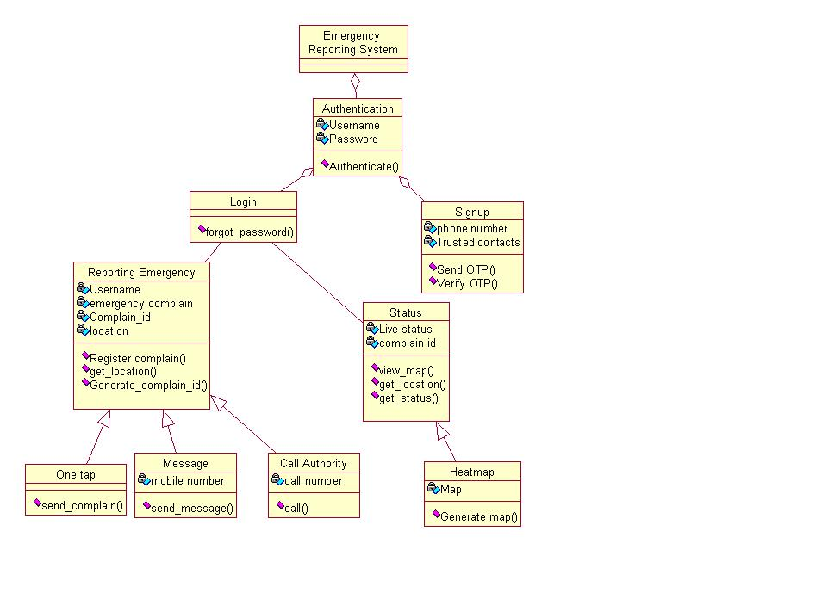

* **Class Diagram after Primary Noun Analysis by Requirement Needs**

