**Task-1**

**Aim:**

Declare a variable using var, let, and const. Assign different data types to each variable

and print their values.

**Theory Background:**

**Source Code:**

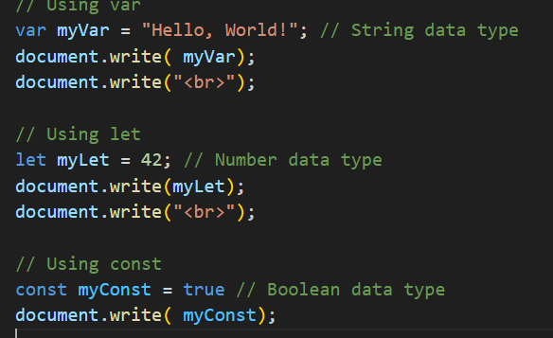

**Output:**  
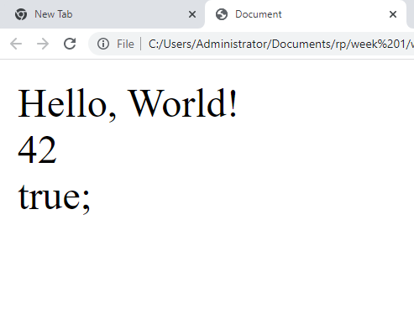

**Task-2**

**Aim:**

Write a function that takes two numbers as arguments and returns their sum, difference,

product, and quotient using arithmetic operators.

**Theory Background:**

**Source Code:**

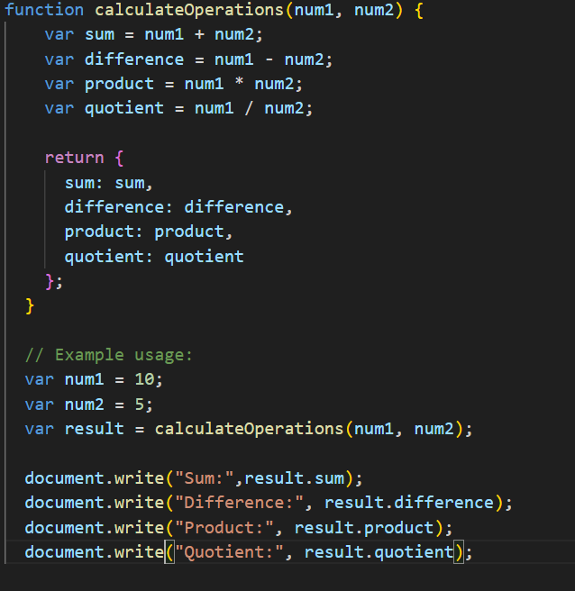

**Output:**

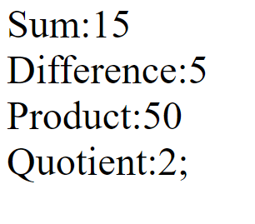

**Task-3**

**Aim:**

Write a program that prompts the user to enter their age. Based on their age, display

different messages:

○ If the age is less than 18, display "You are a minor."

○ If the age is between 18 and 65, display "You are an adult."

○ If the age is 65 or older, display "You are a senior citizen."

**Theory Background:**

**Source Code:**

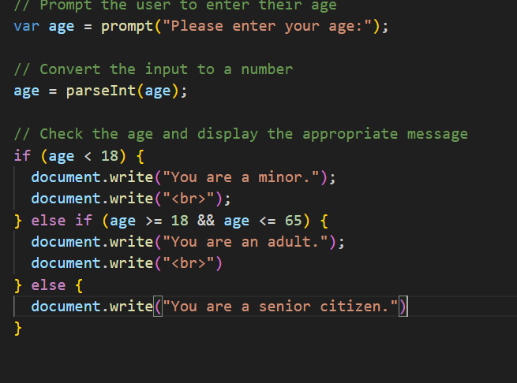

**Output:**

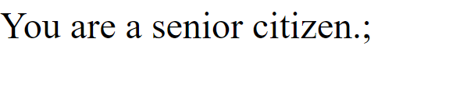

**Task-4**

**Aim:**

Write a function that takes an array of salary as an argument and returns the min/max

salary in the array.

**Theory Background:**

**Source Code:**

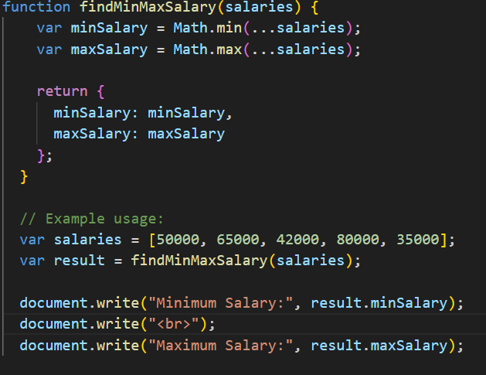

**Output:**

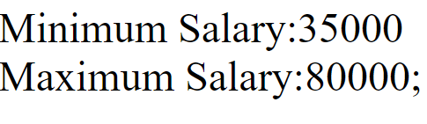

**Task-5**

**Aim:**

Create an array of your favorite books. Write a function that takes the array as an

argument and displays each book title on a separate line.

**Theory Background:**

**Source Code:**

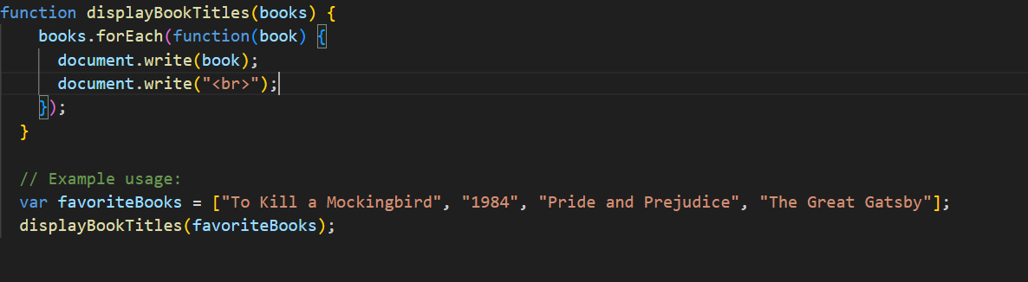

**Output:**

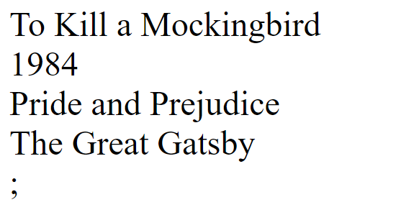

**Task-6**

**Aim:**Declare a variable inside a function and try to access it outside the function. Observe the scope behavior and explain the results. [var vs let vs const]

**Theory Background:**

**Source Code:**

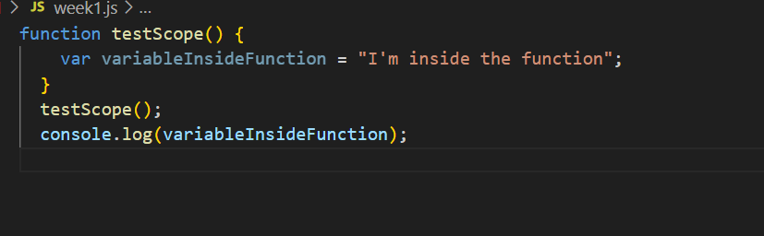

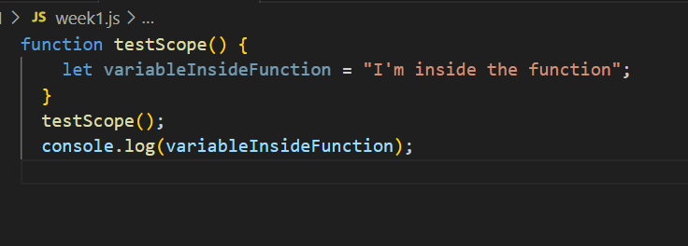

**Output:**

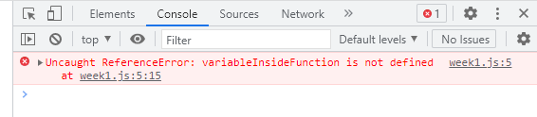

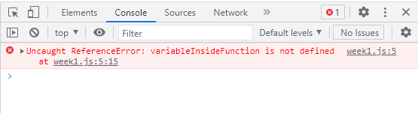

**Task-7**

**Aim:**Create an HTML page with a button. Write JavaScript code that adds an event listener to the button and changes its text when clicked.

**Theory Background:**

**Source Code:**

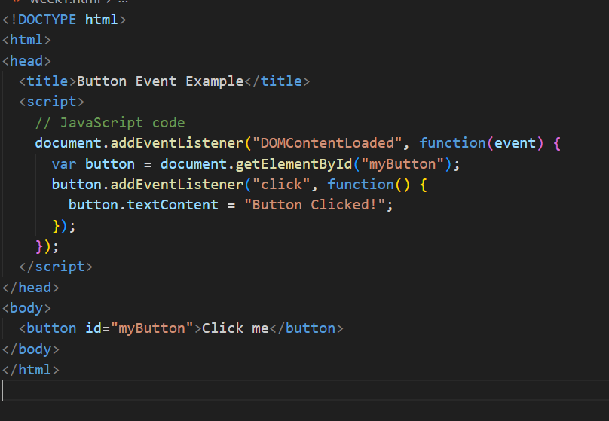

**Output:**

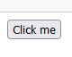 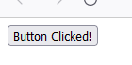

**Task-8**

**Aim:**Write a function that takes a number as an argument and throws an error if the number

is negative. Handle the error and display a custom error message.

.

**Theory Background:**

**Source Code:**

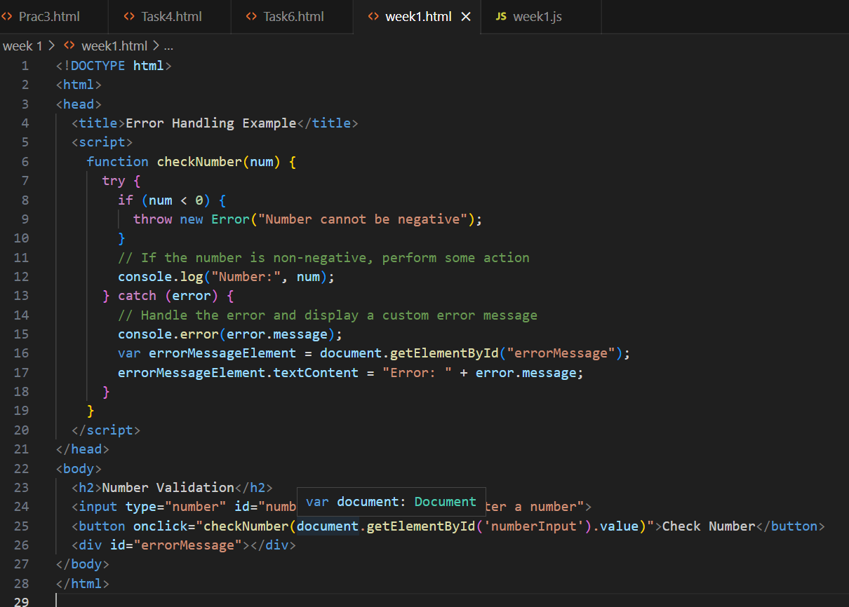

**Output:**

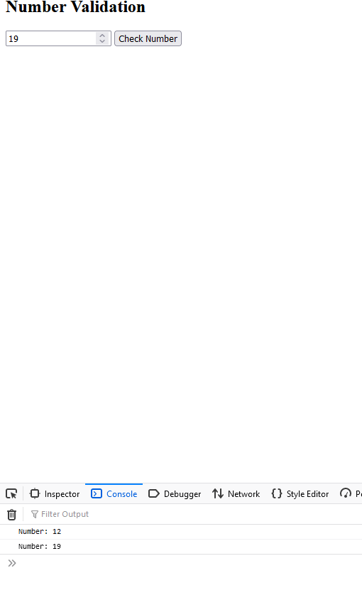

**Task-9**

**Aim:**Write a function that uses setTimeout to simulate an asynchronous operation. Use a

callback function to handle the result.

.**Theory Background:**

**Source Code:**

-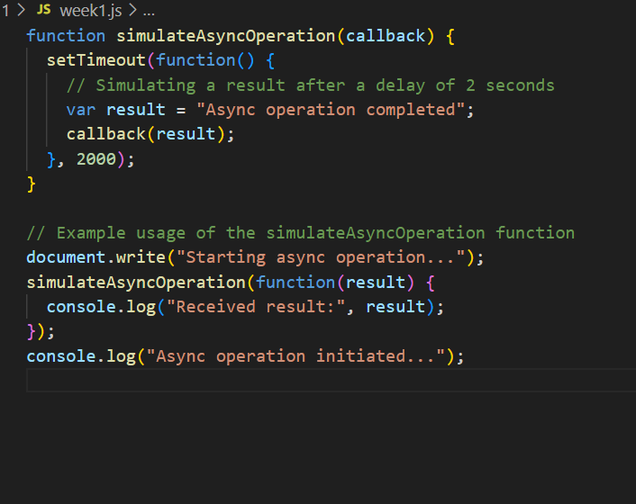

**Output:**

