**CS246: Mining Massive Datasets**

# Assignment number: 1

Fill in and include this cover sheet with each of your assignments. Assignments and code are due at 5:00 PM on Scoryst and SNAP respectively. Failure to include the coversheet with you assignment will be penalized by 2 points.

Each student will have a total of *two* free late periods. *One late period expires at the start of each class.* (Assignments are due on Thursdays, which means the first late period expires on the following Tuesday at 5:00 PM.) Once these late periods are exhausted, any assignments turned in late will be penalized 50% per late period. However, no assignment will be accepted more than *one* late period after its due date. (If an assignment is due on Thursday 5 PM then we will not accept it after the following Tuesday 5 PM.)

# Your name: Priyank mathur

**Email:**[priyankm@stanford.edu](mailto:priyankm@stanford.edu) **SUNetID:** priyankm

Collaborators: Dibyajyoti Ghosh

I acknowledge and accept the Honor Code.

*(Signed)* Priyank Mathur

Q1.

1) Source Code available towards the end of this file.

2) I solved this problem using a single map reduce job. The way I tackled this is for each line in the file, I outputted 2 sets of key value pairs from the mapper. First a list of direct relations to that user and the second was a set of distance 2 friends created from generating all pairs from the friends list of that line. For eg:

For line : 1 2,3

I generate the following pairs

1 1-2

1 1-3

2 2-3

Where the value is of the form distance-user2

In the reducer, for each user I kept track of others users distance to it and counted the number of people at distance of 2 from it. I sorted this counted list and outputted users who had most number of mutual friends. [1]

Sample output –

0 38737,18591,27383,34211,337,352,1532,12143,12561,17880

1 35621,44891,14150,15356,35630,13801,13889,14078,25228,13805

2 41087,1,5,95,112,1085,1404,2411,3233,4875

3 27679,1,10,16,29,30,38,82,83,85

3)

924 439,2409,6995,11860,15416,43748,45881

8941 8943,8944,8940

8942 8939,8940,8943,8944

9019 9022,317,9023

9020 9021,9016,9017,9022,317,9023

9021 9020,9016,9017,9022,317,9023

9022 9019,9020,9021,317,9016,9017,9023

9990 13134,13478,13877,34299,34485,34642,37941

9992 9987,9989,35667,9991

9993 9991,13134,13478,13877,34299,34485,34642,37941

[1] Cems.uwe.ac.uk, (2014). Paul Matthews Blog @ UWE | Teaching MapReduce. [online] Available at: <http://www.cems.uwe.ac.uk/~pmatthew/blog/2014/03/04/teaching-mapreduce> [Accessed 21 Jan. 2015].

Q2.

d)

Rule, Confidence

'DAI93865 -> FRO40251', 1.0

'GRO85051 -> FRO40251', 0.999176276771005

'GRO38636 -> FRO40251', 0.9906542056074766

'ELE12951 -> FRO40251', 0.9905660377358491

'DAI88079 -> FRO40251', 0.9867256637168141

e)

Rule, Confidence

'DAI23334,ELE92920 -> DAI62779', 1.0

'DAI31081,GRO85051 -> FRO40251', 1.0

'DAI55911,GRO85051 -> FRO40251', 1.0

'DAI62779,DAI88079 -> FRO40251', 1.0

'DAI75645,GRO85051 -> FRO40251', 1.0

Source Code available towards the end of this file.

Q4.

d)

1)

Average search time for LSH - 0.019817

Average search time for Linear search - 0.25485

We see significant improvement in run time of LSH, which is approximately 10 times faster than linear search.

2)

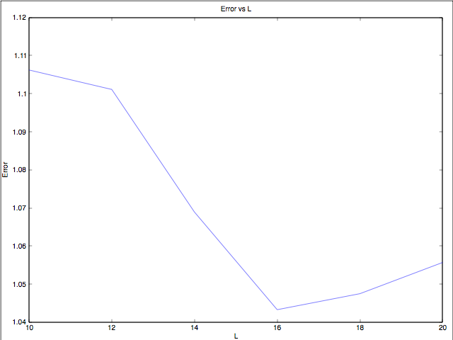

We notice from the above graph that increasing L (number of tables) generally should decrease the error of the approximate search of LSH. This may be because we are increasing the number of terms in the OR construct (buckets) and hence increasing the probability of similar things hashing together.

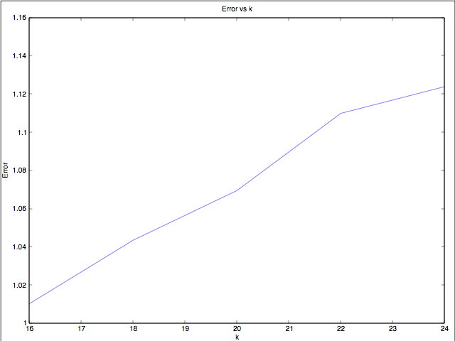

We notice from the above graph that increasing k (key length) increases the error of the search by LSH. This may be because we are increasing the number of terms in the AND construct (rows) and hence decreasing the probability of similar things hashing together.

3)

**Query point (column 100) –**

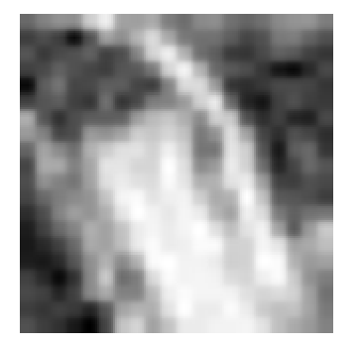

**LSH –**

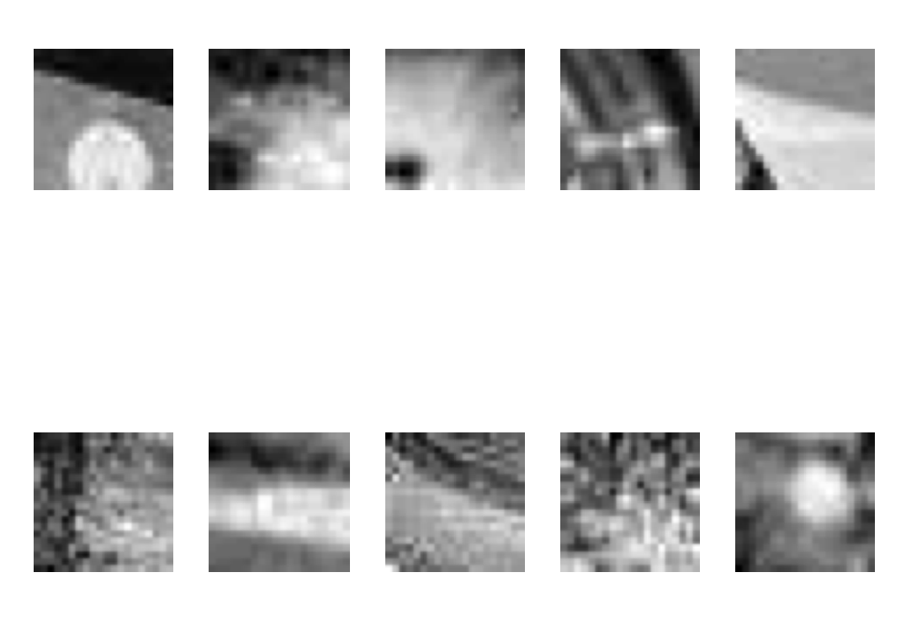

The nearest neighbors found look to be similar to query image above but some options towards the end (towards bottom and right) appear to further diverge away from the query.

**Linear –**

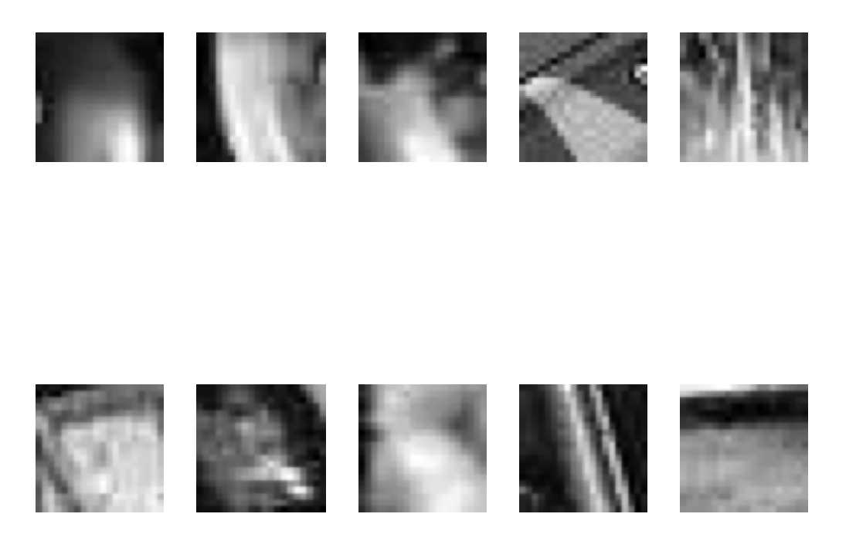

The result of linear search is much better than LSH. The query image contains a bright-elongated spot in the middle and is darker towards the edges. Most of the neighbors found by linear search have similar appearance. In contrast, some of the neighbors produced by LSH (eg. number 3 and 5 in top row) are different from this pattern.

We can conclude from this experiment that even though LSH is significantly faster, it might not produce very accurate results.

**Q1 Source code –**

package edu.stanford.cs246.friendrecommender;

import java.io.IOException;

import java.util.ArrayList;

import java.util.Arrays;

import java.util.Collection;

import java.util.Comparator;

import java.util.HashMap;

import java.util.Iterator;

import java.util.Map.Entry;

import java.util.PriorityQueue;

import java.util.Stack;

import java.util.regex.Matcher;

import java.util.regex.Pattern;

import org.apache.hadoop.conf.Configuration;

import org.apache.hadoop.conf.Configured;

import org.apache.hadoop.fs.Path;

import org.apache.hadoop.io.IntWritable;

import org.apache.hadoop.io.LongWritable;

import org.apache.hadoop.io.Text;

import org.apache.hadoop.mapreduce.Job;

import org.apache.hadoop.mapreduce.Mapper;

import org.apache.hadoop.mapreduce.Reducer;

import org.apache.hadoop.mapreduce.lib.input.FileInputFormat;

import org.apache.hadoop.mapreduce.lib.input.TextInputFormat;

import org.apache.hadoop.mapreduce.lib.output.FileOutputFormat;

import org.apache.hadoop.mapreduce.lib.output.TextOutputFormat;

import org.apache.hadoop.util.Tool;

import org.apache.hadoop.util.ToolRunner;

public class FriendRecommender extends Configured implements Tool {

public static void main(String[] args) throws Exception {

System.out.println(Arrays.toString(args));

int res = ToolRunner.run(new Configuration(), new FriendRecommender(), args);

System.exit(res);

}

@Override

public int run(String[] args) throws Exception {

System.out.println(Arrays.toString(args));

Job job = new Job(getConf(), "FriendRecommender");

job.setJarByClass(FriendRecommender.class);

job.setOutputKeyClass(IntWritable.class);

job.setOutputValueClass(Text.class);

job.setMapperClass(Map.class);

job.setReducerClass(Reduce.class);

job.setInputFormatClass(TextInputFormat.class);

job.setOutputFormatClass(TextOutputFormat.class);

FileInputFormat.addInputPath(job, new Path(args[0]));

FileOutputFormat.setOutputPath(job, new Path(args[1]));

job.waitForCompletion(true);

return 0;

}

public static class Map extends Mapper<LongWritable, Text, IntWritable, Text> {

Text dist1Text = new Text();

Text dist2Text = new Text();

@Override

public void map(LongWritable key, Text value, Context context)

throws IOException, InterruptedException {

// Get the information from the line

String line = value.toString();

String[] users = line.split("\\t");

String friendString = users.length > 1 ? users[1] : "";

String[] friends = friendString.split(",");

/* Loop through friends list to generate pairs of following types -

* For line : 1 2,3

* we generate the following pairs

* 1 1-2

* 1 1-3

* 2 2-3

*

* Where the value is of the form distance-user2

*/

for (int i=0; !friendString.equals("") && i<friends.length; i++) {

String dist1Str = "1-" + friends[i];

dist1Text.set(dist1Str);

context.write(new IntWritable(Integer.parseInt(users[0])), dist1Text);

// Generate pairs with distance 2

for (int j=i+1; j<friends.length; j++) {

String dist2Str = "2-" + friends[j];

dist2Text.set(dist2Str);

context.write(new IntWritable(Integer.parseInt(friends[i])), dist2Text);

dist2Str = "2-" + friends[i];

dist2Text.set(dist2Str);

context.write(new IntWritable(Integer.parseInt(friends[j])), dist2Text);

}

}

}

}

public static class Reduce extends Reducer<IntWritable, Text, IntWritable, Text> {

/*

* For each user user1, keep track of how many common friends does he

* have with another user user2. Then remove direct relations and

* output the distance 2 users sorted by the number of mutual friends.

*/

@Override

public void reduce(IntWritable key, Iterable<Text> values, Context context)

throws IOException, InterruptedException {

HashMap<Integer, Integer> map = new HashMap<Integer, Integer>();

for (Text val : values) {

String association = val.toString();

int length = Integer.parseInt(association.split("-")[0]);

int friend = Integer.parseInt(association.split("-")[1]);

// Keep track of other users and their distance

if (length == 1)

map.put(friend, 0);

else if (length == 2) {

if (map.containsKey(friend)) {

if (map.get(friend)!=0)

map.put(friend, map.get(friend)+1);

}

else {

map.put(friend, 1);

}

}

}

PriorityQueue<Entry<Integer, Integer>> queue = new PriorityQueue<Entry<Integer, Integer>>(10, new EntryComparator());

// Put them in a priority queue to get the 10 users

// with most number of mutual friends

for (Entry<Integer, Integer> e: map.entrySet()) {

if (e.getValue()==0)

continue;

if (queue.size() < 10)

queue.add(e);

else {

int tempValue = ((Entry<Integer, Integer>) queue.peek()).getValue();

int tempKey = ((Entry<Integer, Integer>) queue.peek()).getKey();

if ((tempValue < e.getValue()) || (tempValue == e.getValue() && tempKey > e.getKey())){

queue.poll();

queue.add(e);

}

}

}

String recommendations = "";

Stack<Entry<Integer, Integer>> reverser = new Stack<Entry<Integer, Integer>>();

// Reverse the order

while (queue.size() > 0) {

reverser.push(queue.poll());

}

if (reverser.size() > 0) {

Entry<Integer, Integer> element = reverser.pop();

recommendations += element.getKey();

}

while (reverser.size() > 0) {

Entry<Integer, Integer> element = reverser.pop();

recommendations += "," + element.getKey();

}

Text recommendationsText = new Text(recommendations);

// Write out the output

context.write(key, recommendationsText);

}

}

}

/*

* Comparator to sort the entries in the priority queue

* first by value and then by ascending numerical order

* of the keys

*/

class EntryComparator implements Comparator<Entry<Integer, Integer>>

{

public int compare(Entry<Integer, Integer> e1, Entry<Integer, Integer> e2)

{

if (e1.getValue() != e2.getValue())

return e1.getValue().compareTo(e2.getValue());

else

return e2.getKey().compareTo(e1.getKey());

}

}

**Q2 Source Code** –

from collections import defaultdict

from itertools import chain, combinations

# Globals

data_file = 'browsing.txt'

support = 100

item_counter = 1

def getNewId():

global item_counter

retVal = item_counter

item_counter += 1

return retVal

# Containers

name_hash = defaultdict(getNewId)

id_hash = {}

C1_ctr = defaultdict(int)

C2_ctr = defaultdict(int)

C3_ctr = defaultdict(int)

R2_conf = defaultdict(int)

R3_conf = defaultdict(int)

def readFileGenerator(filename=data_file):

'''

Return lines of data

'''

file_obj = open(data_file)

for line in file_obj:

yield line

def count_singletons():

'''

Count single items

'''

for line in readFileGenerator():

items = set(line.strip().split(" "))

for item in items:

key = name_hash[item] # maintain name to id mapping

id_hash[key] = item # maintain id to name mapping

C1_ctr[key] = C1_ctr[key] + 1

def isFrequentItem(item):

'''

Check if an item has support > min support

'''

key = name_hash[item] if item in name_hash else None

return C1_ctr[key] > support if key else False

def isFrequentPair(pair):

'''

Check if a pair has support > min support

'''

key1 = name_hash[pair[0]] if pair[0] in name_hash else None

key2 = name_hash[pair[1]] if pair[1] in name_hash else None

if key1==None or key2==None:

return False

dict_key = tuple(sorted((key1, key2)))

return C2_ctr[dict_key] > support if dict_key in C2_ctr else False

def prune_storage(storage):

'''

Remove counts of items where support < min support

'''

remove_keys = [key for key in storage.keys() if storage[key] < support]

for k in remove_keys: del storage[k]

def prune_items(items, k=2):

'''

Returns a list of items to be used for creation of

higher order item sets

'''

freq_items = {item:0 for item in items if isFrequentItem(item)}

if k == 3:

candidate_sets = combinations(freq_items, 2)

freq_candidate_sets = [pair for pair in candidate_sets if isFrequentPair(pair)]

'''

Check each of the items appears in at least 2 freq pairs

'''

for it in freq_items:

for c in freq_candidate_sets:

if it in c:

freq_items[it] = freq_items[it] + 1

freq_items = {item:cnt for item, cnt in freq_items.items() if cnt >= 2}

return freq_items

def makePassK(k=2):

'''

Create and filter item sets of size k

'''

cnt = 0

storage = C2_ctr if k==2 else C3_ctr

storage.clear()

for line in readFileGenerator():

items = set(line.strip().split(" "))

freq_items = prune_items(items, k)

#print freq_items

candidate_sets = combinations(freq_items, k)

for c in candidate_sets:

key1 = name_hash[c[0]]

key2 = name_hash[c[1]]

key3 = name_hash[c[2]] if k==3 else None

dict_key = (key1, key2, key3) if k==3 else (key1, key2)

dict_key = tuple(sorted(dict_key))

storage[dict_key] = storage[dict_key] + 1

prune_storage(storage)

def get3Rules(k):

'''

Generate rules from triples of form

item1, item2 -> item3

'''

ks = set(k)

for t in combinations(k, 2):

C2_key = tuple(sorted(t))

#print C2_key

n1 = id_hash[t[0]]

n2 = id_hash[t[1]]

srt = sorted([n1, n2])

lhs = srt[0] + "," + srt[1]

ts = set(t)

rhs = ks.difference(ts)

rhs = rhs.pop()

representation = lhs + " -> " + id_hash[rhs]

num = C3_ctr[k] * 1.0 if k in C3_ctr else None

denom = C2_ctr[C2_key] if C2_key in C2_ctr else None

#print num , denom

if num==None or denom==None:

yield (representation, 0)

else:

conf = num / denom

yield (representation, conf)

def get2Rules(k):

'''

Generate rules from pairs of form

item1 -> item2

'''

ks = set(k)

for t in combinations(k, 1):

C1_key = t[0]

#print C1_key

lhs = str(C1_key)

ts = set(t)

rhs = ks.difference(ts)

rhs = rhs.pop()

representation = id_hash[C1_key] + " -> " + id_hash[rhs]

num = C2_ctr[k] * 1.0 if k in C2_ctr else None

denom = C1_ctr[C1_key] if C1_key in C1_ctr else None

#print num , denom

if num==None or denom==None:

yield (representation, 0)

else:

conf = num / denom

yield (representation, conf)

def getRules(k):

'''

Create and store rules of length k

'''

if k==3:

for triplet in C3_ctr:

#print triplet

for rule in get3Rules(triplet):

R3_conf[rule[0]] = rule[1]

elif k==2:

for pair in C2_ctr:

for rule in get2Rules(pair):

R2_conf[rule[0]] = rule[1]

# Execute commands

count_singletons()

makePassK(2)

makePassK(3)

getRules(2)

getRules(3)

# Display results

#sorted(R2_conf.items(), key=lambda x: (x[1],x[0]), reverse=True )[:20]

#sorted(R3_conf.items(), key=lambda x: (x[1],x[0]), reverse=True )[:20]

**Q4 Source Code** –

%% One time initialization

load patches;

% Perform linear search and return nearest neighbors

function nnlinind = linearsearch(query, data, num)

d = sum(abs(bsxfun(@minus, query, data)));

[ignore,ind]=sort(d);

cand = ind(1:num+1);

nnlinind = cand;

end

%% Calculate error ratio

function [err] = calcerror(linn, lshnn, data)

err=0;

for i=1:10,

qcol = data(:, lshnn(i, 1));

lshids = lshnn(i, 2:4);

lshids = lshids(lshids ~= 0);

lshdcols = data(:, lshids);

linids = linn(i, 2:4);

linids = linids(linids ~= 0);

lindcols = data(:, linids);

lshdist = sum(sum(abs(bsxfun(@minus, lshdcols, qcol))));

lindist = sum(sum(abs(bsxfun(@minus, lindcols, qcol))));

% disp(sprintf('%s%d%s%d%s%f', 'lshdist-', lshdist, '; lindist-', lindist, '; error-', lshdist/lindist));

err = err + (lshdist * 1.0 /lindist);

end

err /= 10;

end

%% driver function to calulate error

function [errors] = driver(data)

errors = [];

% Vary L and get nearest neighbors

for i=10:2:20,

T1=lsh('lsh',i,24,size(data,1),data,'range',255);

linn = findnn(data, 'linearsearch', T1, 3);

lshnn = findnn(data, 'lsh', T1, 4);

err = calcerror(linn, lshnn, data);

errors = [errors err];

end

% Vary k and get nearest neighbors

for i=16:2:24,

T1=lsh('lsh',10,i,size(data,1),data,'range',255);

linn = findnn(data, 'linearsearch', T1, 3);

lshnn = findnn(data, 'lsh', T1, 4);

err = calcerror(linn, lshnn, data);

errors = [errors err];

end

end

% find nearest neighbors based on search type

function op = findnn(patches, searchtype, T1, num)

neigbours = [];

disp(searchtype);

tic;

for i=1:10,

colno = i*100;

query = patches(:, colno);

if strcmp(searchtype, 'linearsearch'),

nn=linearsearch(query, patches, num);

elseif strcmp(searchtype, 'lsh'),

[nn,numcand]=lshlookup(query, patches, T1, 'k', num, 'distfun', 'lpnorm', 'distargs', {1});

if numcand < num,

pads = zeros(1, num-numcand);

disp('-- Padding --');

nn = [nn pads]

end

end

disp(sprintf('%s%d%s%d', 'neigbours-', size(neigbours,2), '; numcand-', size(nn,2)));

neigbours = [neigbours; nn];

end

op = neigbours;

time = toc;

disp(time/10);

end

%% plot nearest neighbors

function plotnn(data, query, nn, numcand)

% plot the query point

figure(1); clf;

imagesc(reshape(query,20,20));

colormap gray;

axis image;

set(gca,'YTickLabel', sprintf('',[]));

set(gca,'XTickLabel', sprintf('',[]));

% plot neigbours

figure(2);clf;

for k=1:numcand,

subplot(2,5,k);

imagesc(reshape(data(:,nn(k+1)),20,20));

colormap gray;

axis image;

set(gca,'YTickLabel', sprintf('',[]));

set(gca,'XTickLabel', sprintf('',[]));

end

end

% Plot the 10 nearest neighbors for both types

query = patches(:, 100);

T1=lsh('lsh',10,24,size(patches,1),patches,'range',255);

[nn,numcand]=lshlookup(query, patches, T1, 'k', 11, 'distfun', 'lpnorm', 'distargs', {1});

plotnn(patches, query, nn, 10);

nn=linearsearch(query, patches, 10);

plotnn(patches, query, nn, 10);