**Assignment #4**

Priyanka Kundu Moumi

Student ID: 8644105

Date: 11-19-2019

|  |  |  |  |
| --- | --- | --- | --- |
| **#** | **Marks** | **Weight** | **Criteria** |
|  |  |  | **Part 1: Decision Table** |
| **1.** |  | 6 | All conditions and actions identified in the full decision table |
| **2.** |  | 3 | Correct "don't cares" identified in second decision table |
| **3.** |  | 3 | All redundancies removed in final decision table |
| **4.** |  | 8 | Correct test cases derived from final decision table |
|  |  |  | **Part 2, Task 1: Web Application** |
| **5.** |  | 3 | Form input fields are validated properly |
| **6.** |  | 3 | Data input is saved |
| **7.** |  | 3 | After saving, information entered is displayed, including link to the  correct JD Power and Associates page |
| **8.** |  | 3 | Page created to display a list of previously saved data |
|  |  |  | **Part 2, Task2: System Tests** |
| **9.** |  | 8 | System test 1 works and is unique compared to the other system tests |
| **10.** |  | 8 | System test 2 works and is unique compared to the other system tests |
| **11.** |  | 8 | System test 3 works and is unique compared to the other system tests |
| **12.** |  | 8 | System test 4 works and is unique compared to the other system tests |
| **13.** |  | 8 | System test 5 works and is unique compared to the other system tests |
|  |  |  | **Version Control** |
| **14.** |  | 3 | Screenshot showing repository with a commit history. |
|  |  | -0.50 per | **Programming standards deductions (i.e. spelling, naming, etc...)** |
|  |  | -15 | **Failure to present deduction or not ready to present when asked** |
|  |  | -15 | **Late submission (per day)** |
|  |  | -7.5 | **Hard or soft copy not handed in or not all documents listed handed in** |
|  |  | **75** | **Total Marks** |

**Part 1- Decision Table:**

|  |  |  |  |  |  |  |  |  |  |  |  |  |  |  |  |  |
| --- | --- | --- | --- | --- | --- | --- | --- | --- | --- | --- | --- | --- | --- | --- | --- | --- |
| **Conditions** |  |  |  |  |  |  |  |  |  |  |  |  |  |  |  |  |
| No. of accidents | >=3 | >=3 | >=3 | >=3 | >=3 | >=3 | >=3 | >=3 | <3 | <3 | <3 | <3 | <3 | <3 | <3 | <3 |
| Experience | 0 | 0 | 1 | 1 | 2-9 | 2-9 | >9 | >9 | 0 | 0 | 1 | 1 | 2-9 | 2-9 | >9 | >9 |
| Age | >=30 | <30 | >=30 | <30 | >=30 | <30 | >=30 | <30 | >=30 | <30 | >=30 | <30 | >=30 | <30 | >=30 | <30 |
| **Actions** |  |  |  |  |  |  |  |  |  |  |  |  |  |  |  |  |
| Don’t provide insurance | X | X | X | X | X | X | X | X |  |  |  |  |  |  |  |  |
| $3000 |  |  |  |  |  |  |  |  | X | X |  |  |  |  |  |  |
| $2000 |  |  |  |  |  |  |  |  |  |  | X | X | X | X |  |  |
| $1000 |  |  |  |  |  |  |  |  |  |  |  |  |  |  | X | X |
| 22% discount |  |  |  |  |  |  |  |  |  |  |  |  | X |  | X |  |

|  |  |  |  |  |  |  |  |  |  |  |  |  |  |  |  |  |
| --- | --- | --- | --- | --- | --- | --- | --- | --- | --- | --- | --- | --- | --- | --- | --- | --- |
| **Conditions** |  |  |  |  |  |  |  |  |  |  |  |  |  |  |  |  |
| No. of accidents | >=3 | >=3 | >=3 | >=3 | >=3 | >=3 | >=3 | >=3 | <3 | <3 | <3 | <3 | <3 | <3 | <3 | <3 |
| Experience | - | - | - | - | - | - | - | - | 0 | 0 | 1 | 1 | 2-9 | 2-9 | >9 | >9 |
| Age | - | - | - | - | - | - | - | - | - | - | - | - | >=30 | <30 | >=30 | <30 |
| **Actions** |  |  |  |  |  |  |  |  |  |  |  |  |  |  |  |  |
| Don’t provide insurance | X | X | X | X | X | X | X | X |  |  |  |  |  |  |  |  |
| $3000 |  |  |  |  |  |  |  |  | X | X |  |  |  |  |  |  |
| $2000 |  |  |  |  |  |  |  |  |  |  | X | X | X | X |  |  |
| $1000 |  |  |  |  |  |  |  |  |  |  |  |  |  |  | X | X |
| 22% discount |  |  |  |  |  |  |  |  |  |  |  |  | X |  | X |  |

**Reduced Decision Table:**

|  |  |  |  |  |  |  |  |
| --- | --- | --- | --- | --- | --- | --- | --- |
| **Conditions** |  |  |  |  |  |  |  |
| No. of accidents | >=3 | <3 | <3 | <3 | <3 | <3 | <3 |
| Experience | - | 0 | 1 | 2-9 | 2-9 | >9 | >9 |
| Age | - | - | - | >=30 | <30 | >=30 | <30 |
| **Actions** |  |  |  |  |  |  |  |
| Don’t provide insurance | X |  |  |  |  |  |  |
| $3000 |  | X |  |  |  |  |  |
| $2000 |  |  | X | X | X |  |  |
| $1000 |  |  |  |  |  | X | X |
| 22%discount |  |  |  | X |  | X |  |

**Test Cases:**

|  |  |  |
| --- | --- | --- |
| **Test Id** | **Test Steps** | **Expected Outcome** |
| **1** | No. of Accidents= 3  Experience= 10  Age=38 | Don’t provide insurance |
| **2** | No. of Accidents= 0  Experience= 0  Age= 25 | Insurance rate= $3000 |
| **3** | No. of Accidents= 1  Experience=1  Age=35 | Insurance rate= $2000 |
| **4** | No. of Accidents= 1  Experience= 5  Age= 32 | Insurance rate= $1560 |
| **5** | No. of Accidents= 2  Experience= 2  Age=28 | Insurance rate= $2000 |
| **6** | No. of Accidents= 2  Experience= 12  Age=35 | Insurance rate= $780 |
| **7** | No. of Accidents= 1  Experience=10  Age=29 | Insurance rate= $1000 |

**Part 2- Web Application:**

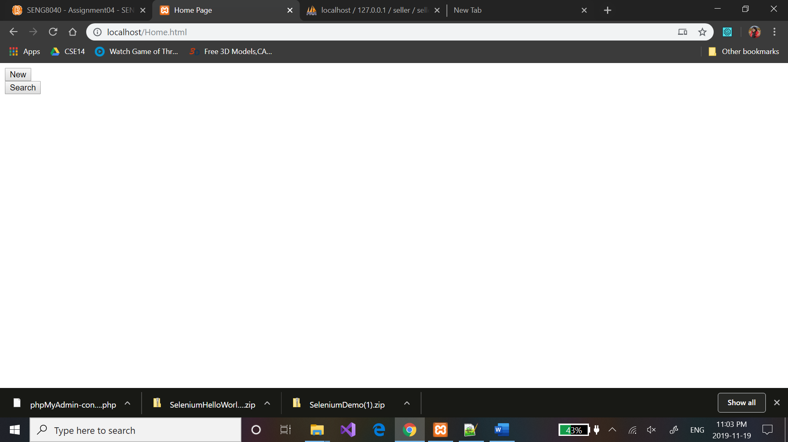

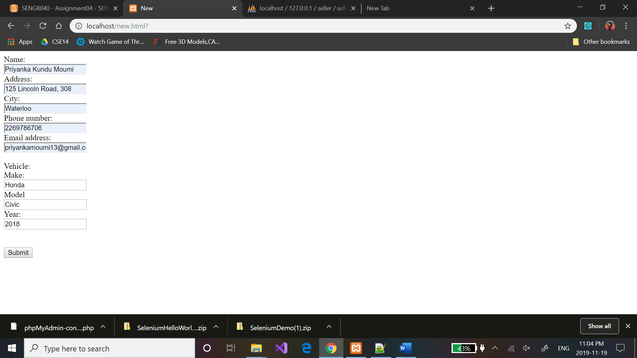

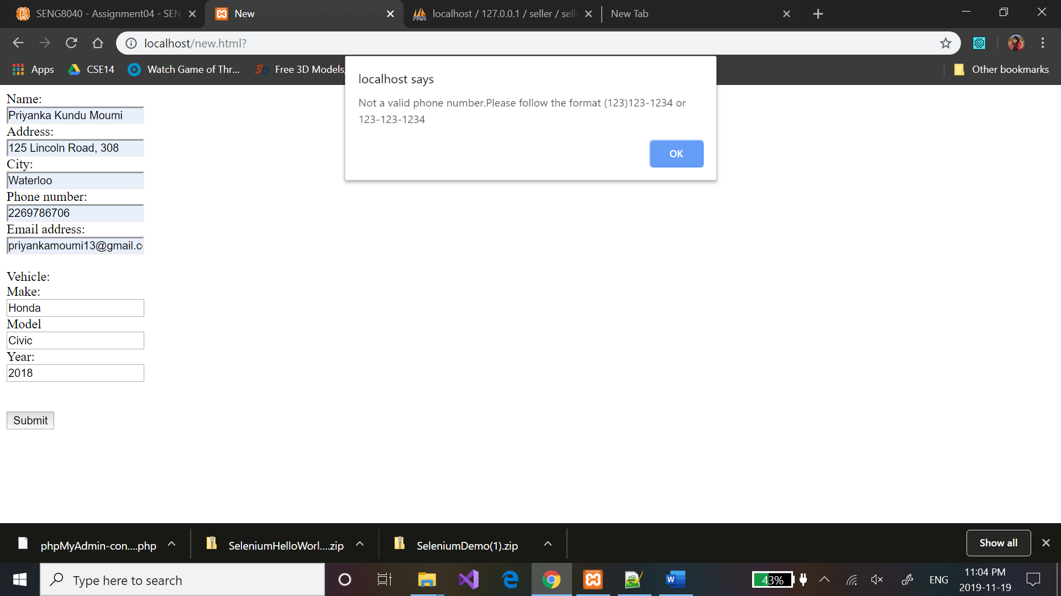

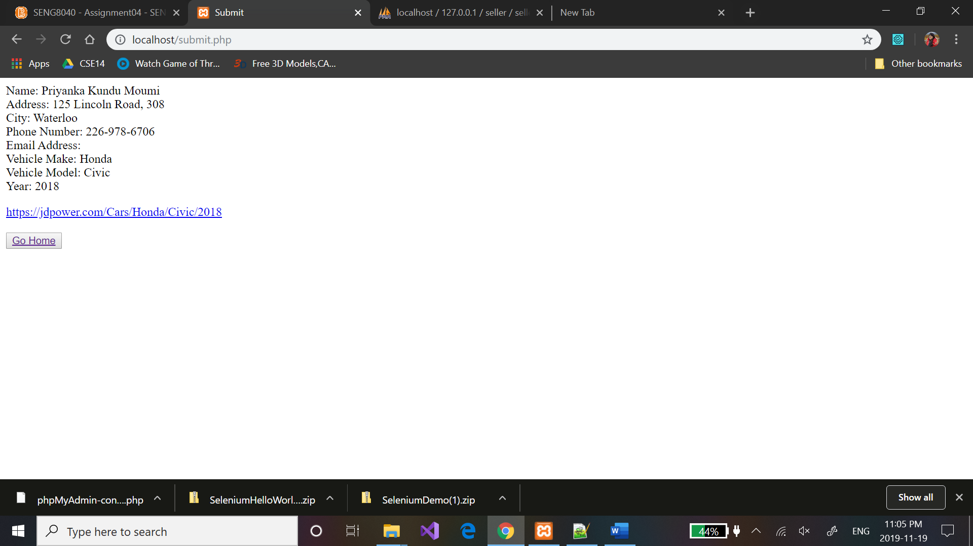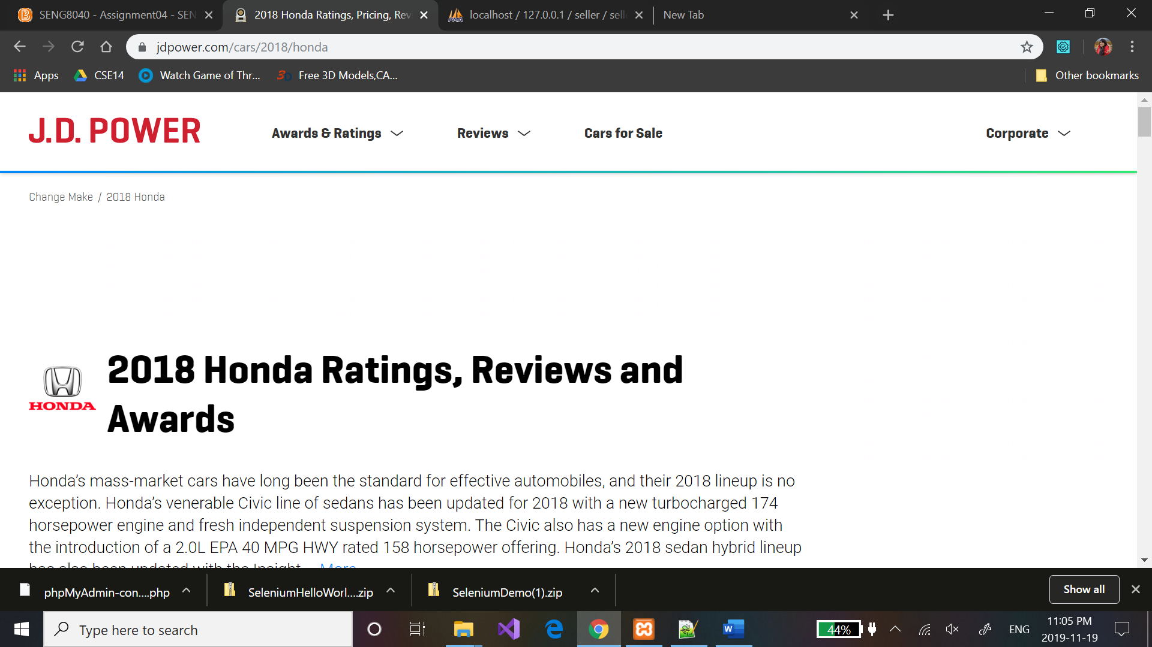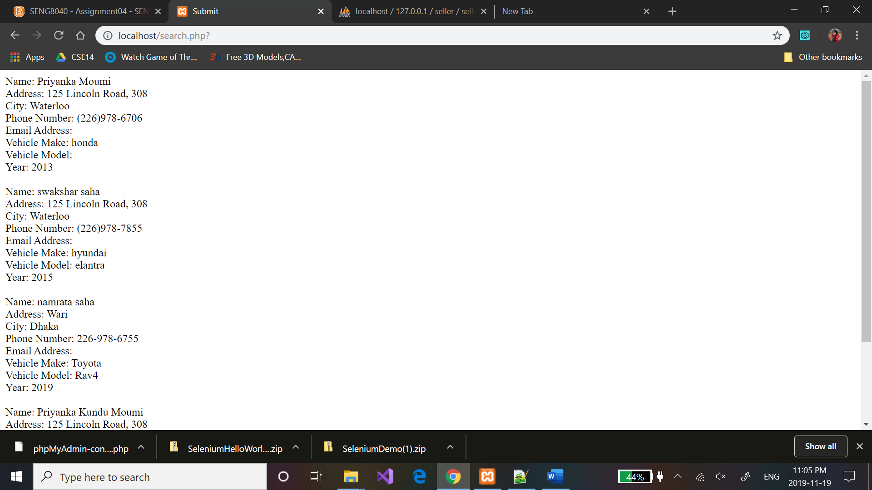

**System Test Code:**

using System;

using System.Text;

using System.Text.RegularExpressions;

using System.Threading;

using NUnit.Framework;

using OpenQA.Selenium;

using OpenQA.Selenium.Firefox;

using OpenQA.Selenium.Support.UI;

namespace SeleniumTests

{

[TestFixture]

public class PhoneNumberInput2269786706OutputInvalidFormat

{

private IWebDriver driver;

private StringBuilder verificationErrors;

private string baseURL;

private bool acceptNextAlert = true;

[SetUp]

public void SetupTest()

{

driver = new FirefoxDriver();

baseURL = "http://localhost/Home.html";

verificationErrors = new StringBuilder();

}

[TearDown]

public void TeardownTest()

{

try

{

driver.Quit();

}

catch (Exception)

{

// Ignore errors if unable to close the browser

}

Assert.AreEqual("", verificationErrors.ToString());

}

[Test]

public void ThePhoneNumberInput2269786706OutputInvalidFormatTest()

{

driver.Navigate().GoToUrl("http://localhost/Home.html");

driver.FindElement(By.XPath("//input[@value='New']")).Click();

driver.FindElement(By.Name("phone")).Click();

driver.FindElement(By.Name("name")).Click();

driver.FindElement(By.Name("name")).Clear();

driver.FindElement(By.Name("name")).SendKeys("Priyanka");

driver.FindElement(By.Name("address")).Clear();

driver.FindElement(By.Name("address")).SendKeys("125 Lincoln");

driver.FindElement(By.Name("city")).Click();

driver.FindElement(By.Name("city")).Clear();

driver.FindElement(By.Name("city")).SendKeys("Waterloo");

driver.FindElement(By.Name("phone")).Click();

driver.FindElement(By.Name("phone")).Clear();

driver.FindElement(By.Name("phone")).SendKeys("2269786706");

driver.FindElement(By.Name("email")).Click();

driver.FindElement(By.Name("email")).Click();

driver.FindElement(By.Name("email")).Click();

// ERROR: Caught exception [ERROR: Unsupported command [doubleClick | name=email | ]]

driver.FindElement(By.Name("email")).Click();

driver.FindElement(By.Name("email")).Clear();

driver.FindElement(By.Name("email")).SendKeys("AAA@gmail.com");

driver.FindElement(By.Name("make")).Click();

driver.FindElement(By.Name("make")).Clear();

driver.FindElement(By.Name("make")).SendKeys("Toyota");

driver.FindElement(By.Name("model")).Clear();

driver.FindElement(By.Name("model")).SendKeys("Corolla");

driver.FindElement(By.Name("year")).Clear();

driver.FindElement(By.Name("year")).SendKeys("2000");

driver.FindElement(By.XPath("//input[@value='Submit']")).Click();

Assert.AreEqual("Not a valid phone number.Please follow the format (123)123-1234 or 123-123-1234", CloseAlertAndGetItsText());

}

[Test]

public void TheJDPowerInputClickUrlOutputJDPowerPageTest()

{

driver.Navigate().GoToUrl("http://localhost/Home.html");

driver.FindElement(By.XPath("//input[@value='New']")).Click();

driver.FindElement(By.Name("name")).Click();

driver.FindElement(By.Name("name")).Click();

driver.FindElement(By.Name("name")).Click();

// ERROR: Caught exception [ERROR: Unsupported command [doubleClick | name=name | ]]

driver.FindElement(By.Name("name")).Click();

driver.FindElement(By.Name("name")).Clear();

driver.FindElement(By.Name("name")).SendKeys("Priyanka");

driver.FindElement(By.Name("address")).Click();

driver.FindElement(By.Name("address")).Clear();

driver.FindElement(By.Name("address")).SendKeys("1/1 k m Das Lane");

driver.FindElement(By.Name("city")).Click();

driver.FindElement(By.Name("city")).Clear();

driver.FindElement(By.Name("city")).SendKeys("Dhaka");

driver.FindElement(By.Name("phone")).Click();

driver.FindElement(By.Name("phone")).Clear();

driver.FindElement(By.Name("phone")).SendKeys("(519)787-2342");

driver.FindElement(By.Name("email")).Click();

driver.FindElement(By.Name("email")).Clear();

driver.FindElement(By.Name("email")).SendKeys("BBB@gmail.com");

driver.FindElement(By.Name("make")).Click();

driver.FindElement(By.Name("make")).Clear();

driver.FindElement(By.Name("make")).SendKeys("Hyundai");

driver.FindElement(By.Name("model")).Click();

driver.FindElement(By.Name("model")).Clear();

driver.FindElement(By.Name("model")).SendKeys("Sonata");

driver.FindElement(By.Name("year")).Click();

driver.FindElement(By.Name("year")).Clear();

driver.FindElement(By.Name("year")).SendKeys("2008");

driver.FindElement(By.XPath("//input[@value='Submit']")).Click();

driver.FindElement(By.Id("url")).Click();

Assert.IsTrue(IsElementPresent(By.CssSelector("svg.logo-svg")));

}

[Test]

public void TheYearInputAbcdOutputNumericCharactersOnlyTest()

{

driver.Navigate().GoToUrl("http://localhost/new.html");

driver.FindElement(By.Name("name")).Click();

driver.FindElement(By.Name("name")).Click();

driver.FindElement(By.Name("name")).Clear();

driver.FindElement(By.Name("name")).SendKeys("Priyanka");

driver.FindElement(By.Name("address")).Click();

driver.FindElement(By.Name("address")).Click();

driver.FindElement(By.Name("address")).Clear();

driver.FindElement(By.Name("address")).SendKeys("125 Lincoln");

driver.FindElement(By.Name("city")).Clear();

driver.FindElement(By.Name("city")).SendKeys("B");

driver.FindElement(By.Name("phone")).Clear();

driver.FindElement(By.Name("phone")).SendKeys("226-978-7893");

driver.FindElement(By.Name("email")).Clear();

driver.FindElement(By.Name("email")).SendKeys("AAA@gmail.com");

driver.FindElement(By.Name("make")).Clear();

driver.FindElement(By.Name("make")).SendKeys("honda");

driver.FindElement(By.Name("model")).Clear();

driver.FindElement(By.Name("model")).SendKeys("Coupe");

driver.FindElement(By.Name("year")).Clear();

driver.FindElement(By.Name("year")).SendKeys("abcd");

driver.FindElement(By.XPath("//input[@value='Submit']")).Click();

Assert.AreEqual("Please input numeric characters only", CloseAlertAndGetItsText());

}

[Test]

public void TheEmailInput13GmailCOutputInvalidEmailTest()

{

driver.Navigate().GoToUrl("http://localhost/Home.html");

driver.FindElement(By.XPath("//input[@value='New']")).Click();

driver.FindElement(By.Name("name")).Click();

driver.FindElement(By.Name("name")).Click();

driver.FindElement(By.Name("name")).Click();

// ERROR: Caught exception [ERROR: Unsupported command [doubleClick | name=name | ]]

driver.FindElement(By.Name("name")).Click();

driver.FindElement(By.Name("name")).Clear();

driver.FindElement(By.Name("name")).SendKeys("Priyanka");

driver.FindElement(By.Name("address")).Click();

driver.FindElement(By.Name("address")).Clear();

driver.FindElement(By.Name("address")).SendKeys("125 Lincoln");

driver.FindElement(By.Name("city")).Click();

driver.FindElement(By.Name("city")).Click();

// ERROR: Caught exception [ERROR: Unsupported command [doubleClick | name=city | ]]

driver.FindElement(By.Name("city")).Clear();

driver.FindElement(By.Name("city")).SendKeys("Waterloo");

driver.FindElement(By.Name("phone")).Click();

driver.FindElement(By.Name("phone")).Clear();

driver.FindElement(By.Name("phone")).SendKeys("226-978-6706");

driver.FindElement(By.Name("email")).Click();

driver.FindElement(By.Name("email")).Clear();

driver.FindElement(By.Name("email")).SendKeys("13@gmail.c");

driver.FindElement(By.Name("make")).Click();

driver.FindElement(By.Name("make")).Clear();

driver.FindElement(By.Name("make")).SendKeys("Toyota");

driver.FindElement(By.Name("model")).Clear();

driver.FindElement(By.Name("model")).SendKeys("Corolla");

driver.FindElement(By.Name("year")).Clear();

driver.FindElement(By.Name("year")).SendKeys("2000");

driver.FindElement(By.XPath("//input[@value='Submit']")).Click();

Assert.AreEqual("Not a valid email.Please enter the again", CloseAlertAndGetItsText());

}

[Test]

public void TheUntitledTestCaseTest()

{

driver.Navigate().GoToUrl("http://localhost/Home.html");

driver.FindElement(By.XPath("//input[@value='New']")).Click();

driver.FindElement(By.Name("name")).Click();

driver.FindElement(By.Name("name")).Clear();

driver.FindElement(By.Name("name")).SendKeys("aaaaaaaaaaaaaaaaaaaaaaaaaaaaaaaaaaaaaaaaaaaaaaaaaaaaaaaaaaaaaaaaaaaaaaaaaaaaaaaaaaaaaaaaaaaaaaaaaaaaaaaaaaaaaaaaaaaaaaaaaaaaaaaaaaaaaaaaaaaaaaaaaaaaaaaaaaaaaaaaaaaaaaaaaaaaaaaa");

driver.FindElement(By.Name("address")).Click();

driver.FindElement(By.Name("address")).Clear();

driver.FindElement(By.Name("address")).SendKeys("125 Lincoln");

driver.FindElement(By.Name("city")).Click();

driver.FindElement(By.Name("city")).Clear();

driver.FindElement(By.Name("city")).SendKeys("Waterloo");

driver.FindElement(By.Name("phone")).Clear();

driver.FindElement(By.Name("phone")).SendKeys("(519)787-2342");

driver.FindElement(By.Name("email")).Clear();

driver.FindElement(By.Name("email")).SendKeys("BBB@gmail.com");

driver.FindElement(By.Name("make")).Clear();

driver.FindElement(By.Name("make")).SendKeys("honda");

driver.FindElement(By.Name("model")).Clear();

driver.FindElement(By.Name("model")).SendKeys("Coupe");

driver.FindElement(By.Name("year")).Clear();

driver.FindElement(By.Name("year")).SendKeys("2008");

driver.FindElement(By.XPath("//input[@value='Submit']")).Click();

Assert.AreEqual("Name cannot be more than 50 characters", CloseAlertAndGetItsText());

}

private bool IsElementPresent(By by)

{

try

{

driver.FindElement(by);

return true;

}

catch (NoSuchElementException)

{

return false;

}

}

private bool IsAlertPresent()

{

try

{

driver.SwitchTo().Alert();

return true;

}

catch (NoAlertPresentException)

{

return false;

}

}

private string CloseAlertAndGetItsText()

{

try

{

IAlert alert = driver.SwitchTo().Alert();

string alertText = alert.Text;

if (acceptNextAlert)

{

alert.Accept();

}

else

{

alert.Dismiss();

}

return alertText;

}

finally

{

acceptNextAlert = true;

}

}

}

}

**Home.html:**

<!DOCTYPE html>

<html>

<head>

<meta charset="UTF-8">

<title>Home Page</title>

</head>

<body>

<form action="new.html">

<input type="submit" value="New">

</form>

<form action="search.php">

<input type="submit" value="Search">

</form>

</body>

</html>

**search.php:**

<!DOCTYPE html>

<html>

<head>

<meta charset="UTF-8">

<title>Submit</title>

</head>

<body>

<?php

error_reporting(E_ALL ^ E_NOTICE);

$servername = "localhost";

$username = "root";

$password = "";

$database = "seller";

$link = mysqli_connect($servername, $username, $password, $database);

if(!$link)

{die("Failed to Setup the Connection: " . mysqli_connect_error());}

$sql1="SELECT name, address, city,phone, email, make,model, year FROM seller_table";

$result = $link->query($sql1);

$sql1="SELECT name, address, city,phone, email, make,model, year FROM seller_table;";

$result = $link->query($sql1);

// output data of each row

while($row = $result->fetch_assoc()) {

echo "Name: " . $row["name"]. "<br>". "Address: " . $row["address"]. "<br>". "City: " . $row["city"]. "<br>". "Phone Number: " . $row["phone"]. "<br>". "Email Address: " . $row["emai"]. "<br>". "Vehicle Make: " . $row["make"]. "<br>". "Vehicle Model: " . $row["model"]. "<br>". "Year: " . $row["year"];

echo "</br></br>";

}

?>

<button><a href="Home.html" class="btn" >Go Home</a></button>

</body>

</html>

**New.html:**

<!DOCTYPE html>

<html>

<head>

<meta charset="UTF-8">

<title>New</title>

</head>

<body>

<script>

function validateForm() {

x = document.forms["myForm"]["name"].value;

if (x.length >50) {

alert("Name cannot be more than 50 characters");

return false;

}

x = document.forms["myForm"]["address"].value;

if (x.length >50) {

alert("Address cannot be more than 50 characters");

return false;

}

x = document.forms["myForm"]["city"].value;

if (x.length >50) {

alert("CIty cannot be more than 50 characters");

return false;

}

//phone

x = document.forms["myForm"]["phone"].value;

var phoneno = /^[(]{1}[0-9]{3}[)]{1}[0-9]{3}[-]{1}[0-9]{4}$/

var phoneno1 = /^[0-9]{3}[-]{1}[0-9]{3}[-]{1}[0-9]{4}$/

if(!x.match(phoneno) &&!x.match(phoneno1))

{

alert("Not a valid phone number.Please follow the format (123)123-1234 or 123-123-1234");

return false;

}

//email

x = document.forms["myForm"]["email"].value;

var phoneno = /^\w+([\.-]?\w+)*@\w+([\.-]?\w+)*(\.\w{2,3})+$/

if(!x.match(phoneno))

{

alert("Not a valid email.Please enter the again");

return false;

}

//make

x = document.forms["myForm"]["make"].value;

if (x.length >50)

{

alert("Vehicle make cannot be more than 50 characters");

return false;

}

//model

x = document.forms["myForm"]["model"].value;

if (x.length >50)

{

alert("Vehicle model cannot be more than 50 characters");

return false;

}

//year

x = document.forms["myForm"]["year"].value;

var numbers = /^[0-9]+$/;

if(!x.match(numbers))

{

alert('Please input numeric characters only');

return false;

}

if(parseInt(x)<1970 || parseInt(x)>2019)

{

alert('Please input numbers between 1970 and 2019');

return false;

}

document.write

}

</script>

<form name="myForm" onsubmit="return validateForm()" action="submit.php" method="post">

Name:<br>

<input type="text" name="name" value="" required>

<br>

Address:<br>

<input type="address" name="address" value="" required>

<br>

City:<br>

<input type="city" name="city" value="" required>

<br>

Phone number:<br>

<input type="text" name="phone" required>

<br>

Email address:<br>

<input type="email" name="email" value="" required>

<br>

<br>

Vehicle:<br>

Make:<br>

<input type="text" name="make" value="" required>

<br>

Model<br>

<input type="text" name="model" value="" required>

<br>

Year:<br>

<input type="text" name="year" value="" required>

<br>

<br><br>

<input type="submit" onclick="validateForm" value="Submit">

</form>

</body>

</html>

**submit.php:**

<!DOCTYPE html>

<html>

<head>

<meta charset="UTF-8">

<title>Submit</title>

</head>

<body>

<?php

error_reporting(E_ALL ^ E_NOTICE);

$servername = "localhost";

$username = "root";

$password = "";

$database = "seller";

$link = mysqli_connect($servername, $username, $password, $database);

if(!$link)

{die("Failed to Setup the Connection: " . mysqli_connect_error());}

$name = mysqli_real_escape_string($link, $_REQUEST["name"]);

$address = mysqli_real_escape_string($link, $_REQUEST['address']);

$city = mysqli_real_escape_string($link, $_REQUEST['city']);

$phone = mysqli_real_escape_string($link, $_REQUEST['phone']);

$email = mysqli_real_escape_string($link, $_REQUEST['email']);

$make = mysqli_real_escape_string($link, $_REQUEST['make']);

$model = mysqli_real_escape_string($link, $_REQUEST['model']);

$year = mysqli_real_escape_string($link, $_REQUEST['year']);

$url = "https://jdpower.com/Cars/$make/$model/$year";

$sql = "INSERT INTO seller_table (name, address, city,phone, email, make,model, year) VALUES ('$name', '$address', '$city','$phone', '$email', '$make','$model', '$year');";

if(mysqli_query($link, $sql)){

$last_id=$link->insert_id;

//echo $last_id;

// echo "Records added successfully.";

} else{

echo "ERROR: Could not able to execute $sql. " . mysqli_error($link);

}

$sql1="SELECT name, address, city,phone, email, make,model, year FROM seller_table where Seller_id=$last_id;";

$result = $link->query($sql1);

// output data of each row

while($row = $result->fetch_assoc()) {

echo "Name: " . $row["name"]. "<br>". "Address: " . $row["address"]. "<br>". "City: " . $row["city"]. "<br>". "Phone Number: " . $row["phone"]. "<br>". "Email Address: " . $row["emai"]. "<br>". "Vehicle Make: " . $row["make"]. "<br>". "Vehicle Model: " . $row["model"]. "<br>". "Year: " . $row["year"];

}

?>

<p><a id="url" href="<?php echo $url; ?>"><?php echo $url; ?></a>

<?php

// Attempt insert query execution

// Close connection

mysqli_close($link);

?>

</br>

</br>

<button><a href="Home.html" class="btn" >Go Home</a></button>

</body>

</html>

**NUnit:**