PowerShell Scripting

1. **PowerShell Commands:**

* **get-help :** Displays information about Windows PowerShell commands and concepts.
* **Get-Process :** To retrieve information about running processes on a system.
* **Get-Command :** To retrieve information about cmdlets, functions, scripts, and executables available in the session.
* **Get-Command Get-Process :** Retrieves details about the Get-Process cmdlet**.**
* **Stop-Process -id <number> :** Used to stop a process with the id.
* **Get-Service –** Retrieves information about system services.
* **stop-service <serviceName> :** To stop a service .

1. **Creating Files and Directories:**

**Creating a new Folder:**

New-Item -ItemType Directory -Path "D:\AzureDevops\PStest1"

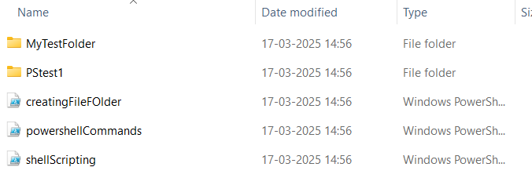

**Creating a File:**

New-Item -ItemType File -Path "D:\AzureDevops\PStest1\sample.txt"

New-Item -ItemType File -Path "D:\AzureDevops\PStest1\sample1.txt" -Force

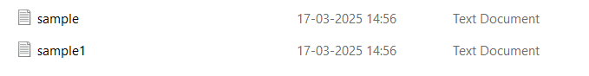

**Writing into a File:**

Set-Content -Path "D:\AzureDevops\PStest1\sample.txt" -Value "This is

Priya_gowtami"

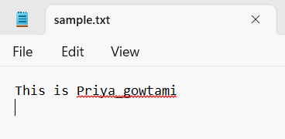

**Get content from File:**

Get-Content -Path "D:\AzureDevops\PStest1\sample.txt"

**Removing Files from a directory:**

Remove-Item -Path "D:\AzureDevops\PStest1\sample1.txt"

**List out files in a directory:**

Get-ChildItem "D:\AzureDevops\PStest1"

**Remvoing a folder/directory**

New-Item -ItemType Directory -Path "D:\AzureDevops\PStest2"

New-Item -ItemType File -Path "D:\AzureDevops\PStest2\sample2.txt"

Remove-Item -Path "D:\AzureDevops\PStest2" -Force

**Copying Files:**

Copy-Item -Path "D:\AzureDevops\PStest1\sample.txt" -Destination

“D:\AzureDevops\PStest1\sample1.txt"

Get-Content -Path "D:\AzureDevops\PStest1\sample1.txt"

1. **Shell Scripting:**

* **creating a variable**

$var = "value"

**$var** – used to print the value

**Write-Host $var** – Displays the value

$Age = **Read-Host** “Enter your age?” #read input from user

* **if conditional script:**

$number = 10

if($number -gt 5)

{

Write-Host "$($Number) is greater than 5" #get variable value inside ""

}

elseif($number -eq 5)

{

Write-Host "Number is equal to 5"

}

else

{

Write-Host "$($Number) is less than 5"

}

**Output:**

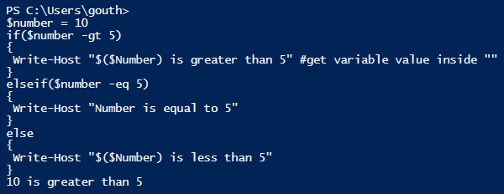

* **for loop script**

To write a script that creates 5files which are of the same format using loops

$folderName = "MyTestFolder"

$folderPath = Join-Path -Path "D:\AzureDevops\10-3-25Day1PS"

-ChildPath $folderName

#D:\AzureDevops\10-3-25Day1PS\MyTestFolder

if(-not (Test-Path -Path $folderPath))

{

New-Item -ItemType directory -Path $folderPath | Out-Null

Write-Host "created folder: $($folderPath)"

}

else

{

Write-Host "Folder already exists: $($folderPath)"

}

create 5 files within that folder with date and time as file name and add content

for($i=1;$i -le 5;$i++)

{

$dateTime = Get-Date -Format "yyyy-MM-dd"

$fileName = "file_$($dateTime)_$($i).txt"

$filePath = Join-Path -Path $folderpath -ChildPath $fileName

create file

New-Item -ItemType File -Path $filePath -Force | Out-Null

set content

$fileContent = "softwareGurukulam_$($fileName)"

Set-Content -Path $filePath -Value $fileContent

Write-Host "created file: $($filePath) with content: $($fileContent)"

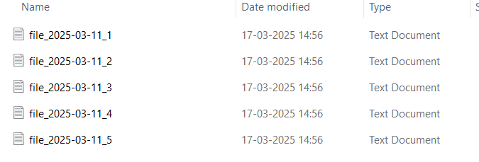}

**Output:**