 Pokhara University Affiliate

**LA GRANDEE INTERNATIONAL COLLEGE**

**Simalchaur, Pokhara, Nepal**

**A Project Proposal**

on

“**Tasknity**”

**Submitted to**

Bachelor of Computer Application (BCA) Department

LA GRANDEE International College

In partial fulfillment of the requirements for the degree of Bachelor of Computer Application under Pokhara University

**Submitted by**

Priyanka Ghimire (2021-1-53-0360)

Manisha Sharma (2021-1-53-0354)

Diptan Gurung (2021-1-53-0350)

Bachelor of Computer Application, 8th Semester

Date: 9/25/2025

**Table of contents**

1. Introduction 1

2. Background Study 2

3. Problem Statement 3

4. Objectives 4

5. Methodology 5

6. Project Gantt Chart 6

7. Deliverables 7

8. References 8

**Table of Figure**

Figure 5.1Agile-Methodology 5

Figure 6.1Gantt chart 6

# Introduction

Project management plays an important role in the success of group-based tasks in academics and organizations. Without a proper system, projects may suffer from poor communication, missed deadlines, and lack of accountability.

This project proposes the development of a **Project Management System** consisting of a **web-based admin panel** and a **mobile application** with a user-friendly UI/UX. The system will provide role-based access for administrators, project leaders, and team members. It will include features such as group creation and approval, leader assignment, task management, deadline notifications, progress updates, and report generation, along with secure authentication.

# Background Study

Several project management tools like Trello, Asana, and Jira exist, but they are often too complex or expensive for student groups and small academic teams. Academic projects require a simpler, customized solution that supports:

* Group formation and leader assignment,
* Task and member management,
* Deadline alerts and reminders,
* Easy report generation.

Therefore, this project focuses on designing a lightweight, secure, and easy-to-use system specifically tailored for student project management.

# Problem Statement

Student teams face several challenges in managing projects effectively:

* Difficulty in creating groups and assigning leaders.
* Lack of timely reminders for deadlines.
* Limited ways to track individual contributions.
* Difficulty in generating structured reports.
* Gaps in communication between leaders and members.

A dedicated project management system is required to solve these problems by providing clear roles, notifications, progress tracking, and reporting features.

# Objectives

The main objectives of this project are:

* To build a role-based project management system enabling admins to manage groups and reports, leaders to assign tasks and track progress, and members to update tasks and communicate issues.
* To provide a secure, user-friendly platform with mobile UI/UX and deadline notifications for effective collaboration and timely project completion.

# Methodology

The project will be developed using the Agile Methodology because it allows flexibility and step-by-step development. The stages will include:

* Requirement Analysis: Collecting requirements from users and supervisors.
* System Design: Designing system architecture, database schema, and wireframes.
* Implementation: Developing the web-based admin panel and mobile app for leaders/members.
* Testing: Conducting unit, integration, and user acceptance testing.
* Deployment: Hosting the system on a server and making the mobile app available for testing.
* Maintenance: Fixing bugs and making improvements as needed.

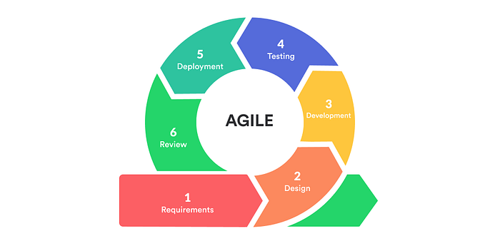

Figure 5.1Agile-Methodology

# Project Gantt Chart

Figure 6.1Gantt chart

# Deliverables

The final deliverables of this project will include:

1. Web-based Admin Panel with group management, leader assignment, reporting, and notifications.
2. Mobile Application (for leaders and members) with a user-friendly UI/UX.
3. Deadline Notification System for groups and individuals.
4. Printable Reports for project evaluation and submission.
5. Database Design & Documentation including ER diagrams and schema.

`

# References

Atlassian. (2023). *Jira Software: Project management for agile teams*. Atlassian. https://www.atlassian.com/software/jira

Atlassian. (2023). *Trello: Visual project management tool*. Atlassian. https://trello.com/

Asana, Inc. (2023). *Asana: Work management platform*. Asana. https://asana.com/

# 