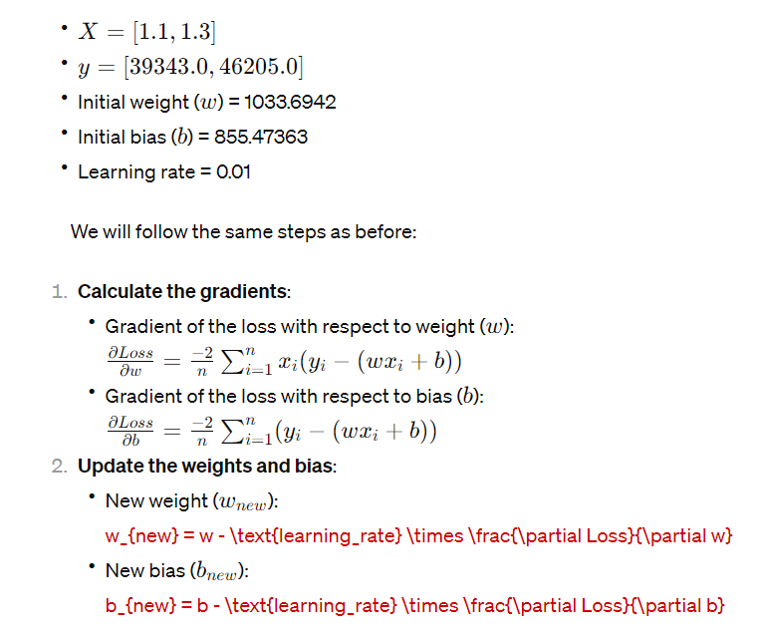

|  |  |  |  |  |
| --- | --- | --- | --- | --- |
| Feature (X) | Label (y) | Predicted Label (ŷ) | Loss (y - ŷ) | Squared Loss |
| 5 | 10 | 12 | -2 | 4 |
| 7 | 20 | 10 | 10 | 100 |
|  |  |  | **MAE =**  **|-2| + |10|/2 = 6** | **MSE =**  **4 + 100 = 52** |