Lab assignment-2(Thursday)

Insurance data set
import pandas as pd
import numpy as np
import matplotlib.pyplot as plt

from sklearn.model_selection import train_test_split
from sklearn.preprocessing import LabelEncoder, StandardScaler
from sklearn.metrics import mean_absolute_error, mean_squared_error, r2_score

import torch
import torch.nn as nn
import torch.optim as optim

df = pd.read_csv("insurance (1).csv")

for col in df.select_dtypes(include="object").columns:
le = LabelEncoder()
df[col] = le.fit_transform(df[col])

X = df.drop("charges", axis=1)
y = df["charges"]

scaler = StandardScaler()
X = scaler.fit_transform(X)

X_train, X_test, y_train, y_test = train_test_split(
X, y, test_size=0.2, random_state=42
)

X_train = torch.tensor(X_train, dtype=torch.float32)
X_test = torch.tensor(X_test, dtype=torch.float32)

y_train = torch.tensor(y_train.values, dtype=torch.float32).view(-1, 1)
y_test = torch.tensor(y_test.values, dtype=torch.float32).view(-1, 1)

class SalaryModel(nn.Module):
def __init__(self, input_size):
super().__init__()

self.network = nn.Sequential(
nn.Linear(input_size, 64),
nn.ReLU(),
nn.Linear(64, 32),
nn.ReLU(),
nn.Linear(32, 16),
nn.ReLU(),
nn.Linear(16, 1)
)

def forward(self, x):
return self.network(x)

model = SalaryModel(X_train.shape[1])

criterion = nn.MSELoss()
optimizer = optim.Adam(model.parameters(), lr=0.01)

epochs = 200
train_loss = []

for epoch in range(epochs):
model.train()
optimizer.zero_grad()
outputs = model(X_train)
loss = criterion(outputs, y_train)
loss.backward()
optimizer.step()
train_loss.append(loss.item())

if (epoch + 1) % 20 == 0:
print(f"Epoch [{epoch+1}/{epochs}] Loss: {loss.item():.2f}")

model.eval()

with torch.no_grad():
predictions = model(X_test)

predictions = predictions.numpy()
actual = y_test.numpy()

mae = mean_absolute_error(actual, predictions)
mse = mean_squared_error(actual, predictions)
rmse = np.sqrt(mse)
r2 = r2_score(actual, predictions)

print("MAE:", round(mae, 2))
print("MSE:", round(mse, 2))
print("RMSE:", round(rmse, 2))
print("R2 Score:", round(r2, 4))

plt.figure(figsize=(8, 5))
plt.plot(train_loss)
plt.xlabel("Epoch")
plt.ylabel("Loss")
plt.title("Training Loss")
plt.grid(True)
plt.show()

plt.figure(figsize=(6, 6))
plt.scatter(actual, predictions)
plt.plot([actual.min(), actual.max()],
[actual.min(), actual.max()],
color="red")
plt.xlabel("Actual Charges")
plt.ylabel("Predicted Charges")
plt.title("Actual vs Predicted")
plt.show()

errors = actual.flatten() - predictions.flatten()

plt.figure(figsize=(8, 5))
plt.hist(errors, bins=25)
plt.xlabel("Error")
plt.ylabel("Frequency")
plt.title("Prediction Error Distribution")
plt.show()

Output:for 200 epoches
Epoch [20/200] Loss: 320642784.00
Epoch [40/200] Loss: 287593920.00
Epoch [60/200] Loss: 122815080.00
Epoch [80/200] Loss: 50769084.00
Epoch [100/200] Loss: 35651764.00
Epoch [120/200] Loss: 33650900.00
Epoch [140/200] Loss: 32567900.00
Epoch [160/200] Loss: 31600758.00
Epoch [180/200] Loss: 30686416.00
Epoch [200/200] Loss: 29837502.00
MAE: 3555.4
MSE: 27787298.0
RMSE: 5271.37
R2 Score: 0.821

For 100 epoches:
Epoch [20/100] Loss: 320798752.00
Epoch [40/100] Loss: 290714848.00
Epoch [60/100] Loss: 133235240.00
Epoch [80/100] Loss: 51168740.00
Epoch [100/100] Loss: 35635144.00
MAE: 3978.49
MSE: 31768024.0c
RMSE: 5636.31
R2 Score: 0.7954
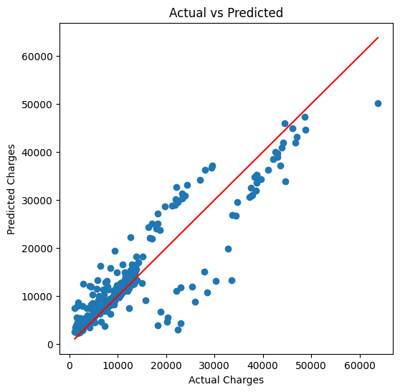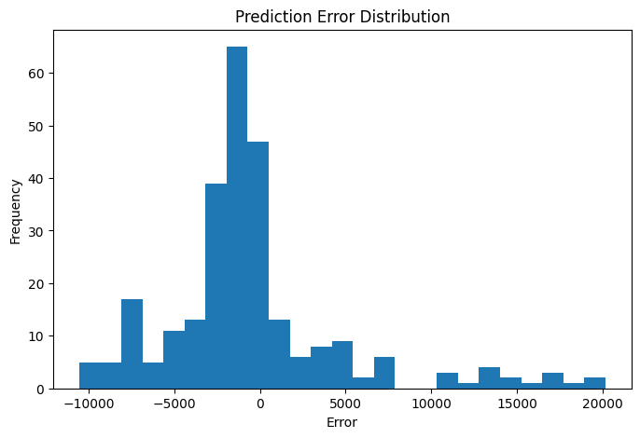
Observation:
- The loss decreases continuously in both cases, showing that the model is learning effectively.
- Training for 200 epochs gives a lower final loss (29,837,502) than 100 epochs (35,635,144).
- MAE decreases from 3978.49 to 3555.40, indicating more accurate predictions with 200 epochs.
- MSE decreases from 31,768,024 to 27,787,298, meaning prediction errors are reduced.
- RMSE decreases from 5636.31 to 5271.37, showing improved model performance.
- The R² score increases from 0.7954 to 0.821, indicating the model explains more variance in the data after 200 epochs.
- Increasing the number of epochs improved the overall accuracy, but additional epochs beyond this may show smaller improvements and could eventually lead to overfitting.
- If the learning rate, number of neurons, batch size, or other hyperparameters are changed, the loss and evaluation metrics may also improve or worsen.
- Overall, the 200-epoch model performs better than the 100-epoch model across all evaluation metrics.

