

**Smart Bill Boards using IBM Watson**

M A Y 2 0 1 9 / / P R E P A R E D B Y T E A M S Y N E R G I C

**PROJECT NAME :** Smart Bill Boards using IBM Watson

**TEAM NAME :** Team Synergic

**TEAM MEMBERS:** Vasanth Korada

Priyanka Kosana Harshitha Muddada

# INTRODUCTION:

Billboards, the oldest and least technology-driven of all advertising media, are now being given an Internet-of-things upgrade, as brands and media owners look for new ways to ensure proof of performance.

Out-of-home displays have typically suffered because simple things like torn ads or electric lights not being put on at night affect the usefulness of a campaign. Brands and advertising agencies still rely on people on bikes taking pictures of hoardings to ensure that they are getting what they have paid for.

# PROJECT DESCRIPTION:

The use of Smart boards has widely increased these days. The applications that can be developed using these smart boards have been increasing day-by-day. Smart billboards can also target motorists on the highway or pedestrians passing bus shelters. Companies can attract the customers by doing advertisements. These smart bill boards will help them in attracting their customers and make their task easier. In this we can upload the required data on the bill board simply by giving inputs through user interface. And we can check the lamps working status which is connected to bill board through the UI.

Through device we can select the mode of the display and according to the selected mode we can change the data on the display. the data can be entered through user interface which is created in Node Red. We can get the status of the lamps which are connected to the bill boards in the user interface. If any lamp fails we can send notifications to authorities.

# USAGE:

Integrating the objects around the billboard into your design Playing with the borders of the board

Adding special effects

Taking advantage of natural lighting Interacting with people who pass by Relying on clever visuals

# HARDWARE USED:

Node MCU, Buttons, OLED Display, LED’s, Smoke Sensors, IR-Sensors, Temperature Sensor, LDR Sensor.

# SOFTWARE USED:

Arduino, IBM Cloud,Node Red

# NODE-RED UI

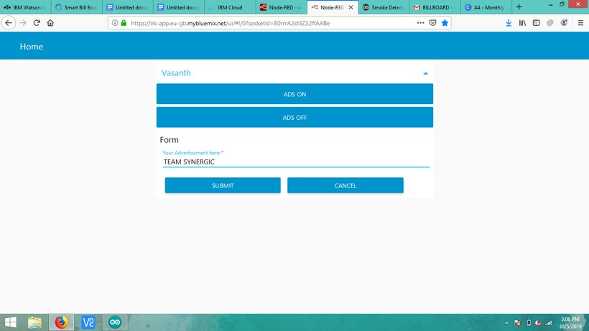

After giving the Input

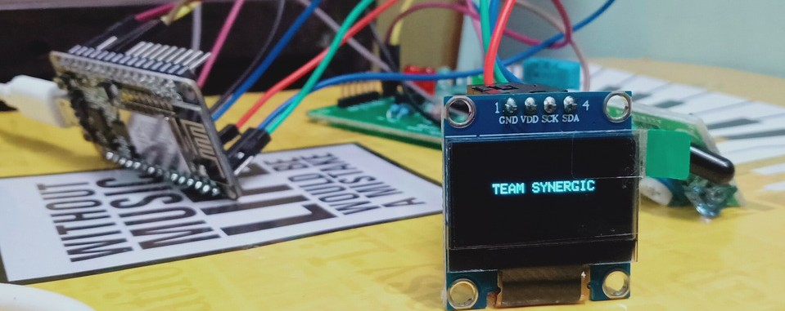

After clicking ADS OFF Button

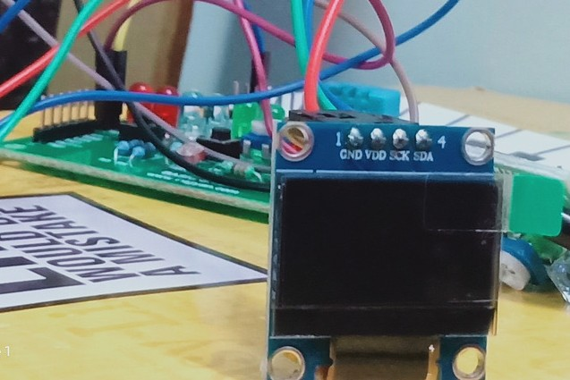

After clicking ADS ON Button

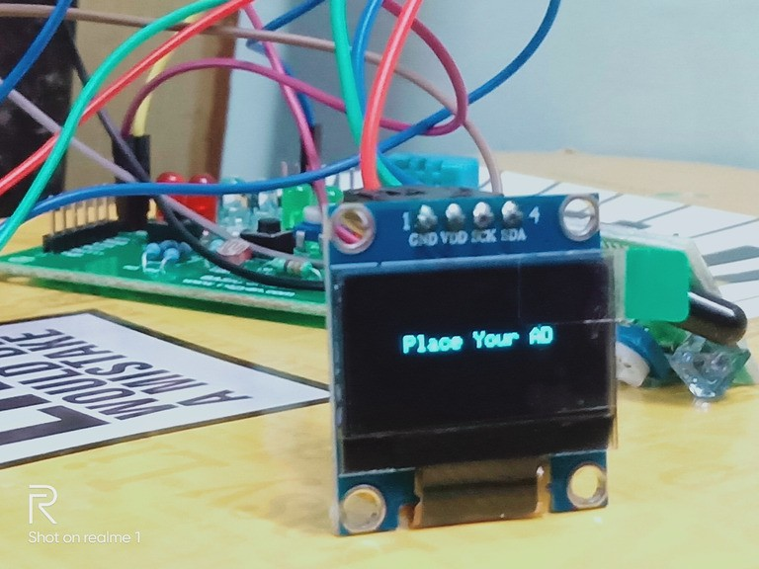

When the IR sensors detects Human the OLED changes to

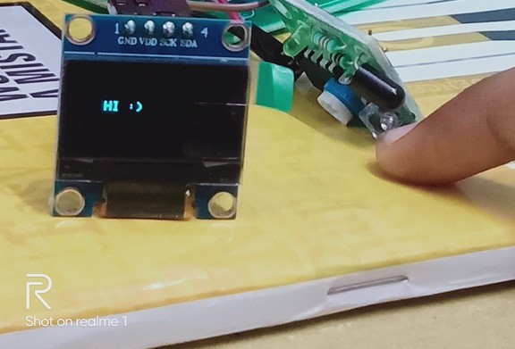

# ADVANTAGES

Reduces manual effect in advertising.

Data or a particular advertisement can be changed periodically. Efficient method of publishing advertisement.