2420030132
Experiment 1: Case Study
Real World Case Study: Flipkart – E-Commerce Platform
1. Functional Requirements
Customer
- User Registration and Login
- Searching
- View Product Details
- Add Products to Cart
- Wishlist
- Place Orders
- Online Payment
- Track Orders
- Reviews
Admin
- Manage Products
- Manage Categories
- Update Inventory
- Process Orders
- Manage Customers
- Generate Sales Reports

2. User Stories
User ID | User Story | Priority
US-01 | As a customer, I want to register in order to utilize the platform.. | High
US-02 | As a customer, I want to log in to my account. | High
US-03 | As a customer, I want to search the products to buy them. | High
US-04 | As a customer, I want to add my products to cart in order to check out. | High
US-05 | As a customer, I want to add products to wishlist for future purposes. | Medium
US-06 | As a customer, I want to make payment for my order fulfillment. | High
US-07 | As a customer, I want to access my profile for details. | High
US-08 | As a customer, I want to track my order. | High
US-09 | As a customer, I want to give reviews. | High
US-10 | As an admin, I want to manage products. | High
US-11 | As an admin, I want to generate maximum reports. | Medium
3. Selected Software Development Process Model
Agile Scrum
Reason for Selection
- Customer requirements change frequently.
- Features can be delivered incrementally.
- Continuous customer feedback improves quality.
- Easy to fix bugs during each sprint.
- Faster development and deployment.
- Suitable for large web-based applications like Flipkart.

Sprint Plan
Sprint | Features
Sprint 1 | User Registration & Login
Sprint 2 | Product Adding & Searching
Sprint 3 | Shopping Cart & Order Placement
Sprint 4 | Profile & Reviews

4. Programming Language Selection
Backend
- Java (Spring Boot)
Reasons
- Secure
- Scalable
- Enterprise-level applications
Frontend
- HTML5
- CSS3
- JavaScript
- React.js

Database
- MySQL
Other Technologies
- REST API

5. System Architecture
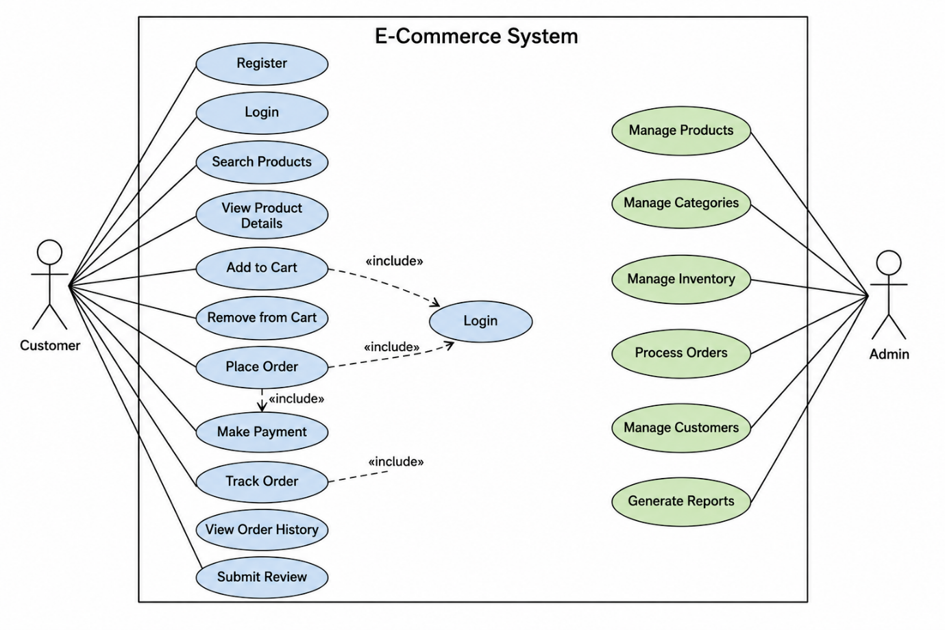

6. Implementation Strategy
Phase 1 – Requirement Analysis
- Gather customer requirements.
- Identify functional and non-functional requirements.
Phase 2 – System Design
- Design database schema.
- Prepare UML diagrams.
- Design system architecture.
Phase 3 – Development
- User Authentication
- Product Catalog
- Payment Gateway
- Order Management
Phase 4 – Testing
- Unit Testing
- Integration Testing
- System Testing
Phase 5 – Deployment
- MySQL Database

7. Evaluation Strategy
Evaluation Parameter | Method
Functional Accuracy | Requirement verification
Performance | Load testing
Security | Authentication
Reliability | Continuous monitoring
Maintainability | Code review and documentation

8. Expected Outcomes
- Centralized E-Commerce Platform.
- Improved Monitoring.
- Easier Access and Better User Interface.
- Scalable architecture for future enhancements.

