2420030132
Experiment 2: Case Study
Real-world Case Study on KL ERP System
1. Functional Requirements
Student
The KL ERP system allows students to:
- Login securely
- View attendance records and details
- Register for academic courses
- View class timetable
- View CGPA and academic performance
Faculty
- Login securely
- View assigned courses
- View student details
- Mark attendance
- Upload learning materials
Administrator
- Manage student records
- Manage faculty records
- Manage courses and attendance
- Manage timetables
- Manage examination details
- Manage hostel and transportation

2. User Stories
User ID | User Story | Priority
US-01 | As a student, I want to login into the ERP system so that I can access the ERP system. | High
US-02 | As a student, I want to register academic courses so that I can attend my academic subjects. | High
US-03 | As a student, I want to view my timetable so that I can monitor my attendance percentage. | High
US-04 | As a student, I want to submit feedback so that I can communicate my concerns. | Medium
US-05 | As a faculty member, I want to mark attendance so that student attendance is recorded. | High
US-06 | As a faculty member, I want to upload marks so that the student can view their marks. | High
US-07 | As an administrator, I want to manage records. | High
3. Selected Software Development Process Model
Agile Scrum
Reason for Selection
- The ERP contains many independent modules.
- Students, faculty and administrators can provide continuous feedback.
- Bugs can be fixed easily.
- New modules can be developed over a period of time.
Sprint Plan
Sprint | Features
Sprint 1 | Login, Profile and Role-Based Access, Academic Registration and Course Management
Sprint 2 | Attendance Register, Timetable, CGPA, Marks and Examination Section
Sprint 3 | Fee Payment, Library and Hall Ticket, Analytics Dashboard and Reports
Sprint 4 | Testing, Deployment and Evaluation, Management

4. Programming Language Selection
Backend
Java – Spring Boot
Reasons
- Secure
- Scalable
- Suitable for enterprise applications
- Supports REST APIs
- Provides excellent database connectivity
- Supports role-based authentication
Frontend
- HTML5
- CSS
- JavaScript
- React.js

Database
- MySQL
- Data Analytics
5. System Architecture
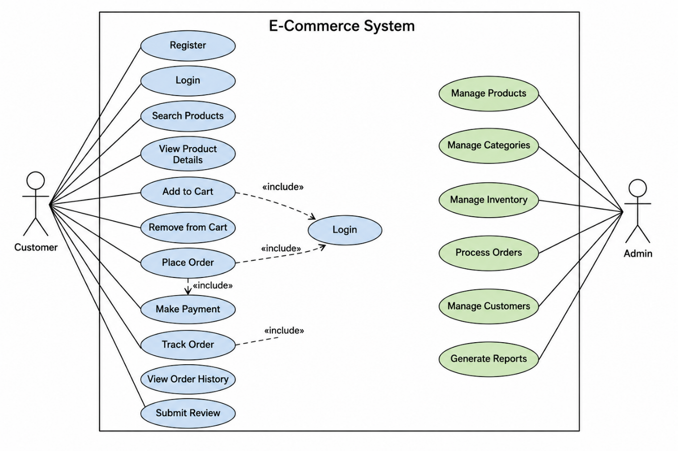

6. Implementation Strategy
Phase 1 – Requirement Analysis
- Study existing KL ERP modules.
- Identify requirements of students, faculty and administrators.
- Create use case diagrams.
- Identify analytics requirements.

Phase 2 – System Design
- Design ERP database schema.
- Design analytics database.
- Design dashboard.
- Design system architecture.

Phase 3 – Development
- ERP module development
- Authentication
- Academic Registration
- Attendance Register
- Courses
- Examination Section
- Fee Payments
- Timetables
- CAPA
- Feedback

Phase 4 – Testing
Unit Testing
- Login
- Registration
System Testing
- Complete application testing
- User Acceptance Testing (UAT)
- Verify user requirements

7. Evaluation Strategy
Evaluation Parameter | Method
Functional Accuracy | Requirement verification
Performance | Load testing using JMeter
Security | Automation and security
Reliability | System monitoring
Usability | Student and faculty feedback
Scalability | Concurrent user testing
Maintainability | Code review

8. Expected Outcomes
- Centralized KL ERP management system.
- Easy access to academic and administrative activities.
- Improved attendance monitoring.
- Better student performance analysis.
- Scalable architecture for future KL ERP enhancements.

