Adaptive Software Engineering

Experiment-4: Jira Tool
Name: Pilyani Priyanka
Roll no: 2420030132

Section - 1
Step 1: Sign up / log in to Jira
https://www.atlassian.com/software/jira
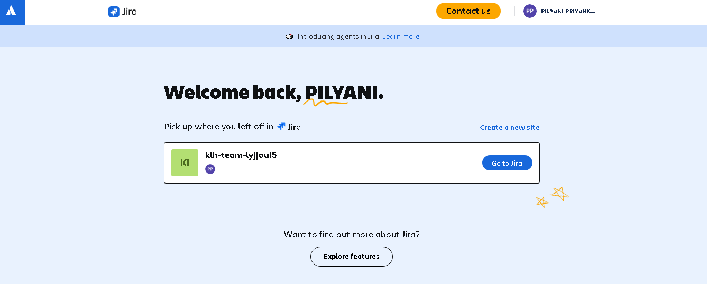
Step 2: Create a Jira project, name it Online Food Ordering System, and select a Scrum project template.
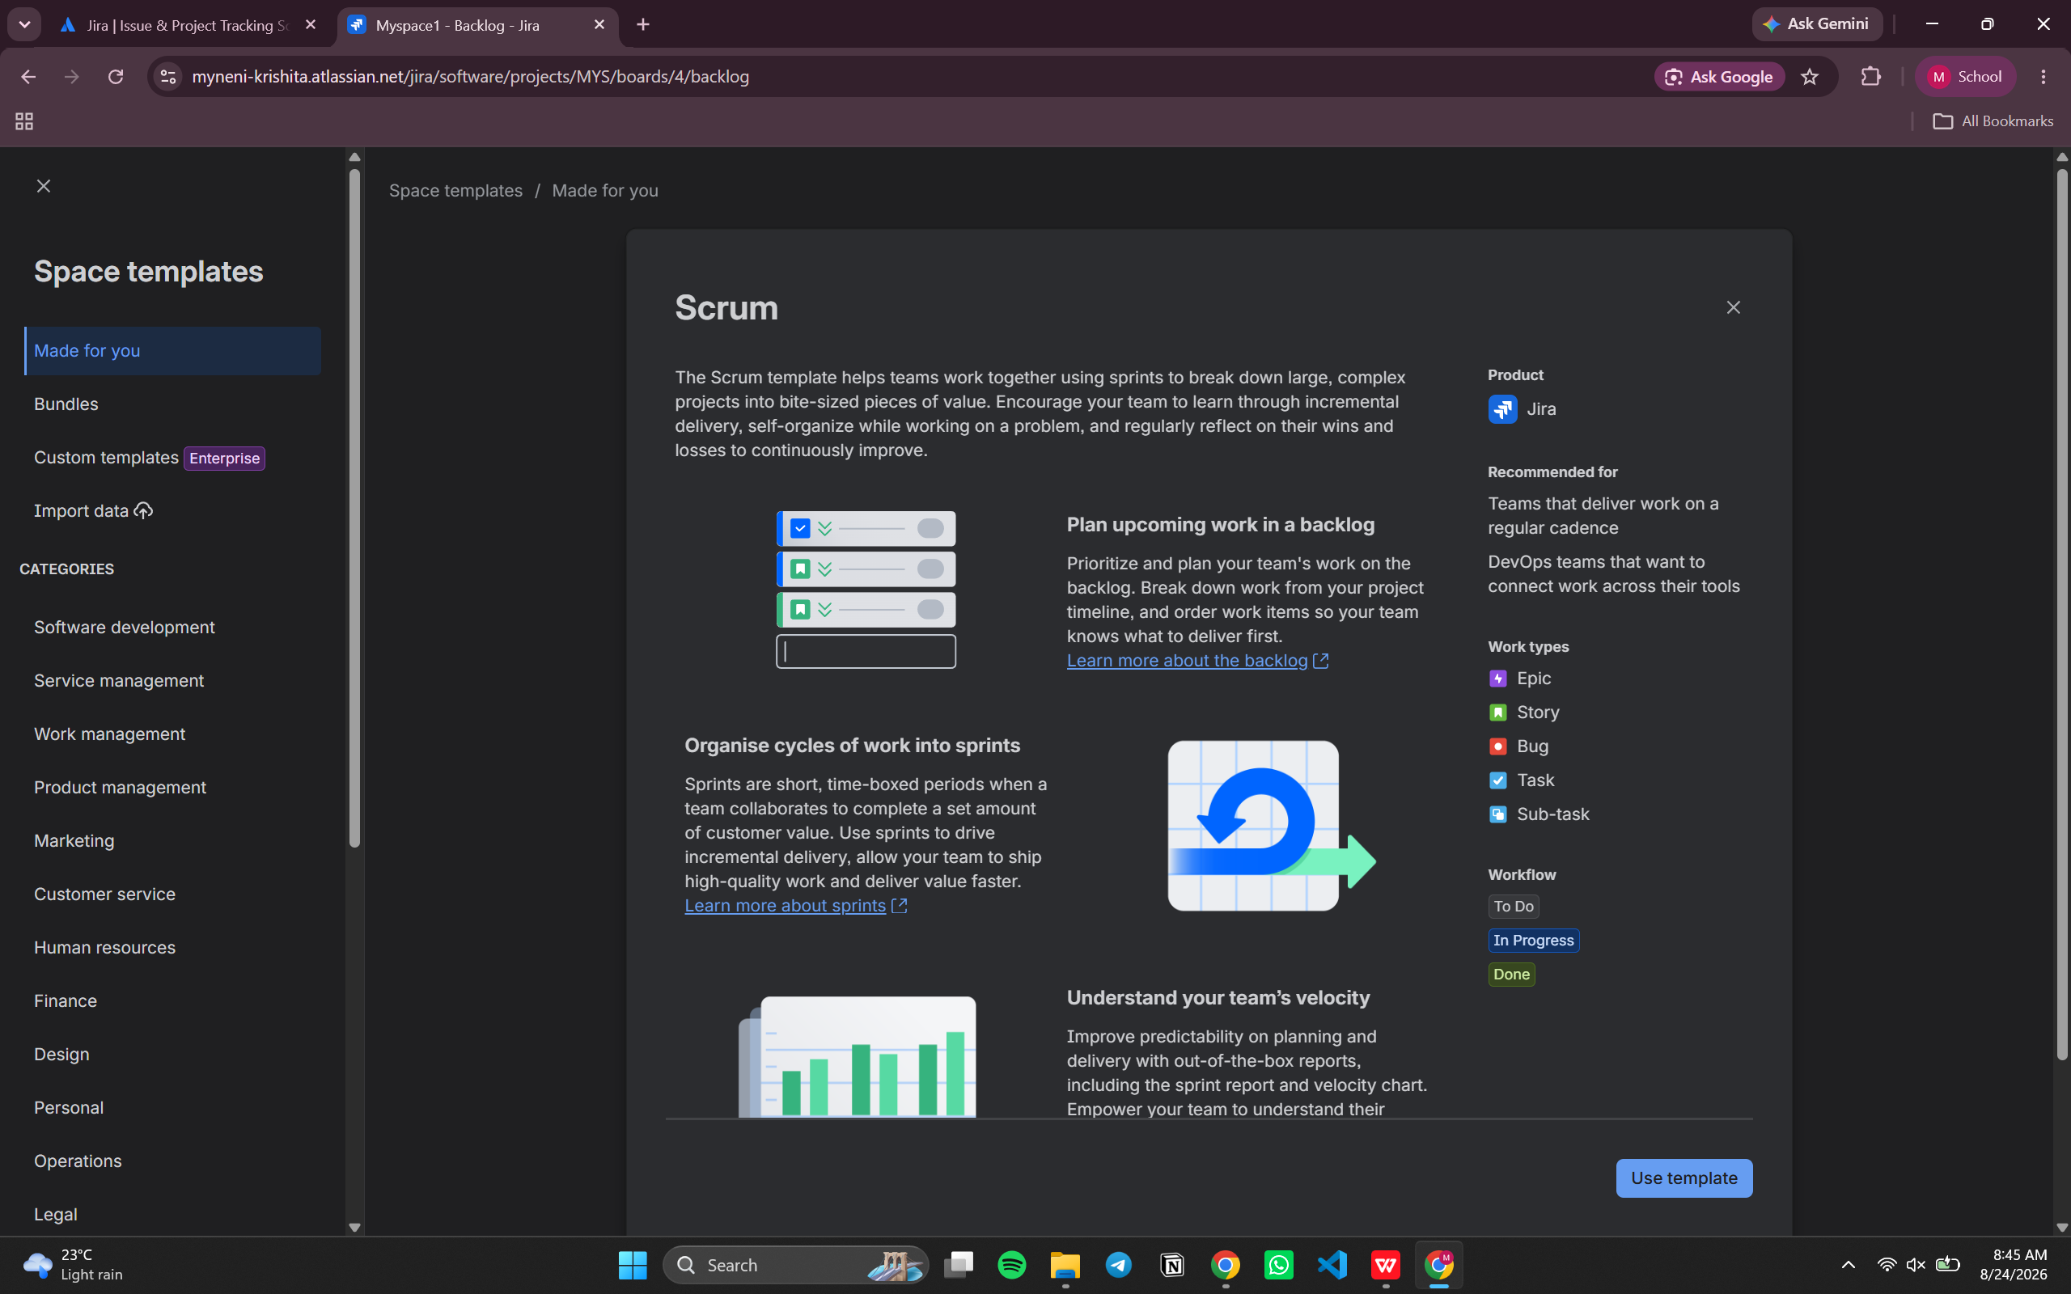

Create the project so that the team can manage the product backlog, sprint backlog, and user stories.

Step 3: Invite team members
Open Project settings / People and add the required team members to the Jira project.
For example, add team members such as abc and xyz.
Step 4: Create Project Board → Board Name: Food Ordering App Sprint Board
Create a Scrum board for the project and use it to manage the user stories through the development workflow.
Step 5: Create Columns / Workflow
Product Backlog
Sprint Backlog
To Do
In Progress
Code Review
Testing
Done
Create all columns / workflow stages as follows.
Step 6: Create 5 User Stories under the Product Backlog
Create the following five user stories as Jira issues and assign story points.
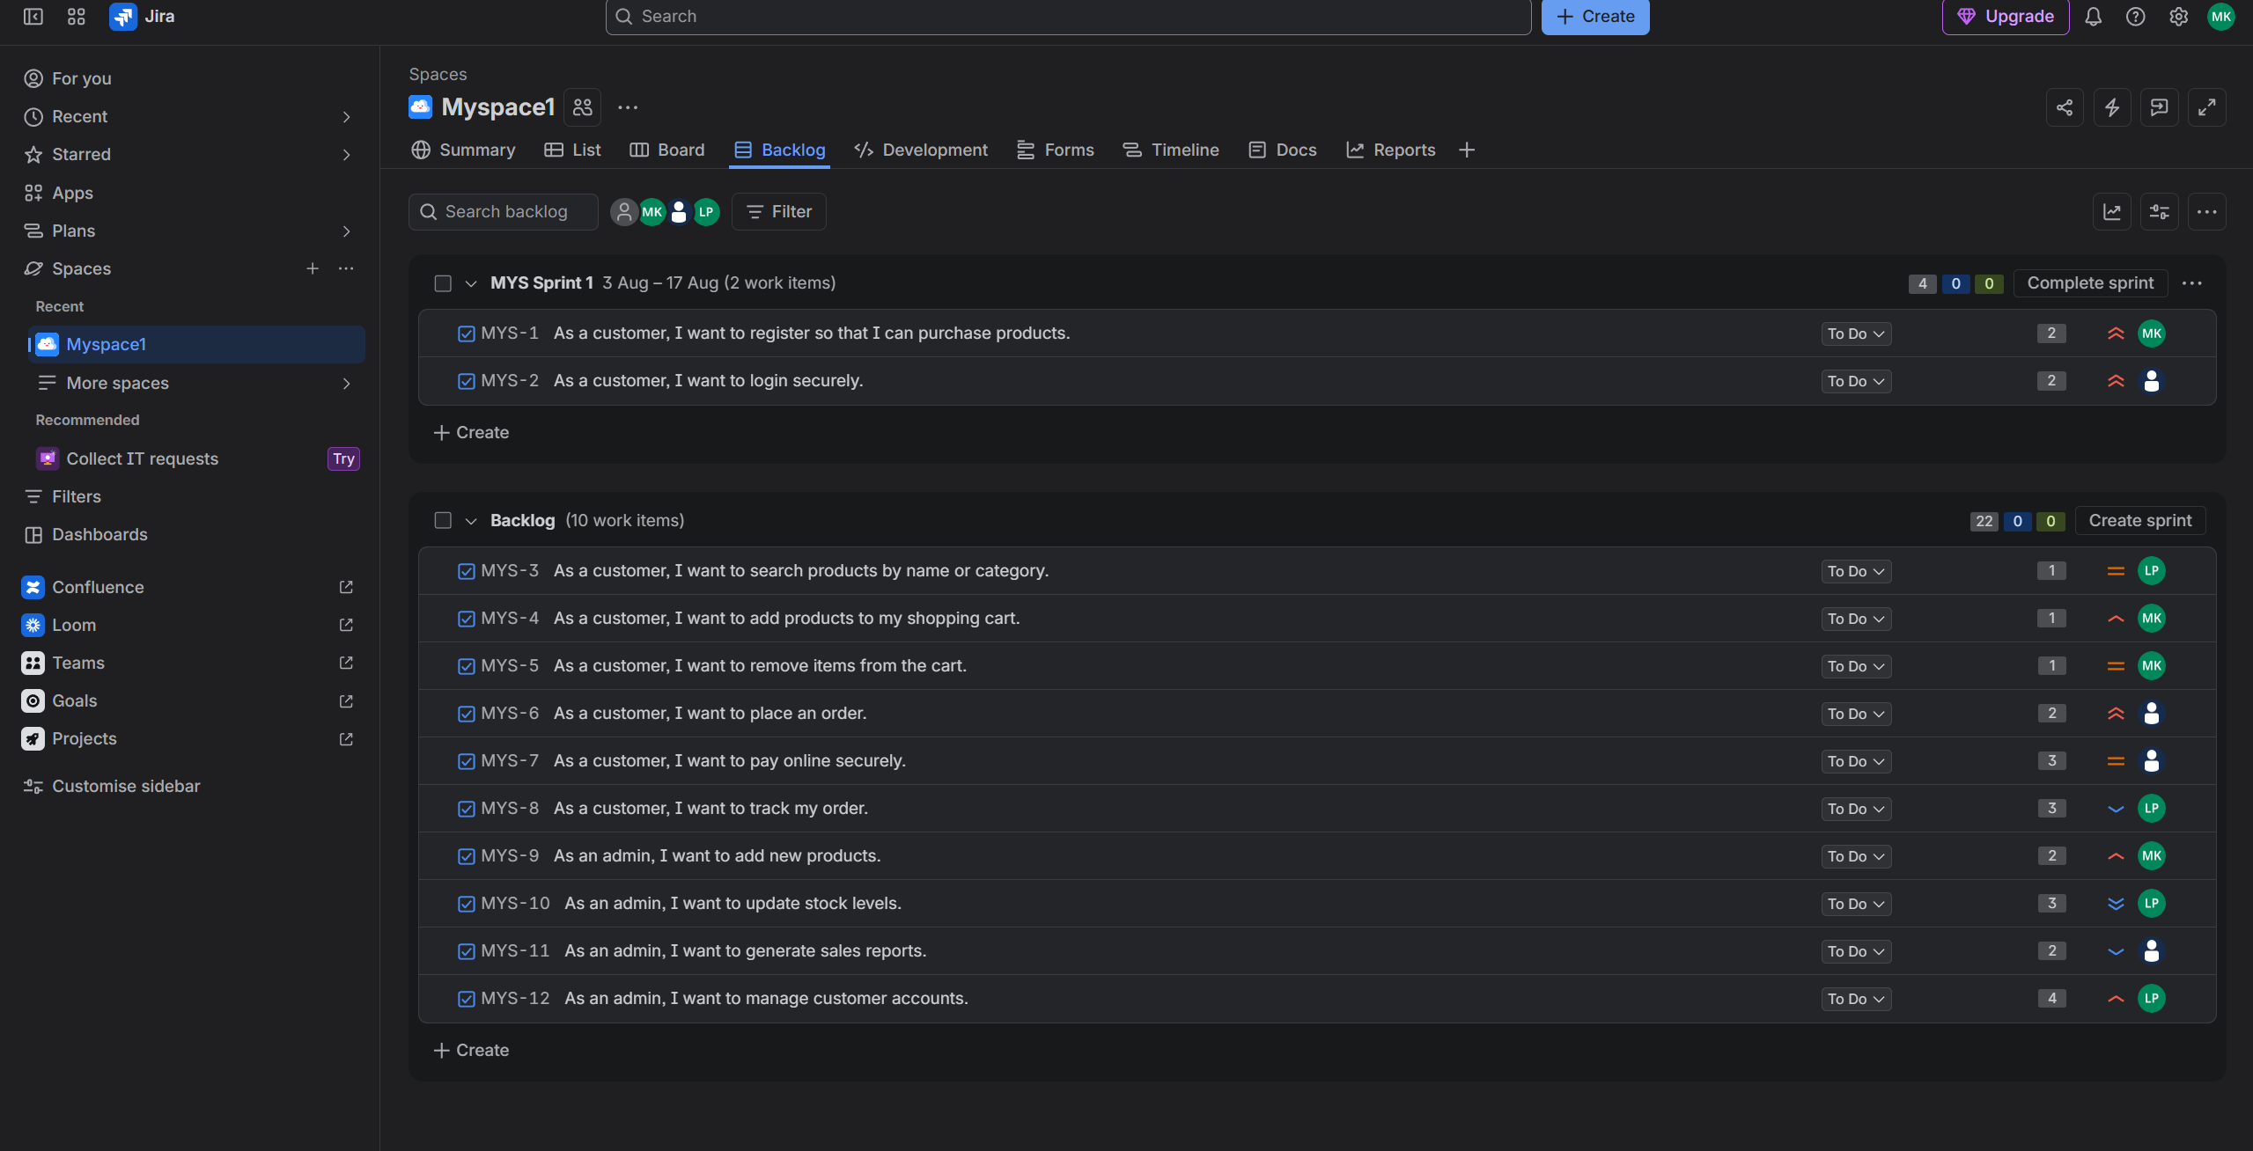
User Story 1
As a customer,
I want to register an account,
So that I can order food.
Story Points: 3

User Story 2
As a customer,
I want to login securely,
So that I can access my account.
Story Points: 2

User Story 3
As a customer,
I want to search restaurants,
So that I can order food quickly.
Story Points: 5

User Story 4
As a customer,
I want to add food to cart,
So that I can place my order.
Story Points: 5

User Story 5
As a customer,
I want to pay online,
So that I can complete my purchase.
Story Points: 3

Step 7: Assign Story Points
The story points assigned to the five user stories are 3, 2, 5, 5, and 3 respectively. These values are entered in the Story Points field of each Jira issue.
Step 8: Move User Stories through the Board
Move the user stories from Product Backlog to Sprint Backlog and then through To Do, In Progress, Code Review, Testing, and finally Done as the work progresses.
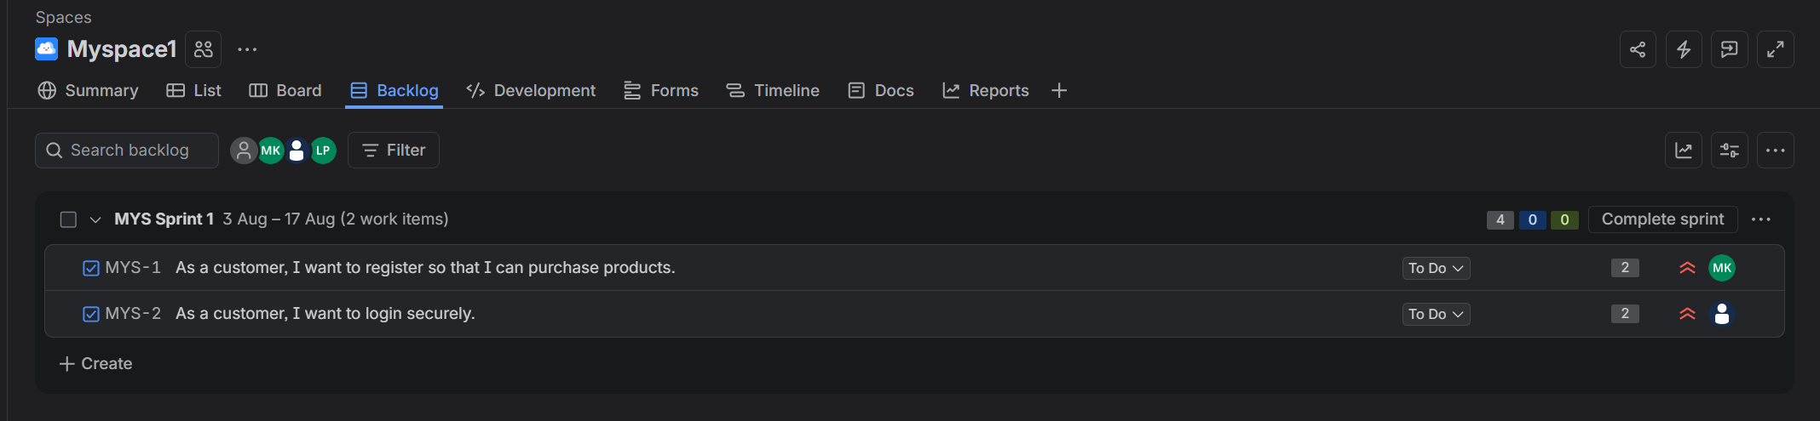
User Story and Story Points Summary
User Story | Description | Story Points
User Story 1 | Register an account | 3
User Story 2 | Login securely | 2
User Story 3 | Search restaurants | 5
User Story 4 | Add food to cart | 5
User Story 5 | Pay online | 3

