Assignment module 2 : Installation and Maintenance of Hardware and Its Components

**Section 1: Multiple Choice**

1. Which of the following precautions should be taken before working on computer hardware?

a) Ensure the computer is plugged in to prevent electrostatic discharge.

b) Wear an anti-static wrist strap to prevent damage from electrostatic discharge.

c) Work on carpeted surfaces to prevent slipping.

d) Use magnetic tools to handle components more easily.

Answer:b)Wear an anti-static wrist strap to prevent damage from electrostatic discharge.

Reason:When we touch computer parts,static electricity from our body can damage them.

An anti-static wrist strap safely removes that electricty ,so the computer parts stay safe.

2.What is the purpose of thermal paste during CPU installation?

a) To insulate the CPU from heat.

b) To provide mechanical support for the CPU.

c) To improve thermal conductivity between the CPU and the heat sink.

d) To prevent the CPU from overheating.

Answer:c) To improve thermal conductivity between the CPU and the heat sink.

Reason:Thermal paste fills the tiny gaps between the CPU and the hear sink,so heat moves quickly from the CPU to the heat sink.

This helps keep the CPU cool.

3. Which tool is used to measure the output voltage of a power supply unit (PSU)?

a) Multimeter

b) Screwdriver

c) Pliers

d) Hex key

Answer:a)Multimeter

Reason:A multimeter is a tool that helps to measure voltage,current, and resistance in electronic devices.It is also used to check the output voltage of a PSU(Power Supply Unit).

4. Which component is responsible for storing BIOS settings, such as date and time, even when the computer is powered off?

a) CMOS battery

b) CPU

c) RAM

d) Hard drive

Answer:a) CMOS battery

Reason:The CMOS battery gives power to the chips that stores BIOS settings like data and time,even when the computer is turned off.

Without this battery,the computer would forget the date/time every time it's shut down.

**Section 2: True or** **False**

5.When installing a new hard drive, it is essential to format it before use.

Answer:True

6.A POST (Power-On Self-Test) error indicates a problem with the CPU.

Answer:True

7. True or False: It is safe to remove a USB flash drive from a computer without ejecting it first

Answer:False

Reason:If you remove a USB without ejecting,the computer might still be using it(like saving a file).Removing it suddenly can damage the files or the USB.

**Section 3: Short Answer**

8. Describe the steps involved in installing a new graphics card in a desktop computer.

Answer:

1. Turn off the computer - Shut down the PC and unplug the power cable.
2. Open the case - Remove the side panel of the computer cabinet.
3. Find the PCI-E slot - Look for the long slot on the motherboard where the graphics card fits(called PCI Express slot).
4. Remove the old card - If a card is already there,unscrew and gently pull it out.
5. Insert the new graphics card - Line up the card with the slot and push it in firmly.
6. Secure the card - Use a screw to hold the card in place at the back of the case.
7. Connect power cable - Some cards need extra power-connect the power cable from PSU.
8. Close the case - Put the side panel back and tighten the screws.
9. Turn on the computer - Plug in and start the PC.
10. Install drivers - Windows may auto-install,or you can dowload from the card's website.

9. What is RAID, and what are some common RAID configurations? 9. What is RAID, and what are some common RAID configurations?

Answer:RAID stands for Redundant Array of Independent Disks.

It is a methods of combining multiple hard drives to:

* Increase speed
* Provide data backup
* Or both

Common RAID Configurations:-

1. RAID 0(Speed only)

* Data is split across two or more disks.
* Fast,but no backup.
* If one disk fails,all data is lost.

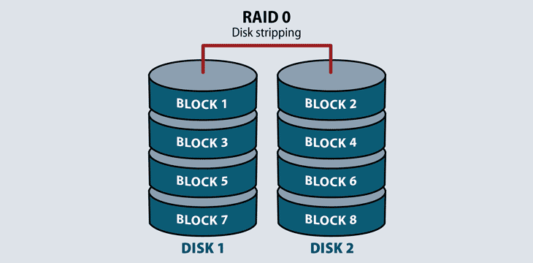

2. RAID 1 (Backup only)

* Data is copied(mirrored)on two disks.
* Safe,but no speed boost.
* If one disk fails,the other still has the data.

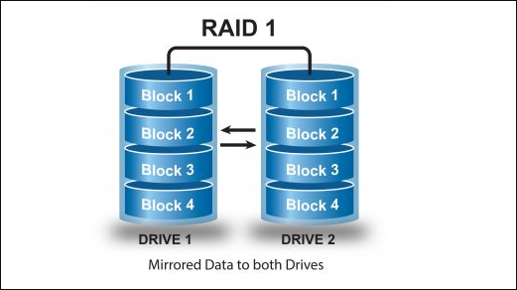

3. RAID 5 (Speed +Backup)

* Needs at least 3 disks.
* Data and parity(backup info) are spread across all disks.

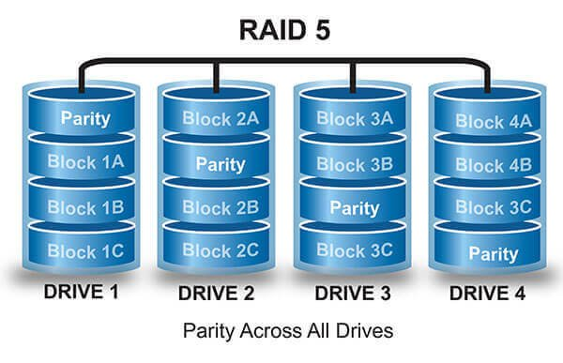

4. RAID 10(Speed + Strong Backup)

* Mix of RAID 0 and RAID 1.
* Needs at least 4 disks
* Fast and safe,but uses more space.

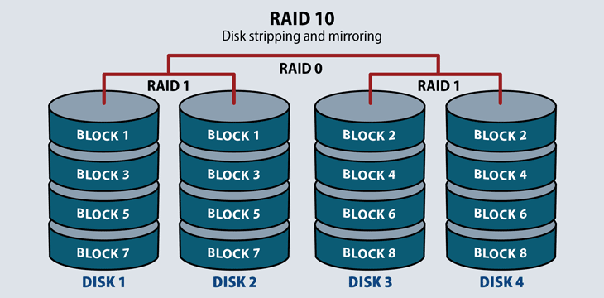

**Section 4: Practical Application**

10. Demonstrate how to replace a CPU fan in a desktop computer?

Answer: Steps to Replace a CPU Fan:-

1. Turn off the computer

* Shut down the PC and unplug the power cable.

2. Open the cabinet

* Remove the side cover of the CPU case.

3. Remove the old CPU fan

* Unplug the fan wire from the motherboard.
* Unscrew or unlock the fan clips carefully.
* Lift the fan and heat sink off the CPU.

4. Clean the CPU

* Wipe off the old thermal past from the CPU with soft cloth or tissue.

5. Apply new thermal paste

* This helps in cooling the CPU properly.

6. Install the new CPU fan

* Place the new fan with heat sink on the CPU.
* Lock it in place with clips or screws.

7. Connect the fan wire

* Plug the fan cable into the CPU fan header on the motherboard.

8. Close the cabinet

* Put the side cover back and tighten the screws.

9. Turn on the computer

* Plug in power and start the PC.
* Check if the fan is spinning.

**Section 5: Essay**

11. Discuss the importance of regular maintenance for computer hardware and provide examples of maintenance tasks.

Answer:Regular maintenance keeps your computer working fast,smooth and safe.It helps to avoid problems,increase life of parts and save money on repairs.

Examples of Maintenance Tasks:

1. Cleaning the inside

* Remove dust from fans,CPU and power supply using air blower or brush.

2. Checking Cables

* Make sure all wires are tight and not damaged.

3. Updating software and drivers

* Helps to keep hardware working properly.

4. Running antivirus scans

* Removes harmful files that can slow or damage your system .

5. Checking hard drive health

* Use tools like CHKDSK to find and fix disk errors.

6. Making backup

* Save your data so you don't lose it in case of a problem.