**Ctrl+B = It is used for to beautify your query**

**Basic:**

1. **Retrieve the total number of orders placed.**

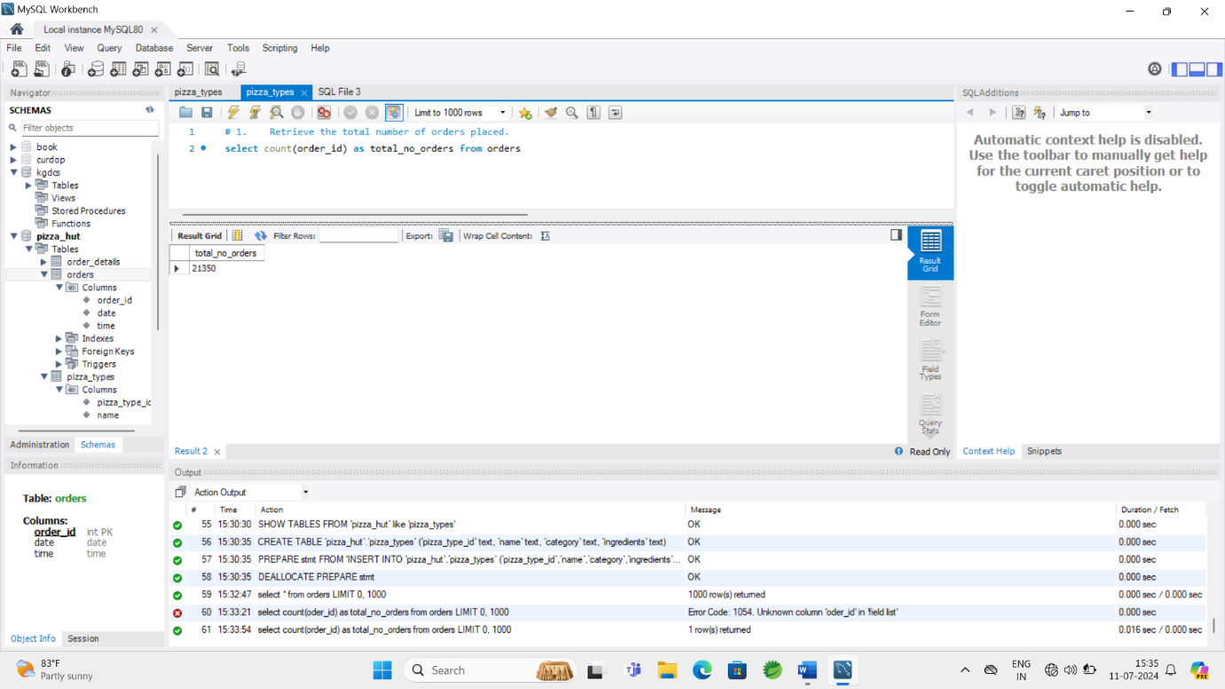

1. **Calculate the total revenue generated from pizza sales.**

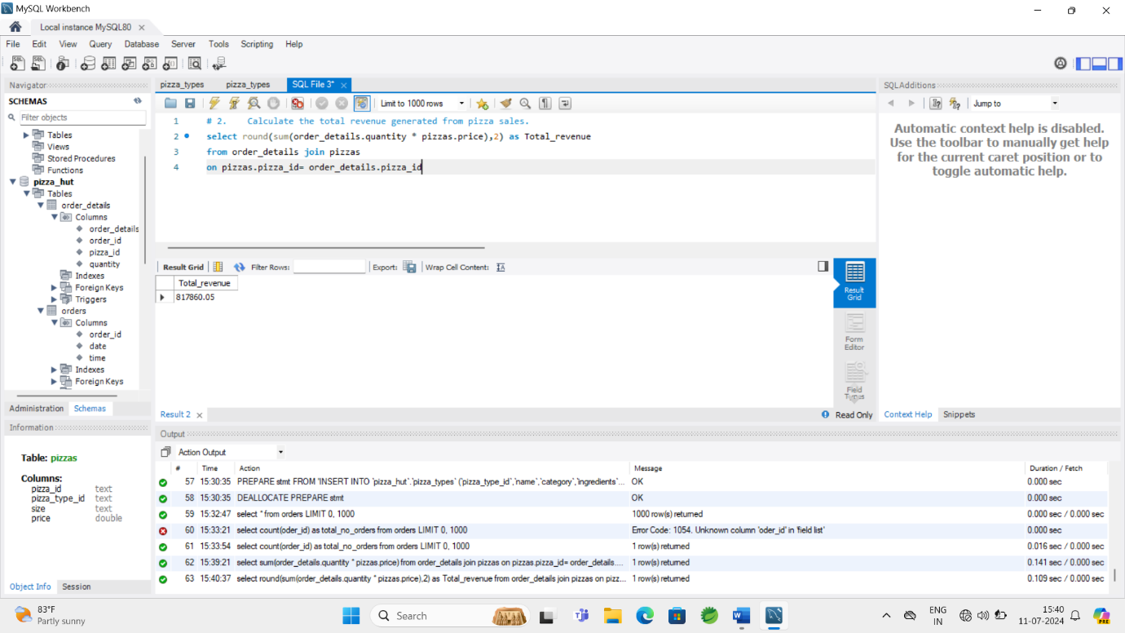

1. **Identify the highest-priced pizza.**

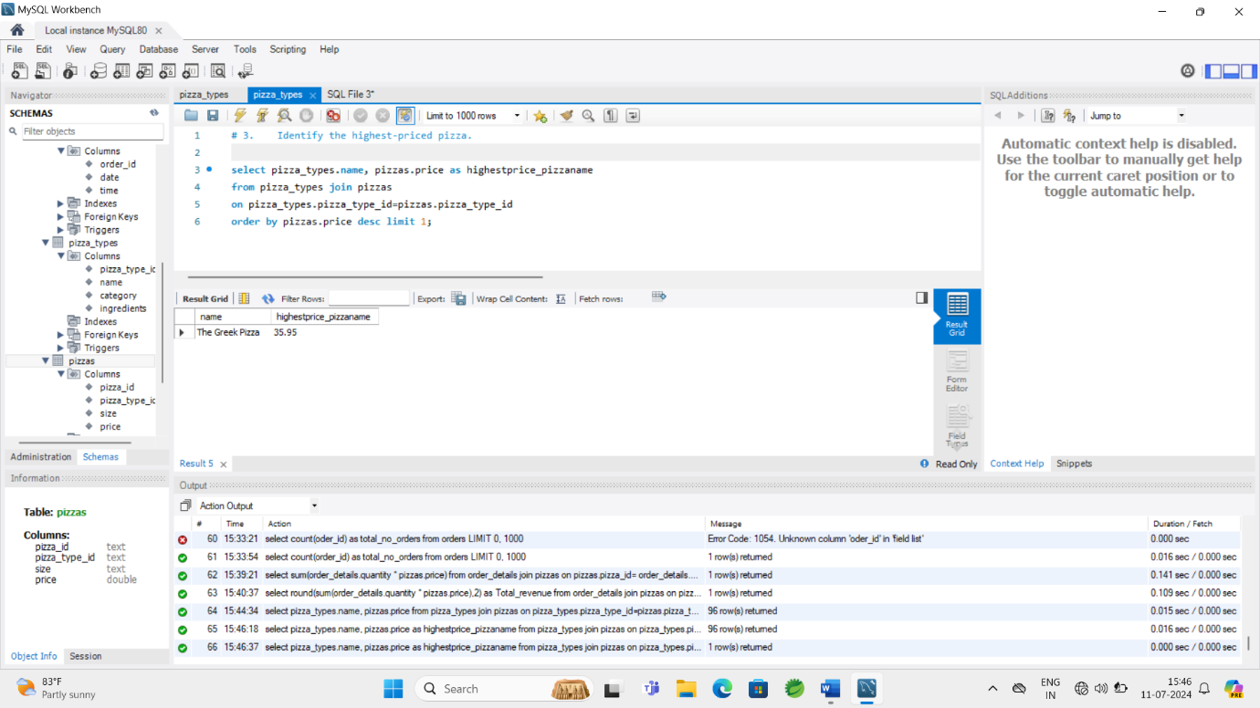

1. **Identify the most common pizza size ordered.**

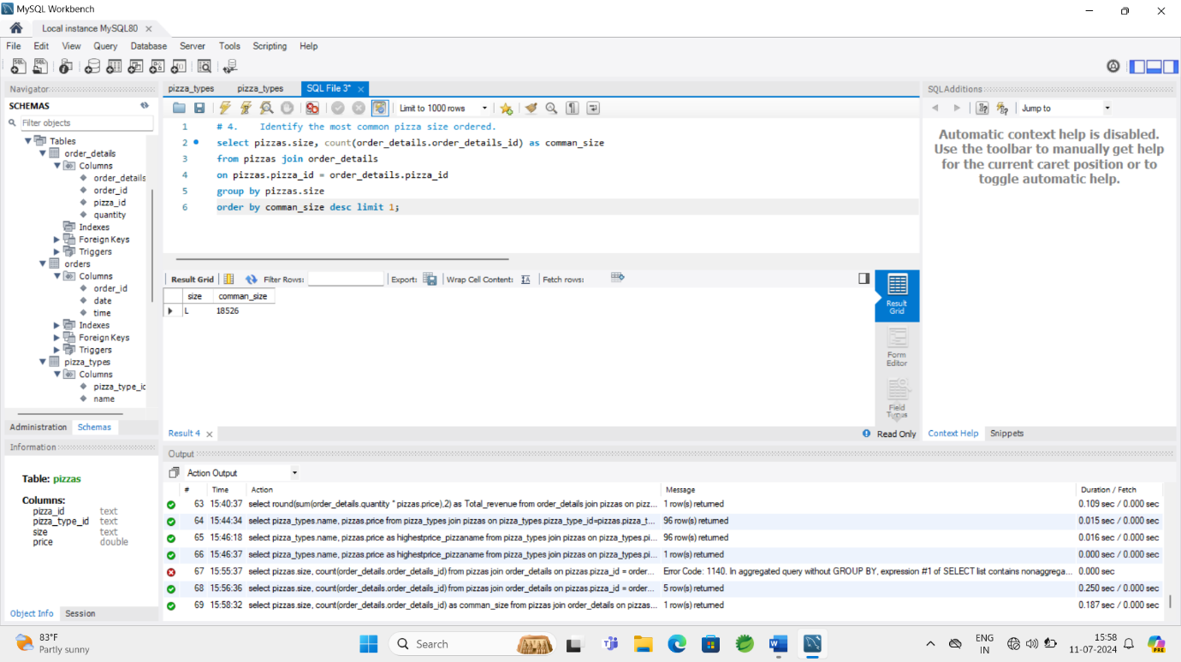

1. **List the top 5 most ordered pizza types along with their quantities.**

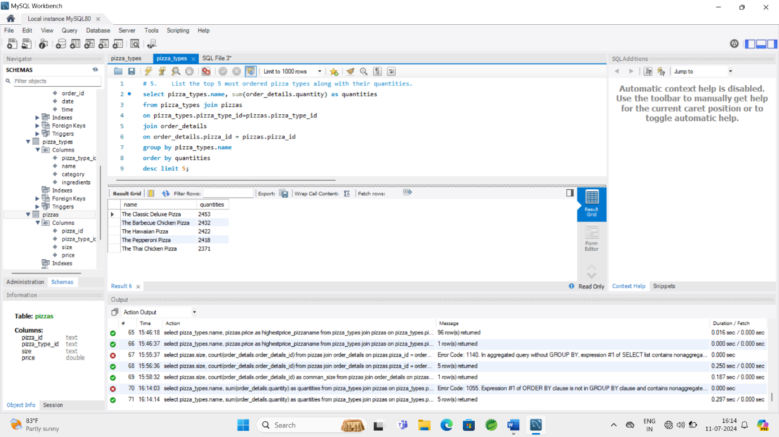

**Intermediate:**

1. **Join the necessary tables to find the total quantity of each pizza category ordered.**

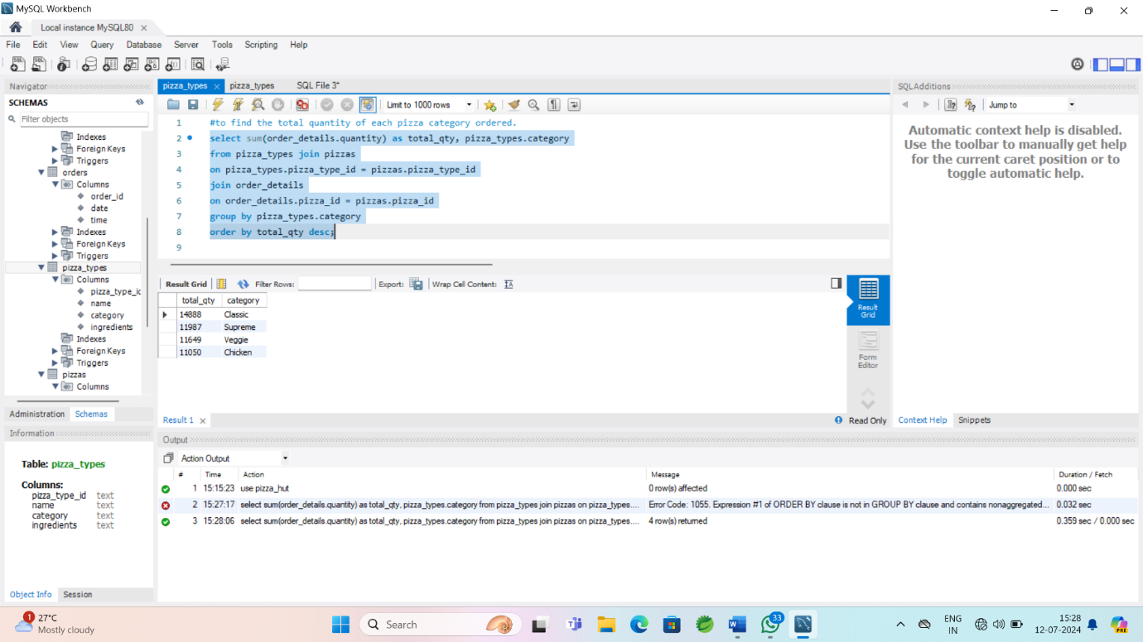

1. **Determine the distribution of orders by hour of the day.**

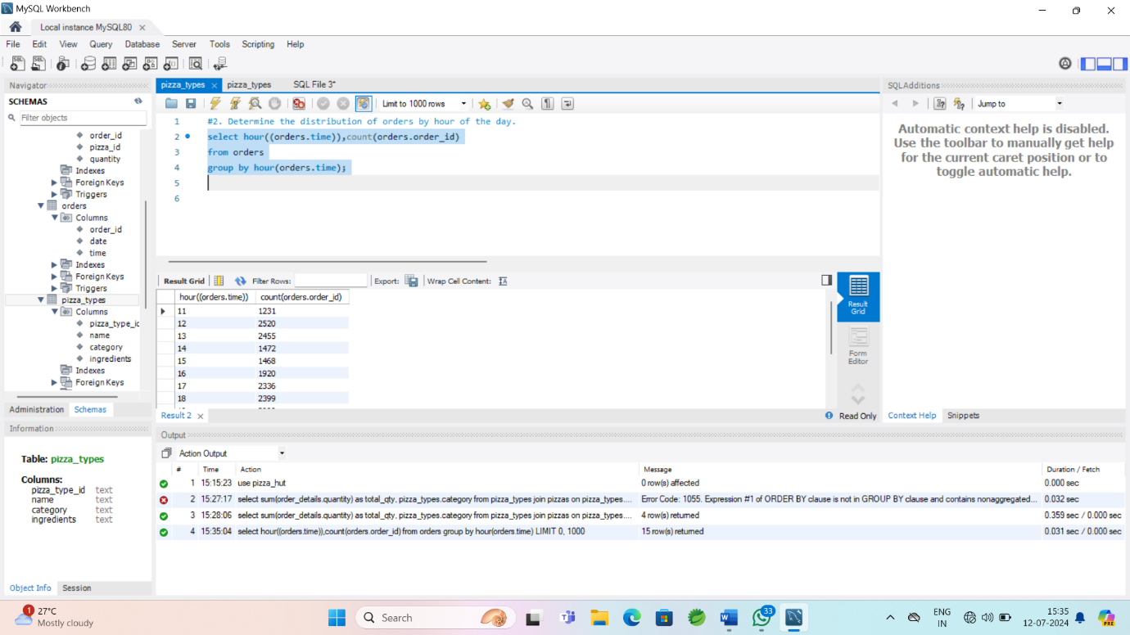

1. **Join relevant tables to find the category-wise distribution of pizzas.**

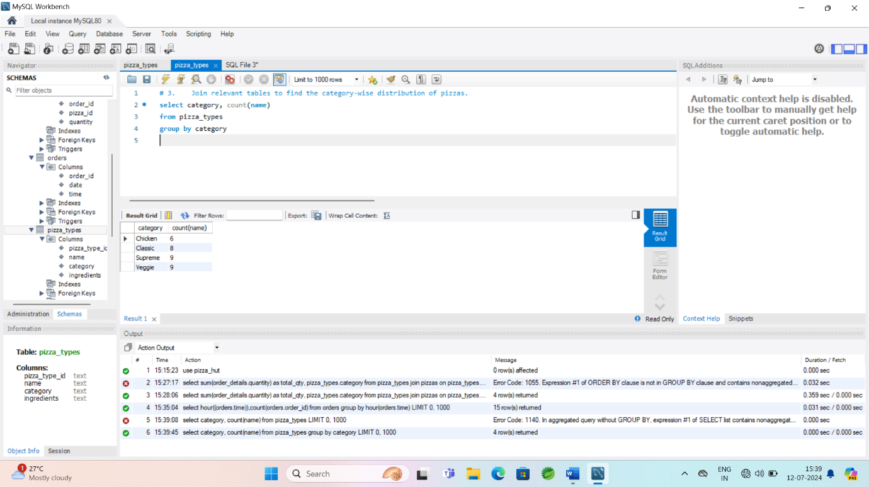

1. **Group the orders by date and calculate the average number of pizzas ordered per day.**

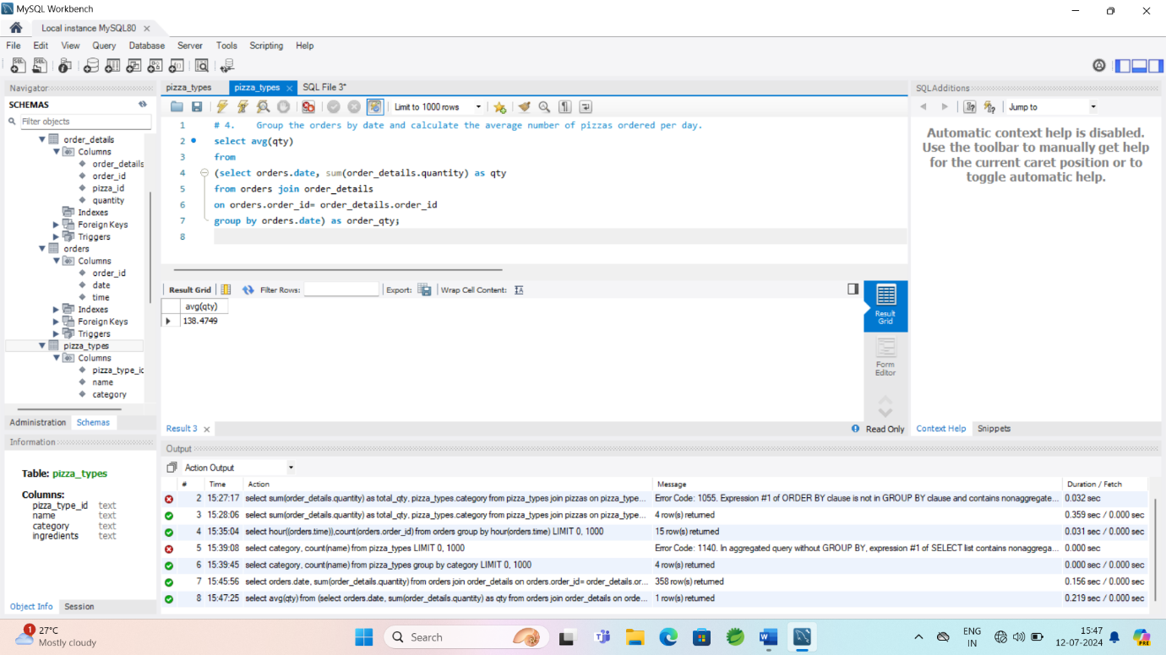

1. **Determine the top 3 most ordered pizza types based on revenue.**

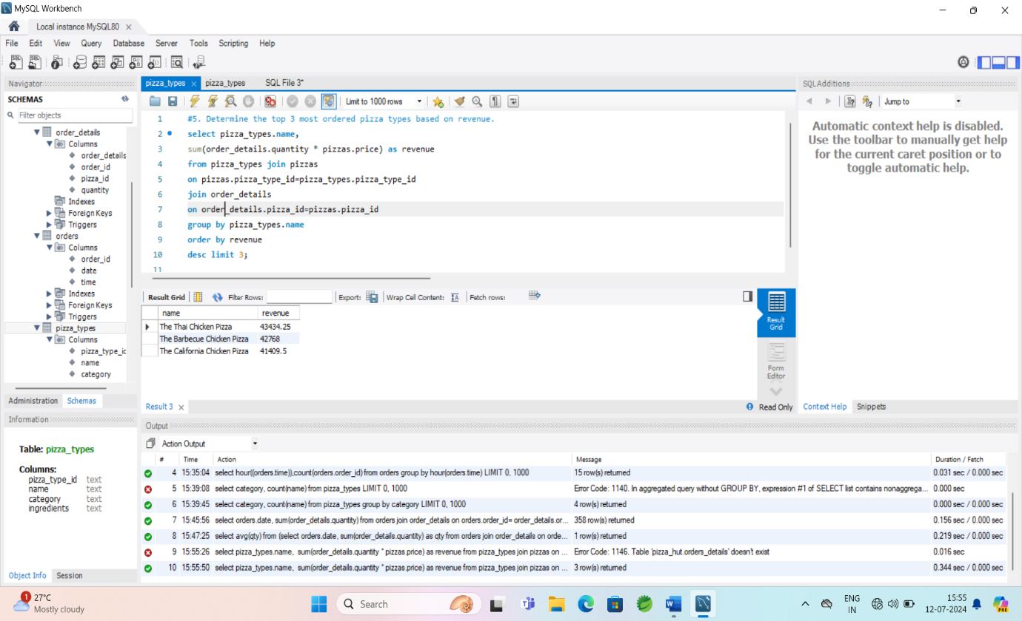

**Advanced:**

1. **Calculate the percentage contribution of each pizza type to total revenue.**
2. **Analyze the cumulative revenue generated over time.**
3. **Determine the top 3 most ordered pizza types based on revenue for each pizza category.**