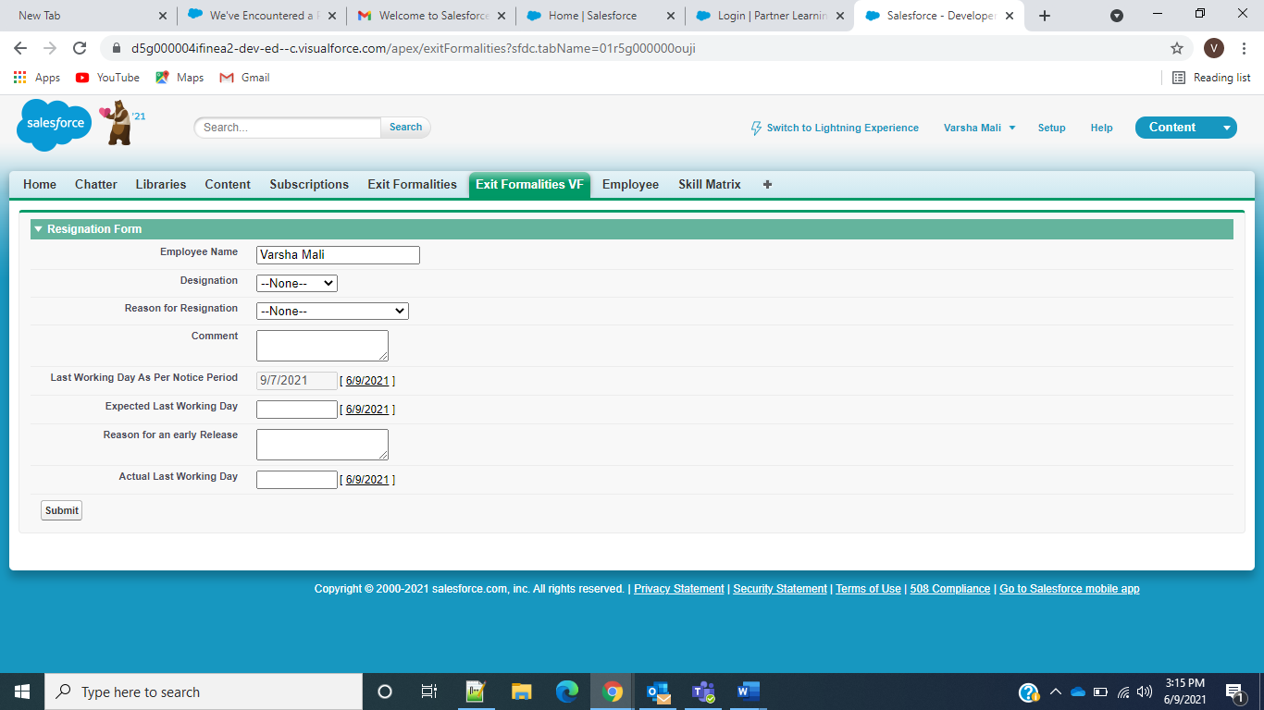

------------------------------------VF Page Code -------------------------------

<apex:page Controller="exitFormalitiesApex" sidebar="false" showHeader="true" standardStylesheets="False">

<style>

.fsWrapper{

width: 960px;

margin: 0 auto;

}

.headerTitle{

font-family: arial, Sans-serif;

font-size: 30px;

font-weight: 600;

color: #fff!important;

text-align: left;

text-transform: uppercase;

background: #4e75a3;

display: block;

padding: 10px;

margin:0;

}

</style>

<apex:form id="theform">

<apex:pageBlock id="thepageblock">

<apex:pageBlockSection id="thepageblockscn" title="Resignation Form" rendered="{!hideFormFlag}" columns="1">

<apex:inputfield value="{!ef.Employee_Name__c}" />

<apex:inputfield value="{!ef.Designation__c}"/>

<apex:inputfield value="{!ef.Reason_for_Resignation__c}"/>

<apex:inputfield value="{!ef.Comment__c}"/>

<apex:inputfield id="LWdayNp" value="{!ef.Last_Working_Day_As_Per_Notice_Period__c}" html-disabled="true" />

<apex:inputfield id="ELWday" value="{!ef.Expected_Last_Working_Day__c}" />

<apex:inputTextarea id="reasonForELWday" value="{!ef.Reason_for_an_early_release__c}" />

<apex:inputfield id="ALWday" value="{!ef.Actual_Last_Working_Day__c}" />

<apex:commandButton value="Submit" action="{!saveRecord}" />

</apex:pageBlockSection>

<apex:pageMessages />

<apex:pageBlockSection title="Resignation Form" rendered="{!readonlyflag}" columns="1">

<apex:outputfield value="{!ef.Employee_Name__c}" />

<apex:outputfield value="{!ef.Designation__c}"/>

<apex:outputfield value="{!ef.Reason_for_Resignation__c}"/>

<apex:outputfield value="{!ef.Comment__c}"/>

<apex:outputfield value="{!ef.Last_Working_Day_As_Per_Notice_Period__c}"/>

<apex:outputfield value="{!ef.Expected_Last_Working_Day__c}"/>

<apex:outputfield value="{!ef.Reason_for_an_early_release__c}" />

<apex:outputfield value="{!ef.Actual_Last_Working_Day__c}" />

</apex:pageBlockSection>

</apex:pageBlock>

</apex:form>

</apex:page>

-----------------------------------------Apex Controller---------------------------------------------------

public class exitFormalitiesApex {

public Exit_Formalities__c ef {get;set;}

public user currentuser {get;set;}

public boolean readonlyflag {get;set;}

public boolean hideFormFlag {get;set;}

public exitFormalitiesApex()

{

currentuser=new User();

currentuser=[Select Id,Name,Email from User where Id=:userinfo.getuserId()];

ef=new Exit_Formalities__c();

ef.Employee_Name__c=currentuser.Name;

ef.Last_Working_Day_As_Per_Notice_Period__c = (Date.today()).addDays(90);

List< Exit_Formalities__c> existingUser=[ Select Id,Employee_Name__c,Designation__c,Reason_for_Resignation__c,Comment__c,Last_Working_Day_As_Per_Notice_Period__c,Expected_Last_Working_Day__c,Reason_for_an_early_release__c,Actual_Last_Working_Day__c from Exit_Formalities__c where Employee_Name__c=:currentuser.Name limit 1];

if(existingUser.size() ==0){

readonlyflag=false;

hideFormFlag=true;

} else {

system.debug('=====In else ');

ef.Employee_Name__c=existingUser[0].Employee_Name__c;

ef.Designation__c=existingUser[0].Designation__c;

ef.Reason_for_Resignation__c=existingUser[0].Reason_for_Resignation__c;

ef.Comment__c=existingUser[0].Comment__c;

ef.Last_Working_Day_As_Per_Notice_Period__c=existingUser[0].Last_Working_Day_As_Per_Notice_Period__c;

ef.Expected_Last_Working_Day__c=existingUser[0].Expected_Last_Working_Day__c;

ef.Reason_for_an_early_release__c=existingUser[0].Reason_for_an_early_release__c;

ef.Actual_Last_Working_Day__c=existingUser[0].Actual_Last_Working_Day__c;

readonlyflag=true;

hideFormFlag=false;

}

}

public Date Today { get { return (Date.today()).addDays(90); }}

public void saveRecord()

{

try{

insert ef;

ApexPages.Message myMsg = new ApexPages.Message(ApexPages.Severity.CONFIRM,'Your resignation request has been sent for an approval to your reporting Manager.Please get in touch with HR team for any queries.');

ApexPages.addMessage(myMsg);

PageReference pr = new PageReference('/apex/exitFormalities?&id='+ef.Id);

pr.setRedirect(false);

readonlyflag = true;

hideFormFlag =false;

}catch(exception ex){

//system.debug('Error'+ex.getMessage());

}

}

/*---It is for Exit Formalities Lightning Component-----------------

@AuraEnabled

public static List<String> getPickList(String objName,String fldName)

{

List<String> pkList = new List<String>();Map<String,Schema.SObjectType> allObj = Schema.getGlobalDescribe();

Map<String,Schema.SObjectField> allFlds = allObj.get(objName).getDescribe().fields.getMap();

List<Schema.PicklistEntry> pickList = allFlds.get(fldName).getDescribe().getPickListValues();

for(Schema.PicklistEntry pk : pickList)

{

pkList.add(pk.getValue());

}

return pkList;

}

@AuraEnabled

public static Exit_Formalities__c createExitForm( Exit_Formalities__c exitObj){

system.debug('In apex exitObj==>'+exitObj);

insert exitObj;

return exitObj;

}*/

}