**Docker**

**What is Docker**

Docker is an open-source containerization platform by which you can pack your application and all its dependencies into a standardized unit called a container.

**Why Docker is popular**

**Portability**

**Reproducibility**

**Efficiency**

**Scalability**

**Key Components of Docker**

**Docker Engine**

**Docker Image**

**Docker Hub**

**Dockerfile**

**Docker Registry**

**What is a Dockerfile**

The Dockerfile uses DSL (Domain Specific Language) and contains instructions for generating a Docker image.

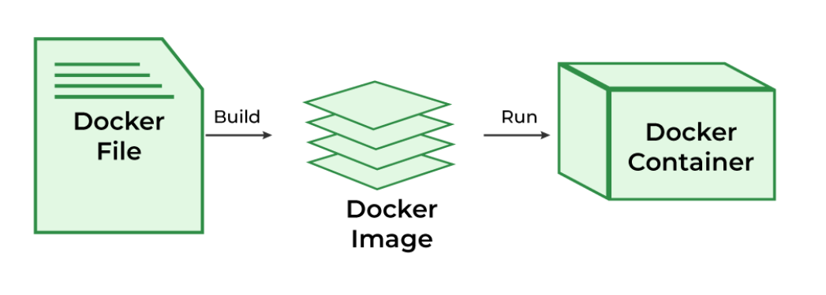

**What is Docker Architecture and How Docker Works**

