**Introduction**

**Why Cloud?**

* 90% of software companies use the cloud
* Global cloud market expected to reach 1.2$ trillion by 2027
* Cloud infrastructure spending surpassed 87$ billion in 2022.
* About a third companies IT budget goes for cloud services.
* The world is going to be cloud

**Why Microsoft Azure**

* 2nd largest public cloud in industry
* Azure has the highest growth rate
* Most popular in enterprises

**Introduction to cloud**

* Before the cloud

If you needed a server, you had to:

Buy it

Install it

Maintain it

Replace it

Have an IT team to maintain







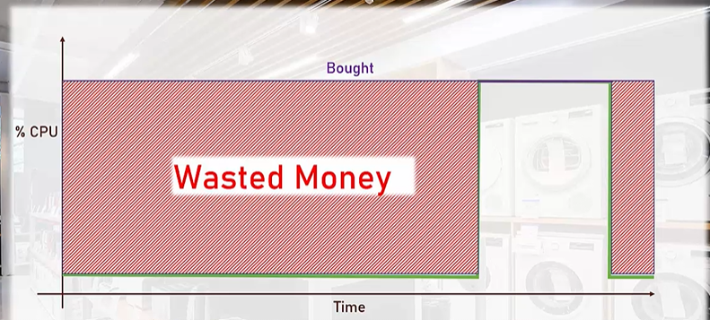

**Cloud**

* Compute, Networking, storage and other services
* Large data centres

**Cloud Providers**

* Fill it with servers, networking, cooling, electricity etc
* Publicly accessible

**Cloud Services**

* AI
* IoT
* Kubernetes

**Characteristics of cloud**

* On -Demand self-service
* Broad Network access
* Resource pooling
* Rapid Elasticity
* Measured service