A PROJECT REPORT ON
CINEMATCH
A Content-Based Movie Recommendation System Using Machine Learning
Submitted by
Rohan Yadav
Enrollment No. : 230022
Under the Guidance of
Priyanka pal, Data Science trainer
Computer science
Starex University
[July, 2026

CERTIFICATE
This is to certify that the project report entitled “CineMatch”: A Content-Based Movie Recommendation System Using Machine Learning is a Bonafide record of work carried out by Rohan Yadav (Enrolment No.: 230022) in partial fulfilment of the requirements, during the academic year 2026, at Starex University
The work embodied in this report has been carried out under my supervision and guidance and has not been submitted elsewhere, in part or in full, for the award of any other degree or diploma.

[CineMatch]
Project Guide
[Computer Science]

Date: [24/07/2026] Place: [Gurugram]

DECLARATION
I, Rohan Yadav, Enrolment No. 230022, hereby declare that the project report entitled “CineMatch: A Content-Based Movie Recommendation System Using Machine Learning”, submitted to Starex University in partial fulfilment of the requirements is an original record of work carried out by me under the guidance of Priyanka Pal.
I further declare that this report, or any part of it, has not been submitted previously to this or any other university or institute for the award of any degree or diploma, and that all sources of information used in this report have been duly acknowledged.

Place: Gurugram
Date: [24/07/2026]

[Rohan Yadav]

ACKNOWLEDGEMENT
I would like to express my sincere gratitude to my project guide, Priyanka Pal, for the invaluable guidance, continuous encouragement, and constructive feedback provided throughout the course of this project. Their insights were instrumental in shaping both the technical direction and the presentation of this work.
I am also thankful to Ritu Malik, Head of the Department of Computer Science, and to all the faculty members of the department for providing the resources, infrastructure, and academic environment that made this project possible.
I extend my gratitude to Starex University for the opportunity to undertake this project as part of the curriculum. I would also like to thank my family and friends for their constant support and motivation throughout this endeavour.
Finally, I acknowledge the open-source community behind the Python data science ecosystem — pandas, scikit-learn, Streamlit, and Plotly — whose tools formed the technical foundation of this project.

[Rohan Yadav]

ABSTRACT
The exponential growth of digital movie catalogues has made manual discovery increasingly difficult for users, creating a genuine need for automated recommendation tools. This project presents CineMatch, a content-based movie recommendation system built entirely from item metadata, without relying on any user rating history. Using the TMDB Top 10,000 Movies dataset, the system cleans and enriches 9,658 unique movie records, computes a Bayesian-adjusted “weighted rating” that balances a film's average rating against its vote count, and encodes each movie into a 20-dimensional feature vector combining one-hot genre membership with scaled popularity and rating signals.
A k-Nearest Neighbours model using cosine similarity is trained on this feature space to retrieve movies whose profiles most closely match an idealised query for a chosen genre. Candidates are then filtered for genre consistency and minimum audience votes, and ranked by weighted rating and popularity. The trained pipeline is serialised and served through an interactive Streamlit web application, “CineMatch”, which lets users filter by genre, release year, and minimum votes, view results as illustrated cards or an interactive scatter chart, maintain a session-based watchlist, and export results as CSV.
Exploratory analysis and a PCA projection of the feature space confirm that the model organises movies into genre-consistent neighbourhoods, and that the weighted-rating formula successfully favours well-established, broadly-voted films over statistically unreliable high-rating outliers. The report also discusses the limitations of a purely content-based approach and outlines a future path toward hybrid, collaborative-filtering-augmented recommendations.

TABLE OF CONTENTS
CERTIFICATE ii
DECLARATION iii
ACKNOWLEDGEMENT iv
ABSTRACT v
TABLE OF CONTENTS vi
1. INTRODUCTION 1
2. PROBLEM STATEMENT 3
3. OBJECTIVES 4
4. LITERATURE REVIEW 5
5. DATASET DESCRIPTION 7
5.1 Data Quality 7
5.2 Descriptive Statistics 7
5.3 Derived Columns 8
6. METHODOLOGY 9
6.1 Data Cleaning 9
6.2 Weighted Rating (Bayesian Average) 9
6.3 Feature Engineering 9
6.4 Model Training 10
6.5 Recommendation Function 10
6.6 Serialisation 10
7. IMPLEMENTATION 11
7.1 Technology Stack 11
7.2 Notebook Pipeline 11
7.3 Streamlit Web Application (“CineMatch”) 11
8. RESULTS AND ANALYSIS 12
8.1 Example Recommendations 12
8.2 Rating Quality Analysis 12
8.3 Feature Space Visualisation 14
8.4 Evaluation Approach 15
9. FUTURE SCOPE 16
10. REFERENCES 17

1. INTRODUCTION
Recommendation systems have become a foundational technology behind nearly every major digital content platform, from streaming services such as Netflix and Amazon Prime Video to e-commerce and music platforms. As catalogues grow into the tens of thousands of items, users are increasingly unable to browse or search their way to content that matches their taste; instead, platforms must proactively surface relevant items. This challenge, often referred to as information overload, is precisely the problem that recommender systems are designed to solve.
Broadly, recommendation approaches are classified into three categories: collaborative filtering, which infers preferences from patterns across many users' historical ratings; content-based filtering, which recommends items similar to those a user has liked based on the items' own attributes; and hybrid methods that combine both (Adomavicius & Tuzhilin, 2005). Collaborative filtering typically produces highly personalised results but requires a substantial history of user-item interactions, and suffers from the well-known “cold-start” problem when such history is unavailable. Content-based filtering, by contrast, can operate purely from item metadata — such as genre, cast, or plot — making it well suited to situations where user interaction data does not exist.
This project, CineMatch, implements a content-based movie recommendation system built on the publicly available TMDB Top 10,000 Movies dataset. Because this dataset provides rich item-level metadata (genre, rating, popularity, vote counts) but no per-user rating history, a content-based formulation using a k-Nearest Neighbours (KNN) model over engineered movie features was chosen as the most appropriate and practical approach. The system is designed around three components: an offline data-processing and model-training pipeline built in a Jupyter notebook; a serialised model bundle capturing the trained encoders and index; and an interactive Streamlit web application that serves recommendations to an end user in real time.
The remainder of this report is organised as follows. Section 2 states the specific problem being addressed. Section 3 lists the project's objectives. Section 4 reviews related literature on movie recommendation techniques. Section 5 describes the dataset used. Section 6 details the methodology, including data cleaning, feature engineering, and model training. Section 7 describes the software implementation of both the notebook pipeline and the Streamlit application. Section 8 presents results and analysis, Section 9 discusses future scope, and Section 10 lists references.

2. PROBLEM STATEMENT
Publicly available movie datasets, such as the TMDB catalogue used in this project, typically provide rich descriptive metadata about each title — genre, overview, popularity, and aggregate audience ratings — but do not include any individual user's viewing or rating history. This absence of user-level interaction data makes classical collaborative filtering, which depends on a user-item ratings matrix, inapplicable without additional data collection.
At the same time, simply ranking movies by raw average rating is unreliable: a film with only a handful of votes can achieve a very high average rating purely by chance, while genuinely well-regarded films with thousands of votes may be ranked lower. A naïve genre filter, similarly, does not distinguish between widely-loved classics and obscure, poorly-received titles that merely happen to share a genre tag.
The problem this project addresses, therefore, is: given only item-level movie metadata (no user history), how can a system generate movie recommendations for a user-specified genre that are simultaneously genre-consistent, statistically reliable in their rating, and reflective of real audience popularity — and how can such a system be delivered through an accessible, interactive interface rather than a static script or notebook?

3. OBJECTIVES
The specific objectives of this project are:
- To collect, clean, and prepare a real-world movie metadata dataset (the TMDB Top 10,000 Movies dataset) for analysis and modelling.
- To design a statistically sound weighted rating metric that balances a movie's raw average rating against its vote count, using a Bayesian-average formulation, so that low-vote outliers do not distort rankings.
- To engineer a numeric feature representation for each movie by combining one-hot encoded genre membership with scaled popularity and rating signals.
- To train a similarity-based machine learning model (k-Nearest Neighbours with cosine distance) capable of retrieving genre-consistent, quality-ranked recommendations from the engineered feature space.
- To implement a reusable recommendation function parameterised by genre, minimum vote count, and number of results, and to validate it with representative example queries.
- To perform exploratory data analysis and visualise the learned feature space (via distribution plots, correlation analysis, and PCA projection) to verify that the model behaves as intended.
- To serialise the trained pipeline and deploy it through an interactive Streamlit web application offering filtering, sorting, visual analytics, and CSV export.

4. LITERATURE REVIEW
Adomavicius and Tuzhilin (2005) provide a foundational survey of recommender systems, classifying them into content-based, collaborative, and hybrid categories, and further distinguishing heuristic-based approaches from model-based ones. Their work highlights well-known limitations of each paradigm: collaborative filtering suffers from sparsity and cold-start problems when few ratings are available, while content-based systems risk over-specialisation, tending to recommend items too similar to what a user has already seen. This classification directly informed the design choice in the present project: since the available dataset contains no user-interaction history, a content-based approach was the only paradigm directly applicable without collecting additional data.
Delimayanti et al. (2022) developed a web-based movie recommender that combines genre-based content filtering with a k-Nearest Neighbours algorithm and cosine similarity, evaluated on the MovieLens dataset. Their results showed that layering KNN-based neighbourhood ranking on top of simple content similarity improved recommendation quality over content similarity alone. This finding supports the present project's architecture, in which a genre-based “ideal profile” query is passed through a trained KNN index rather than relying on a single similarity score.
Ahuja, Solanki, and Nayyar (2019) proposed combining k-means clustering with KNN for movie recommendation, first partitioning the item space into clusters before performing neighbourhood search within a cluster. Their approach illustrates a common strategy for improving both the relevance and computational efficiency of neighbourhood-based recommenders as catalogue size grows — a direction identified as future work for the present system in Section 9, which currently performs a flat, brute-force cosine search over the entire dataset.
Badugu and Manivannan compared KNN-based and collaborative-filtering-based recommendation using several distance and correlation measures on the MovieLens dataset, reporting that cosine- and correlation-based neighbourhoods produced strong recommendation accuracy. This result reinforces the choice of cosine distance as the similarity metric for the KNN model implemented in this project.
A common thread across this literature is that most published KNN-based and collaborative movie recommenders are evaluated on datasets such as MovieLens or the Netflix Prize dataset, both of which include substantial per-user rating histories. The TMDB Top 10,000 dataset used in this project, by contrast, provides only item-level metadata with no per-user interaction log. This distinction is the primary reason the present system adopts a purely content-based KNN formulation over engineered item features, rather than a user-item collaborative filtering matrix, and it is also the basis for the evaluation approach discussed in Section 8, which relies on genre-consistency and qualitative rating validation rather than user-based accuracy metrics such as RMSE or precision-at-k.

5. DATASET DESCRIPTION
The project uses the “Top 10K TMDB Movies” dataset (top10K-TMDB-movies.csv), sourced from The Movie Database (TMDB). In its raw form, the dataset contains 10,000 records across 9 columns, described in Table 5.1.
Column | Description
id | Unique numeric identifier for the movie
title | Movie title
genre | Comma-separated list of genre labels
original_language | ISO language code of the original release
overview | Short plot synopsis
popularity | TMDB popularity score
release_date | Theatrical release date
vote_average | Mean audience rating (0–10 scale)
vote_count | Number of audience votes received

5.1 Data Quality
Inspection of the raw data revealed 3 records with a missing genre field, 13 records with a missing plot overview, and 339 duplicate movie titles. After removing rows with a missing title or genre and dropping duplicate titles (retaining the first occurrence), 342 rows were removed in total, leaving 9,658 unique movie records. No records had an invalid (zero or negative) rating or popularity value, so no additional rows were removed on that basis. Missing overviews were retained and filled with a placeholder string, since the overview field is not used as a modelling feature.

5.2 Descriptive Statistics
Across the cleaned dataset, the mean vote_average is 6.62 (standard deviation 0.77), ranging from 4.6 to 8.7. The vote_count field is heavily right-skewed, ranging from 200 to 31,917 votes with a mean of 1,547. Popularity is even more skewed, ranging from 0.6 to over 10,000 with a mean of approximately 34.7. Release years span from 1902 to 2022. In terms of language, 78.1% of titles are in English, with the remainder spread across 42 other languages including French, Italian, Japanese, Spanish, and German. After splitting the multi-label genre field, 18 distinct genres are present, with Drama and Comedy the most frequent (Figure 5.2).
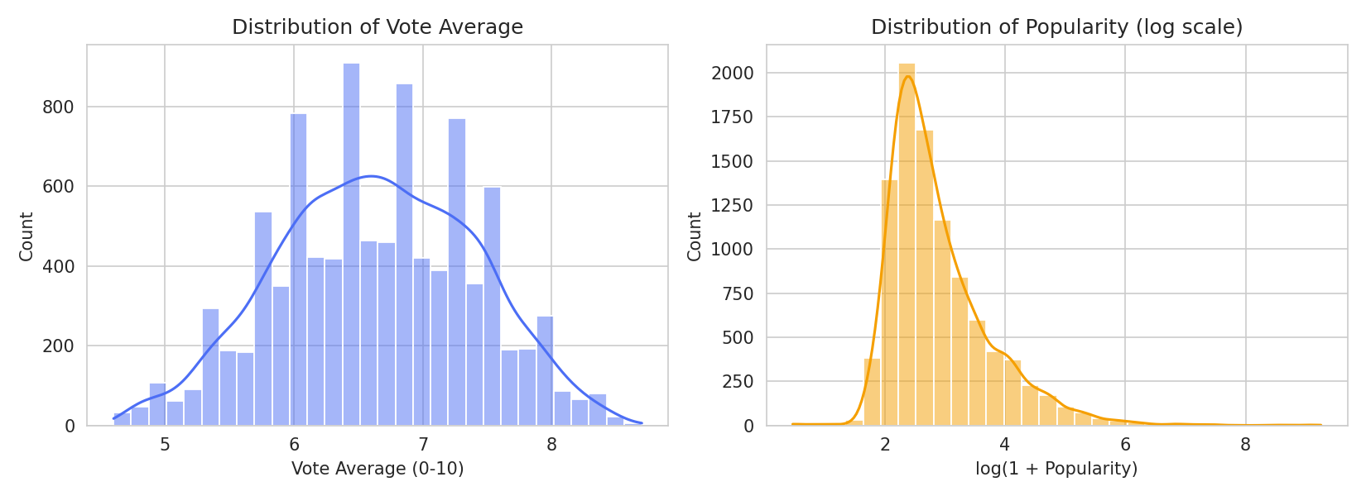
Figure 5.1: Distribution of Vote Average and (log-scaled) Popularity
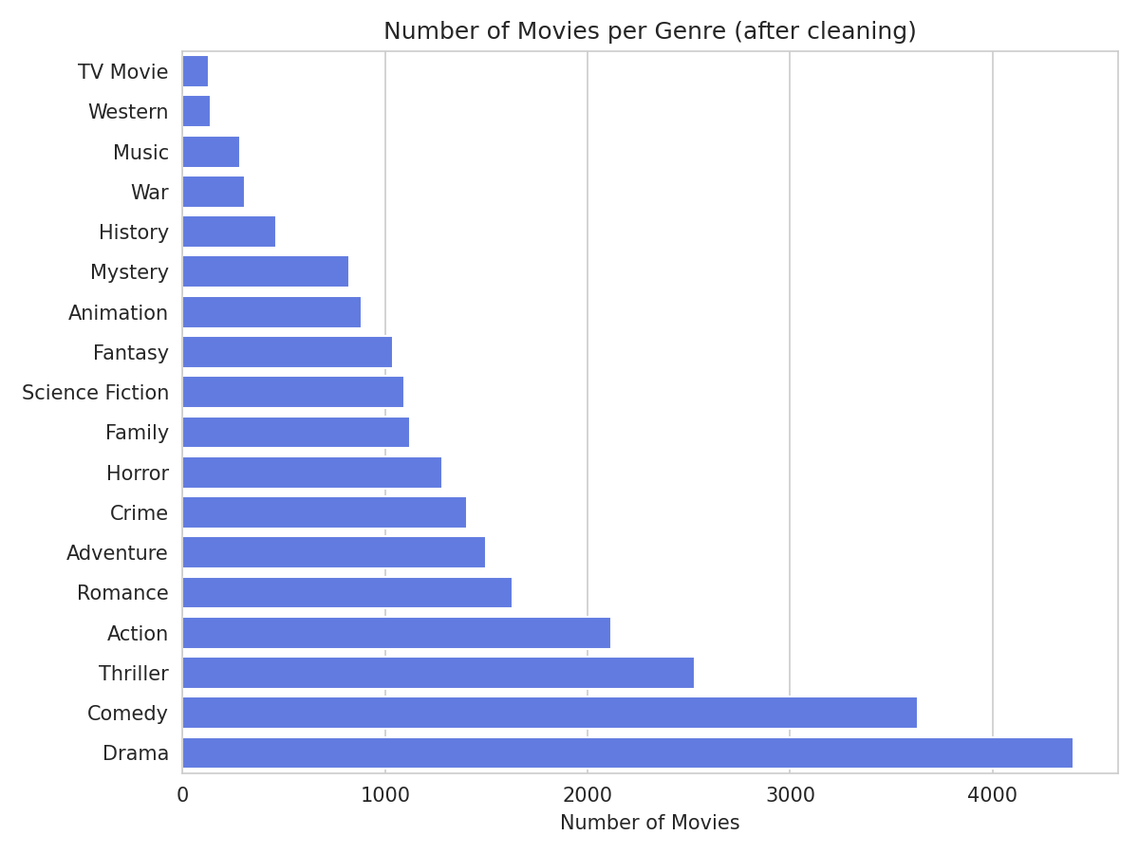
Figure 5.2: Number of Movies per Genre after Cleaning

5.3 Derived Columns
Three columns were engineered from the raw fields for use in modelling: release_year (parsed from release_date), genre_list (the genre string split into a Python list for multi-label handling), and weighted_rating (a Bayesian-adjusted rating score, detailed in Section 6.2). After these additions, the cleaned working dataframe contains 9,658 rows and 12 columns.

6. METHODOLOGY
The system was built as a staged, reproducible pipeline in a Jupyter notebook, progressing from raw data to a trained, serialised recommendation model. Each stage is described below.

6.1 Data Cleaning
The raw CSV was loaded with pandas and cleaned in the following order: (1) rows with a missing title or genre were dropped; (2) duplicate titles were removed, keeping the first occurrence; (3) missing overviews were filled with a placeholder string rather than dropped, since the field is not used in the model; (4) release_date was parsed into a datetime and a numeric release_year extracted; (5) the genre string was split on commas into a genre_list for multi-label handling; and (6) rows with a non-positive vote_average or popularity were dropped (none were found). This left a cleaned dataset of 9,658 rows.

6.2 Weighted Rating (Bayesian Average)
Ranking movies purely by vote_average is statistically unreliable for titles with very few votes. To address this, a weighted rating was computed for every movie using the same Bayesian-average formulation popularised by IMDB's “Top Rated” list:
WR = (v ÷ (v + m)) × R + (m ÷ (v + m)) × C
where R is the movie's own vote_average, v is its vote_count, C is the mean vote_average across the entire cleaned dataset, and m is a minimum-votes threshold below which a movie's own rating is proportionally pulled toward the dataset mean. In this project, C was computed as 6.636 and m was set to the 75th percentile of vote_count across the dataset, which evaluated to 1,454 votes. This formulation means a movie with very few votes is scored close to the dataset average C, while a movie with many votes (v ≫ m) is scored close to its own rating R, preventing small-sample outliers from dominating the rankings.

6.3 Feature Engineering
Each movie was represented as a numeric feature vector for use in similarity search. Genre membership was one-hot encoded using scikit-learn's MultiLabelBinarizer, producing 18 binary columns (one per distinct genre, since a movie may belong to multiple genres). Separately, the popularity and vote_average columns were scaled to the [0, 1] range using a MinMaxScaler, and each scaled column was then multiplied by a tunable weight (POPULARITY_WEIGHT = 1.5 and RATING_WEIGHT = 1.5) to control their influence relative to the 18 binary genre dimensions. The genre one-hot matrix and the two weighted numeric columns were concatenated to form the final feature matrix, of shape (9658, 20).

6.4 Model Training
A NearestNeighbors model from scikit-learn was fitted on the 20-dimensional feature matrix, using cosine distance as the similarity metric and brute-force search (metric="cosine", algorithm="brute", n_neighbors=50). Cosine distance was chosen because it measures the angle between feature vectors rather than their magnitude, which is appropriate for a feature space dominated by sparse binary genre indicators.

6.5 Recommendation Function
The core recommend_by_genre(genre, top_n, min_vote_count) function operationalises the trained model as follows: (1) an “ideal profile” query vector is constructed with a 1 in the position of the requested genre and the configured popularity/rating weights in the last two positions; (2) the trained model's kneighbors method retrieves up to 200 nearest candidates by cosine distance; (3) candidates are filtered to keep only movies actually tagged with the requested genre and with vote_count at or above a configurable threshold; and (4) the remaining candidates are sorted by weighted_rating (descending) and then popularity (descending), with the top_n results returned.

6.6 Serialisation
The cleaned dataframe, the fitted NearestNeighbors model, the fitted MinMaxScaler and MultiLabelBinarizer, the genre and feature name lists, and the configured weights were bundled into a single Python dictionary and serialised with pickle. This allows the Streamlit application (Section 7.3) to load a ready-to-use model instantly, without repeating the cleaning or training steps at runtime.

7. IMPLEMENTATION

7.1 Technology Stack
The project was implemented in Python 3.13. Data handling used pandas and NumPy; machine learning components (MultiLabelBinarizer, MinMaxScaler, NearestNeighbors, and PCA for analysis) used scikit-learn; the trained pipeline was serialised with the built-in pickle module. Exploratory visualisations were produced with Matplotlib and Seaborn. The user-facing application was built with Streamlit, using Plotly for interactive, in-app charts.

7.2 Notebook Pipeline
The modelling notebook is organised into eight clearly logged stages: (1) loading the raw CSV; (2) data cleaning; (3) computing the weighted rating; (4) building the one-hot and scaled feature matrix; (5) training the NearestNeighbors model; (6) defining the recommendation function; (7) running example recommendations for representative genres (Action, Comedy, and Animation) to sanity-check the pipeline end-to-end; and (8) serialising the final bundle for use by the Streamlit application. Each stage prints a labelled progress summary, making the notebook self-documenting and easy to re-run in full.

7.3 Streamlit Web Application (“CineMatch”)
The trained model is served through a Streamlit application styled with a custom “late-night cinema” theme (dark navy background, gold and velvet-red accents). The model bundle is loaded once via st.cache_resource so it is not reloaded on every user interaction. The sidebar (“Build Your Screening”) exposes controls for genre selection, number of results, minimum vote count, release-year range, sort order (best match, highest rated, most popular, newest, oldest), and a grid/list layout toggle.
On submission, the application calls the same recommend_by_genre function used in the notebook, applies the additional year-range filter and chosen sort order, and renders the results in two ways: an interactive Plotly scatter chart plotting rating against popularity (with marker size representing vote count and colour representing weighted rating), and a set of illustrated “movie ticket” cards showing the title, year, genre, a star rating, and a popularity bar. Each card includes an “Add to Watchlist” checkbox backed by Streamlit's session state, and the full result set can be exported as a CSV file. When no query has yet been run, the landing view instead shows a library-wide genre-distribution chart, giving the user an overview of the underlying catalogue.

8. RESULTS AND ANALYSIS

8.1 Example Recommendations
The recommendation function was validated against three representative genres. In every case, the top results are well-known, critically regarded titles for that genre, indicating that the weighted-rating correction and the genre/vote-count filters are working as intended.
Table 8.1: Top 5 recommendations for genre “Action”
Title | Year | Rating | Popularity | Weighted Rating
The Lord of the Rings: The Return of the King | 2003 | 8.5 | 134.71 | 8.373
Inception | 2010 | 8.4 | 111.76 | 8.323
The Lord of the Rings: The Fellowship of the Ring | 2001 | 8.4 | 168.45 | 8.287
The Lord of the Rings: The Two Towers | 2002 | 8.4 | 162.72 | 8.271
The Empire Strikes Back | 1980 | 8.4 | 28.32 | 8.238

Table 8.2: Top 5 recommendations for genre “Comedy”
Title | Year | Rating | Popularity | Weighted Rating
Life of Brian | 1979 | 7.8 | 17.84 | 7.462
Young Frankenstein | 1974 | 7.9 | 14.00 | 7.447
Three Men and a Leg | 1997 | 8.0 | 7.46 | 7.400
Ferris Bueller's Day Off | 1986 | 7.6 | 15.38 | 7.342
The Hangover | 2009 | 7.3 | 150.98 | 7.240

Table 8.3: Top 5 recommendations for genre “Animation”
Title | Year | Rating | Popularity | Weighted Rating
Spirited Away | 2001 | 8.5 | 92.06 | 8.314
Your Name. | 2016 | 8.5 | 158.27 | 8.238
Spider-Man: Into the Spider-Verse | 2018 | 8.4 | 118.79 | 8.202
The Lion King | 1994 | 8.3 | 204.16 | 8.158
Howl's Moving Castle | 2004 | 8.4 | 75.09 | 8.112

8.2 Rating Quality Analysis
Figure 8.1 shows the top 10 movies in the entire dataset by weighted rating. All are widely recognised, high-vote-count titles (e.g. The Shawshank Redemption, The Godfather), confirming that the Bayesian correction successfully suppresses low-vote-count outliers that might otherwise dominate a plain average-rating ranking.
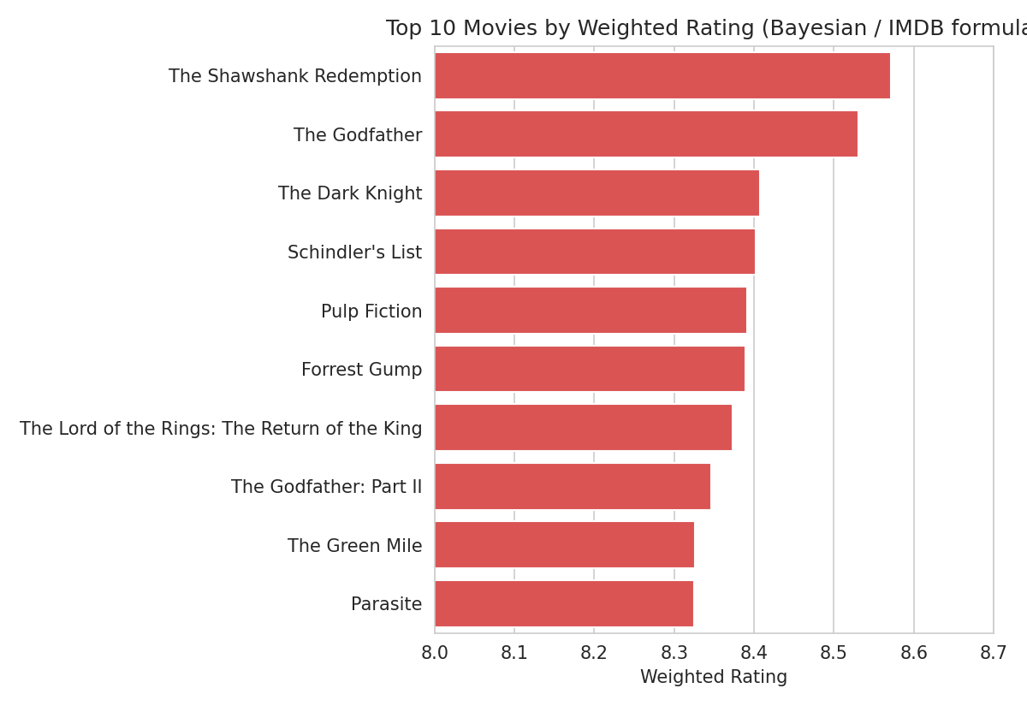
Figure 8.1: Top 10 Movies by Weighted Rating
Figure 8.2 shows the correlation between the key numeric features. As expected, weighted_rating correlates very strongly with vote_average, since it is directly derived from it. Popularity, however, shows only a weak correlation with rating, confirming that popularity and perceived quality are largely independent signals in this dataset — which justifies the design decision to include both explicitly in the feature vector and query construction, rather than assuming one implies the other.
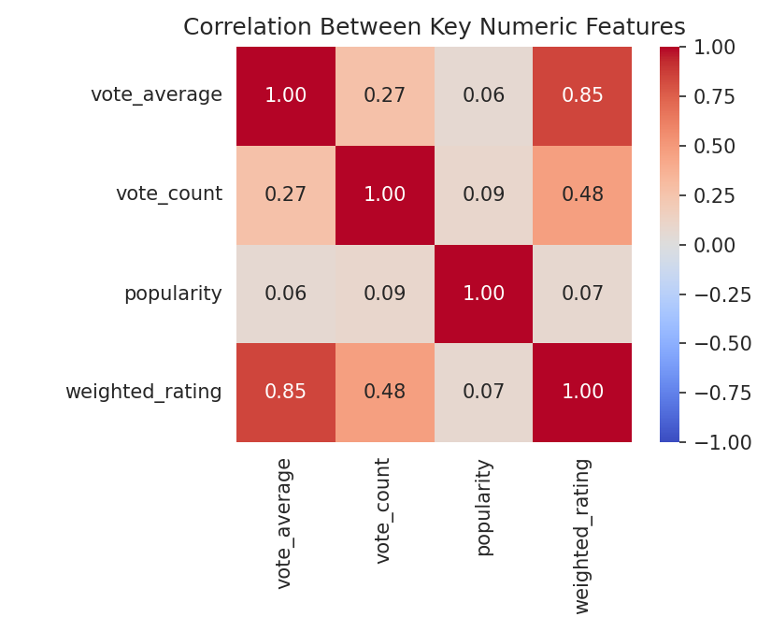
Figure 8.2: Correlation Between Key Numeric Features

8.3 Feature Space Visualisation
To validate that the trained model organises movies sensibly, the 20-dimensional feature matrix was projected to two dimensions using Principal Component Analysis (PCA). Figure 8.3 plots this projection, coloured by each movie's primary genre. Distinct genres form loosely separated regions — most visibly Animation, Horror, and Thriller — confirming that genre one-hot encoding, which occupies 18 of the 20 feature dimensions, dominates the neighbourhood structure that the KNN model searches over.
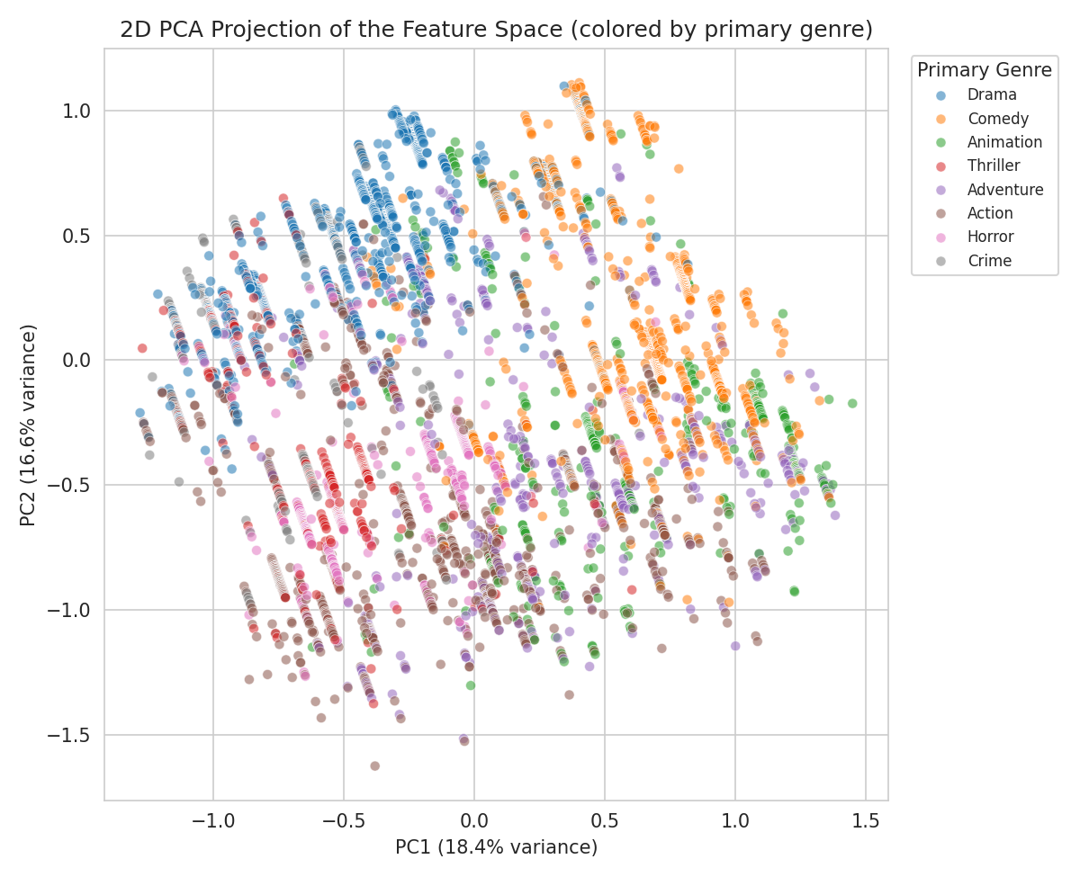
Figure 8.3: 2D PCA Projection of the Feature Space, Coloured by Primary Genre
Figure 8.4 shows the rating-versus-popularity distribution for the top 25 candidate recommendations under the “Action” genre query, mirroring the interactive chart shown in the Streamlit application. The plot shows that high-popularity and high-rating are not mutually exclusive within the filtered candidate set, and that marker size/colour (both driven by weighted_rating) allow a user to visually identify the strongest picks at a glance.
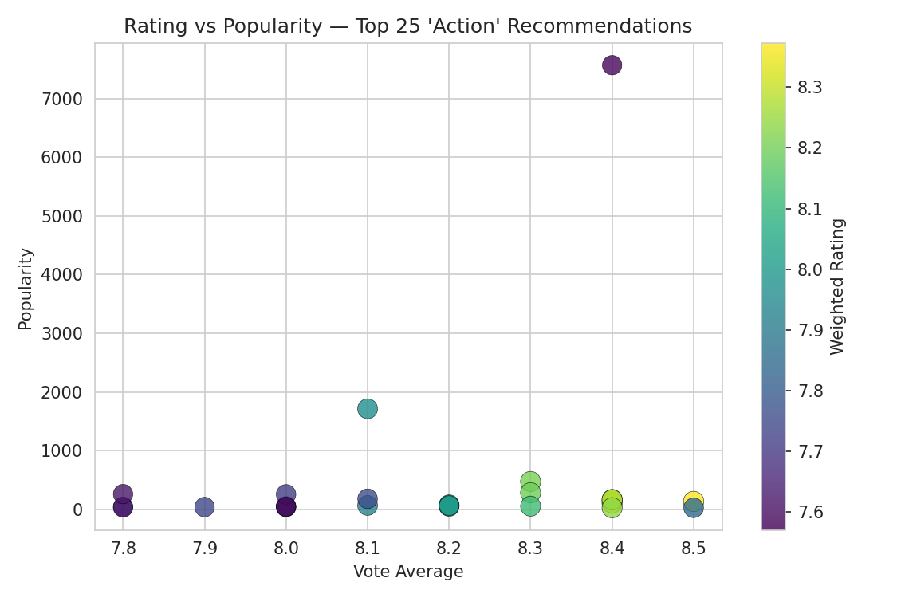
Figure 8.4: Rating vs Popularity for the Top 25 'Action' Candidates

8.4 Evaluation Approach
Because the dataset provides no user-interaction history, standard collaborative-filtering metrics such as RMSE or precision-at-k could not be computed. Instead, the system was evaluated using two proxy checks appropriate to a content-based formulation: genre consistency, which is guaranteed by construction since results are filtered to require genre membership before ranking; and qualitative rating validation, confirming that the returned titles for each genre are indeed well-regarded, high-vote-count films rather than statistical anomalies. Both checks, presented above, indicate that the pipeline behaves as intended.

9. FUTURE SCOPE
While the current system meets its stated objectives, several extensions could improve it further:
- Hybrid recommendation: once user rating or interaction logs become available, the system could be extended into a hybrid recommender combining the existing content-based model with collaborative filtering, as suggested by Adomavicius and Tuzhilin (2005).
- Clustering before search: partitioning the item space with k-means clustering prior to nearest-neighbour search, as explored by Ahuja, Solanki, and Nayyar (2019), could reduce query latency as the catalogue grows beyond the current ~9,700 titles.
- Richer content features: incorporating cast, director, keywords, or plot-overview embeddings (via TF-IDF or sentence embeddings) would allow finer-grained similarity beyond genre alone.
- Formal offline evaluation: introducing a genre-holdout or precision@k evaluation protocol once any interaction data is available, to complement the qualitative checks used in this report.
- Similarity search by movie: exposing a “movies similar to X” query using the already-fitted scaler and encoder, rather than only genre-based querying.
- Persistent user accounts: extending the current session-based watchlist into an account-backed feature that persists across visits, and deploying the application to a public host.

10. REFERENCES
[1] Adomavicius, G., & Tuzhilin, A. (2005). Toward the next generation of recommender systems: A survey of the state-of-the-art and possible extensions. IEEE Transactions on Knowledge and Data Engineering, 17(6), 734–749.
[2] Delimayanti, M. K., Laya, M., Warsuta, B., Faydhurrahman, M. B., Khairuddin, M. A., Ghoyati, H., & Naryanto, R. F. (2022). Web-based movie recommendation system using content-based filtering and KNN algorithm. Proceedings of the 2022 9th International Conference on Information Technology, Computer, and Electrical Engineering (ICITACEE), 314–318.
[3] Ahuja, R., Solanki, A., & Nayyar, A. (2019). Movie recommender system using K-means clustering and K-nearest neighbour. Proceedings of the 9th International Conference on Cloud Computing, Data Science & Engineering (Confluence).
[4] Badugu, S., & Manivannan, R. K-nearest neighbor and collaborative filtering-based movie recommendation system. In Inventive Computation and Information Technologies, Lecture Notes in Networks and Systems, Vol. 141. Springer, Singapore.
[5] Pedregosa, F., Varoquaux, G., Gramfort, A., Michel, V., Thirion, B., Grisel, O., et al. (2011). Scikit-learn: Machine learning in Python. Journal of Machine Learning Research, 12, 2825–2830.
[6] The Movie Database (TMDB). Top 10,000 Popular Movies dataset. Retrieved from Kaggle (kaggle.com).
[7] Streamlit Inc. Streamlit documentation. Retrieved from https://docs.streamlit.io
[8] Plotly Technologies Inc. Plotly Python graphing library documentation. Retrieved from https://plotly.com/python/

