**ONLINE SHOPPING**

**By**

**PRIYANKA KHUNE  
(BSC COMPUTER SCIENSE)**

**ABSTRACT**

The Online Shopping is a web based application intended for online retailers. The main  
objective of this application is to make it interactive and its ease of use. It would make  
searching, viewing and selection of a product easier.

Shopping has long been considered a recreational activity by many. Shopping online is no exception. The goal of this application is to develop a web based interface for online retailers. The system would be easy to use and hence make the shopping experience pleasant for the users.

**Hardware Specification**

AMD E2-7110 APU WITH AMD RADEON R2 GRAPHICS  
3.46B RAM  
64BIT OS

**SOFTWARE Specification**

OPERATING ENVIORNMENT Win 10

**Testing:**

Testing Software testing is a process of running with intent of finding errors in software. Software testing assures the quality of software and represents final review of other phases of software like specification, design, code generation etc.

**Use case diagram**

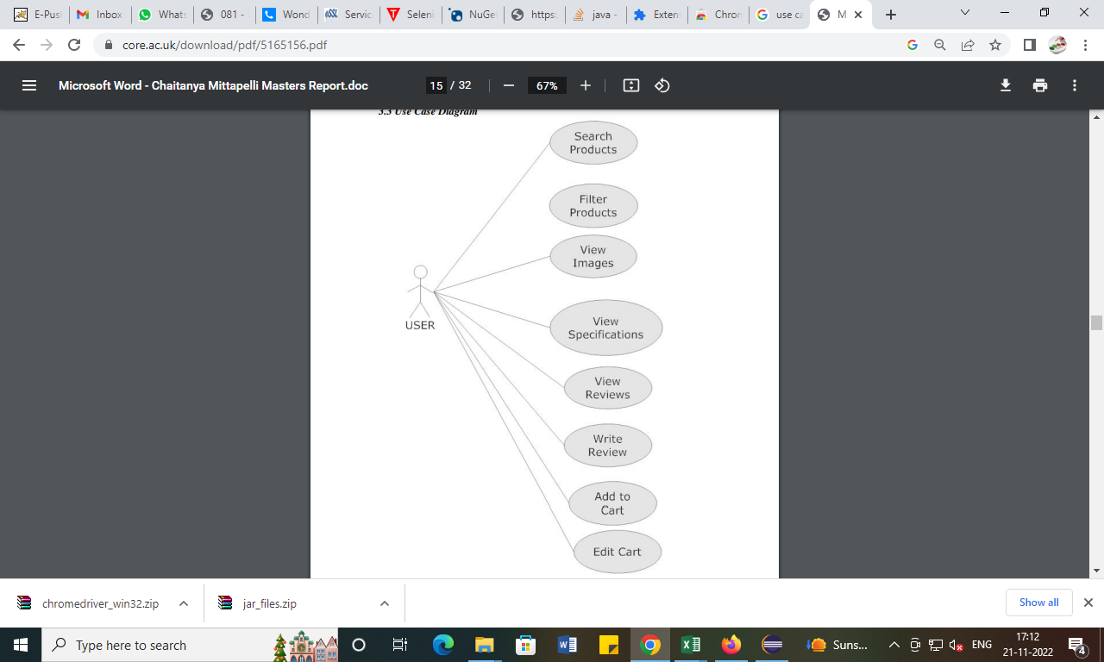

Test script  
package project;

import org.openqa.selenium.By;

import org.openqa.selenium.JavascriptExecutor;

import org.openqa.selenium.WebDriver;

import org.openqa.selenium.chrome.ChromeDriver;

public class Amazon {

public static void main(String[] args) {

// declaration and instantiation of objects/variables

System.setProperty("webdriver.chrome.driver","C:\\Users\\abc\\Downloads\\chromedriver_win32_Support108\\chromedriver.exe");

WebDriver driver=new ChromeDriver();

JavascriptExecutor js = (JavascriptExecutor) driver;

// Launch website

driver.navigate().to("https://www.amazon.in/");

//Maximize window

driver.manage().window().maximize();

// Click on the search text box and send value and click search

driver.findElement(By.id("twotabsearchtextbox")).sendKeys("smart watch");

driver.findElement(By.id("nav-search-submit-button")).click();

// This will scroll down the page by 500 pixel vertical

js.executeScript("window.scrollBy(0,500)");

// Click on filter product by Brand

driver.findElement(By.id("low-price")).sendKeys("1000");

driver.findElement(By.id("high-price")).sendKeys("3000");

driver.findElement(By.id("a-autoid-1")).click();

// This will scroll down the page by 1000 pixel vertical

js.executeScript("window.scrollBy(0,1000)");

driver.findElement(By.className("a-size-medium a-color-base a-text-normal")).click();

}

}