

A Project

Report On

Automation testing using maven on New demo tour website

**By**

**Rohini Thakare**

**Batch- EON(2020-5187)**

**Under the Guidance of,**

**Priyanka Desle**

**(Technical Trainer)**

**EduBridge**

**Introduction:-**

This Project is on to check the functionality of new Demo tour Website.

**Software Requirements**

Operating System :- Window 10

Browser:- Latest version of Google Chrome

IDE :- Eclipse IDE

Front-end:- Java & Maven

TC01- Launch the browser and open New Demo Tour Website.

WebDriverManager.*chromedriver*().browserPath("89.0.4389.82").setup();

WebDriverManager.*chromedriver*().setup()

WebDriver w= **new** ChromeDriver();

w.get("http://demo.guru99.com/test/newtours/");

TC02- To test the functionality of Register Page of New Demo Tour Website.

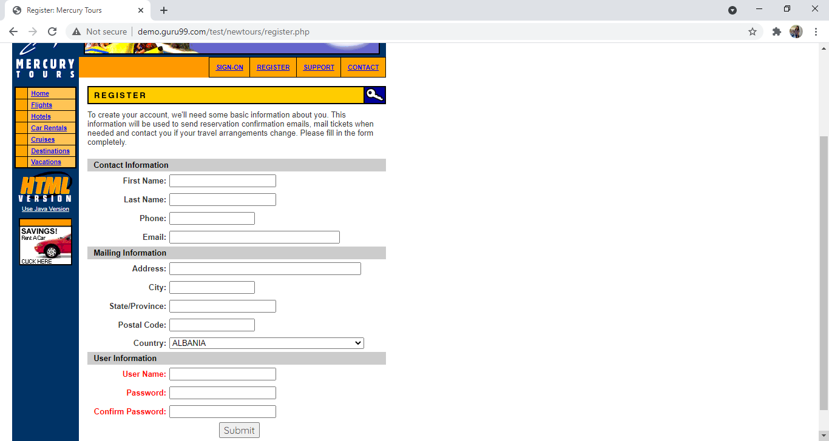

w.get("http://demo.guru99.com/test/newtours/register.php");

w.findElement(By.*linkText*("REGISTER")).click();

w.findElement(By.*name*("firstName")).sendKeys("Rohini");

w.findElement(By.*name*("lastName")).sendKeys("Thakare");

w.findElement(By.*name*("phone")).sendKeys("123456");

w.findElement(By.*id*("userName")).sendKeys("rohini@gmail.com");

w.findElement(By.*name*("address1")).sendKeys("abcd");

w.findElement(By.*name*("city")).sendKeys("Chandrapur");

w.findElement(By.*name*("state")).sendKeys("MH");

w.findElement(By.*name*("postalCode")).sendKeys("442401");

Select s= **new** Select(w.findElement(By.*name*("country")));

s.selectByValue("INDIA");

w.findElement(By.*id*("email")).sendKeys("rohini@gmail.com");

w.findElement(By.*name*("password")).sendKeys("1234");

w.findElement(By.*name*("confirmPassword")).sendKeys("1234");

w.findElement(By.*name*("submit")).click();

TC03- To Test the functionality of login button with valid username and valid password.

//UserName-Rohini

//Password-rohini

w.findElement(By.*name*("userName")).sendKeys("Rohini");

w.findElement(By.*name*("password")).sendKeys("rohini");

w.findElement(By.*name*("submit")).click();

TC04- For login Successful take a screenshot.

TakesScreenshot t= (TakesScreenshot) w;

File src= t.getScreenshotAs(OutputType.***FILE***);

Files.*copy*(src,**new** File("C:\\Users\\VAIBHAV\\Desktop\\ScreenShot_Floder\\p6.png"));

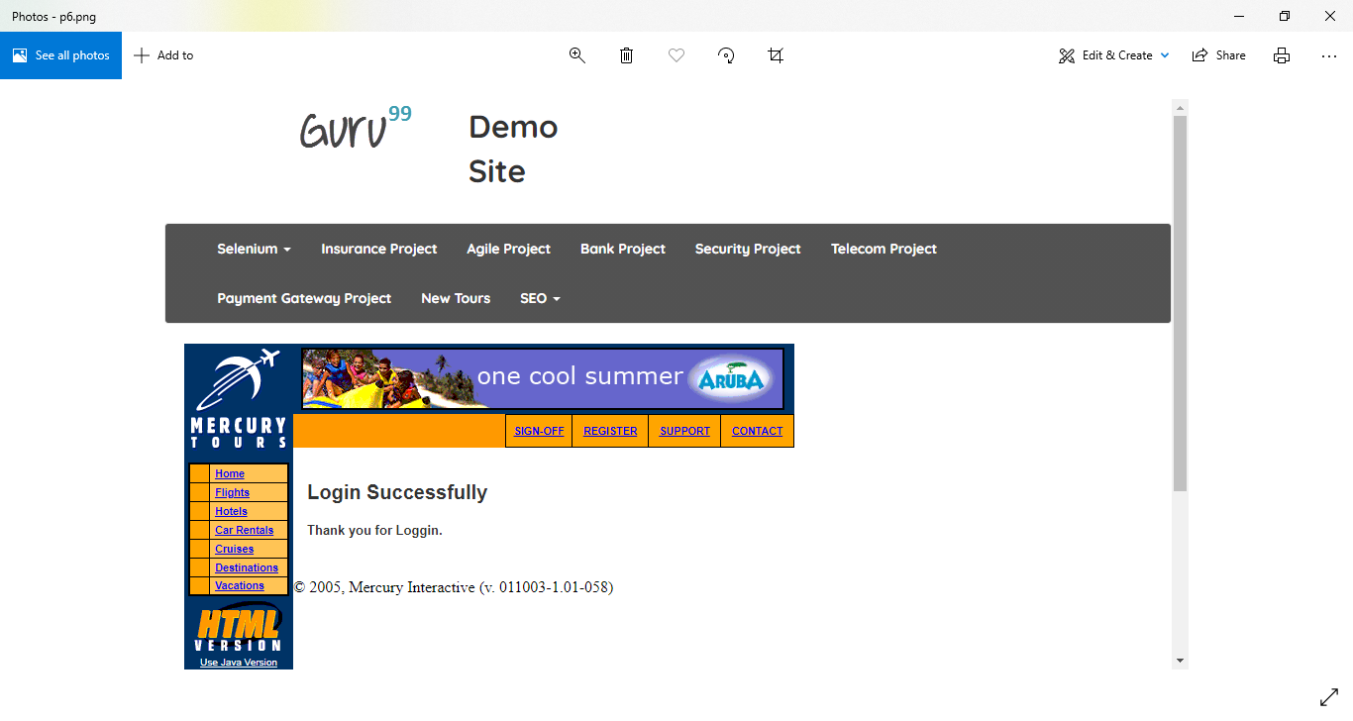

TC04- To check different link available on new demo tour website page.

w.findElement(By.*linkText*("Home")).click();

w.findElement(By.*linkText*("Flights")).click();

w.findElement(By.*name*("tripType")).click();

Select s1= **new** Select(w.findElement(By.*name*("passCount")));

s1.selectByVisibleText("2");

Select s2= **new** Select(w.findElement(By.*name*("fromPort")));

s2.selectByVisibleText("London");

Select s3= **new** Select(w.findElement(By.*name*("fromMonth")) s3.selectByVisibleText("May");

Select s4= **new** Select(w.findElement(By.*name*("fromDay")));

s4.selectByVisibleText("1");

Select s5= **new** Select(w.findElement(By.*name*("toPort")));

s5.selectByVisibleText("Seattle");

Select s6= **new** Select(w.findElement(By.*name*("toMonth")));

s6.selectByVisibleText("June"); w.findElement(By.*name*("servClass")).click();

Select s7= **new** Select(w.findElement(By.*name*("airline")));

s7.selectByVisibleText("Blue Skies Airlines");

w.findElement(By.*name*("findFlights")).click();

w.findElement(By.*linkText*("Home")).click();

w.findElement(By.*linkText*("Hotels")).click();

w.navigate().to("http://demo.guru99.com/test/newtours/");

w.findElement(By.*linkText*("Car Rentals")).click();

w.findElement(By.*linkText*("Home")).click();

w.findElement(By.*linkText*("Cruises")).click();

w.findElement(By.*linkText*("Destinations")).click();

w.findElement(By.*linkText*("Home")).click();

w.findElement(By.*linkText*("Vacations")).click();

TC05- To test the functionality of selenium dropdown login button with valid data.

[Emailaddress-rohini@gmail.com](mailto:Emailaddress-rohini@gmail.com)

Password-1234

w.findElement(By.*className*("dropdown-toggle")).click();

w.findElement(By.*linkText*("Login")).click();

JavascriptExecutor js= (JavascriptExecutor) w;

js.executeScript("arguments[0].value='rohini@gmail.com'", w.findElement(By.*id*("email")));

js.executeScript("arguments[0].value='1234'", w.findElement(By.*id*("passwd")));

w.findElement(By.*id*("SubmitLogin")).click();

w.navigate().back();

TC06- To Check Whether the title of login page matched or not

**if**(w.getTitle().equals("Welcome: Mercury Tours"))

{

w.findElement(By.*name*("userName")).sendKeys("Rohini");

w.findElement(By.*name*("password")).sendKeys("rohini");

w.findElement(By.*name*("submit")).click();

System.***out***.println("Login Successfully Done");

}

**else**

{

System.***out***.println("Login Failed");

}

Pom.xml File

<project xmlns=*"http://maven.apache.org/POM/4.0.0"* xmlns:xsi=*"http://www.w3.org/2001/XMLSchema-instance"* xsi:schemaLocation=*"http://maven.apache.org/POM/4.0.0 http://maven.apache.org/xsd/maven-4.0.0.xsd"*>

<modelVersion>4.0.0</modelVersion>

<groupId>101</groupId>

<artifactId>New_Demo_Tour2</artifactId>

<version>0.0.1-SNAPSHOT</version>

<dependencies>

<dependency>

<groupId>org.seleniumhq.selenium</groupId>

<artifactId>selenium-java</artifactId>

<version>3.141.5</version>

</dependency>

<dependency>

<groupId>org.seleniumhq.selenium</groupId>

<artifactId>selenium-firefox-driver</artifactId>

<version>3.141.5</version>

</dependency>

<dependency>

<groupId>org.seleniumhq.selenium</groupId>

<artifactId>selenium-chrome-driver</artifactId>

<version>3.141.5</version>

</dependency>

<dependency>

<groupId>org.apache.poi</groupId>

<artifactId>poi</artifactId>

<version>5.0.0</version>

</dependency>

<dependency>

<groupId>org.apache.poi</groupId>

<artifactId>poi</artifactId>

<version>3.14</version>

</dependency>

<dependency>

<groupId>io.github.bonigarcia</groupId>

<artifactId>webdrivermanager</artifactId>

<version>3.7.1</version>

</dependency>

<dependency>

<groupId>commons-io</groupId>

<artifactId>commons-io</artifactId>

<version>2.8.0</version>

</dependency>

</dependencies>

</project>