SMART GRID

13) b) Phasor measurement

A phasor measurement unit (PMU) or synchrophasor is a device which measures the electrical waves on an electricity grid, using a common time source for synchronization. A PMU can measure 50/60 Hz AC waveforms (voltages and currents) typically at a rate of 48 samples per cycle (2880 samples per second for 60Hz systems). The analog AC waveforms are digitized by an Analog to Digital converter for each phase.

PMU-Phasor measurement unit consists of  an Anti Aliasing Filter,A/D Converter,GPS unit,PLL oscillator, Microprocessor unit,Modem- Transmitter etc. checkout the block diagram of PMU. For the sampled analog input signals, it estimate the states out of it and time signals are tagged.The time stamp is an 8-byte message consisting of a 4 byte S.O.Cand a 3 byte FoS and a 1 byte time quality indicator as per  IEEEC37.118 /IEEE C37.224

Through an Remote terminal unit informations are exchanged to Station PMU's later ThroughTCP/IP Protocols the communication is held. The data get stored  for further processing at PDC .

In general, a PMU measures the electrical waves using GPS for time synchronisation. The devices are installed at the begin as well as the end of a line and send both signals to a Wide Area Measurement System (WAMS). The WAMS compares the signals and determines the phase difference. So it is possible to determine the complex voltage vector respectively the system state.  
  
PMU  is consists of filters,Analog to digital converters,Receivers,PLL.Usually it measures waves and all the mesurements are synchronised and time stamped.Calculates signal magnitude and angle called phasor.Usually an unknown signal passes through filters ,converters and then estimators and receivers and during the process,PMU configuration is able to extract the above said informations.  
  
A **phasor measurement unit** (PMU) is a device used to estimate the magnitude and phase angle of an electrical Phasor quantity like voltage or current in the electricity grid using a common time source for synchronization. Time synchronization is usually provided by GPS and allows synchronized real-time measurements of multiple remote measurement points on the grid. PMUs are capable of capturing samples from a waveform in quick succession and reconstruct the Phasor quantity. The resulting measurement is known as a **synchrophasor**. These devices can also be used to measure the frequency in the power grid. A typical commercial PMU can report measurements with very high temporal resolution in the order of 30-60 measurements per second. This helps engineers in analyzing dynamic events in the grid which is not possible with traditional SCADA measurements that generate one measurement every 2 or 4 seconds. Therefore, PMUs equip utilities with enhanced monitoring and control capabilities and are considered to be one of the most important measuring devices in the future of power systems. A PMU can be a dedicated device, or the PMU function can be incorporated into a protective relay or other device.

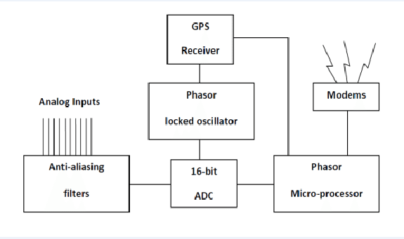

14)a) load flow for smart grid

Smart Grid technologies hold the promise of being able to solve many of the problems currently facing in the electric power industry. However, the large scale deployment of these new technologies has been limited due to an inability to accurately model their effects or to quantify their potential benefits. GridLAB-D is a new open source power system modeling and simulation environment developed by the United States Department of Energy specifically to integrate detailed power systems and end-use models. In order to effectively model the vast array of possible smart grid technologies GridLAB-D was developed as a general simulation environment. This paper describes the basic design concept, the power flow solutions implemented, and a detailed example of the type of analysis that can be performed within the simulation environment in order to support the evaluation of smart grid technologies.

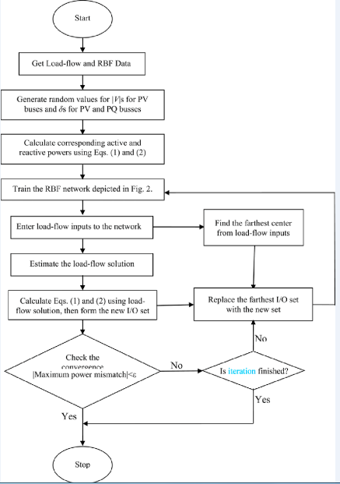

15)a) flowchat for voltage sability

Simple and unordered synchronisation of multiple distributed generation networks

may result in voltage distortion and voltage fluctuation which cause the system

unstable [141]. The reliability and stability of the normal or a weak power system can

be improved by reasonable control strategy. Here, the main objective is coordination

control of reactive power output of generators and other compensator considering

transient status. The multi agent system will be utilized as the main structure of

the desired scheme, where each agent has the computation module of the algorithm.

Chapter 5 presents a framework for voltage stability assessment using Partial

PMU Measurements. It is fact that the aim of voltage stability studies is to avoid

voltage collapse and recovery from transient, thus assessment and monitoring is the

first step. Future work will adapt the control method proposed in Chapter 4 that

voltage stability can be enhanced by using partial PMU measurements. Besides,

transient status will be taken into account.

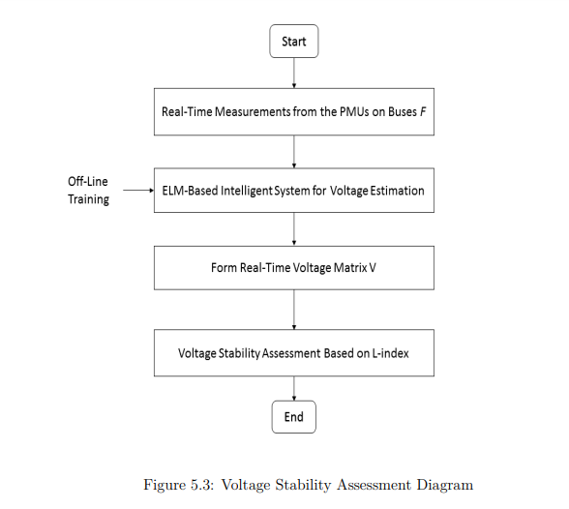

Extreme learning machine (ELM) is introduced in voltage stability assessment. As

a learning algorithm for single-hidden layer feedforward neural network, ELM randomly selects weights and biases for hidden nodes, and analytically determines the

output weights by finding least square solution. The ELM-based method not only

provides much faster on-line state estimation speed, but also outperforms the conventional methods for its less data requirement thus making it an ideal candidate

for future smart grid applications.

By learning from a PMU measurements database, the non-linear relationship

between the measurements from PMU installed buses (input) and the parameters of

buses without PMUs (output) can be extracted and reformulated in a ELM. During

the on-line application phase, the systems stability can be assessed as soon as the

input is available.ELM model should firstly be well trained. A voltage database is required. It can be obtained from power flow results by using Newton-Raphson method based on different load

levels. After the model training is complete, it can be applied on-line. This ELM

model is intended to be implemented at a central location like a data concentrator. The voltages are obtained from installed PMUs and send to the concentrator, the

voltages of buses without PMUs will be estimated rapidly. In this way, the full

voltage matrix V can be formed. Thereafter, a L-index value is obtained from

L-index calculation, it indicates the voltage stability at the present operating time.

16)a)PHEV

16)a)PHEV

**Definition:**

A plug in hybrid electric vehicle (PHEV) is a hybrid electric vehicle with the ability to recharge its energy storage with electricity from an off-board power source such as a grid.

A plug in hybrid electric vehicle (PHEV) is a hybrid electric vehicle with the ability to recharge its energy storage with electricity from an off-board power source such as a grid. PHEVs have the potential to displace a significant amount of fuel in the next 10 to 20 years. It is estimated that they can reduce fuel consumption by up to 45% relative to that of a comparable combustion engine vehicle. However, the PHEV technique is still expensive compared to techniques which improve internal combustion engines, and additional infrastructure investments are needed for the recharging infrastructure. Moreover, the lifespan of the batteries has not been established, yet, for these types of vehicles.

A plug in hybrid electric vehicle (PHEV) is a hybrid electric vehicle with the ability to recharge its energy storage with electricity from an off-board power source such as a grid. (Pesaran et.al, 2009) The PHEV can run either on its Internal Combustion Engine (ICE) or on its battery.

A full electric vehicle uses its energy far more efficiently than a vehicle with an Internal Combustion Engine (ICE) and can drive about 2.5 times further with the same energy. For this reason it is expected that the electric vehicle will replace the ICE vehicle in the long run. However, in the coming 20 years or so vehicles will probably still be equipped with IC engines, possibly in combination with electric engines, because per unit of weight an ICE vehicle can still drive about 40 times further. In this 20 year period the IC engine is expected to improve substantially (Sharpe et al. 2009).

The key advantage of PHEV technology relative to full Battery Electric Vehicles (BEV) is the fuel flexibility. PHEVs have no limitation of the driving range and if the recharging infrastructure is spatially or temporally unavailable, it doesn’t restrict the use of the vehicle. A possible drawback of the PHEV is that it contains two systems to propel the vehicle, making it more costly to build than a BEV. However, the car manufacturing industry expects that PHEVs will be introduced to the market first, and that the switch to BEV could be made when the PHEVs are found to be economically and technological viable. (Gilijamse,2009).

A main problem of the usage of PHEVs is the space required for the battery and the mass increase of the vehicle due to the batteries. However, for most commuters a relatively small 40 kilometer battery package will be sufficient to travel to work and back. The batteries can be recharged at night when the electricity demand is low.

The mass and volume of a 15 kilometer (the maximum distance it can drive electrically) battery is about 60 kg and 40 liters. The mass and volume of a 40 kilometer battery is about 120 kg and 80 liters. (Pesaran et al. 2009) In contrast, full electric vehicles need battery packages of more than 500 kg to obtain an action radius of about 160 kilometers.

To make the widespread use of PHEVs feasible, an infrastructure of recharging stations is needed. This infrastructure needs to be standardized in way that every brand of Plug-in Hybrid Electric Vehicle can be recharged at every recharging station.

Batteries need to improve in a numbers of aspects – durability, life-expectancy, energy density, power density, temperature sensitivity, reductions in recharge time, and reductions in cost. Battery durability and life-expectancy are probably the biggest hurdles technically to mass commercial viability of EVs and PHEVs (IEA, 2011).

New battery chemistries with increased energy densities will enable important changes to battery design. Energy storage systems will require less active material, fewer cells, and less cell and module hardware. These advancements will result in lighter, smaller and cheaper batteries and hence EVs and PHEVs (IEA, 2011).

Plug-in hybrid vehicles (PHEVs) have the potential to displace a significant amount of fuel in the next 10 to 20 years. The main barriers to the commercialization of PHEVs are the cost, weight, safety, volume and lifespan (combined shallow/deep cycle life and calendar life) of the batteries. It is expected that more and more car manufactures will bring plug in vehicles to the market in the coming years.

PHEVs are potentially an important technology for reducing fossil fuel consumption and CO2 emissions. Globally PHEVs could satisfy a large proportion of daily driving demand. In the UK, for example, 97% of trips are estimated to be below 80 km, in Europe 50% of trips are less than 10 km and 80% less than 25 km, and in the U.S. 60% of trips are less than 50 km and 85% less than 100 km. However, there is only a handful of demonstration projects of PHEVs worldwide and no manufacturer produces PHEVs on a commercial scale yet meaning market penetration is almost zero.

