Worksheet 1.1

Student Name:Priyanka Chandwani UID:25MCI10122
Branch:MCA (AI&ML) Section/Group:1/A
Semester:2nd Date of Performance:13/01/2026
Subject Name:- Technical Training Subject Code:25CAP-652

1. Aim of the Session

To design and implement a sample database system using DDL, DML, and DCL commands for managing departments, employees, and projects, and to apply role-based access control for secure data handling.

2. Software Requirements
- PostgreSQL (Database Server)
- pgAdmin
- Windows Operating System

3. Objective of the Session

After completing this practical, the student will be able to:
- Understand the use of DDL commands to create and modify database structures.
- Perform DML operations such as INSERT, UPDATE, DELETE, and SELECT.
- Implement relationships using primary and foreign keys.
- Apply DCL commands to manage roles and privileges.
- Analyze input and output of SQL queries in a real database environment.

4. Practical / Experiment Steps

Design the database schema for Department, Employee, and Project tables.

Create tables using appropriate constraints.

Insert sample records into tables.

Perform update and delete operations.

Retrieve data using SELECT queries.

Create a role and grant/revoke privileges.

Alter and drop database objects.

5. Procedure of the Practical

(i) Start the system and log in to the computer.

(ii) Open PostgreSQL software.

(iii) create database CompanyDB;

(iv) Create tables using DDL commands.

(i) create table Department

CREATE TABLE Department (

dept_id INT PRIMARY KEY,

dept_name VARCHAR(50) NOT NULL UNIQUE,

location VARCHAR(50) NOT NULL

);

(ii) create table Employee

CREATE TABLE Employee (

emp_id INT PRIMARY KEY,

emp_name VARCHAR(50) NOT NULL,

email VARCHAR(100) NOT NULL UNIQUE,

salary DECIMAL(10,2) NOT NULL,

hire_date DATE NOT NULL,

dept_id INT NOT NULL,

CONSTRAINT fk_emp_dept

FOREIGN KEY (dept_id)

REFERENCES Department(dept_id),

CONSTRAINT chk_salary

CHECK (salary >= 10000)

); (iii) create table Project

CREATE TABLE Project (

proj_id INT PRIMARY KEY,

proj_name VARCHAR(100) NOT NULL UNIQUE,

start_date DATE NOT NULL,

end_date DATE,

dept_id INT NOT NULL,

CONSTRAINT fk_proj_dept

FOREIGN KEY (dept_id)

REFERENCES Department(dept_id),

CONSTRAINT chk_dates

CHECK (end_date IS NULL OR end_date >= start_date)

);

(iv) Insert records using DML commands.

insert into Department values

INSERT INTO Department (dept_id, dept_name, location) VALUES

(10, 'HR','Head Office'),

(20, 'IT','Head Office'),

(30, 'Finance','Branch A');

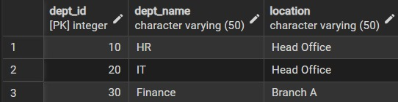

(v) insert into Employee values

INSERT INTO Employee (emp_id, emp_name, email, salary, hire_date, dept_id) VALUES

(1, 'Amit Kumar', 'amitkumar@gmail.com', 35000, '2023-04-10', 20),

(2, 'Priyanka chandwani', 'priyanka@gmail.com', 45000, '2022-11-01', 30),

(3, 'Rohit Singh', 'rohitsingh@gmail.com', 30000, '2024-02-15', 10);

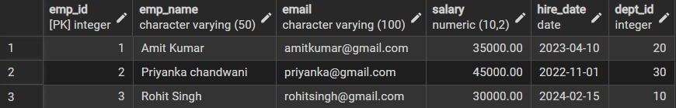

(vi) insert into Project values

INSERT INTO Project (proj_id, proj_name, start_date, end_date, dept_id) VALUES

(101, 'Payroll System', '2024-01-01', NULL, 30),

(102, 'Intranet Upgrade', '2024-03-01', '2024-09-30',20),

(103, 'Recruitment Portal', '2024-05-15', NULL, 10);

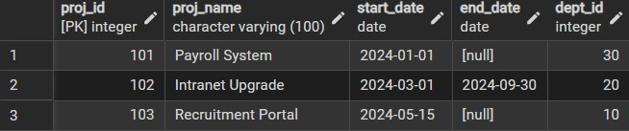

(vii) Update and delete records.

UPDATE Employee

SET salary = salary * 1.10

WHERE dept_id = 20;

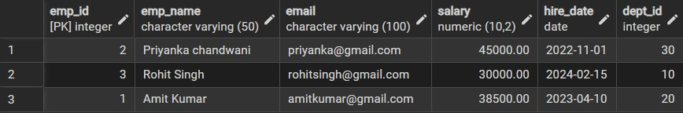

DELETE FROM Employee

WHERE dept_id = 10;

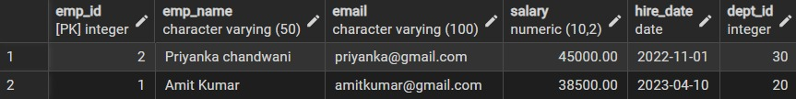

(viii) Create role and assign privileges.

CREATE USER manager WITH PASSWORD 'manager@123';

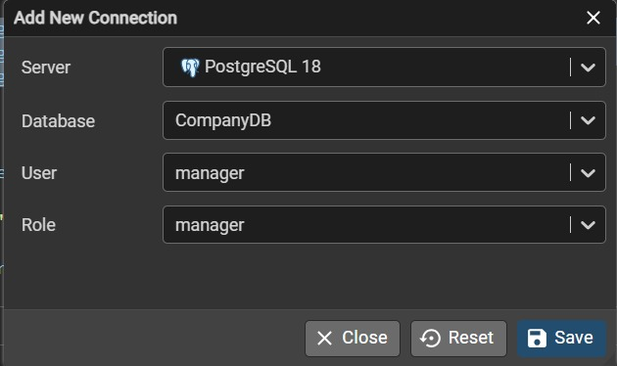

GRANT SELECT ON Department TO manager;

GRANT SELECT ON Employee TO manager;

GRANT SELECT ON Project TO manager;

REVOKE CREATE ON SCHEMA public FROM manager;

REVOKE INSERT, UPDATE, DELETE ON ALL TABLES IN SCHEMA public FROM manager;

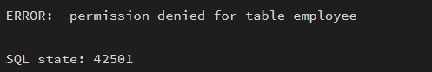

SELECT * FROM Department;

SELECT * FROM Employee;

SELECT * FROM Project;

(ix) Alter and drop table.

ALTER TABLE Employee

ADD phone_no VARCHAR(15);

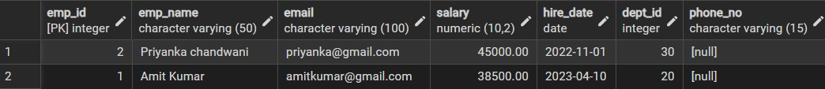

(x) drop table Project;

DROP TABLE Project

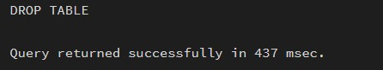

6. I/O Analysis (Input / Output)

Input:

• Department, Employee, and Project table creation queries
• Records inserted into all tables using INSERT commands
• Update query to modify employee department
• Delete queries to remove project and employee records
• Role creation and privilege assignment queries
• ALTER and DROP table commands

Output:

• Department, Employee, and Project tables created successfully
• Records inserted, updated, and deleted correctly
• Referential integrity maintained between tables
• Data displayed correctly using SELECT queries
• Role-based access verified using GRANT and REVOKE
• Table structure modified and project table dropped successfully

Screenshots of execution and obtained results are attached.

7.Learning Outcomes
- Understood the basics of relational database design using tables, keys, and relationships.
- Learned to apply primary and foreign key constraints to maintain data integrity.
- Gained hands-on experience with INSERT, UPDATE, and DELETE operations.
- Understood role-based access control using GRANT and REVOKE.
- Learned how to create read-only users for secure data access.
- Practiced ALTER TABLE and DROP TABLE commands for schema management.

