Student Name : Priyanka Chandwani UID: 25MCI10122
Branch : MCA (AI & ML) Section/Group : 25MAM-1-A Semester : 2nd Date of Performance: 24.02.2026
Subject Name : Technical Training Subject Code : 25CAP-652

Experiment 6:
Experiment Aim: Learn how to create, query, and manage views in SQL to simplify database queries and provide a layer of abstraction for end-users. (Company Tags: Amazon, Zoho, ServiceNow)
Tools used: PostgreSQL

Objectives
- Data Abstraction: To understand how to hide complex table joins and calculations behind a simple virtual table interface.
- Enhanced Security: To learn how to restrict user access to sensitive columns by providing views instead of direct table access.
- Query Simplification: To master the creation of views that pre-join multiple tables, making reporting easier for non-technical users.
- View Management: To understand the syntax for creating, altering, and dropping views, as well as the naming conventions required for efficient data access.

Experiment Steps:

Table Creation and Data Storing-

CREATE TABLE Departments (
DeptID INT PRIMARY KEY,
DeptName VARCHAR(50)
);

CREATE TABLE Employees (
EmpID INT PRIMARY KEY,
EmpName VARCHAR(50),
DeptID INT,
Salary NUMERIC(10,2),
Status VARCHAR(10),
FOREIGN KEY (DeptID) REFERENCES Departments(DeptID)
);

INSERT INTO Departments VALUES
(1,'IT'),
(2,'HR'),
(3,'Finance');

INSERT INTO Employees VALUES
(101,'Amit',1,50000,'Active'),
(102,'Neha',2,45000,'Inactive'),
(103,'Rahul',1,60000,'Active'),
(104,'Pooja',3,70000,'Active');

select * from Departments;
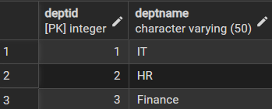

select * from Employees;

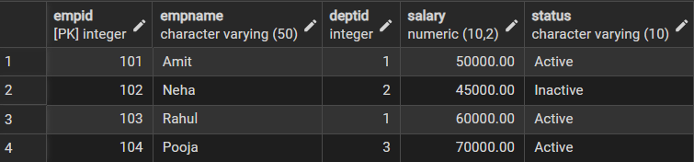
Step 1: Creating a Simple View for Data Filtering
Implementing a view to provide a quick list of active employees without exposing the entire table structure.

CREATE VIEW ActiveEmployees AS
SELECT EmpID, EmpName, DeptID, Salary
FROM Employees
WHERE Status = 'Active';

select * from ActiveEmployees;
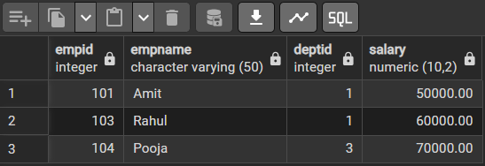

Step 2: Creating a View for Joining Multiple Tables
Simplifying the retrieval of data distributed across Employees and Departments tables.

CREATE VIEW EmpDeptView AS
SELECT
e.EmpID,
e.EmpName,
d.DeptName,
e.Salary
FROM Employees e
JOIN Departments d ON e.DeptID = d.DeptID;

SELECT * FROM EmpDeptView;
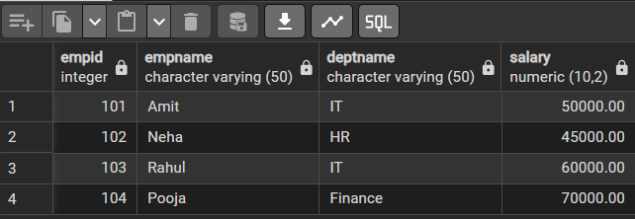

Step 3: Advanced Summarization
View Creating a view to provide department-level statistics automatically

CREATE VIEW DeptSalaryStats AS
SELECT
d.DeptName,
COUNT(e.EmpID) AS TotalEmployees,
SUM(e.Salary) AS TotalSalary,
AVG(e.Salary) AS AvgSalary
FROM Employees e
JOIN Departments d ON e.DeptID = d.DeptID
GROUP BY d.DeptName;

SELECT * FROM DeptSalaryStats;
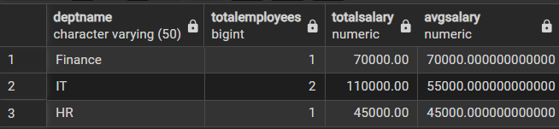

Outcomes:
- Abstraction Proficiency: Students will be able to create and query views to simplify efficient data access and abstraction.
- Security Implementation: Students will understand how to use views for data masking and providing restricted access to sensitive information.
- Syntactic Accuracy: Students will demonstrate the correct syntax for creating and querying views, ensuring logical clarity in naming conventions.
- Real-world Application: Students will be able to design views for practical domains like Library Management Systems or Payroll Systems to demonstrate functionality.

