Experiment 2

Student Name: Priyanka Chandwani UID: 25MCI10122
Branch: MCA (AI & ML) Section/Group: 25MAM_KAR-1_A
Semester: 2 Date of Performance: 20/01/26 Subject Name: Technical Training Subject Code: 25CAP-652

Title
Implementation of SELECT Queries with Filtering, Grouping and Sorting in PostgreSQL

Aim
To implement and analyze SQL SELECT queries using filtering, sorting, grouping, and aggregation concepts in PostgreSQL for efficient data retrieval and analytical reporting.

Objectives
- To retrieve specific data using filtering conditions
- To sort query results using single and multiple attributes
- To perform aggregation using grouping techniques
- To apply conditions on aggregated data
- To understand real‑world analytical queries commonly asked in placement interviews

Practical:

Step 1: Database and Table Preparation
CREATE TABLE customer_orders ( order_id SERIAL PRIMARY KEY,
customer_name VARCHAR(50) NOT NULL, product VARCHAR(50) NOT NULL,
quantity INT NOT NULL,
price NUMERIC(10,2) NOT NULL,
order_date DATE NOT NULL
);

INSERT INTO customer_orders
(customer_name, product, quantity, price, order_date) VALUES
('Amit', 'Laptop', 1, 55000, '2024-01-05'),
('Amit', 'Mouse', 2, 800, '2024-01-05'),
('Priya', 'Mobile', 1, 25000, '2024-01-10'),
('Rohit', 'Headphones', 1, 1500, '2024-01-12'),
('Neha', 'Laptop', 1, 60000, '2024-02-01'),
('Rohit', 'Mobile', 2, 24000, '2024-02-10'),
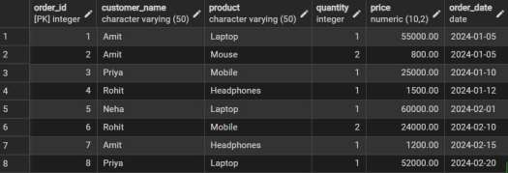
('Amit', 'Headphones', 1, 1200, '2024-02-15'),
('Priya', 'Laptop', 1, 52000, '2024-02-20');

SELECT product,
SUM(quantity * price) AS feb_sales FROM customer_orders
WHERE order_date >= '2024-02-01' AND order_date <= '2024-02-29' GROUP BY product;

Step 2: Filtering Data Using Conditions
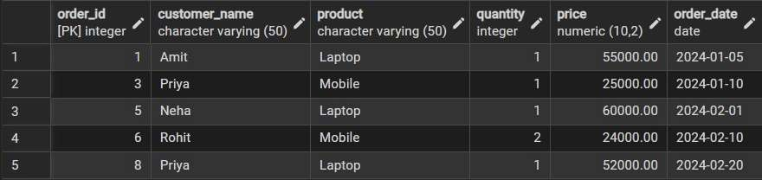
SELECT * FROM customer_orders WHERE price > 20000;

Step 3: Sorting Query Results
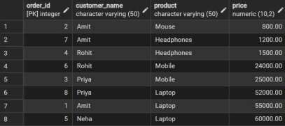
SELECT order_id, customer_name, product, price FROM customer_orders ORDER BY price ASC;

Step 4: Grouping Data for Aggregation
SELECT product,
SUM(quantity) AS total_quantity FROM customer_orders
GROUP BY product;

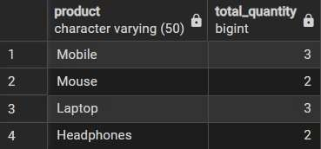

Step 5: Applying Conditions on Aggregated Data
SELECT product,
SUM(quantity * price) AS total_sales FROM customer_orders
GROUP BY product
HAVING SUM(quantity * price) > 50000;
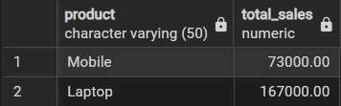

Step 6: Conceptual Understanding of Filtering vs Aggregation Conditions
SELECT product,
SUM(quantity * price) AS feb_sales FROM customer_orders
WHERE order_date >= '2024-02-01' AND order_date <= '2024-02-29' GROUP BY product;
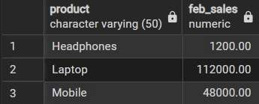

Learning Outcomes

- Understand how conditional filtering is used to retrieve only relevant records from a database.
- Explain how sorting enhances the readability and usefulness of query results in reports.
- Apply grouping techniques to organize data for analytical and summary purposes.
- Distinguish clearly between row-level conditions and group-level conditions using appropriate sql clauses.
- Develop confidence in writing analytical sql queries applicable to real-world database scenarios.
- Demonstrate improved readiness for placement and interview questions related to filtering, grouping, and aggregation concepts.

