Student Name : Priyanka Chandwani UID: 25MCI10122
Branch : MCA (AI & ML) Section/Group : 25MAM-1-A Semester : 2nd Date of Performance: 31.03.2026
Subject Name : Technical Training Subject Code : 25CAP-652

Experiment 7:
Experiment Aim: Implementation of JOINS in PostgreSQL
Tools used: PostgreSQL

Objectives
- Apply joins to a real-world database schema (e.g., Students, Courses, Enrollments, Departments)
Experiment Steps:

Table Creation and Data Storing-

CREATE TABLE Students (
student_id int PRIMARY KEY,
name VARCHAR(50),
dept_id int
);
CREATE TABLE Courses (
course_id int PRIMARY KEY,
course_name VARCHAR(50)
);
CREATE TABLE Enrollments (
enroll_id int PRIMARY KEY,
student_id int,
course_id int,
FOREIGN KEY (student_id) REFERENCES Students(student_id),
FOREIGN KEY (course_id) REFERENCES Courses(course_id)
);
CREATE TABLE Departments (
dept_id int PRIMARY KEY,
dept_name VARCHAR(50)
);
INSERT INTO Departments VALUES (101, 'CSE');
INSERT INTO Departments VALUES (102, 'IT');

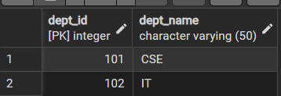

INSERT INTO Students VALUES (1, 'Aman', 101);
INSERT INTO Students VALUES (2, 'Priya', 102);
INSERT INTO Students VALUES (3, 'Rohit', 101);
INSERT INTO Students VALUES (4, 'Neha', NULL);

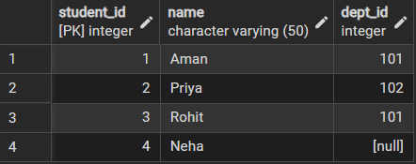

INSERT INTO Courses VALUES (201, 'DBMS');
INSERT INTO Courses VALUES (202, 'OS');
INSERT INTO Courses VALUES (203, 'Java');
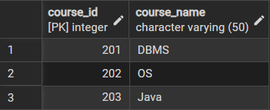

INSERT INTO Enrollments VALUES (1, 1, 201);
INSERT INTO Enrollments VALUES (2, 1, 202);
INSERT INTO Enrollments VALUES (3, 2, 203);

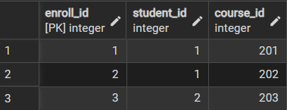

Step 1: Write queries to list students with their enrolled courses (INNER JOIN).
select students.* , enrollments.* , courses.course_name
from students ,enrollments,courses
where students.student_id=enrollments.student_id and courses.course_id=enrollments.course_id;
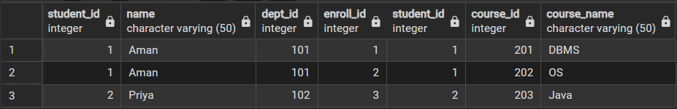

Step 2: Find students not enrolled in any course (LEFT JOIN).
select students.* from students
Left join enrollments
on students.student_id=enrollments.student_id
Left Join courses
on courses.course_id=enrollments.course_id
where courses.course_id is null;
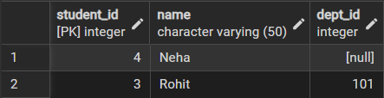

Step 3: Display all courses with or without enrolled students (RIGHT JOIN).
select courses.*
from enrollments
Right Join courses
on courses.course_id=enrollments.course_id;
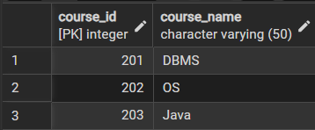
Step 4:Show students with department info using SELF JOIN or multiple joins.
select students.*,departments.dept_name
from students
inner join departments
on students.dept_id=departments.dept_id ;
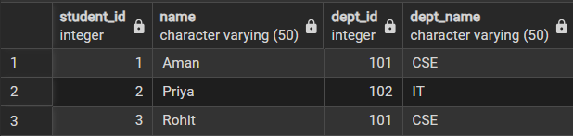

Step 5: Display all possible student-course combinations (CROSS JOIN). (Oracle, SAP, IBM, Microsoft)
select * from students cross join courses;
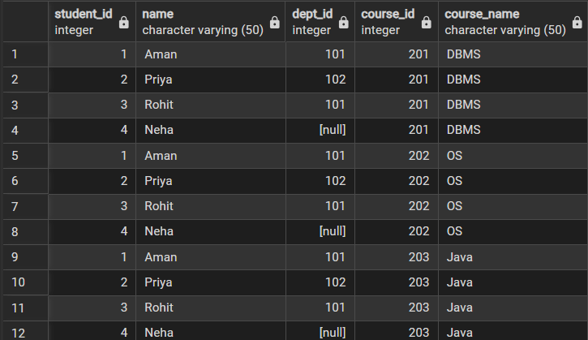

Outcomes:
- Abstraction Proficiency: Students will be able to create and query views to simplify efficient data access and abstraction.
- Security Implementation: Students will understand how to use views for data masking and providing restricted access to sensitive information.
- Syntactic Accuracy: Students will demonstrate the correct syntax for creating and querying views, ensuring logical clarity in naming conventions.
- Real-world Application: Students will be able to design views for practical domains like Library Management Systems or Payroll Systems to demonstrate functionality.

