**Book one way outstation cab and display the lowest charges**

**Automation**

**In Make My Trip Application**

**Problem Statement:**

 Book one way outstation cab and display the lowest charges

* From Delhi to Manali, Himachal Pradesh.
* Pick up from Delhi at 6.30 AM on 23rd Dec 2019
* Car type should be SUV.

**Suggested Site:** <https://www.makemytrip.com/>

**Detailed Description:**

* Book one way outstation cab, From Delhi to Manali, Himachal Pradesh, give future date & time & Car type should be SUV; Display the lowest charges.
* Find Group Gifting in Gift Cards, fill card details & give invalid email; capture & display the error message.
* On the Hotel booking page, extract all the numbers for Adult persons and store in a List; Display the same.

**Key Automation Scope:**

* Handling alerts
* Filling simple form, Capture warning message
* Scrolling down in web page
* Extract dropdown items & store in collections
* Navigation from Menus
* Navigating back to home page

**Hackathon Project Frameworks & Tools Used:**

|  |  |
| --- | --- |
| **Frameworks & Tools** | **Version** |
| Selenium Java | 4.1.0 |
| Webdriver Manager | 5.0.3 |
| Maven | 4.0.0 |
| POM | 4.0.0 |
| TestNG | 7.4.0 |
| ExtentReports | 3.1.5 |
| Apache POI | 4.1.2 |

**Browser Options:**

1.Chrome

2.Firefox

3.Microsoft Edge

**Project Structure:**

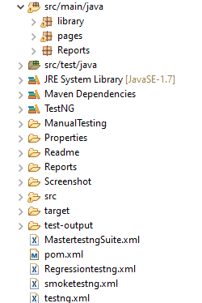

**Structure Details:**

* **src/main/java**:
* library package ->Browser, Reusable Methods, ScreenShot, ReadProperties, UseProperties files.

(This package contains reusable and browser calling methods to be used in automation)

* Pages package ->CabsPage, GiftcardsPage, HotelsPage.

(This package contains pages to be automated)

* Reports package -> ExtentReportsPage.

(This package contains extent report files to create an extent report)

* **src/test/java:**
* TestScript package ->MakeMyTripTest.

(This package contains the TestNG script to automate the code.

* **Reports:**
* It contains the Extent Report for the automated project file.
* **Screenshot:**
* It contains the screenshot taken during the execution of the program.

**Steps to Execute:**

* Import the QEA21SD002_MakeMyTrip file into the eclipse workspace.
* Save the pom.xml file.
* Update the Maven project (Maven->Update Project).
* To Run the program in respective browser such as Chrome, Firefox, Edge change the browser name in the MakeMyTrip properties file (Properties->MakeMyTrip.properties).
* To Run both the smoke and regression test suites continuously right click on MastertestngSuite.xml file and click RunAs->TestngSuite.

**Extent Report:**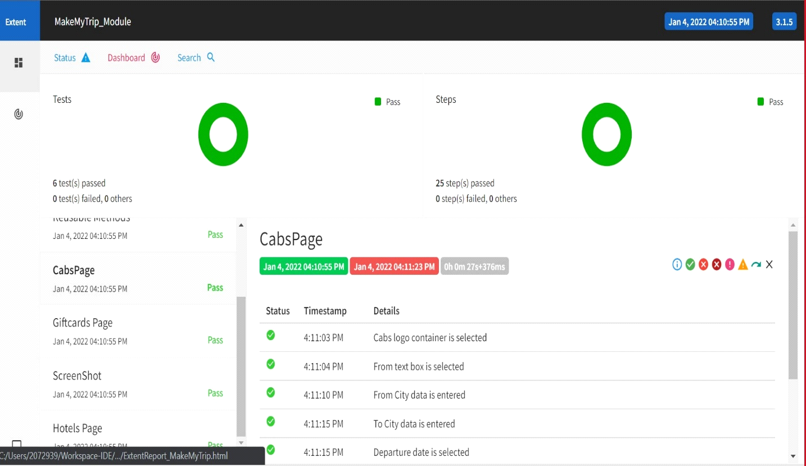

**Team Members:**

* **Shaik Nawaz**
* **Olipi Sandeep kumar**
* **Purohit prayash Ranjan**
* **Ramya**
* **Bhagyashree**
* **Laxmi**