CEFR: Common European Framework of Reference

The Common European Framework of Reference for Languages (CEFR) is an international standard for describing language ability. It describes language ability on a six-point scale, from A1 for beginners, up to C2 for those who have mastered a language.

As professionals we all need to asses ourselves on our English language skills that are imperative for our academic and career development. Therefore, all of you are requested to attempt a small 10 minutes test which comprises a few MCQs which shall assess you on the language in general.

**1st Year BBA & BCA** please attempt through the below link.

<https://www.cambridgeenglish.org/test-your-english/general-english/>

**2nd Year BBA & BCA** please attempt through the below link.

<https://www.cambridgeenglish.org/test-your-english/business/>

Once, you have submitted the test you will get a screen which will reflect your score as given below:

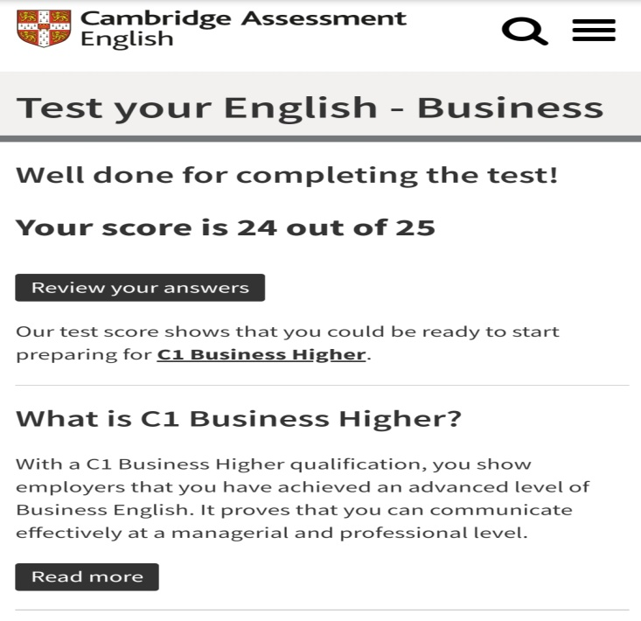

Please take a screenshot of this screen and send it across to email ID: [abspdpassignments@gmail.com](mailto:abspdpassignments@gmail.com)

**It is mandatory for all the students to attempt this test and send the screenshot of the score.**