EXPERIMENT – 01
EXPERIMENT 1.1 :-
AIM - Create a custom EventEmitter that trigger “greet” or “exit”

CODE :-

const EventEmitter = require('events');

const emitter = new EventEmitter();

emitter.on('greet', () => {
console.log('Hello! Welcome!');
});

emitter.on('exit', () => {
console.log('Goodbye! Exiting...');
});

emitter.emit('greet');
emitter.emit('exit');
OUTPUT :-
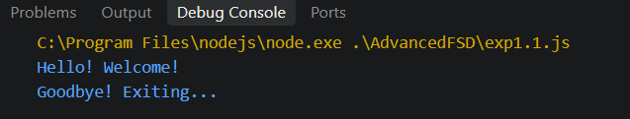

EXPERIMENT 1.2 :-
AIM- Simulate DOM like event handling in Node.js using events

CODE : -

const EventEmitter = require('events');

const button = new EventEmitter();

button.on('click', () => {
console.log("Button was clicked!");
});

button.on('mouseover', () => {
console.log("Mouse is over the button!");
});

button.emit('click');
button.emit('mouseover');

OUTPUT :-
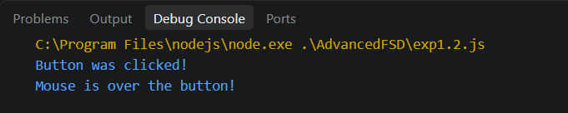

EXPERIMENT 1.3 : -

AIM :- Visualize the event loop using setTimeout , setImmediate , and process.nextTick

CODE : -

console.log("Start");

setTimeout(() => {
console.log("setTimeout");
}, 0);

setImmediate(() => {
console.log("setImmediate");
});

process.nextTick(() => {
console.log("process.nextTick");
});

console.log("End");
OUTPUT : -
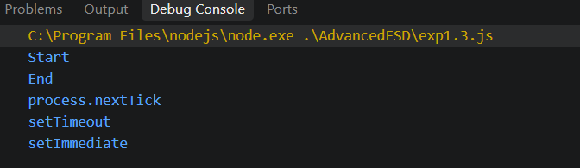
EXPERIMENT- 02
AIM :- Perform CRUD operations on file using fs module

CODE : -

const fs = require('fs');

fs.writeFile("example.txt", "Hello World!", (err) => {
if (err) throw err;

console.log("File created!");

fs.readFile("example.txt", "utf8", (err, data) => {
if (err) throw err;

console.log("File content:", data);

fs.writeFile("example.txt", "This is the updated content", (err) => {
if (err) throw err;

console.log("File overwritten(updated)!");

fs.unlink('example.txt' , (err) => {
if(err) throw err;
console.log('File deleted!');
});
});
});
});

OUTPUT : -

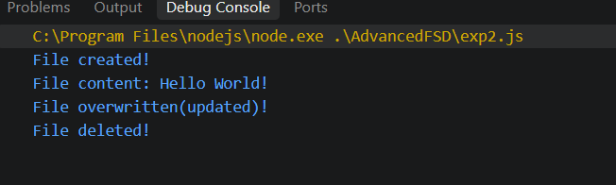

EXPERIMENT-03

AIM : - Create a basic HTTP server using http.createServer() , Respond with “Hello World” and return headers + status code

CODE : -

const http = require('http');

const PORT = 3000;

const server = http.createServer((req, res) => {

const parsedUrl = new URL(req.url, `http://${req.headers.host}`);
const path = parsedUrl.pathname;

console.log(`Request received: ${req.method} ${path}`);

if (path === '/' && req.method === 'GET') {
res.statusCode = 200;
res.setHeader('Content-Type', 'text/plain');
res.end('Welcome! Try /greet?name=Rahul or /headers or POST to /data\n');
}

else if (path === '/greet' && req.method === 'GET') {
const name = parsedUrl.searchParams.get('name') || 'Guest';

res.statusCode = 200;
res.setHeader('Content-Type', 'text/plain');
res.end(`Hello, ${name}! Welcome to the server.\n`);
}

else if (path === '/headers' && req.method === 'GET') {
res.statusCode = 200;
res.setHeader('Content-Type', 'application/json');
res.end(JSON.stringify(req.headers, null, 2));
}

else if (path === '/data' && req.method === 'POST') {
let body = '';

req.on('data', chunk => {
body += chunk;
});

req.on('end', () => {
res.statusCode = 201;
res.setHeader('Content-Type', 'application/json');

res.end(JSON.stringify({
message: 'Data received successfully',
yourData: body
}));
});
}

else if (path === '/error') {
res.statusCode = 500;
res.setHeader('Content-Type', 'text/plain');
res.end('Simulated server error (500)\n');
}

else {
res.statusCode = 404;
res.setHeader('Content-Type', 'text/plain');
res.end('404 - Page Not Found\n');
}
});

server.listen(PORT, () => {
console.log(`Server running at http://localhost:${PORT}`);
});

OUTPUT : -

