1. How many Claims Status in "NY"  
   2. How many Claims Status in "NY" and "CO"  
   3. How many claims "Denied Then Paid" in "NY"  
   4. How many Claims "Denied" "in CO"  
   5. How many claims "Denied Then Paid" in "NY"  
   6. check the Reason for Claims Status is Denied. Check the "Claims Status" and "Reason"  
   7. What is the Claims Status for MemberID C10000639  
   8. Claims Status "Denied Then Paid" for MemberID C10000639  
   9. How many Claims "Denied" and 'Denied Then Paid" in CO  
   10. How many Claims "Denied" in "CO" due to the Reason "Missing Doc"



2.What is the Deny Code for Patient First Name is “KIRSHA” and Patient Last Name is “BUJJI”



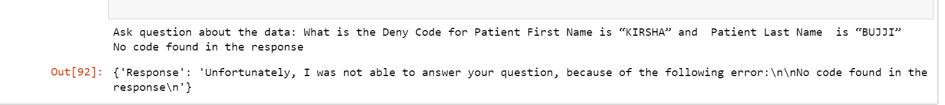

2.How many Deny Code for Patient First Name is “KIRSHA” and Patient Last Name is “BUJJI”

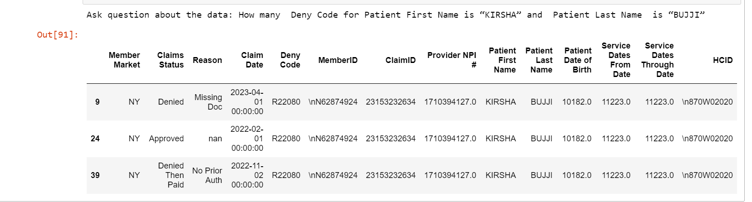



1. Patient First Name=“KIRSHA”, Patient Last Name=“BUJJI”
2. MemberID= C10000639, Patient Date of Birth is 10170 and Service Dates Through Date= 40123
3. What are all the distinct denial codes available
4. Are there any missing values in the data
5. On how many entries these analysis is performed
6. Total count of the entries considered
7. What are different claimid for same membered
8. What is most common hcid for the given entries
9. What is the average claim date range in which claims are denied

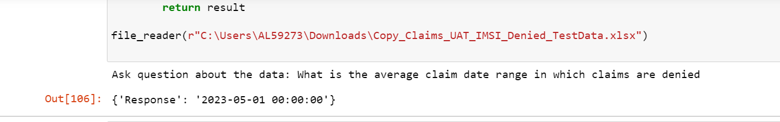

11.During which period the maximum claims are rejected

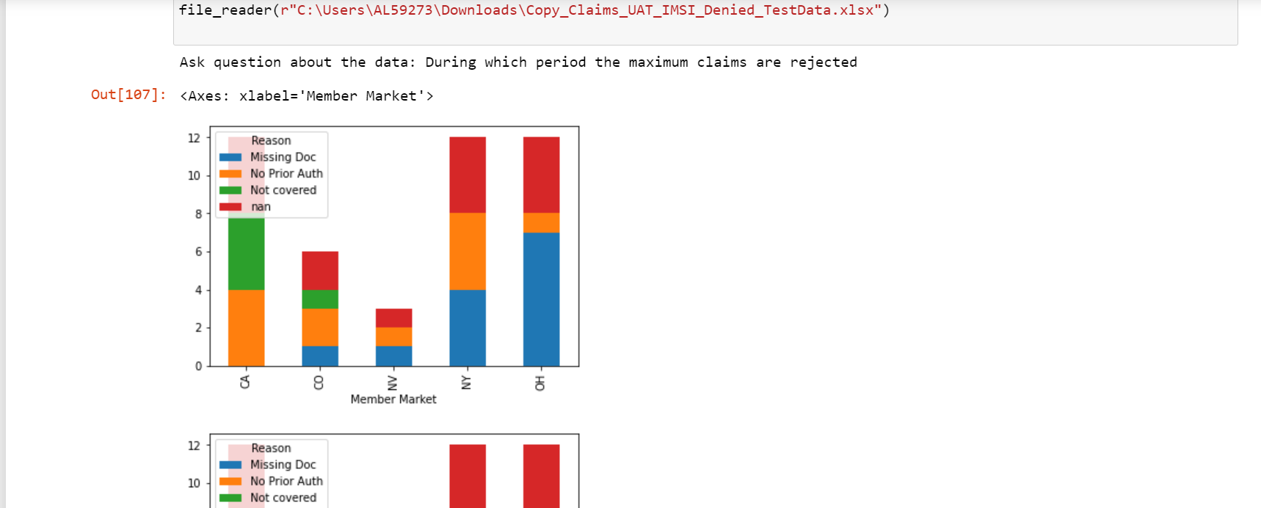

12. What is the average claim date range in which claims are rejected

