**MUSIC_STORE DATA ANALYSIS SQL PROJECT (SOLUTIONS)**

1. Who is the senior most employee based on job title?

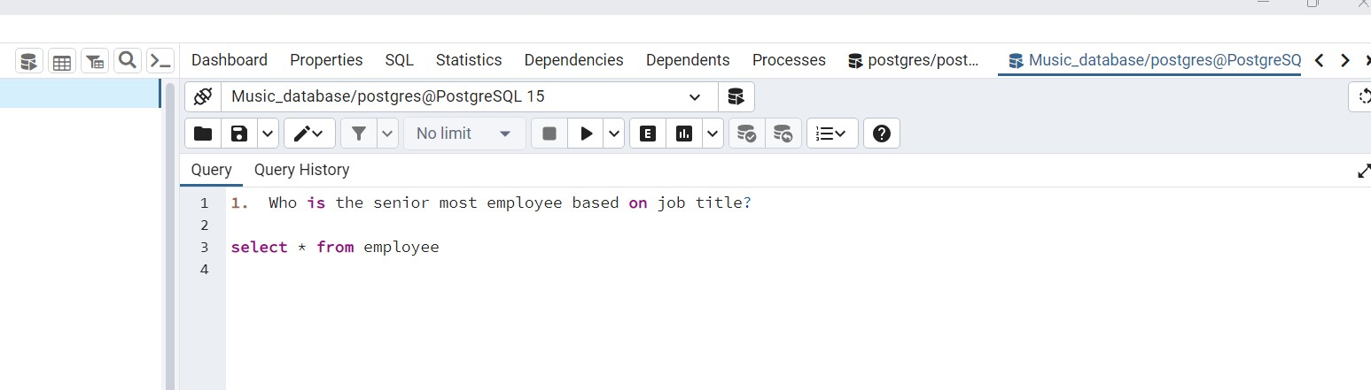

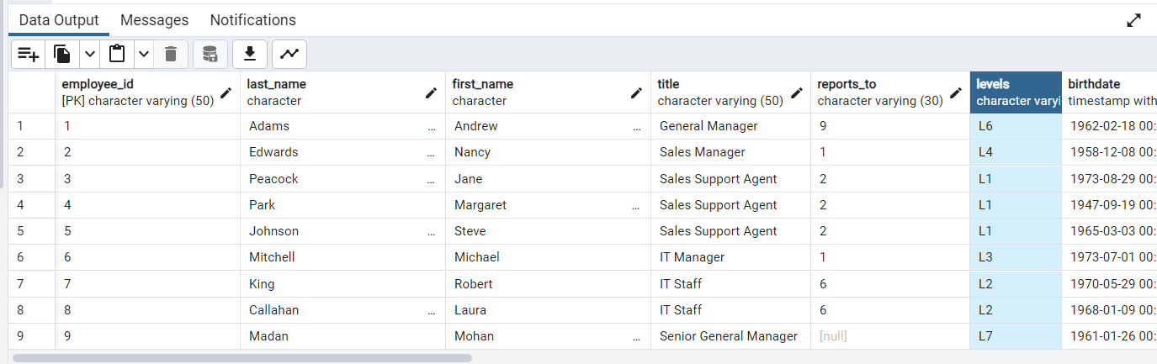

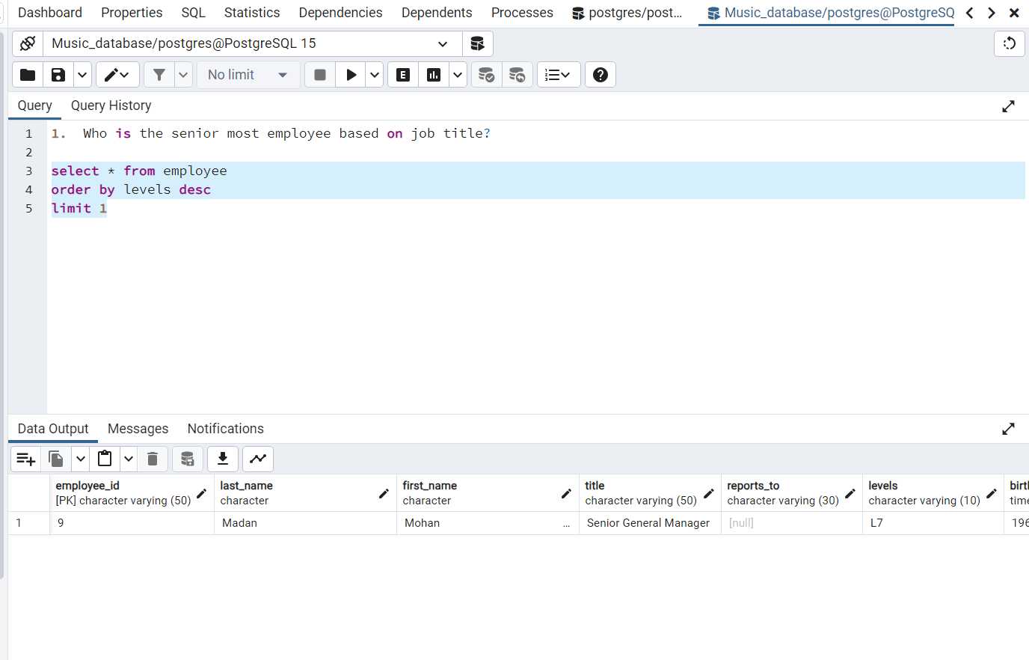

1. Which countries has the most invoices?

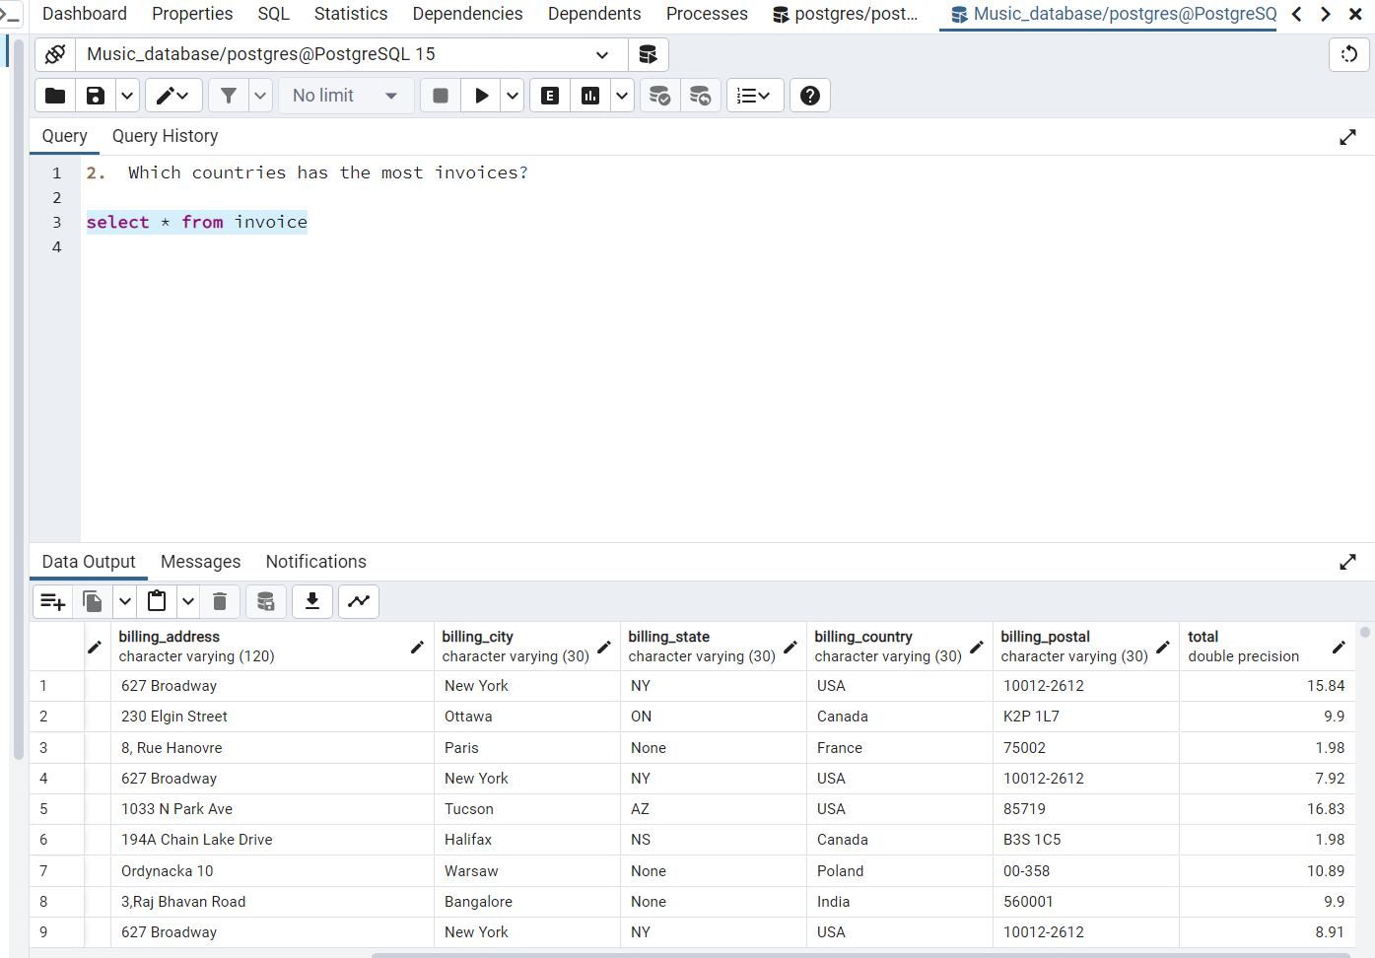

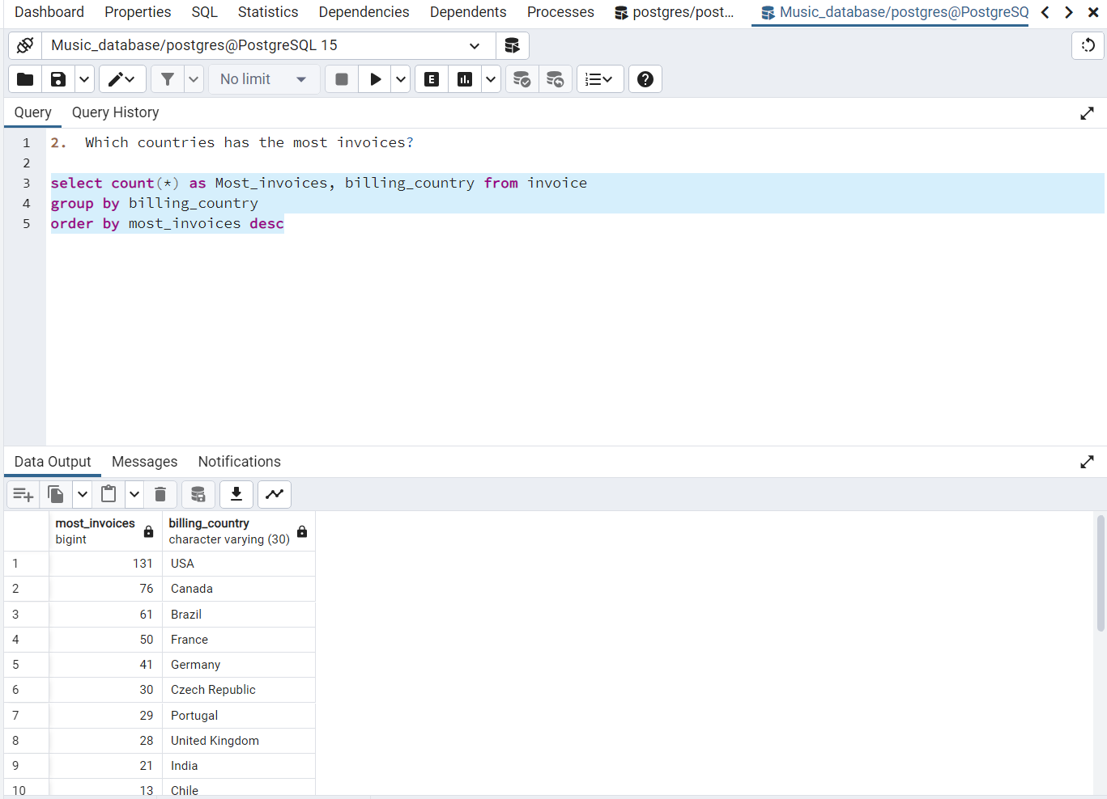

1. What are top 3 values of total invoice?

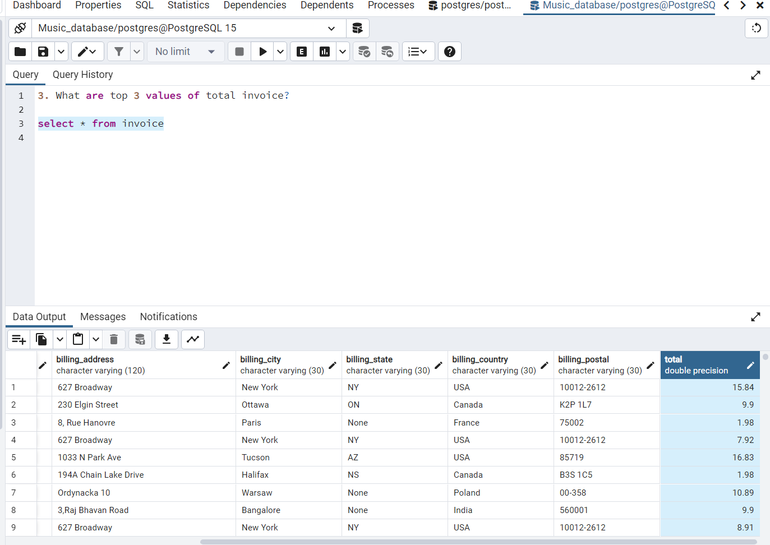

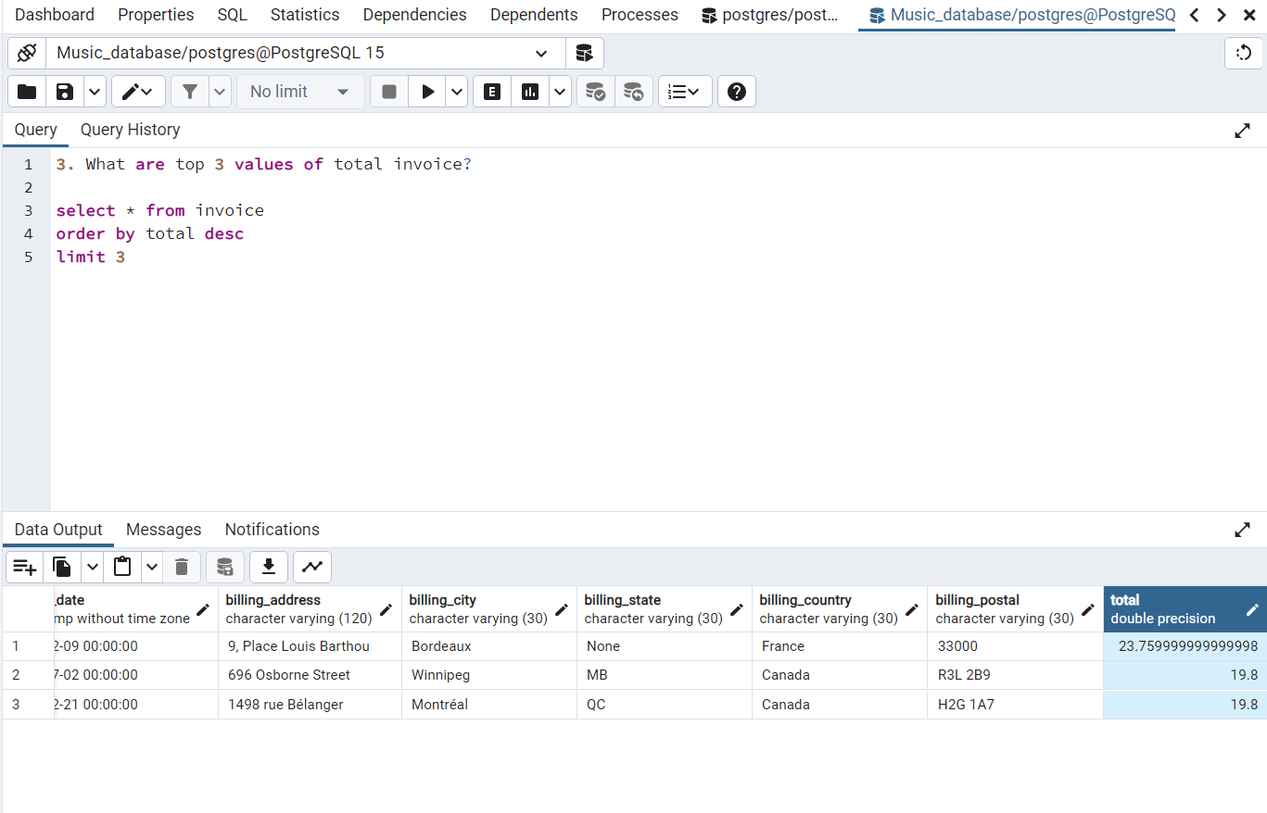

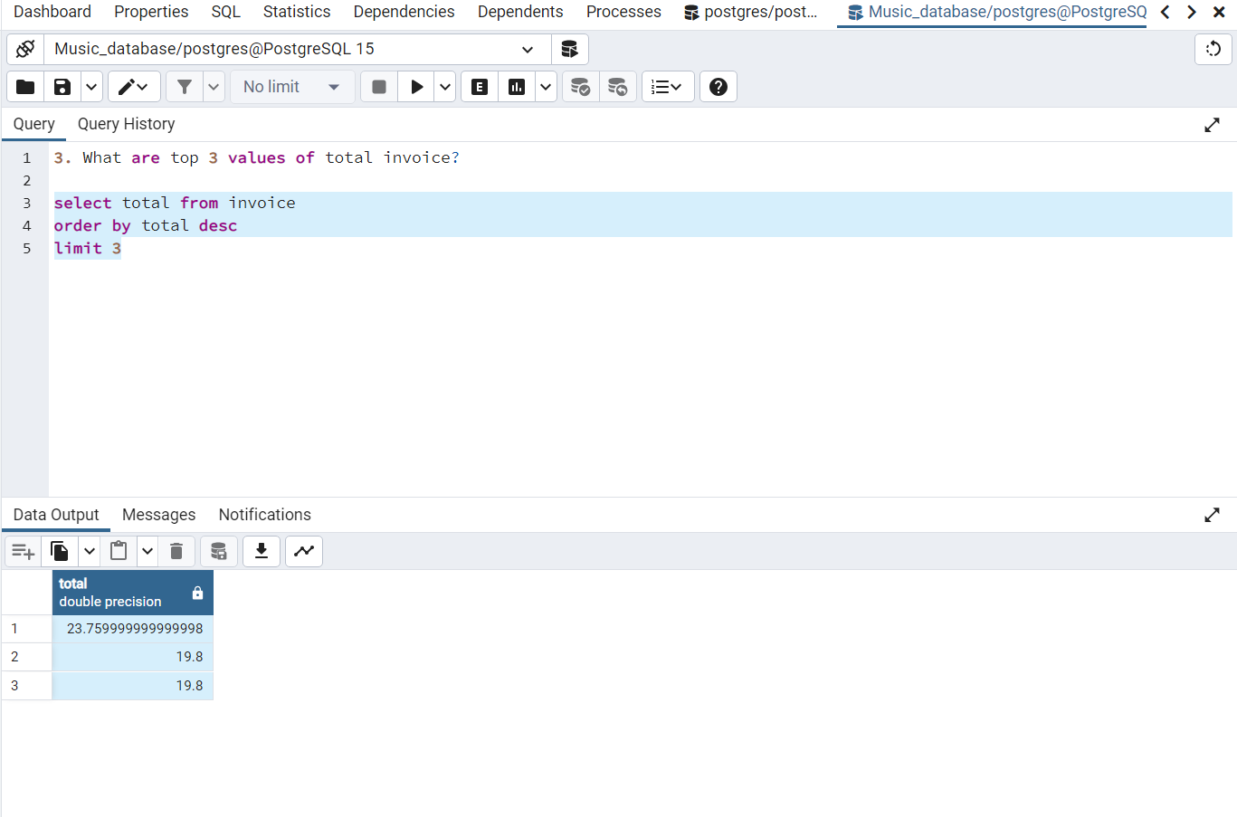

1. Which city has the best customers? We would like to throw a promotional Music Festival in the city we made the most money. Write a query that returns one city that has the highest sum of invoice totals. Return both the city name & sum of all invoice totals?

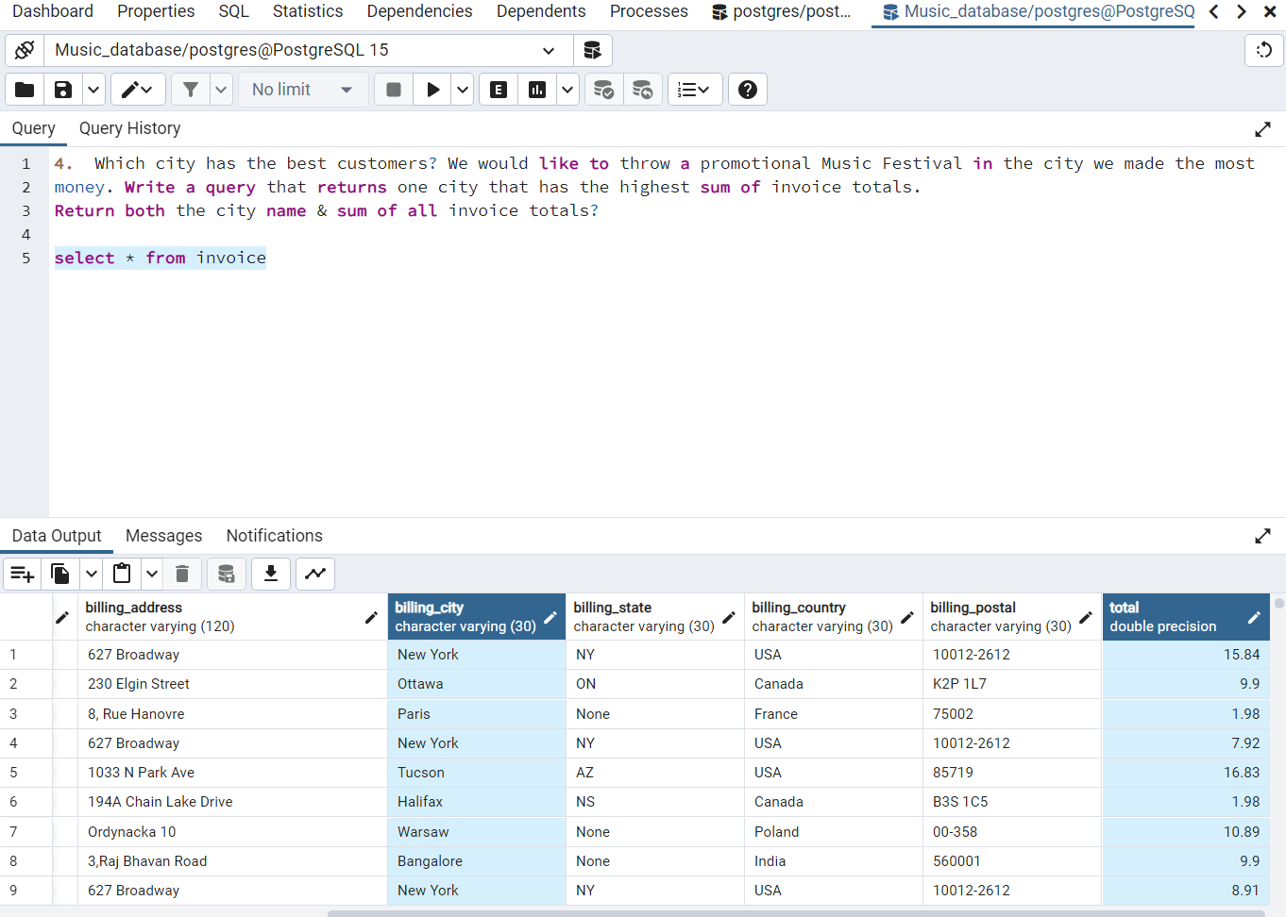

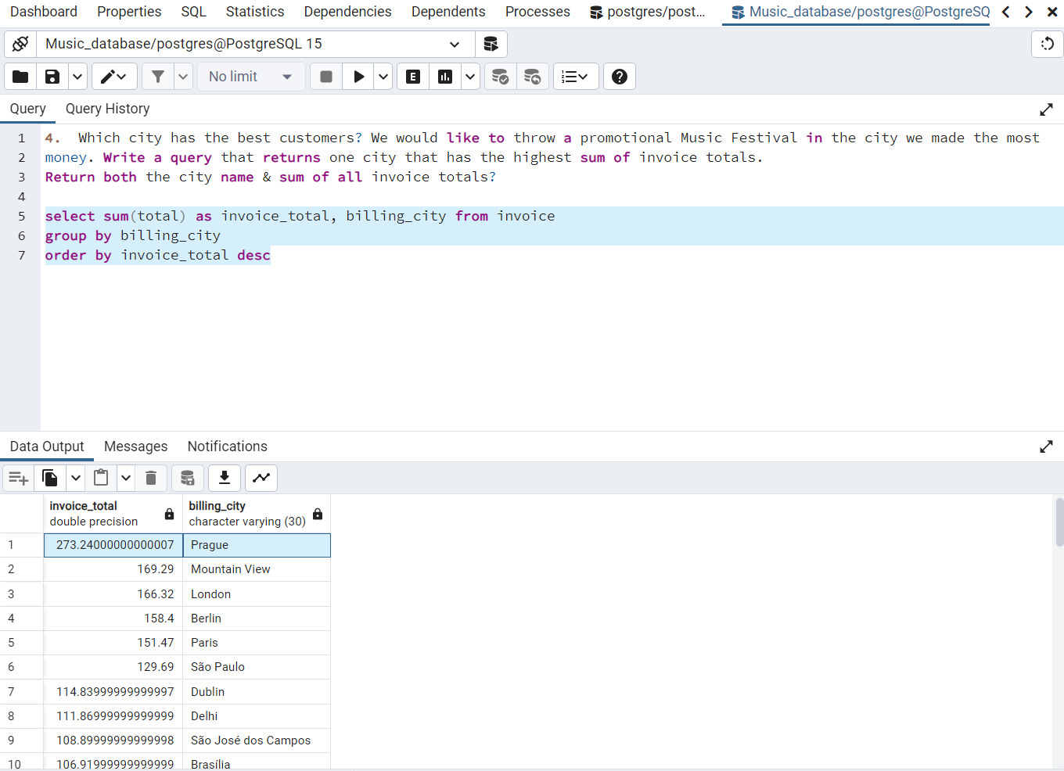

1. Who is the best customer? The customer who has spent the most money will be declared the best customer. Write a query that returns the person who has spent the most money?

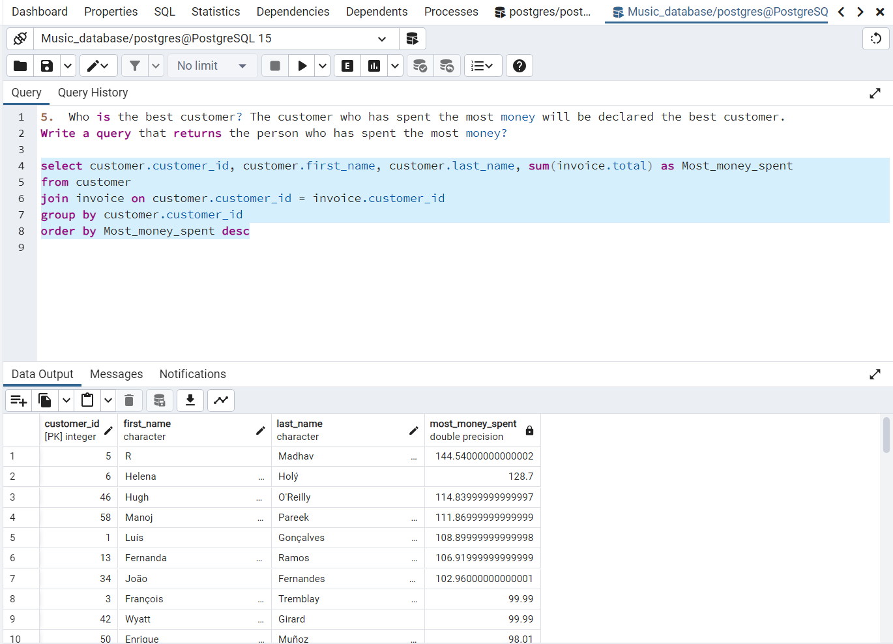

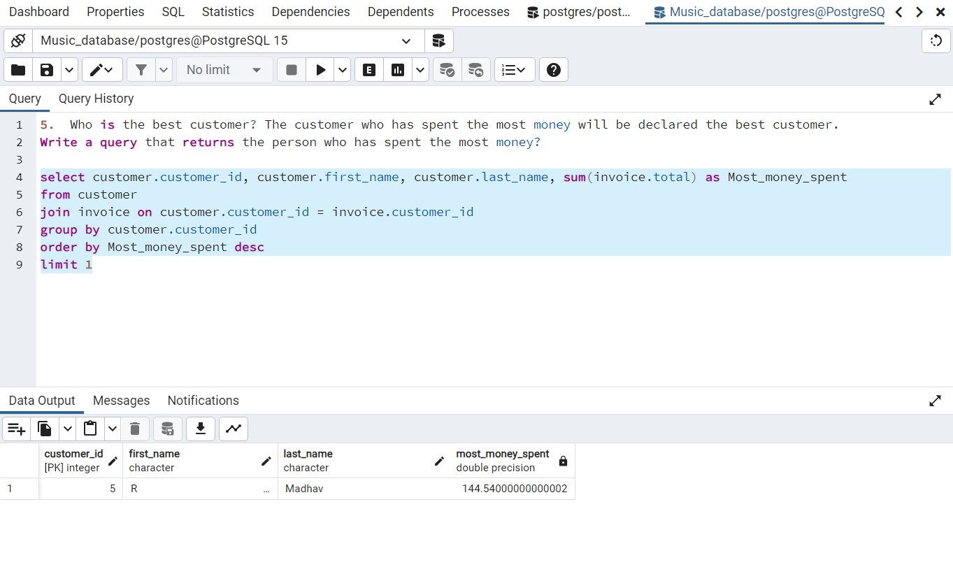

1. Write query to return the email, first name, last name, & Genre of all Rock Music listeners. Return your list ordered alphabetically by email starting with A?

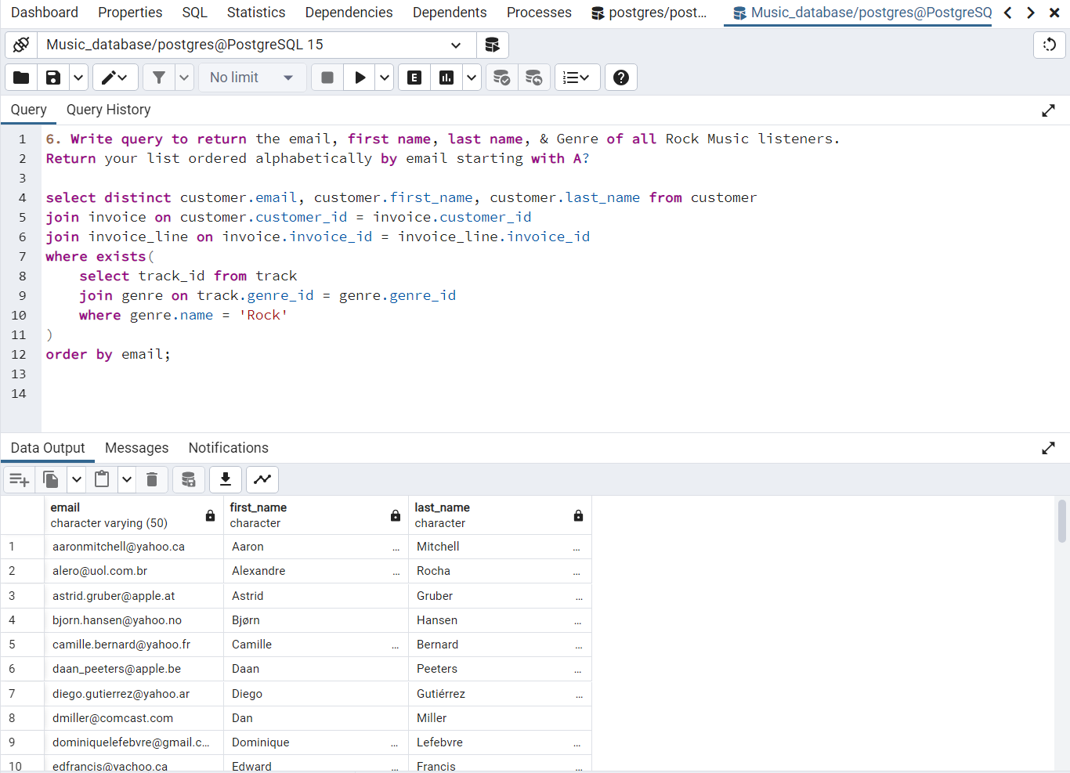

**OR (another way for same query)**

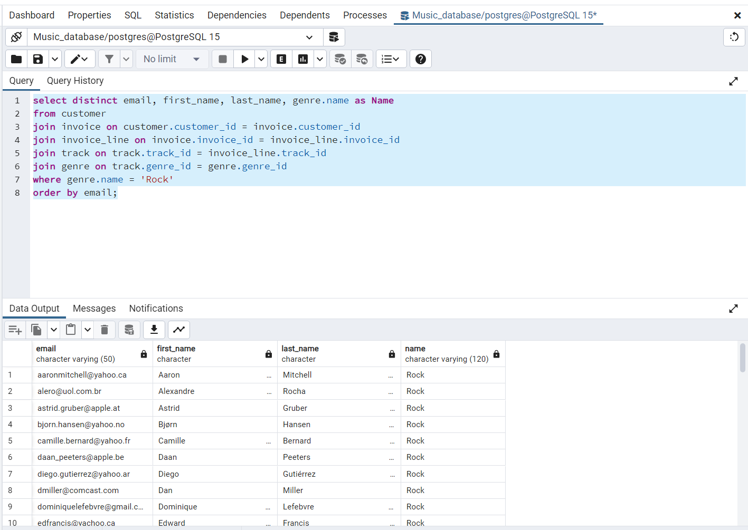

1. Let's invite the artists who have written the most rock music in our dataset. Write a query that returns the Artist name and total track count of the top 10 rock bands?

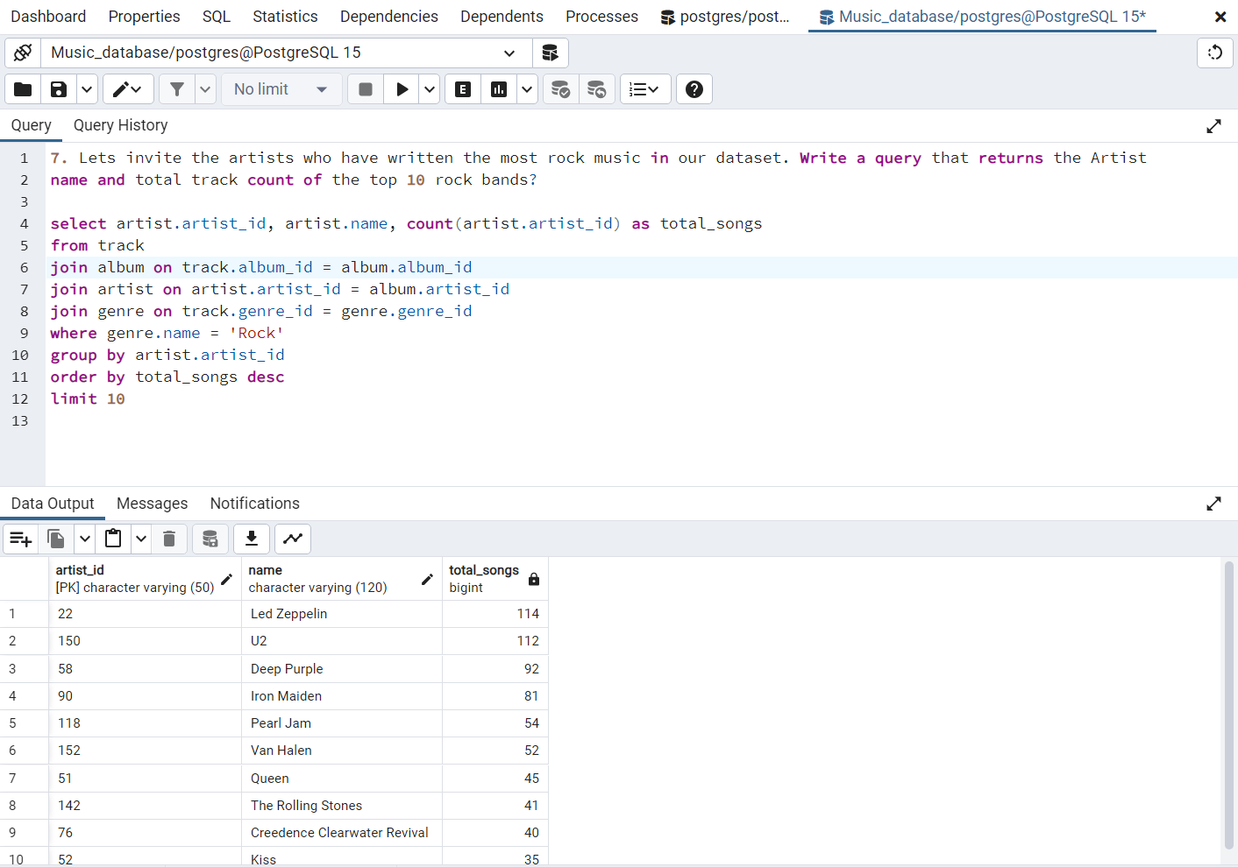

1. Return all the track names that have a song length longer than the average song length. Return the Name and Milliseconds for each track. Order by the song length with the longest songs listed first?

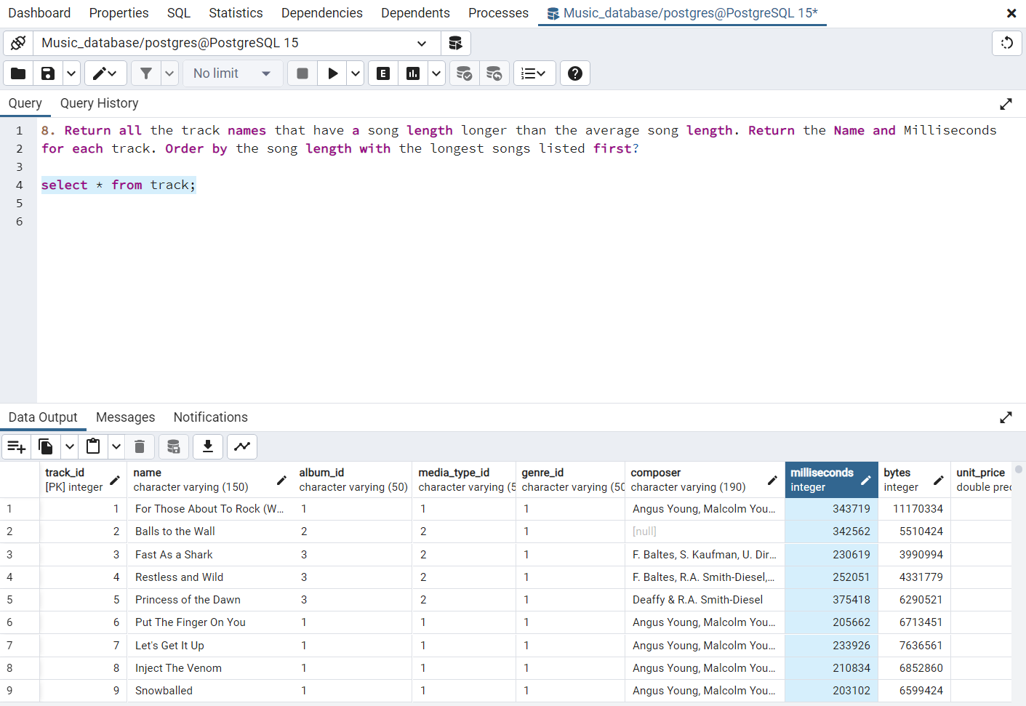

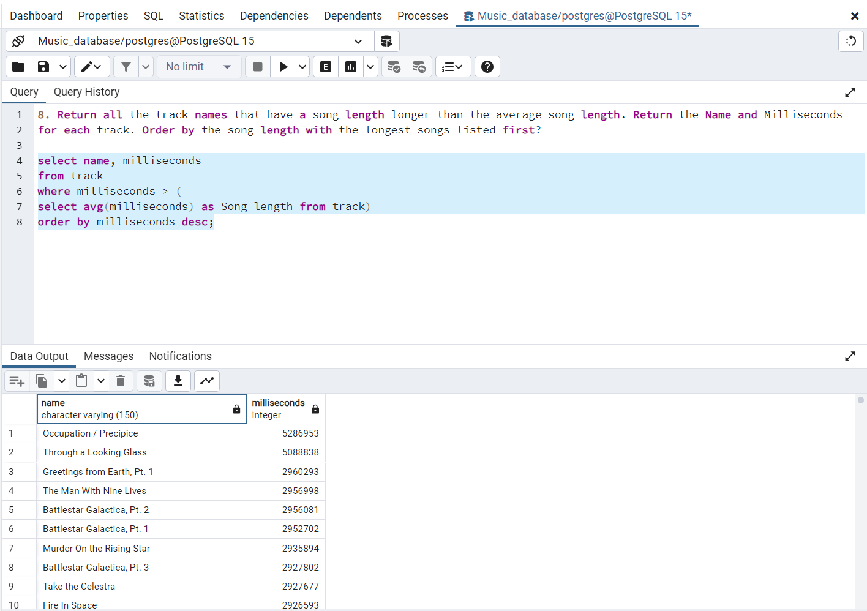

1. Find how much amount spent by each customer on artists? Write a query to return customer name, artist name and total spent?

WITH best_selling_artist AS (

SELECT artist.artist_id AS artist_id, artist.name AS artist_name, SUM(invoice_line.unit_price * invoice_line.quantity)

AS total_sales FROM invoice_line

JOIN track ON track.track_id = invoice_line.track_id

JOIN album ON album.album_id = track.album_id

JOIN artist ON artist.artist_id = album.artist_id

GROUP BY artist.artist_id

ORDER BY total_sales DESC

LIMIT 1

)

SELECT customer.customer_id, customer.first_name, customer.last_name, best_selling_artist.artist_name,

SUM(invoice_line.unit_price*invoice_line.quantity) AS amount_spent

FROM invoice

JOIN customer ON customer.customer_id = invoice.customer_id

JOIN invoice_line ON invoice_line.invoice_id = invoice.invoice_id

JOIN track ON track.track_id = invoice_line.track_id

JOIN album ON album.album_id = track.album_id

JOIN best_selling_artist ON best_selling_artist.artist_id = album.artist_id

GROUP BY customer.customer_id, customer.first_name, customer.last_name, best_selling_artist.artist_name

ORDER BY amount_spent DESC;

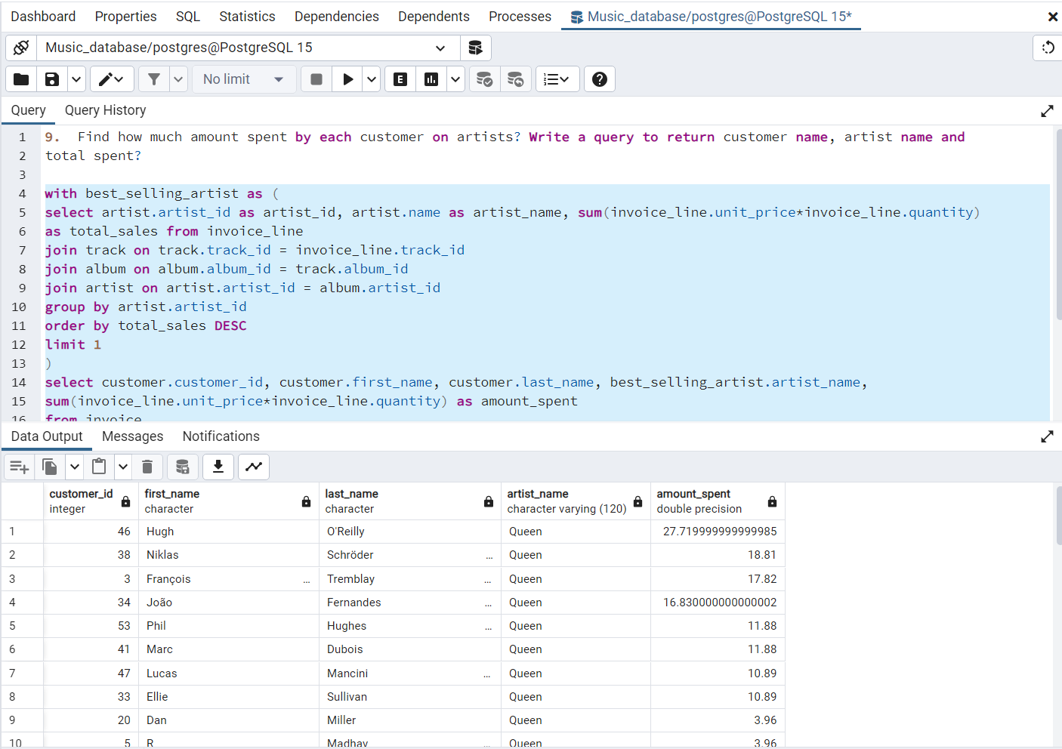

1. We want to find out the most popular music Genre for each country. We determine the most popular genre as the genre with the highest number of purchases. Write a query that returns each country along with the top Genre. For countries where the maximum number of purchases is shared return all Genres?

WITH popular_genre AS

(

SELECT COUNT(invoice_line.quantity) AS purchases, customer.country, genre.name, genre.genre_id,

ROW_NUMBER() OVER(PARTITION BY customer.country ORDER BY COUNT(invoice_line.quantity) DESC) AS RowNo

FROM invoice_line

JOIN invoice ON invoice.invoice_id = invoice_line.invoice_id

JOIN customer ON customer.customer_id = invoice.customer_id

JOIN track ON track.track_id = invoice_line.track_id

JOIN genre ON genre.genre_id = track.genre_id

GROUP BY customer.country, genre.name, genre.genre_id

ORDER BY customer.country ASC

)

SELECT * FROM popular_genre WHERE RowNo <= 1

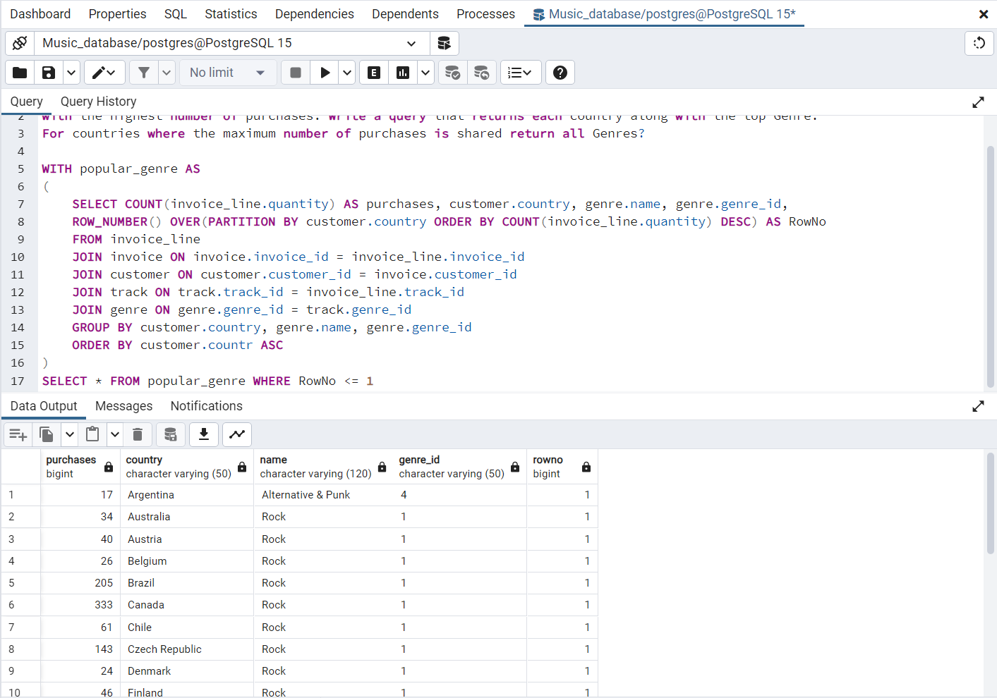

1. Write a query that determines the customer that has spent the most on music for each country. Write a query that returns the country along with the top customer and how much they spent. For countries where the top amount spent is shared, provide all customers who spent this amount?

WITH Customer_with_country AS (

SELECT customer.customer_id,first_name,last_name,billing_country,SUM(total) AS total_spending,

ROW_NUMBER() OVER(PARTITION BY billing_country ORDER BY SUM(total) DESC) AS RowNo

FROM invoice

JOIN customer ON customer.customer_id = invoice.customer_id

GROUP BY 1,2,3,4

ORDER BY 4 ASC )

SELECT * FROM Customer_with_country WHERE RowNo <= 1

