PES UNIVERSITY • RR CAMPUS
FITZONE

Gym Membership
Management System
PROJECT REPORT
Database Management Systems
SUBMITTED BY
Student SRN Programme
Ramalakshmi M N PES1UG24AM219 CSE (AI & ML)
Priyanka B M PES1UG24AM207 CSE (AI & ML)
PES University • RR Campus • Academic Year 2026–2027
Report prepared: 09 November 2026

Acknowledgement
The project team thanks PES University, RR Campus, and the Department of Computer Science and Engineering (AI & ML) for the opportunity to undertake the FITZONE Gym Membership Management System as a Database Management Systems project.
The team also acknowledges the open-source communities behind Next.js, React, TypeScript, MySQL, MongoDB and the supporting libraries used in this work, whose documentation and tools made the implementation and verification possible.
Abstract
FITZONE is a gym membership management system that centralises member records, membership plans, memberships, trainers, trainer assignments, attendance, payments and reports. It is built with Next.js, React and TypeScript, with server-side Route Handlers that use MySQL 8.0 as the relational system of record and MongoDB for selected activity-log documents.
The relational design links seven core tables with primary and foreign keys and protects data with unique, ENUM and CHECK constraints for attendance times, payment amounts and payment statuses. Reporting views and the stored procedure GetMemberPayments support administrative reporting. Authentication uses an auth_users table, bcrypt password verification and signed session tokens. MongoDB records attendance check-in events in an activity_logs collection.
The report documents the problem context, requirements, architecture, technology stack, database design, modules, API layer, workflows, testing, collaboration and results. Verification evidence includes a successful local administrator login, manual testing of the attendance, trainer, assignment, payment and report modules, a successful Next.js production build and successful GitHub Actions build checks. Items still outstanding, such as member-account authentication alignment, and broader activity logging, are stated explicitly.
Keywords: gym management, MySQL, MongoDB, Next.js, TypeScript, referential integrity, activity logging.
Table of Contents
1. Introduction 1
1.1 Introduction to the System 1
1.2 Background and Motivation 1
1.3 Problem Statement 1
1.4 Project Objectives 1
1.5 Scope of the Project 2
1.6 Intended Users 2
1.7 Key Benefits of the System 2
1.8 Organisation of the Report 3
2. Existing System and Proposed Solution 4
2.1 Limitations of Traditional Gym Management 4
2.2 Problems with Manual Member and Payment Tracking 4
2.3 Need for Centralised Management 4
2.4 Proposed FITZONE Solution 4
2.5 Advantages of the Proposed System 5
3. System Requirements 6
3.1 Functional Requirements 6
3.2 Non-Functional Requirements 7
3.3 Hardware Requirements 7
3.4 Software and Technology Requirements 7
3.5 User Roles and Access Levels 8
3.6 System Constraints and Assumptions 8
4. System Architecture and Design 9
4.1 Overall System Architecture 9
4.2 Frontend Architecture 9
4.3 Backend and API Architecture 9
4.4 Database Architecture 10
4.5 Authentication Flow 10
4.6 MongoDB Integration 11
4.7 Interaction between Frontend, APIs, MySQL and MongoDB 11
4.8 Application Workflow 11
4.9 Configuration and Secrets 12
5. Technology Stack 13
6. Database Design and Implementation 14
6.1 Overview 14
6.2 Entity-Relationship Diagram 15
6.3 Table Definitions 16
6.4 Referential Integrity 19
6.5 Constraints and Validation 19
6.6 Views and Stored Procedures 19
6.7 Normalisation 20
6.8 MongoDB Activity Logging 20
7. Application Modules and Functionalities 21
7.1 Dashboard 21
7.2 Member Management 22
7.3 Membership Plan Management 23
7.4 Membership Management 23
7.5 Attendance Management 24
7.6 Trainer Management 25
7.7 Trainer Assignment Management 26
7.8 Payment Management 27
7.9 Reports and Analytics 28
7.10 Authentication and User Management 29
7.11 Activity Logging 29
8. API and Backend Implementation 30
8.1 Overview 30
8.2 Request and Response Handling 30
8.3 Database Operations 30
8.4 Validation and Error Handling 30
8.5 Authentication and Authorisation 31
8.6 Frontend–Backend Integration 31
9. User Interface and Application Workflow 32
9.1 Login and Registration 32
9.2 Dashboard Navigation 32
9.3 Member Management Workflow 32
9.4 Membership Workflow 33
9.5 Attendance Check-in and Check-out 33
9.6 Trainer Assignment Workflow 33
9.7 Payment Workflow 33
9.8 Reports Generation 33
9.9 Member Self-Service View 33
10. Testing and Validation 35
10.1 Testing Approach and Evidence Policy 35
10.2 Functional Testing 35
10.3 API Testing 36
10.4 Database Testing 36
10.5 Integration Testing 37
10.6 Manual Testing 37
10.7 Build Verification and GitHub Actions Checks 38
10.8 Validation and Error-Handling Tests 38
10.9 Summary of Test Status 38
11. Version Control and Team Collaboration 40
11.1 Git and GitHub Workflow 40
11.2 Repository Structure 40
11.3 Branching Strategy 40
11.4 Pull Request Workflow 40
11.5 Code Review 40
11.6 Continuous Integration 41
11.7 Team Collaboration and Integration Process 41
11.8 Member 2 Contribution within the Overall Project 41
11.9 Integration Considerations 41
12. Results and Discussion 42
12.1 Overall System Functionality 42
12.2 Completed Modules 42
12.3 Integration Results 42
12.4 Testing Outcomes 43
12.5 Benefits Achieved 43
12.6 Current Limitations 43
13. Future Enhancements 44
14. Conclusion 45
References 46
Appendix A: Database Scripts and Queries 47
A.1 MySQL Statements 47
A.2 MongoDB Shell Commands 47
A.3 Authentication Table Specification 47
Appendix B: Supporting Evidence 48
B.1 Database Inspection Screenshots 48
B.2 Diagram Files 48
B.3 Test Evidence Summary 49
Appendix C: API Route Data-Access Summary 50
Appendix D: Pre-Submission Checklist 51
List of Figures
Figure 4.1: High-level architecture of FITZONE 9
Figure 4.2: Authentication flow 10
Figure 4.3: Level-1 data flow diagram 11
Figure 4.4: Application workflow 12
Figure 6.1: Entity-relationship diagram of the Gym Membership Management System (team ERD) 15
Figure 7.1: Administrator dashboard 21
Figure 7.2: Members Management page 22
Figure 7.3: Membership Management page 24
Figure 7.4: Attendance Management page 25
Figure 7.5: Trainers Management page, including the assignment section 26
Figure 7.6: Payments Management page 27
Figure 7.7: Reports and Analytics page 28
Figure 9.1: Dashboard sidebar and Quick Navigation cards 32
Figure 9.2: Member Dashboard 34
Figure B.1: SHOW TABLES output for gym_membership_db 48
Figure B.2: DESCRIBE output for Member, Membership_Plan, Membership and Trainer 48
List of Tables
Table 1.1: Intended users of FITZONE 2
Table 2.1: Traditional approach compared with FITZONE 5
Table 3.1: Functional requirements 6
Table 3.2: Non-functional requirements and how they are addressed 7
Table 3.3: Software requirements 7
Table 3.4: User roles and observed access 8
Table 5.1: Technologies used in FITZONE 13
Table 6.1: Database object summary 14
Table 6.2: Relationships 16
Table 6.3: Member table (from DESCRIBE) 16
Table 6.4: Membership_Plan table (from DESCRIBE) 16
Table 6.5: Membership table (from DESCRIBE) 17
Table 6.6: Attendance table (from the team ER diagram and report text) 17
Table 6.7: Trainer table (from DESCRIBE) 17
Table 6.8: Trainer_Assignment table (from the team ER diagram) 18
Table 6.9: Payment table (from the team ER diagram and report text) 18
Table 6.10: auth_users table (from the setup-script description) 18
Table 6.11: Constraints and validation rules 19
Table 6.12: Reporting objects 19
Table 6.13: MongoDB verification observed on the local service 20
Table 7.1: Dashboard module profile 21
Table 7.2: Member management module profile 22
Table 7.3: Membership plan module profile 23
Table 7.4: Membership management module profile 23
Table 7.5: Attendance module profile 24
Table 7.6: Trainer management module profile 25
Table 7.7: Trainer assignment module profile 26
Table 7.8: Payment module profile 27
Table 7.9: Reports module profile 28
Table 7.10: Authentication module profile 29
Table 7.11: Activity logging module profile 29
Table 8.1: API route directories and documented responsibilities 30
Table 10.1: Status legend 35
Table 10.2: Functional test cases 35
Table 10.3: API test cases 36
Table 10.4: Database test cases 36
Table 10.5: Integration test cases 37
Table 10.6: MongoDB checks 37
Table 10.7: Build and CI test cases 38
Table 10.8: Validation test cases 38
Table 10.9: Test status summary 39
Table 11.1: Team members and responsibilities 41
Table 12.1: Module status and evidence 42
Table 13.1: Proposed enhancements 44
Table B.1: Observed evidence and interpretation 49
Table C.1: Route to data-store summary 50
Table D.1: Items to complete or confirm before submission 51

1. Introduction

1.1 Introduction to the System
FITZONE is a web-based Gym Membership Management System that brings the everyday records of a gym into one application. Member profiles, membership plans, memberships, trainers, trainer assignments, attendance, payments and administrative reports are managed through a single interface and stored in a MySQL relational database named gym_membership_db. A MongoDB collection, activity_logs, stores selected operational events as documents.
The application is built with Next.js, React and TypeScript. Server-side logic is implemented as Next.js Route Handlers that read and write MySQL through the mysql2 driver and write activity events to MongoDB through the official mongodb driver. FITZONE was developed by a two-member team in the Department of Computer Science and Engineering (AI & ML) at PES University, RR Campus, as a Database Management Systems project.

1.2 Background and Motivation
A gym maintains a long-running relationship with every member. Each member has a chosen plan, a membership period, a payment history, a record of visits and, often, an assigned trainer. When these facts are kept in paper registers or separate spreadsheets, they drift out of step with each other, and simple questions such as who is due for renewal this week or which payments are still pending become slow to answer.
A relational database is a natural fit for this domain because the entities (members, plans, memberships, payments, trainers, attendance) have well-defined relationships and integrity rules. Operational events such as a check-in, on the other hand, are append-only records whose fields may vary. FITZONE therefore combines MySQL for the structured core with MongoDB for flexible, document-style activity logging.

1.3 Problem Statement
Manual or disconnected record keeping can cause duplicate records, difficulty tracking membership periods, inconsistent payment records and slow retrieval of attendance or trainer-assignment information. FITZONE addresses this by providing a shared application interface backed by structured database tables, integrity constraints and reporting queries.

1.4 Project Objectives
- Maintain member and membership information in MySQL.
- Record attendance with check-in and check-out validation.
- Maintain trainer details and trainer-to-member assignments.
- Record payments with valid amounts and controlled statuses.
- Provide dashboards and reports for administrative use.
- Protect access through authenticated sign-in using hashed passwords and signed session tokens.
- Store selected operational activity events in MongoDB.
- Use Git, GitHub and GitHub Actions to integrate the work of both team members and verify that the application builds.

1.5 Scope of the Project
The scope below reflects what is evidenced in the project materials (application screenshots, database inspection output, build and CI results).

1.5.1 In scope
- Dashboard, Member Management, Membership Management, Trainer Management, Trainer Assignment, Attendance Management, Payment Management and Reports.
- Authenticated sign-in with an administrator account and a Member Dashboard showing a member’s own memberships, attendance and payments.
- MySQL schema with primary keys, foreign keys, unique and check constraints, reporting views and the stored procedure GetMemberPayments.
- MongoDB activity logging of attendance check-in events.

1.5.2 Outside the verified scope
- No vector database, embedding pipeline or similarity search is part of FITZONE. MongoDB is used only as a document store for activity logs.
- MongoDB logging is verified for attendance only; logging for trainer, assignment and payment actions has not been established.
- Member-account authentication is not yet aligned with the shared Member data (see Chapter 12).

1.6 Intended Users
Table 1.1: Intended users of FITZONE
User | Role in the system | Typical interactions
Gym administrator / front-desk staff | Primary operator. Signs in with an administrator account. | Registers members, assigns memberships, records attendance and payments, manages trainers and assignments, reads dashboard and reports.
Member | Secondary user with a personal, read-only view (Member Dashboard). | Views own member ID, plan, membership status, memberships, attendance and payment history.
Trainer | Maintained as a record (directory entry and assignments). A trainer sign-in is not part of the verified implementation. | Appears in the Trainer Directory and in assignments with members.

1.7 Key Benefits of the System
- Single source of truth: one relational database replaces scattered registers and sheets.
- Integrity by design: primary keys, foreign keys, unique keys and CHECK constraints reject invalid or duplicate data at the database layer.
- Faster retrieval: searchable directories, summary cards, reporting views and a stored procedure for member payments.
- Operational traceability: attendance check-ins are mirrored as activity documents in MongoDB.
- Safer credential handling: passwords are verified against bcrypt hashes, and secrets are kept in a local environment file that is not committed.

1.8 Organisation of the Report
Chapters 2 and 3 describe the problem context and requirements. Chapters 4 to 6 explain the architecture, technology stack and database. Chapters 7 to 9 describe the application modules, API layer and user workflows. Chapters 10 to 12 cover testing, collaboration and results. Chapters 13 and 14 present future work and the conclusion, followed by references and appendices.

2. Existing System and Proposed Solution

2.1 Limitations of Traditional Gym Management
- Member details are held in paper registers or individual spreadsheets, so the same person can be entered more than once with different spellings or contact details.
- Nothing enforces relationships between records. A payment can be recorded against a membership that does not exist, or a trainer can be linked to a person who is not a member.
- Information is hard to search. Finding a member’s current plan, last visit and payment status may require checking several files.
- Reports are compiled by hand, which is slow and error-prone.

2.2 Problems with Manual Member and Payment Tracking
- Membership periods: end dates are calculated by hand from the plan duration, and expiries are noticed late.
- Payments: amounts, dates, methods and statuses (pending, completed, failed, refunded) are recorded inconsistently, which makes revenue totals unreliable.
- Attendance: sign-in sheets cannot be validated, so a check-out earlier than a check-in goes unnoticed.
- Trainer assignments: it is unclear which members each trainer is responsible for, and for how long.

2.3 Need for Centralised Management
A centralised system lets every part of the gym operation refer to the same member and membership records. When attendance, payments and trainer assignments all point to the same Member and Membership keys, summary figures on the dashboard and in reports are produced from one consistent data set rather than reconciled manually.

2.4 Proposed FITZONE Solution
FITZONE provides a web interface for administrators and a personal dashboard for members, supported by a MySQL database with enforced relationships and a MongoDB collection for activity logging. Table 2.1 contrasts the traditional approach with FITZONE.
Table 2.1: Traditional approach compared with FITZONE
Aspect | Traditional approach | FITZONE
Member records | Scattered registers and sheets; duplicates likely. | Single Member table; email and phone are unique.
Membership tracking | End dates calculated manually. | Plan duration gives a calculated end date; status is Active, Expired or Cancelled; the dashboard shows memberships expiring within 7 days.
Attendance | Paper sign-in; no validation. | Check-in and optional check-out records; a CHECK constraint and API validation protect the times.
Payments | Informal notes. | Payment rows linked to memberships; non-negative amounts; controlled status values.
Trainers | Informal arrangements. | Trainer directory and Trainer_Assignment table; assigned-member counts.
Reporting | Manual compilation. | Dashboard cards, Reports page, SQL reporting views and GetMemberPayments.
Activity history | None. | MongoDB activity_logs documents (verified for attendance).

2.5 Advantages of the Proposed System
- One interface for all gym-operation records, reducing duplicate entry.
- Constraint-backed data quality: invalid payment amounts, invalid statuses and inconsistent attendance times are rejected by the database.
- Immediate visibility of totals and statuses through live database data.
- Clear separation between structured data (MySQL) and event history (MongoDB).
- A repeatable build verified locally and by GitHub Actions.

3. System Requirements

3.1 Functional Requirements
Table 3.1 lists the functional requirements that the implemented system satisfies, with the evidence level of each. “UI observed” means the behaviour is visible in the supplied application screenshots; “Manual” means it was tested manually by the team; “Verified” means a specific check was recorded.
Table 3.1: Functional requirements
ID | Requirement | Module | Evidence
FR-01 | An administrator can sign in with email and password; the password is checked against a stored hash and a signed session is created. | Authentication | Verified (local admin login)
FR-02 | The dashboard shows total members, active memberships, memberships expiring within 7 days, total trainers, completed and pending payments, a searchable member directory and quick navigation. | Dashboard | UI observed
FR-03 | An administrator can add a member (name, email, phone, gender) and search the member directory by name or email. | Members | UI observed
FR-04 | An administrator can assign a membership by choosing a member, a plan and a start date; the end date is calculated; membership status can be viewed and changed. | Memberships | UI observed
FR-05 | An administrator can record attendance (member, date, check-in, optional check-out) and search attendance records. | Attendance | Manual
FR-06 | An administrator can add trainers (name, specialization, phone, email) and view the Trainer Directory. | Trainers | Manual
FR-07 | An administrator can assign a member to a trainer and view current assignments. | Assignments | Manual
FR-08 | An administrator can record a payment against a membership (amount, date, method, status) and view payment history and revenue cards. | Payments | Manual
FR-09 | The Reports page shows summary cards, a daily attendance report and a payment report with a status filter. | Reports | Manual
FR-10 | A member can view a personal dashboard of memberships, attendance and payment history. | Member Dashboard | UI observed; member authentication alignment pending
FR-11 | A successful attendance record produces a Check-in activity document in MongoDB. | Activity logging | Verified for attendance

3.2 Non-Functional Requirements
Table 3.2: Non-functional requirements and how they are addressed
ID | Category | Requirement | How addressed
NFR-01 | Data integrity | Invalid or duplicate data must be rejected. | Primary, foreign, unique and CHECK constraints in MySQL.
NFR-02 | Security | Credentials and secrets must be protected. | bcrypt password hashes (bcryptjs), signed tokens (jose), AUTH_SECRET and database credentials kept in .env.local, which is not committed.
NFR-03 | Reliability | A logging fault must not be confused with a database fault. | MongoDB logging errors are handled separately from the MySQL write.
NFR-04 | Usability | Common tasks should be quick to perform. | Form-based entry, summary cards, status badges, search boxes and a persistent sidebar.
NFR-05 | Maintainability | Code should be organised and verifiable. | TypeScript, Route Handlers per module, shared lib/db.ts and lib/mongodb.ts, and a CI build.
NFR-06 | Portability | The system should run on a developer machine. | Node.js with local MySQL and MongoDB services; configuration through environment variables.
NFR-07 | Performance | Not specified. | No benchmark results were recorded, so no performance claim is made.

3.3 Hardware Requirements
Hardware requirements are not documented in the project materials. FITZONE was developed and verified on local development machines running Node.js, a local MySQL 8.0 server and a local MongoDB service. Any computer able to run these three services and a modern web browser is expected to be sufficient for demonstration-scale use; this is an expectation rather than a measured result.

3.4 Software and Technology Requirements
Table 3.3: Software requirements
Component | Requirement
Runtime | Node.js with npm (dependencies in package.json and package-lock.json).
Application framework | Next.js 16.4.2 with React and TypeScript.
Relational database | MySQL 8.0; database gym_membership_db.
Document database | MongoDB; database gym_membership_db, collection activity_logs.
Libraries | mysql2, mongodb, bcryptjs, jose.
Configuration | Local .env.local holding database credentials and AUTH_SECRET (never committed).
Client | A modern web browser.
Tooling | VS Code, PowerShell, MySQL CLI, mongosh, Git and GitHub.

3.5 User Roles and Access Levels
Table 3.4: User roles and observed access
Role | Observed access | Notes
Administrator | Dashboard, Members, Memberships, Trainers (with assignments), Attendance, Payments and Reports. | A local administrator account in auth_users was verified by a successful login.
Member | Personal Member Dashboard (own memberships, attendance, payments). | auth_users.role and member_id link an account to a member. Alignment with shared Member data is pending.

To confirm. The supplied evidence does not include route-level authorisation rules. Whether every administrative page and API route rejects unauthenticated or member-role requests should be confirmed from the source code before this report is submitted.

3.6 System Constraints and Assumptions
- The database and application are configured locally; shared deployment settings are not documented.
- The authentication table was set up by a local script (auth_users_setup.sql). The other team member used a separate local database, so the two authentication setups must be compared before integration.
- CREATE TABLE IF NOT EXISTS does not add constraints to a table that already exists. The integration script must therefore be reviewed against the target schema before it is run on a shared database.
- Table names use mixed case (for example Member, Membership_Plan and attendance, payment). On MySQL servers where table names are case-sensitive, statements must use the exact case.
- MongoDB logging is assumed to be best-effort supplementary data; MySQL is the system of record.

4. System Architecture and Design

4.1 Overall System Architecture
FITZONE follows a three-tier structure. The client tier is a web browser. The application tier is a single Next.js application on Node.js that contains both the React pages and the server-side Route Handlers. The data tier consists of MySQL, which holds the structured records, and MongoDB, which holds activity-log documents. Figure 4.1 shows the components and their connections.
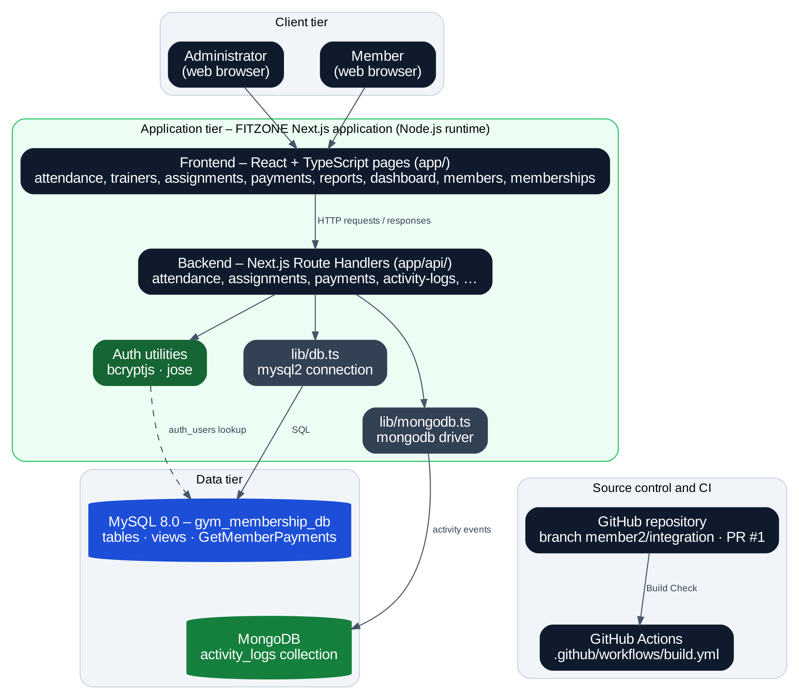
Figure 4.1: High-level architecture of FITZONE

4.2 Frontend Architecture
The frontend is built with Next.js, React and TypeScript. Each module has its own page under the app/ directory, including attendance/, trainers/, assignments/, payments/ and reports/, together with the dashboard, member and membership pages. Pages present forms, tables, summary cards and search boxes, and communicate with the backend through the application’s API routes. The interface uses a dark navy sidebar with a green active-item highlight, light content cards and coloured status badges.

4.3 Backend and API Architecture
Server-side logic is implemented as Next.js Route Handlers under app/api/. The documented route directories are attendance/, assignments/, payments/ and activity-logs/, with further routes for the other modules. Handlers obtain a MySQL connection from lib/db.ts (built on mysql2) and a MongoDB connection from lib/mongodb.ts (built on the mongodb driver). Chapter 8 describes the routes in more detail.

4.4 Database Architecture
MySQL 8.0 hosts the database gym_membership_db. It contains seven core tables (Member, Membership_Plan, Membership, Trainer, Trainer_Assignment, Attendance, Payment), the authentication table auth_users, reporting views and the stored procedure GetMemberPayments. MongoDB hosts the collection activity_logs in a database of the same name. Chapter 6 gives the full design.

4.5 Authentication Flow
Authentication relies on the auth_users table, bcryptjs for verifying passwords against stored hashes and jose for creating a signed session token, with the signing secret read from AUTH_SECRET. Figure 4.2 shows the flow assembled from these documented components.
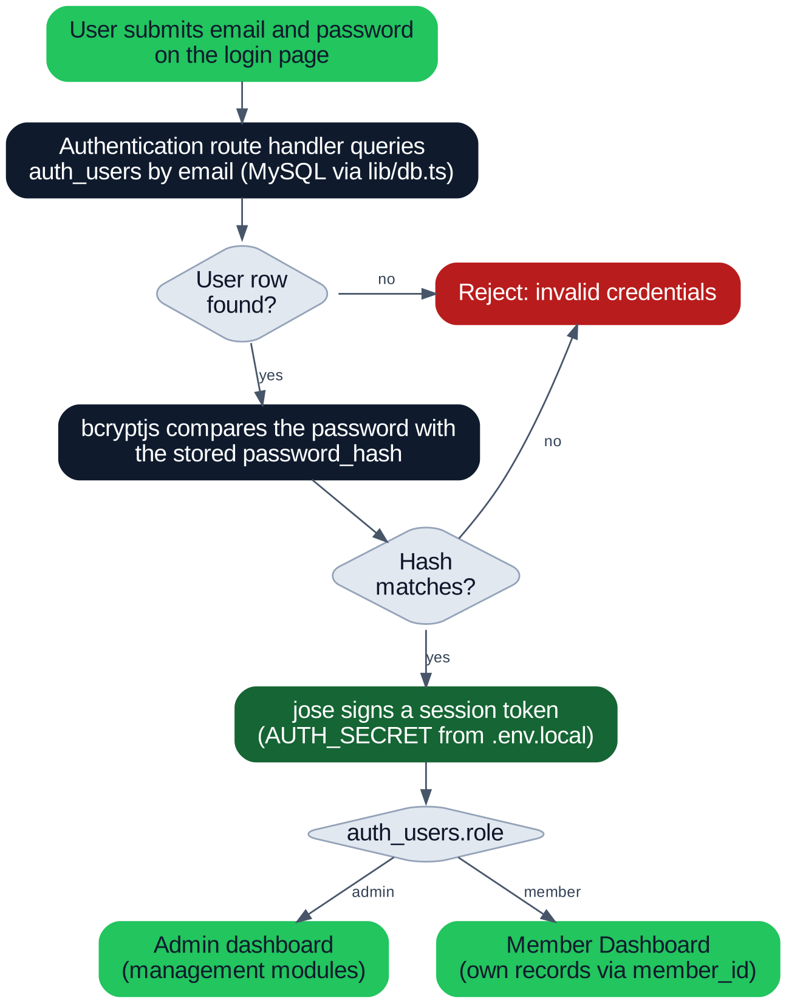
Figure 4.2: Authentication flow
Note. The diagram shows the steps implied by the documented components. The exact route name, where the session token is stored and how each page enforces the role are implementation details that were not part of the supplied evidence.

4.6 MongoDB Integration
When an attendance record is created, the attendance API inserts the row in MySQL and then attempts to write a corresponding Check-in document to the activity_logs collection. MongoDB errors are handled separately, so the relational record remains the source of truth. A stored document contains member_id, activity, timestamp and details (which includes the attendance ID).

4.7 Interaction between Frontend, APIs, MySQL and MongoDB
Figure 4.3 is a Level-1 data flow diagram of the system. Administrators and members enter through authentication; administrators exercise the management processes, which read and write MySQL; attendance additionally emits an event to MongoDB; reports and the member view read from the stored data.
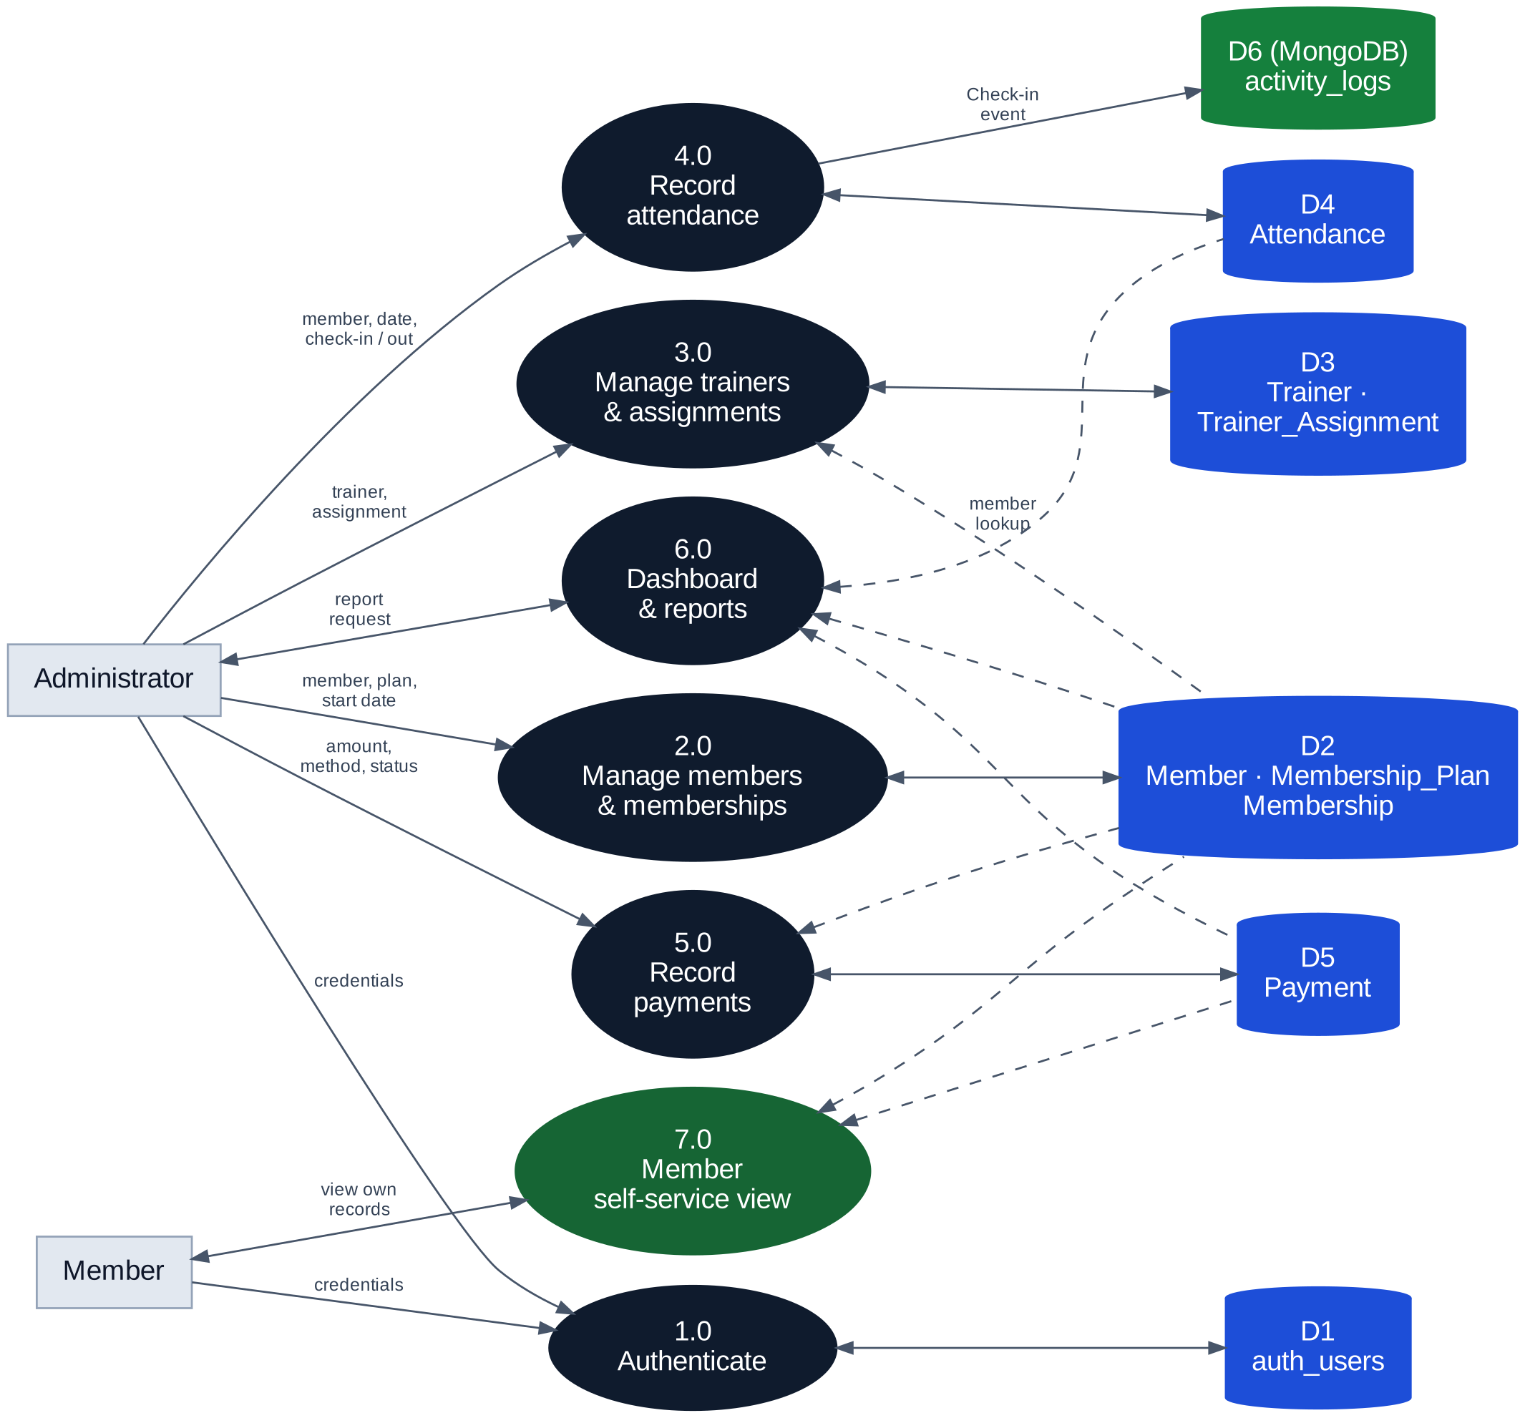
Figure 4.3: Level-1 data flow diagram

4.8 Application Workflow
Figure 4.4 summarises the common path through the application: sign in, open the dashboard, choose a module, submit a form, have the request validated, persist the change in MySQL (with the extra MongoDB step for attendance) and see the refreshed list or totals. Reports are read-only.
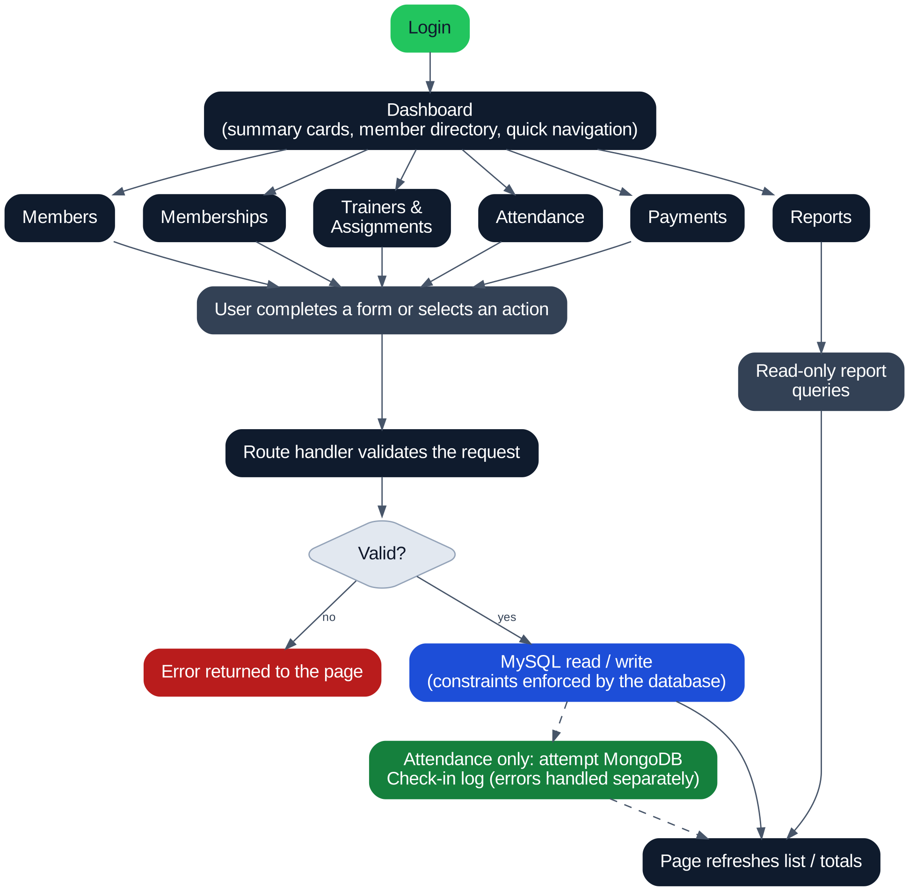
Figure 4.4: Application workflow

4.9 Configuration and Secrets
Database credentials and AUTH_SECRET are stored in a local .env.local file. This file must not be committed to the repository or shown in screenshots.

5. Technology Stack
Table 5.1 lists the technologies documented for FITZONE and the role each plays. Versions are given only where they are recorded in the project materials.
Table 5.1: Technologies used in FITZONE
Technology | Version | Role in the system | Where used
Next.js | 16.4.2 | Full-stack framework: pages, Route Handlers and the production build (30 static pages generated in the verified build). | app/, app/api/
React | Not recorded | Component-based user interface: forms, tables, cards. | app/ pages
TypeScript | Not recorded | Typed source code; type checks run during the build. | Whole project
Node.js | Not recorded | Server runtime for Next.js and the database drivers. | Runtime
MySQL | 8.0 | Primary relational database gym_membership_db: tables, constraints, views, stored procedure. | SQL scripts, lib/db.ts
mysql2 | Not recorded | MySQL driver used by the server code. | lib/db.ts
MongoDB | Not recorded | Document database for the activity_logs collection. | lib/mongodb.ts
mongodb (driver) | Not recorded | Official Node.js driver for MongoDB. | lib/mongodb.ts
bcryptjs | Not recorded | Verification of password hashes. | Authentication
jose | Not recorded | Creation and verification of signed session tokens. | Authentication
npm | Not recorded | Dependency management. | package.json, package-lock.json
ESLint | Not recorded | Static code analysis. A repository-wide run still reports issues in other or shared files. | Development
Git and GitHub | — | Version control; branch member2/integration; Pull Request #1. | Repository
GitHub Actions | — | Automated “Build Check” workflow. | .github/workflows/build.yml
VS Code, PowerShell, MySQL CLI, mongosh | — | Development, database inspection and verification. | Developer workstations

Not part of the verified stack. No vector database, embedding pipeline or similarity query is used. Tailwind CSS is not confirmed by the supplied evidence; it is deliberately not listed and should be added only if package.json shows it as a dependency.

6. Database Design and Implementation

6.1 Overview
The relational design is centred on the Member table. Memberships link members to plans, payments link to memberships, attendance and trainer assignments link to members, and trainers link to assignments. The authentication table optionally links an account to a member. Column definitions below are taken from the DESCRIBE output where it was captured (Member, Membership_Plan, Membership, Trainer) and from the team’s ER diagram and report text for the remaining tables.
Table 6.1: Database object summary
Object | Kind | Purpose | Primary key | Foreign keys
Member | Table | Member profiles | member_id | —
Membership_Plan | Table | Plan catalogue (duration, price) | plan_id | —
Membership | Table | A member’s plan and period | membership_id | member_id → Member  plan_id → Membership_Plan
Attendance | Table | Check-in and check-out records | attendance_id | member_id → Member
Trainer | Table | Trainer directory | trainer_id | —
Trainer_Assignment | Table | Trainer-to-member assignments | assignment_id | trainer_id → Trainer  member_id → Member
Payment | Table | Payments against memberships | payment_id | membership_id → Membership
auth_users | Table (setup script) | Login accounts | user_id | member_id → Member  (ON DELETE SET NULL)
daily_attendance_report | View | Attendance reporting | — | —
payment_report | View | Payment reporting | — | —
member_membership_report | Reporting object | Listed in the schema output; definition not captured | — | —
GetMemberPayments | Stored procedure | Returns a member’s payment records | — | —

Evidence note. The supplied SHOW TABLES output lists nine objects: attendance, auth_users, Member, member_membership_report, Membership, Membership_Plan, payment, trainer and trainer_assignment. daily_attendance_report and payment_report are queried in the project report but do not appear in that particular listing, so their presence should be re-checked with SHOW FULL TABLES.

6.2 Entity-Relationship Diagram
Figure 6.1 shows the entity-relationship diagram supplied by the project team. Rectangles are entities (tables), diamonds are relationships, ovals are attributes, and cardinalities are written as 1 and N. Primary keys are underlined and foreign keys are in italics. The MongoDB ACTIVITY_LOG collection is drawn inside a dashed box, linked to AUTH_USERS by the dashed relationship “generates”.
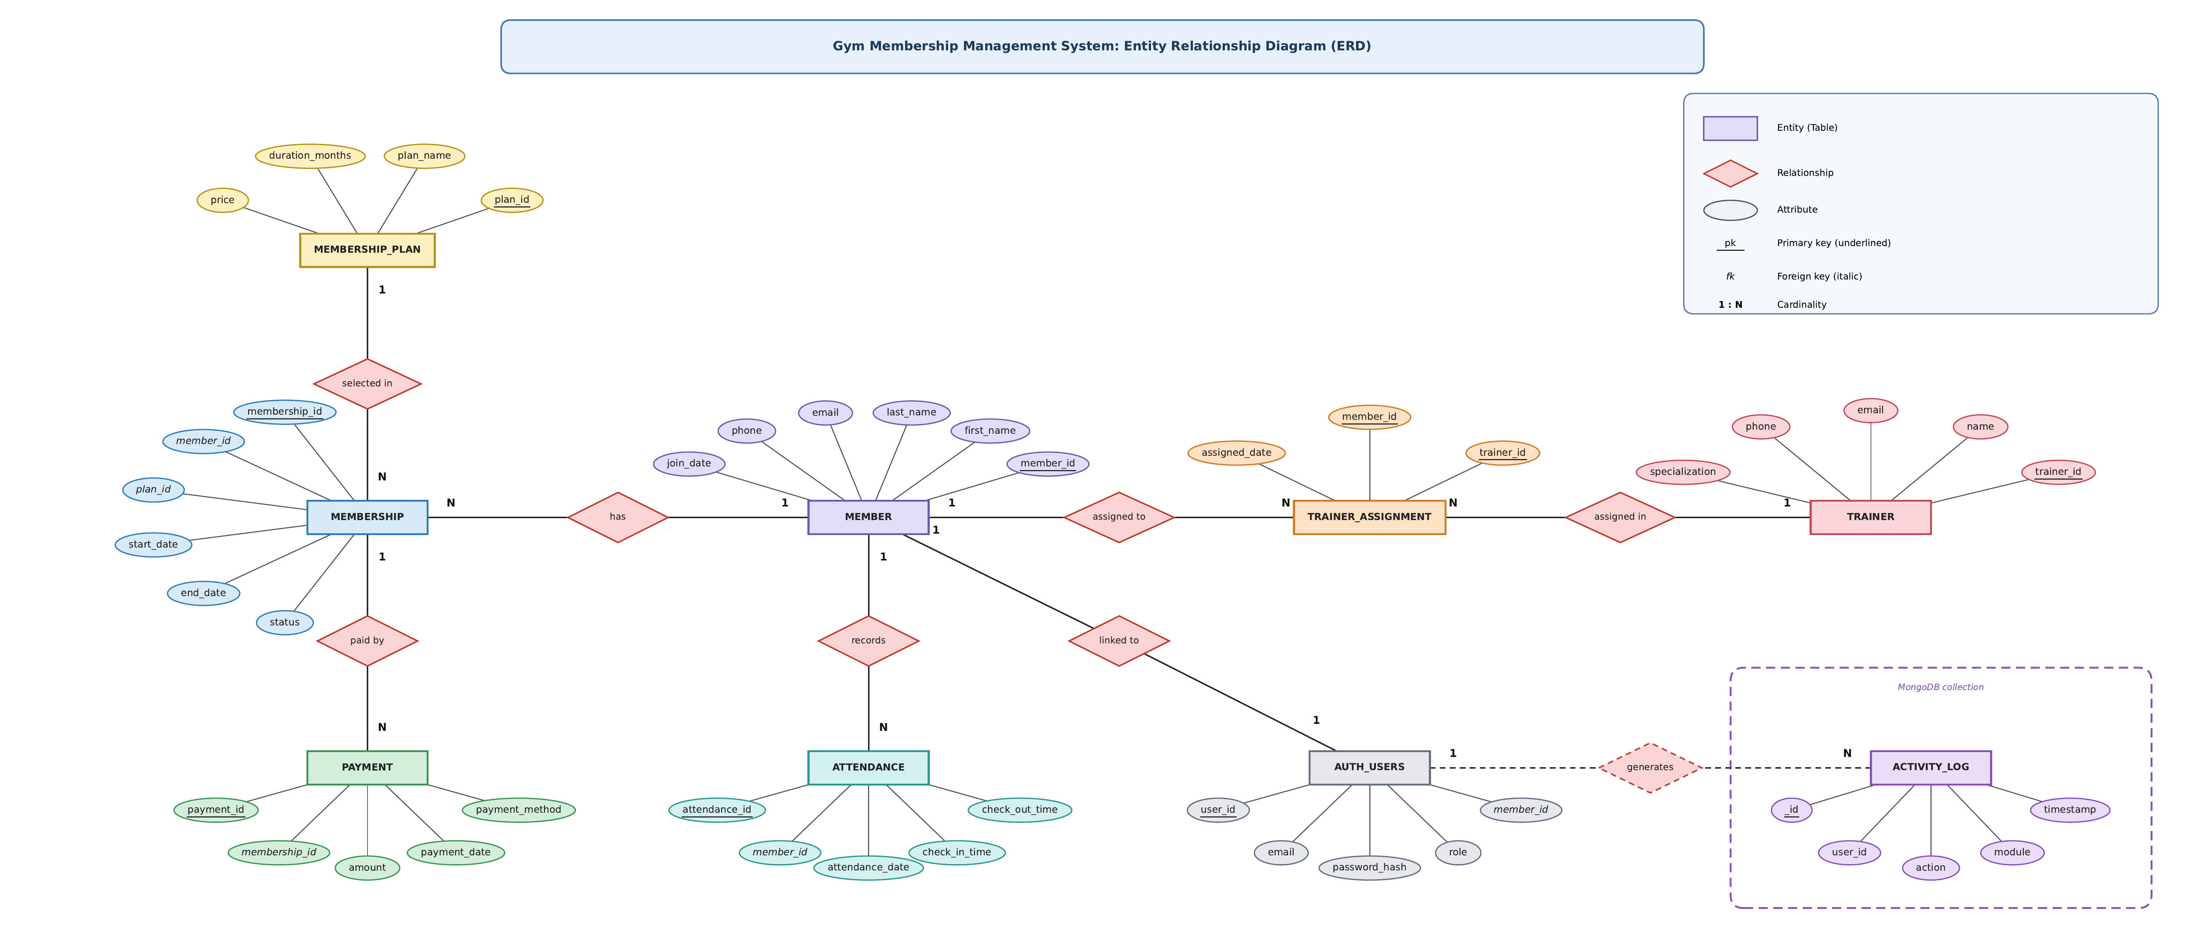
Figure 6.1: Entity-relationship diagram of the Gym Membership Management System (team ERD)

Table 6.2: Relationships
Parent (one) | Child (zero or many) | Foreign key | Meaning
Member | Membership | Membership.member_id | A member can hold many memberships over time.
Membership_Plan | Membership | Membership.plan_id | A plan can be chosen for many memberships.
Membership | Payment | Payment.membership_id | A membership can have many payments.
Member | Attendance | Attendance.member_id | A member can have many attendance records.
Member | Trainer_Assignment | Trainer_Assignment.member_id | A member can be assigned through many assignment rows.
Trainer | Trainer_Assignment | Trainer_Assignment.trainer_id | A trainer can take many assignments.
Member | auth_users | auth_users.member_id (unique) | At most one login account per member; ON DELETE SET NULL.

6.3 Table Definitions

6.3.1 Members
Table 6.3: Member table (from DESCRIBE)
Column | Data type | Key | Constraints and notes
member_id | INT | PK | NOT NULL, AUTO_INCREMENT
full_name | VARCHAR(100) |  | NOT NULL
email | VARCHAR(100) | UNI | NOT NULL, unique
phone | VARCHAR(15) | UNI | NOT NULL, unique
gender | VARCHAR(20) |  | NULL allowed
join_date | DATE |  | NOT NULL, default CURDATE()
created_at | TIMESTAMP |  | NULL allowed, default CURRENT_TIMESTAMP

6.3.2 Membership Plans
Table 6.4: Membership_Plan table (from DESCRIBE)
Column | Data type | Key | Constraints and notes
plan_id | INT | PK | NOT NULL, AUTO_INCREMENT
plan_name | VARCHAR(50) | UNI | NOT NULL, unique
duration_months | INT |  | NOT NULL
price | DECIMAL(10,2) |  | NOT NULL
description | VARCHAR(255) |  | NULL allowed

The application shows four plans: Monthly (1 month, ₹1,500), Quarterly (3 months, ₹4,500), Half-Yearly (6 months, ₹7,500) and Yearly (12 months, ₹12,000).

6.3.3 Memberships
Table 6.5: Membership table (from DESCRIBE)
Column | Data type | Key | Constraints and notes
membership_id | INT | PK | NOT NULL, AUTO_INCREMENT
member_id | INT | MUL | NOT NULL, foreign key to Member
plan_id | INT | MUL | NOT NULL, foreign key to Membership_Plan
start_date | DATE |  | NOT NULL
end_date | DATE |  | NOT NULL (calculated from the plan duration in the interface)
status | ENUM('Active','Expired','Cancelled') | MUL | NOT NULL, default 'Active', indexed

6.3.4 Attendance
Table 6.6: Attendance table (from the team ER diagram and report text)
Column | Data type | Key | Constraints and notes
attendance_id | INT | PK | Primary key
member_id | INT | FK | References Member(member_id)
attendance_date | DATE |  | Date of the visit
check_in_time | TIME |  | Check-in time
check_out_time | TIME |  | NULL allowed; CHECK (check_out_time IS NULL OR check_out_time >= check_in_time)

6.3.5 Trainers
Table 6.7: Trainer table (from DESCRIBE)
Column | Data type | Key | Constraints and notes
trainer_id | INT | PK | NOT NULL, AUTO_INCREMENT
trainer_name | VARCHAR(100) |  | NOT NULL
specialization | VARCHAR(100) |  | NULL allowed
phone | VARCHAR(15) | UNI | NULL allowed, unique
email | VARCHAR(100) | UNI | NULL allowed, unique

6.3.6 Trainer Assignments
Table 6.8: Trainer_Assignment table (from the team ER diagram)
Column | Data type | Key | Constraints and notes
assignment_id | INT | PK | Primary key
trainer_id | INT | FK | References Trainer(trainer_id)
member_id | INT | FK | References Member(member_id)
assigned_date | DATE |  | Date the assignment started
end_date | DATE |  | NULL allowed (open-ended assignment)

6.3.7 Payments
Table 6.9: Payment table (from the team ER diagram and report text)
Column | Data type | Key | Constraints and notes
payment_id | INT | PK | Primary key
membership_id | INT | FK | References Membership(membership_id)
amount | DECIMAL(10,2) |  | CHECK (amount >= 0)
payment_date | DATE |  | Date of payment
payment_method | VARCHAR(30) |  | For example UPI
payment_status | VARCHAR(20) |  | CHECK status IN ('Pending', 'Completed', 'Failed', 'Refunded')

To confirm. The report text writes the status check on a column called status, while the ER diagram names the column payment_status. Confirm the exact column name against member2_integration.sql. For Attendance, Trainer_Assignment and Payment, DESCRIBE output was not among the supplied evidence, so data types follow the team ER diagram.

6.3.8 Authentication Users
The local script auth_users_setup.sql creates auth_users with the columns below. Data types were not captured in the supplied evidence and are therefore not stated.
Table 6.10: auth_users table (from the setup-script description)
Column | Constraints and notes
user_id | Primary key
full_name | Display name
email | Unique key; used as the login identifier
password_hash | bcrypt hash of the password
role | Role of the account (administrator or member)
member_id | Unique key; foreign key to Member(member_id), ON DELETE SET NULL
created_at | Creation timestamp

6.4 Referential Integrity
Foreign keys ensure that a membership refers to an existing member and plan, a payment to an existing membership, attendance to an existing member, and an assignment to an existing trainer and member. The only delete rule captured in the evidence is on auth_users.member_id, which is set to NULL if the member is deleted, so a login account is never left pointing at a missing member. Delete and update rules for the other keys were not captured and should be read from the SQL scripts.

6.5 Constraints and Validation
Table 6.11: Constraints and validation rules
Constraint | Table | Rule | Layer
Primary key, auto-increment | All tables | Surrogate integer identifiers. | Database
UNIQUE | Member | email and phone cannot repeat. | Database
UNIQUE | Membership_Plan | plan_name cannot repeat. | Database
UNIQUE | Trainer | phone and email cannot repeat (NULL allowed). | Database
UNIQUE | auth_users | email and member_id cannot repeat. | Database
ENUM and default | Membership | status limited to Active, Expired, Cancelled; default Active. | Database
CHECK | Attendance | check-out must be NULL or not earlier than check-in. | Database and API
CHECK | Payment | amount must be non-negative. | Database
CHECK | Payment | status must be Pending, Completed, Failed or Refunded. | Database
Foreign keys | See Table 6.2 | Child rows must reference an existing parent row. | Database

6.6 Views and Stored Procedures
Table 6.12: Reporting objects
Object | Kind | Documented use
daily_attendance_report | View | Queried with SELECT * FROM daily_attendance_report; for attendance reporting.
payment_report | View | Queried with SELECT * FROM payment_report; for payment reporting.
member_membership_report | Reporting object | Appears in the schema listing; its definition was not captured.
GetMemberPayments(member_id) | Stored procedure | Accepts a member identifier and returns that member’s payment records: CALL GetMemberPayments(1);.

To confirm. View definitions are not reproduced because they were not part of the supplied evidence. Whether the Reports page reads these views directly or aggregates through route handlers should be confirmed from the source.

6.7 Normalisation
The following analysis is based on the captured schema.
- First normal form: every column holds a single atomic value, and each table has a primary key.
- Second normal form: every table uses a single-column surrogate key, so partial dependencies cannot occur.
- Third normal form: non-key attributes depend on the key and not on one another. Plan price and duration live only in Membership_Plan, member contact data only in Member, trainer contact data only in Trainer, and payments reference a membership rather than copying member or plan details.
- Controlled redundancy: Membership.end_date can be derived from start_date and the plan duration. It is stored deliberately so that expiry queries and reports stay simple, and the interface calculates it from the selected plan.

6.8 MongoDB Activity Logging
The activity_logs collection in gym_membership_db stores operational events that do not need relational structure. Its purpose is to keep a lightweight audit trail of activity alongside the relational data. Inspected documents contain member_id, activity (for example “Check-in”), timestamp and details, where details includes the attendance ID.
Table 6.13: MongoDB verification observed on the local service
Check | Observation
Service | Local MongoDB service running; ping returned { ok: 1 }.
Database and collection | gym_membership_db contained the activity_logs collection.
Document count | 6 documents at the time of inspection (observed, not forced).
Latest document | A Check-in event for member_id 11 with Attendance ID 14 in details.
Coverage | Verified for attendance only; trainer, assignment and payment actions were not shown to create documents.

7. Application Modules and Functionalities
This chapter describes each module of FITZONE as evidenced by the application screenshots, database inspection and project report. Where route-level details were not part of the supplied evidence, the profile says so rather than assuming behaviour. Figures show the live interface at the time of capture.

7.1 Dashboard
Table 7.1: Dashboard module profile
Aspect | Description
Purpose | Landing page giving an at-a-glance operational summary and navigation to every module.
Main functions | Summary cards for Total Members, Active Memberships, Memberships Expiring Soon (within 7 days), Total Trainers, Completed Payments and Pending Payments; a Member Directory with plan and status; Quick Navigation cards; a “Live Database Data” indicator.
User interaction | Search the member directory, open a module from the sidebar or quick-navigation cards, log out.
Backend / API | Figures are loaded server-side from the database. Dashboard-specific route handlers were not itemised in the supplied tree.
Database interaction | Counts and totals drawn from Member, Membership, Trainer and Payment data.
Validation / errors | Read-only page; no data entry.

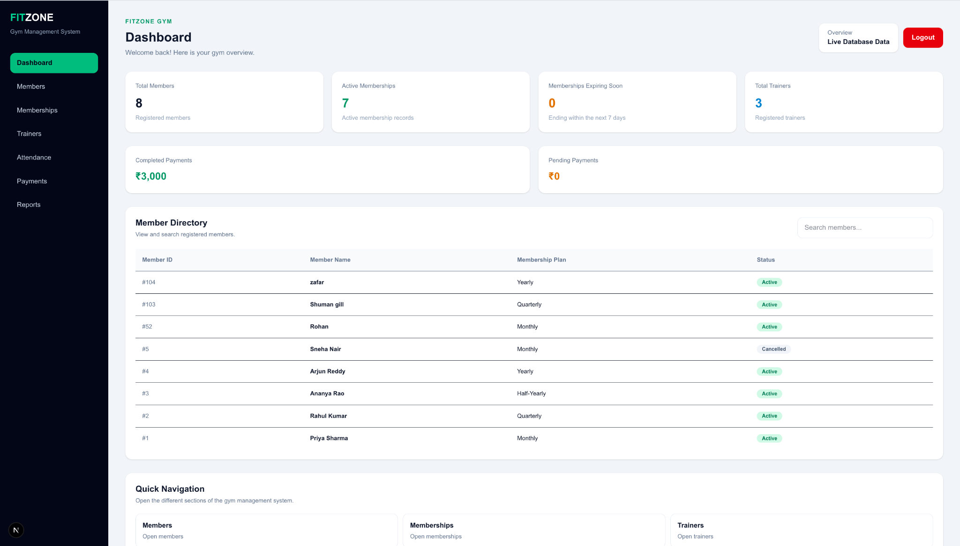
Figure 7.1: Administrator dashboard

7.2 Member Management
Table 7.2: Member management module profile
Aspect | Description
Purpose | Register gym members and look them up.
Main functions | Add New Member form (Full Name, Email, Phone, Gender) and a Member Directory (ID, Name, Email, Phone, Gender) with the number of members displayed.
User interaction | Fill in the form and choose “+ Add Member”; search the directory by name or email.
Backend / API | Member routes under app/api/; method-level detail not itemised in the supplied tree.
Database interaction | Inserts into and reads from Member; join_date and created_at take database defaults.
Validation / errors | NOT NULL on name, email and phone; UNIQUE on email and phone, so duplicates are rejected by the database.

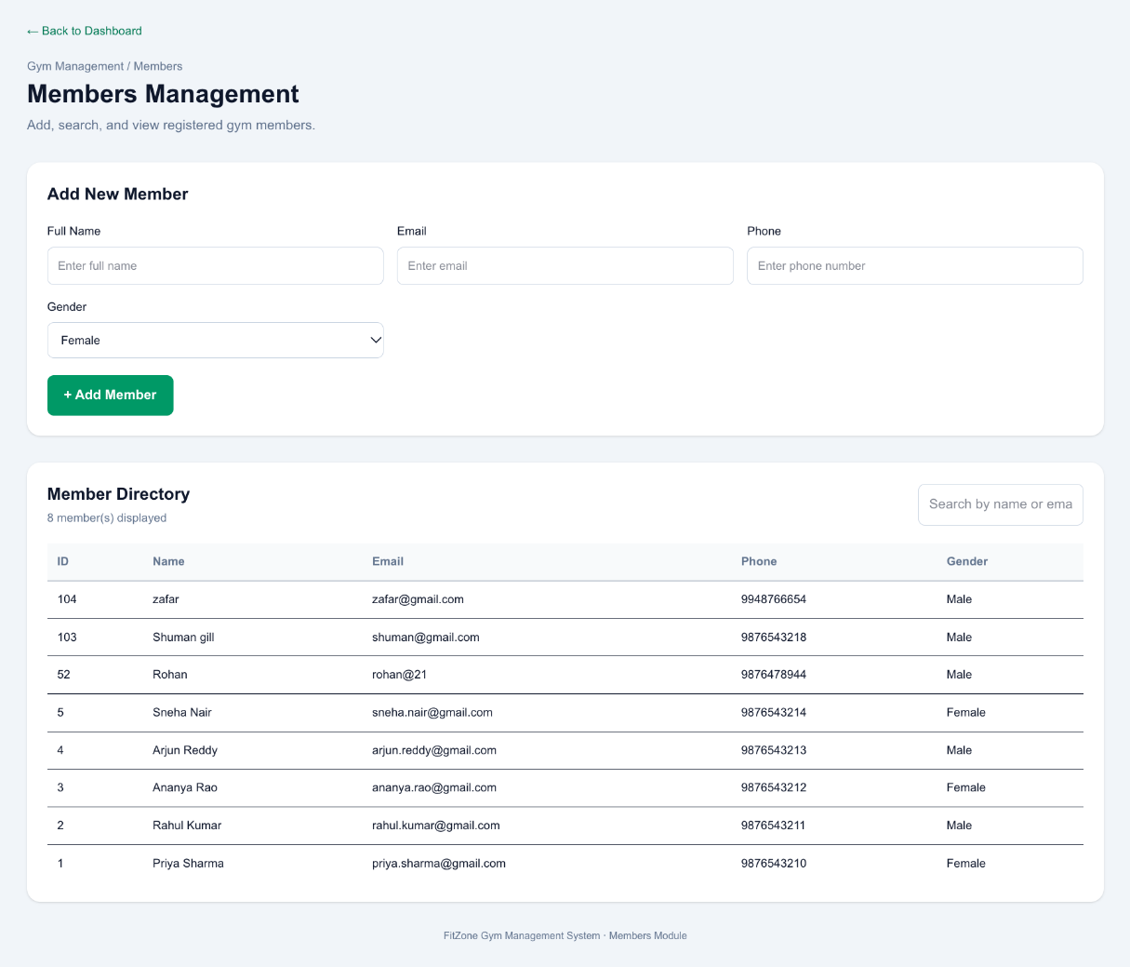
Figure 7.2: Members Management page
Observation. One directory entry has an email value without a domain (“rohan@21”). This suggests that email-format validation is not enforced on every entry path, or that the row was inserted directly. It should be checked and, if confirmed, listed as a limitation.

7.3 Membership Plan Management
Table 7.3: Membership plan module profile
Aspect | Description
Purpose | Define the plans a gym offers, with duration and price.
Main functions | Plans are stored in Membership_Plan and offered in the plan selector of the Membership page: Monthly, Quarterly, Half-Yearly and Yearly.
User interaction | The administrator chooses a plan when assigning a membership. A separate screen for creating or editing plans is not evidenced.
Backend / API | Plan data is read for the selector and membership listing; route detail not itemised.
Database interaction | Membership_Plan (plan_id, plan_name, duration_months, price, description).
Validation / errors | plan_name is unique; duration_months and price are NOT NULL; price is DECIMAL(10,2).

7.4 Membership Management
Table 7.4: Membership management module profile
Aspect | Description
Purpose | Assign plans to members and track membership periods and status.
Main functions | Assign a Membership form (Select Member, Membership Plan, Start Date, read-only Calculated End Date) and an All Memberships table (ID, Member, Plan with duration, Price, Start, End, Status) with a Refresh button and record count.
User interaction | Choose a member and a plan, set the start date, assign; change the status from the status control in the table.
Backend / API | Membership routes under app/api/; method-level detail not itemised.
Database interaction | Writes to and reads from Membership, joined to Member and Membership_Plan.
Validation / errors | Foreign keys on member and plan; status limited to Active, Expired or Cancelled; end date derived from the plan duration.

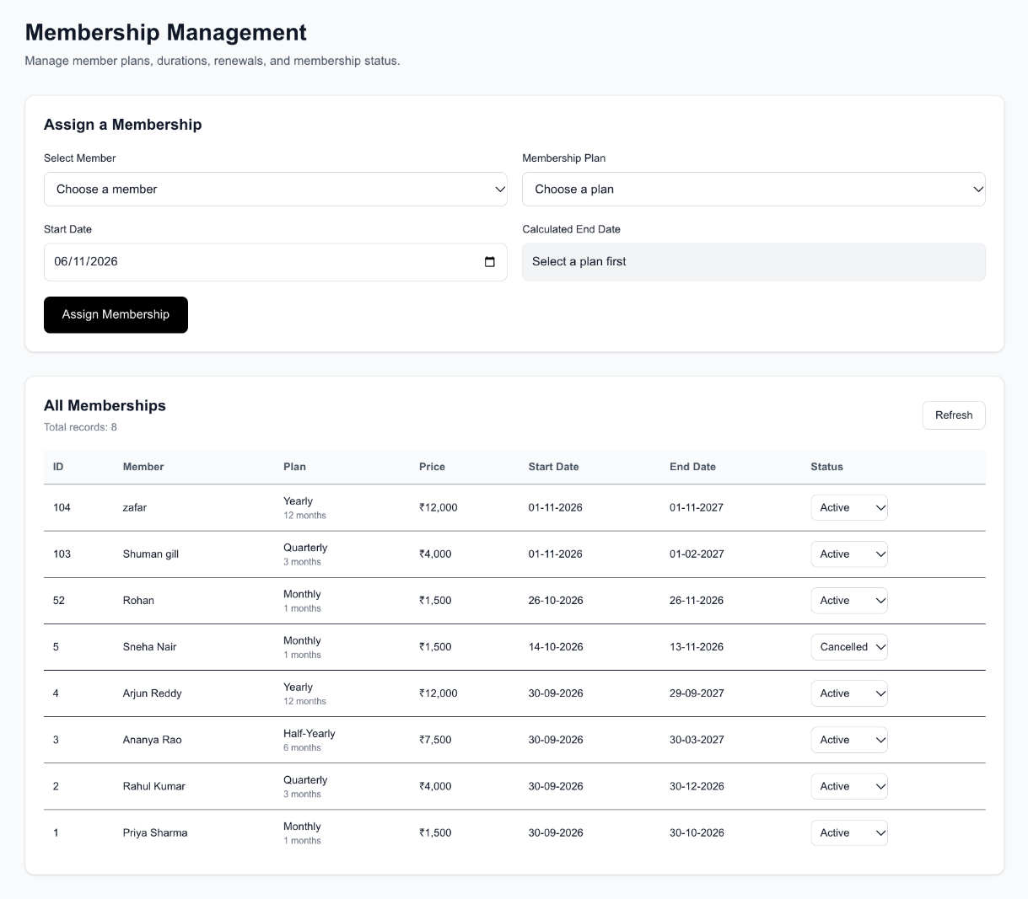
Figure 7.3: Membership Management page

7.5 Attendance Management
Table 7.5: Attendance module profile
Aspect | Description
Purpose | Record member check-ins and optional check-outs.
Main functions | Record Attendance form (Member, Attendance date, Check-in time, optional Check-out time) and an Attendance Records table (Member, Date, Check-in, Check-out, Status) with search by member or date.
User interaction | Select a member, enter date and times, choose “+ Record Attendance”; records appear with a “Present” status and “—” when no check-out was given.
Backend / API | app/api/attendance: validates the submitted values, inserts the attendance row in MySQL, then attempts to write a Check-in document to MongoDB.
Database interaction | Attendance (FK to Member) in MySQL; activity_logs in MongoDB.
Validation / errors | API validation plus the CHECK constraint on check-out time. MongoDB logging errors are handled separately from the MySQL insert.

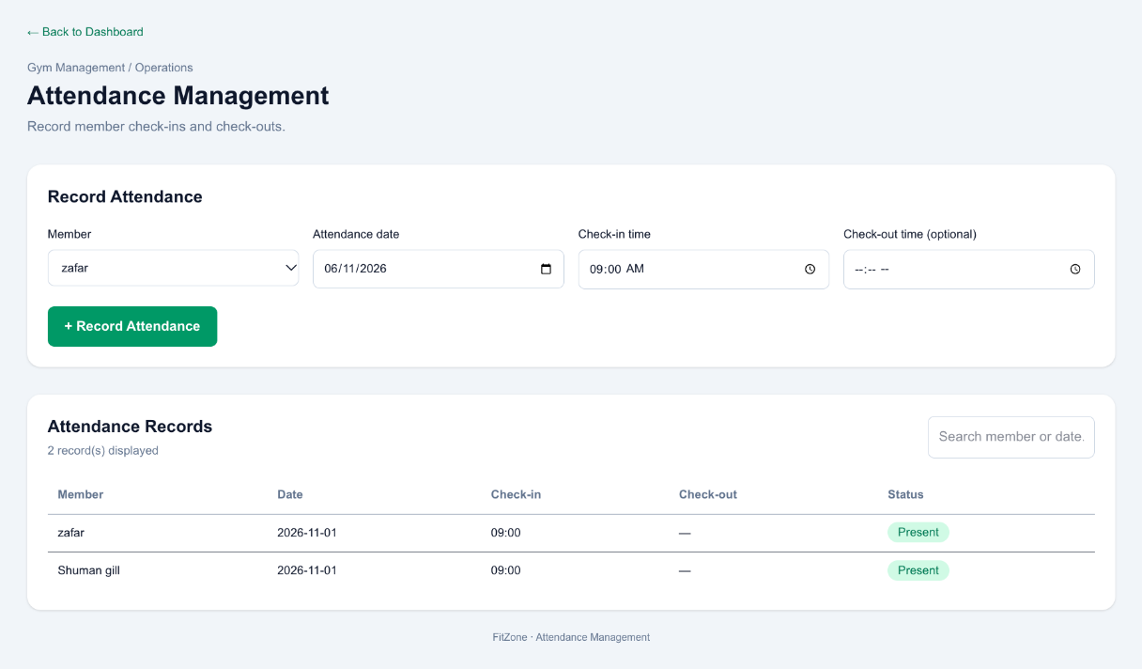
Figure 7.4: Attendance Management page

7.6 Trainer Management
Table 7.6: Trainer management module profile
Aspect | Description
Purpose | Maintain the trainer directory.
Main functions | Summary cards (Total Trainers, Active Trainers, Assignments); Add a Trainer form (name, specialization, phone, email); Trainer Directory with specialization, contact details, assigned-member count and status; search.
User interaction | Enter trainer details and choose “+ Add Trainer”; search the directory.
Backend / API | Trainer data operations run through route handlers; the exact route was not itemised in the supplied tree.
Database interaction | Trainer; assigned-member counts come from Trainer_Assignment.
Validation / errors | trainer_name is required; phone and email are unique. The Trainer table has no status column, so the “Active” label is presented by the application and should be confirmed as derived rather than stored.

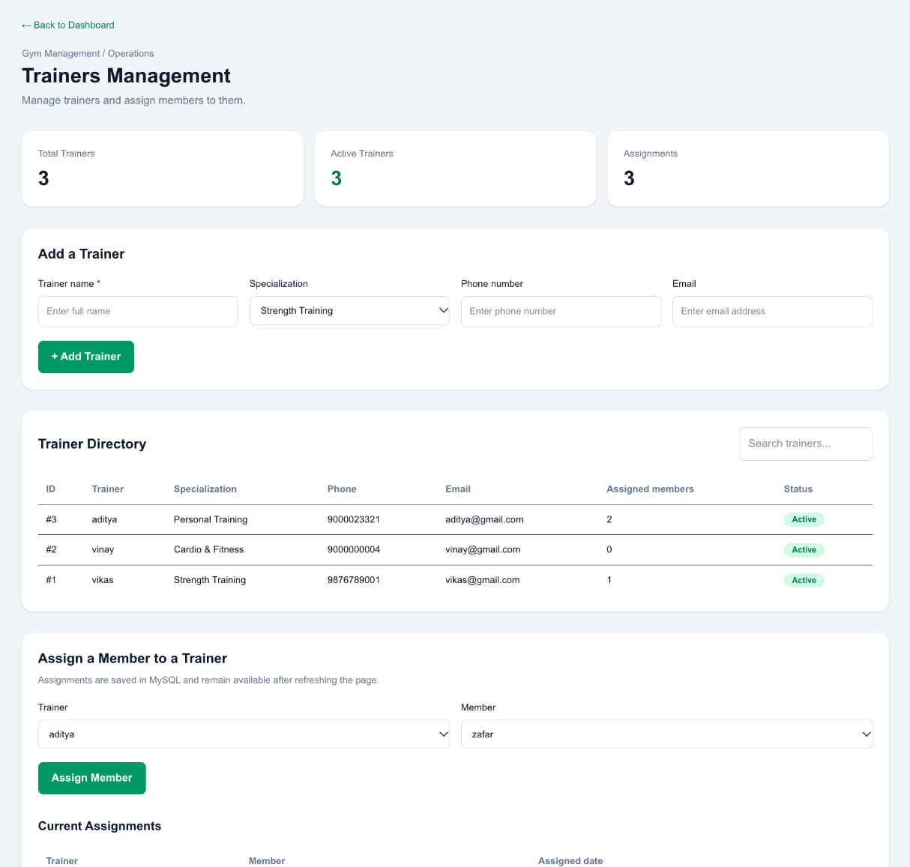
Figure 7.5: Trainers Management page, including the assignment section

7.7 Trainer Assignment Management
Table 7.7: Trainer assignment module profile
Aspect | Description
Purpose | Link members to trainers and show current assignments.
Main functions | Assign a Member to a Trainer (trainer and member selectors, “Assign Member”) and a Current Assignments list (Figure 7.5). The page states that assignments are saved in MySQL and remain available after refreshing.
User interaction | Choose a trainer and a member, then assign.
Backend / API | app/api/assignments, with a corresponding page under app/assignments/.
Database interaction | Trainer_Assignment (assigned_date, optional end_date) with foreign keys to Trainer and Member.
Validation / errors | Foreign keys require an existing trainer and member. Any rule preventing duplicate active assignments was not documented.

7.8 Payment Management
Table 7.8: Payment module profile
Aspect | Description
Purpose | Record payments against memberships and review payment history.
Main functions | Summary cards (Completed Revenue, Pending Payments); Record a Payment form (Membership/Member, Amount, Payment date, Method, Status); Payment History with search.
User interaction | Select a membership, enter amount, date, method and status, choose “+ Record Payment”.
Backend / API | app/api/payments.
Database interaction | Payment (FK to Membership); GetMemberPayments returns payments per member.
Validation / errors | CHECK amount >= 0; CHECK status in Pending, Completed, Failed, Refunded.

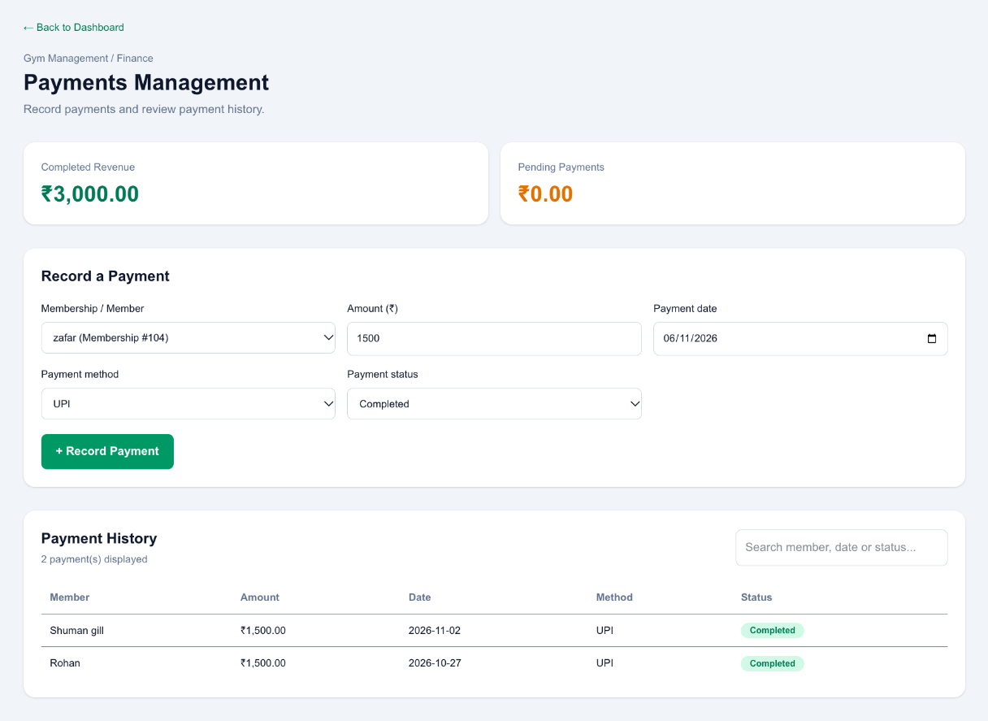
Figure 7.6: Payments Management page

7.9 Reports and Analytics
Table 7.9: Reports module profile
Aspect | Description
Purpose | Give administrators a consolidated view of attendance and payments.
Main functions | Summary cards (Total Members, Total Trainers, Completed Payments, Pending Payments); Attendance Report by date with Total Check-ins; Payment Report with an “All Payments” status filter; a “Live database records” footer.
User interaction | Open the page, review totals, filter payments by status.
Backend / API | Read-only report queries; routes not itemised in the supplied tree.
Database interaction | Reporting views daily_attendance_report and payment_report exist in the database; direct use by the page is not confirmed.
Validation / errors | Read-only; no data entry.

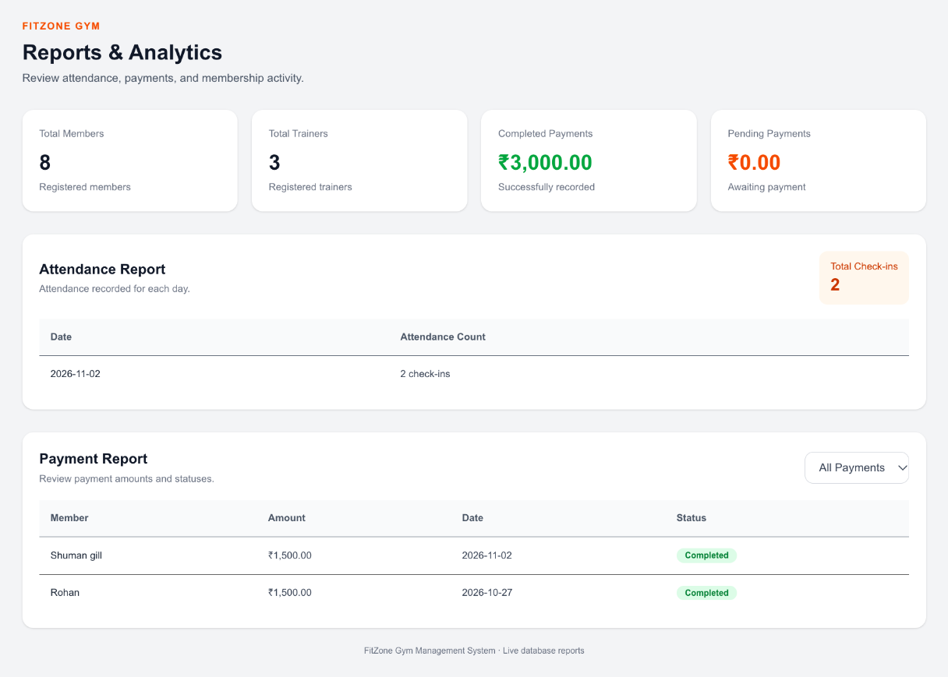
Figure 7.7: Reports and Analytics page

7.10 Authentication and User Management
Table 7.10: Authentication module profile
Aspect | Description
Purpose | Control access and connect a login to an administrator role or to a member.
Main functions | Email and password sign-in; password check against a bcrypt hash; signed session token; Logout button; Member Dashboard for member accounts.
User interaction | Sign in, work within the dashboard, log out.
Backend / API | Uses bcryptjs and jose; AUTH_SECRET read from .env.local.
Database interaction | auth_users (user_id, full_name, email, password_hash, role, member_id, created_at).
Validation / errors | Unique email and member_id; foreign key to Member with ON DELETE SET NULL. A self-registration screen is not evidenced.

Local versus shared setup. The local administrator account was created through auth_users_setup.sql and verified by logging in. The other team member used a separate local database. The local script must be compared with the shared authentication setup before merging or deploying. A test member email was absent from the local Member table, so member-account authentication remains pending.

7.11 Activity Logging
Table 7.11: Activity logging module profile
Aspect | Description
Purpose | Keep a lightweight event trail in MongoDB.
Main functions | Check-in events recorded when attendance is saved; documents hold member_id, activity, timestamp and details.
User interaction | None directly; events are created as a side effect of recording attendance.
Backend / API | Written from the attendance route through lib/mongodb.ts; a route directory app/api/activity-logs/ also exists, but its methods were not itemised.
Database interaction | MongoDB collection activity_logs.
Validation / errors | Errors are handled separately from the MySQL insert. Logging of trainer, assignment and payment actions is not established.

8. API and Backend Implementation

8.1 Overview
The backend is implemented with Next.js Route Handlers in app/api/. Handlers use lib/db.ts for MySQL and lib/mongodb.ts for MongoDB. Table 8.1 lists the route directories identified in the project tree and what is documented about each.
Table 8.1: API route directories and documented responsibilities
Route directory | Module | Documented responsibility | Verification
app/api/attendance | Attendance | Validates submitted attendance values; inserts the attendance row in MySQL; attempts a Check-in document in MongoDB. | Manually tested; MongoDB log observed
app/api/assignments | Trainer assignment | Stores and returns trainer–member assignments in MySQL. | Manually tested
app/api/payments | Payments | Records and returns payments in MySQL; amount and status protected by CHECK constraints. | Manually tested
app/api/activity-logs | Activity logging | Route directory for activity-log data in MongoDB. | Not separately tested
Other routes under app/api/ | Dashboard, members, memberships, trainers, reports, authentication | Present in the application (listed as “other pages and API routes”); not itemised in the supplied tree. | To be documented

Scope of this chapter. HTTP methods, request bodies and response codes for each handler are not reproduced because the route source files were not part of the supplied evidence. No endpoint or behaviour has been invented. Appendix C records the data stores each route is expected to use, and the checklist in Appendix D lists what should be added from the source.

8.2 Request and Response Handling
Pages send requests to the route handlers when a form is submitted or a list is loaded, and render the returned data in tables and cards. The attendance flow is the best documented: the handler receives the submitted member, date and times, validates them, writes to MySQL and then attempts the MongoDB log entry.

8.3 Database Operations
- MySQL: parameterised access through mysql2 for inserts, selects and joins across the core tables; reporting views and GetMemberPayments for reporting.
- MongoDB: insertion of Check-in documents into activity_logs through the mongodb driver.

8.4 Validation and Error Handling
- The attendance API validates submitted values before inserting.
- The database rejects rows that violate unique, foreign-key, ENUM or CHECK rules.
- MongoDB logging errors are handled separately so that a logging failure does not mask the outcome of the relational write.

8.5 Authentication and Authorisation
Credential checks use bcryptjs against password_hash in auth_users, and a session token is signed with jose using AUTH_SECRET. The supplied evidence does not state how individual routes verify the token or enforce the administrator and member roles; this should be confirmed from the source.

8.6 Frontend–Backend Integration
Each page under app/ corresponds to a module and talks to a matching route directory under app/api/ where one exists. Integration of the Member 2 modules with the shared application was carried out on branch member2/integration and verified by a local production build and by GitHub Actions (Chapter 10).

9. User Interface and Application Workflow
This chapter describes the workflows an administrator follows. Screenshots of each module are in Chapter 7; the figures here show navigation and the member view.

9.1 Login and Registration
- Open the application and enter the account email and password.
- The credentials are checked against the stored hash and a signed session is created.
- An administrator is taken to the dashboard; a member account is taken to the Member Dashboard.
Admin login to the dashboard was verified locally. A self-registration screen is not part of the evidenced implementation; accounts are created through the setup script.

9.2 Dashboard Navigation
The dark sidebar lists Dashboard, Members, Memberships, Trainers, Attendance, Payments and Reports, with the active item highlighted in green and the signed-in administrator shown at the bottom. The main area repeats these destinations as Quick Navigation cards. Assignments are managed from the Trainers page.
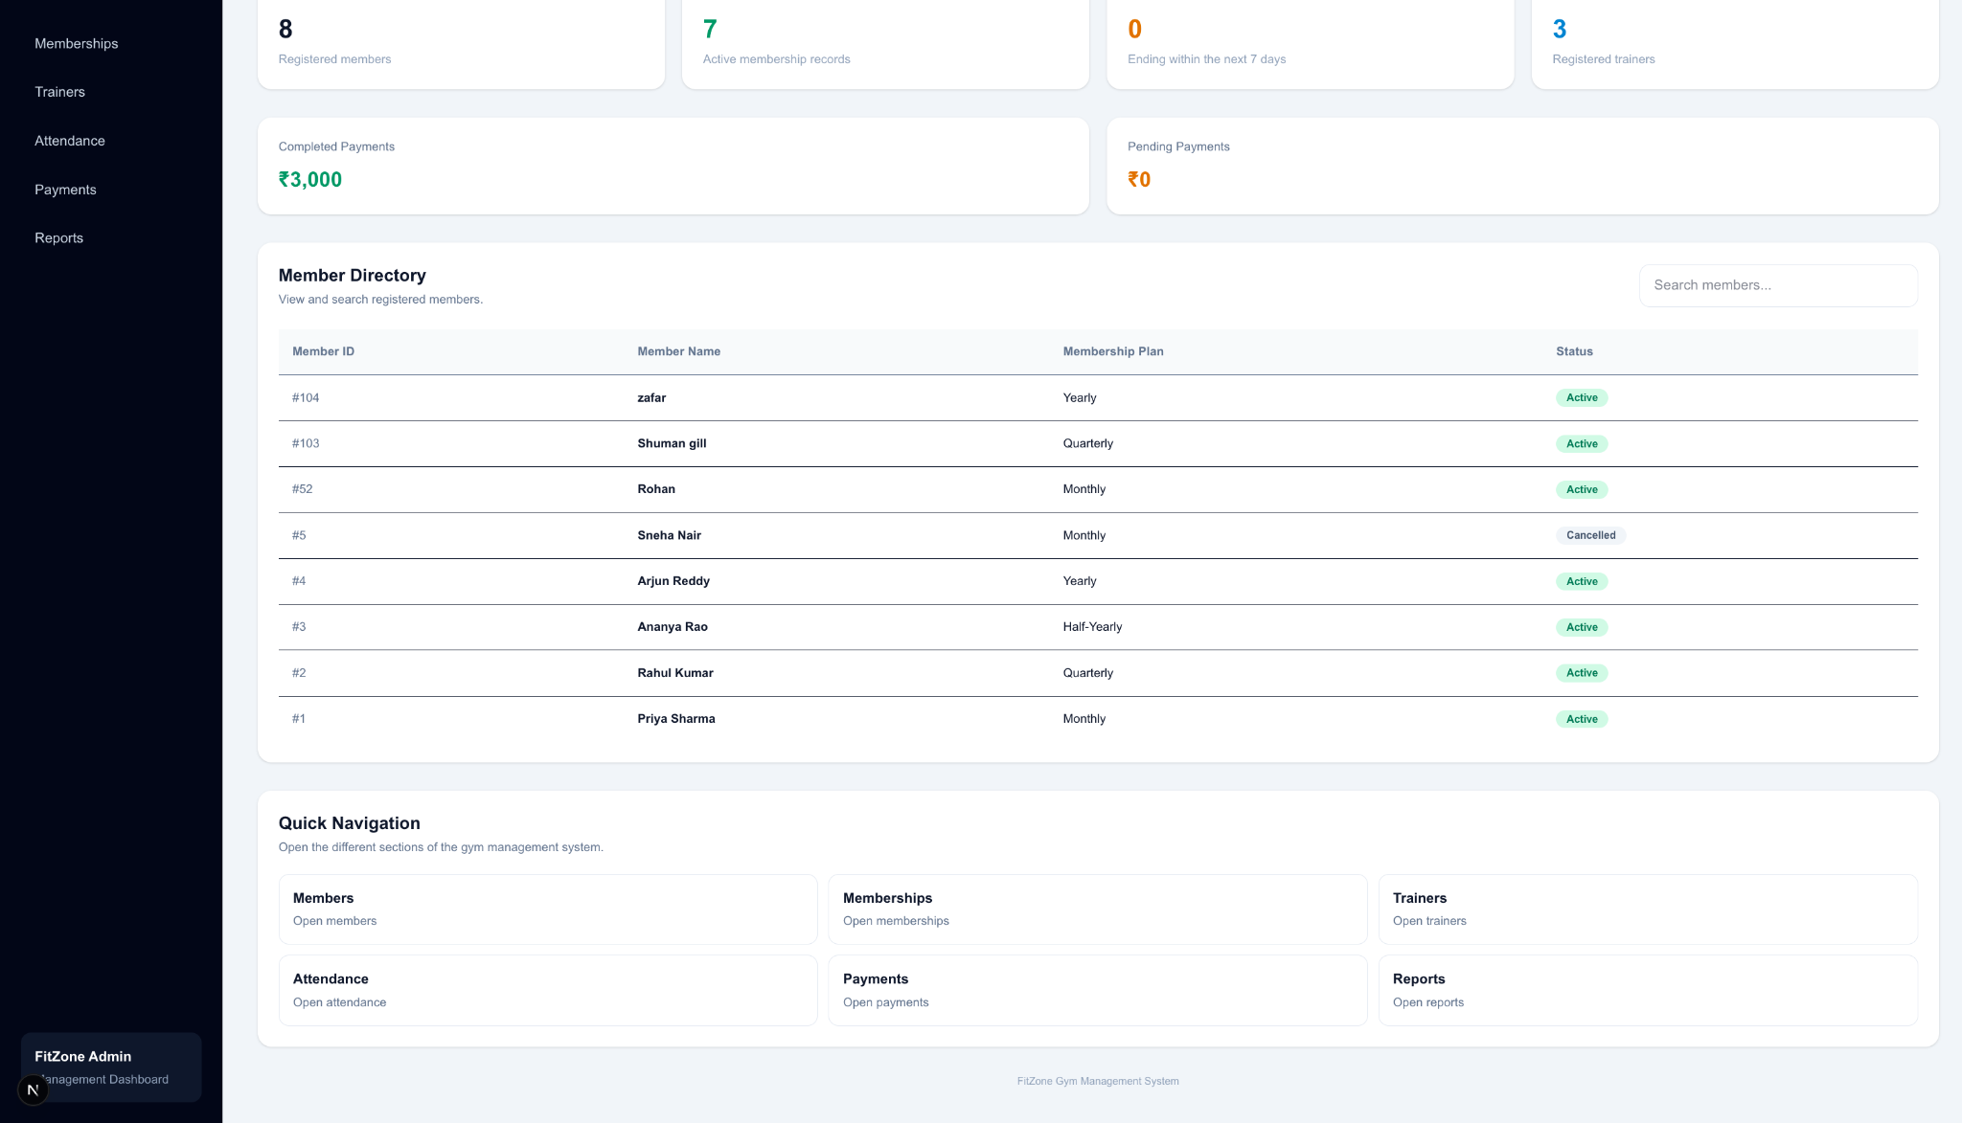
Figure 9.1: Dashboard sidebar and Quick Navigation cards

9.3 Member Management Workflow
- Open Members and complete Full Name, Email, Phone and Gender.
- Choose + Add Member; the new member appears in the Member Directory.
- Use the search box to find members by name or email.

9.4 Membership Workflow
- Open Memberships and choose a member and a plan.
- Select the start date; the end date is calculated and shown read-only.
- Choose Assign Membership; the record appears in All Memberships.
- Change the status from the status control when a membership expires or is cancelled.

9.5 Attendance Check-in and Check-out
- Open Attendance and select the member and date.
- Enter the check-in time and, if already known, the check-out time.
- Choose + Record Attendance. The record is listed with a Present status; a missing check-out shows as a dash.
- For a check-in, a Check-in activity document is also attempted in MongoDB.
Note. The supplied evidence shows check-out entered on the same form as check-in. How a check-out is added to an existing record later is not documented.

9.6 Trainer Assignment Workflow
- Open Trainers and add trainer details if the trainer is not yet listed.
- In Assign a Member to a Trainer, choose the trainer and the member.
- Choose Assign Member; the assignment appears under Current Assignments and the trainer’s assigned-member count updates.

9.7 Payment Workflow
- Open Payments and choose the membership or member.
- Enter the amount and payment date and choose the method and status.
- Choose + Record Payment; the entry appears in Payment History and the revenue cards update.

9.8 Reports Generation
- Open Reports to see the summary cards.
- Read the daily attendance counts in the Attendance Report.
- Use the status filter in the Payment Report to focus on completed, pending or other payments.

9.9 Member Self-Service View
A member account opens the Member Dashboard, which shows the member ID, plan and membership status, followed by My Memberships, My Attendance and My Payment History.
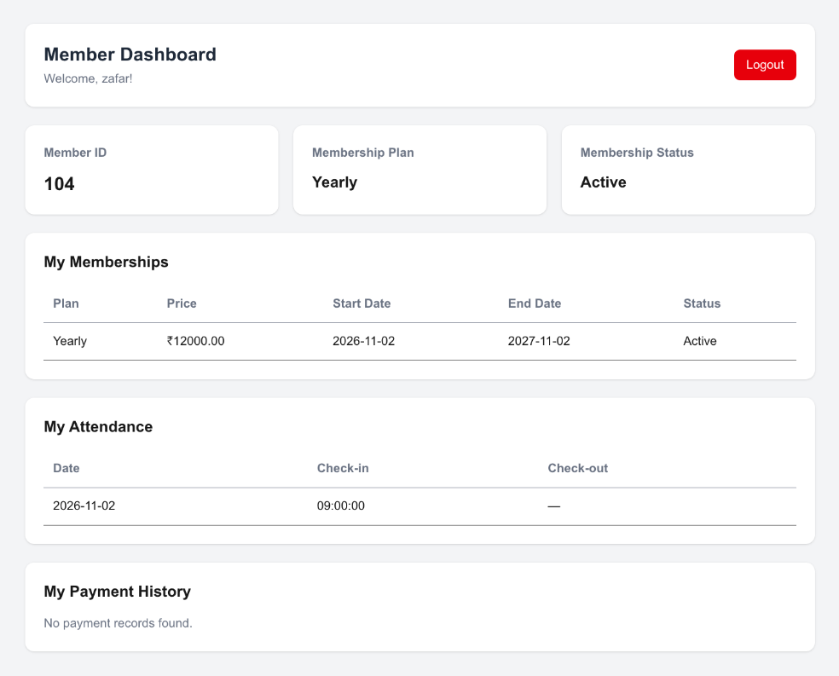
Figure 9.2: Member Dashboard

10. Testing and Validation

10.1 Testing Approach and Evidence Policy
Results in this chapter are limited to what is supported by evidence. Each row carries one of four statuses.
Table 10.1: Status legend
Status | Meaning
Passed | Supported by a recorded observation, build result or inspection output.
Manual | Tested manually by a team member; no detailed test log was supplied.
Pending | Not yet executed or not yet evidenced.
Open | An issue or unresolved check was identified.

10.2 Functional Testing
Table 10.2: Functional test cases
ID | Module | Test scenario | Expected result | Actual result | Status
TC-F01 | Attendance | Record attendance with member, date and check-in time. | Record saved and listed with Present status. | Page and action tested manually; records appear in the list. | Manual
TC-F02 | Attendance | Record attendance without a check-out time. | Record accepted; check-out shown as a dash. | Records without check-out are displayed with a dash. | Manual
TC-F03 | Trainers | Add a trainer with name, specialization, phone, email. | Trainer appears in the Trainer Directory. | Page and actions checked manually. | Manual
TC-F04 | Assignments | Assign a member to a trainer. | Assignment listed and stored in MySQL. | Checked manually; assigned-member counts shown in the directory. | Manual
TC-F05 | Payments | Record a completed payment. | Payment in history; revenue card updated. | Checked manually; completed revenue shows the recorded total. | Manual
TC-F06 | Reports | Open Reports and review totals. | Summary cards, attendance and payment reports render. | Section opened and checked by the contributor. | Manual

10.3 API Testing
Table 10.3: API test cases
ID | Module | Test scenario | Expected result | Actual result | Status
TC-A01 | Attendance API | Create an attendance record through the UI. | Row inserted in MySQL and Check-in document attempted in MongoDB. | Attendance UI tested; Check-in document observed in MongoDB. | Manual
TC-A02 | Attendance API | Submit invalid values (check-out before check-in). | Request rejected with an error. | Validation exists in the API; negative test not recorded. | Pending
TC-A03 | All routes | Automated API test suite. | Requests and responses verified per route. | No automated API tests were recorded. | Pending

10.4 Database Testing
Table 10.4: Database test cases
ID | Module | Test scenario | Expected result | Actual result | Status
TC-D01 | Schema | Run SHOW TABLES on gym_membership_db. | Core tables and reporting objects listed. | Nine objects listed (see Appendix B). | Passed
TC-D02 | Schema | DESCRIBE Member, Membership_Plan, Membership, Trainer. | Keys, unique keys, types and defaults shown. | Output captured and consistent with the design. | Passed
TC-D03 | Views and procedure | Inspect reporting views and GetMemberPayments. | Objects present and queryable. | Tables, views and procedure inspected locally. | Passed
TC-D04 | Views | List objects with SHOW FULL TABLES. | daily_attendance_report and payment_report listed as views. | These two names are absent from the supplied SHOW TABLES output. | Open

10.5 Integration Testing
Table 10.5: Integration test cases
ID | Module | Test scenario | Expected result | Actual result | Status
TC-I01 | Authentication | Sign in with the local administrator account. | Dashboard opens. | Login succeeded and the dashboard opened. | Passed
TC-I02 | Authentication | Sign in with a member account. | Member Dashboard opens. | The provided test email was absent from the local Member table. | Pending
TC-I03 | Attendance + MongoDB | Record attendance and inspect activity_logs. | A Check-in document exists. | Check-in documents observed; latest referenced Attendance ID 14. | Passed
TC-I04 | Logging coverage | Trainer, assignment and payment actions create MongoDB documents. | Documents created (if required). | Inspected code did not establish this; acceptance criterion to be confirmed. | Open
TC-I05 | Shared authentication | Compare auth_users script with the teammate’s version. | Schemas consistent. | Not yet compared; teammate used a separate local database. | Pending

10.6 Manual Testing
The contributor manually tested the five Member 2 sections (Attendance, Trainers, Trainer Assignments, Payments and Reports) and their actions in the running application. A detailed manual test log was not supplied; the functional rows above summarise the reported outcome. The test checks on MongoDB are listed below.
Table 10.6: MongoDB checks
ID | Module | Test scenario | Expected result | Actual result | Status
TC-M01 | MongoDB | Run ping against the local service. | ok: 1 | { ok: 1 } returned. | Passed
TC-M02 | MongoDB | List collections in gym_membership_db. | activity_logs present. | Collection present. | Passed
TC-M03 | MongoDB | Count documents in activity_logs. | Count reported. | 6 documents (observed, not forced). | Passed

10.7 Build Verification and GitHub Actions Checks
Table 10.7: Build and CI test cases
ID | Module | Test scenario | Expected result | Actual result | Status
TC-B01 | Build | Run the Next.js production build locally. | Compile and TypeScript checks pass. | Passed; 30 static pages generated. | Passed
TC-B02 | CI | GitHub Actions “Build Check” workflow. | Workflow succeeds. | Two successful Build Check runs reported. | Passed
TC-B03 | Lint | Run ESLint across the repository. | No errors. | Earlier repository-wide run reported remaining issues in other or shared files. | Open

10.8 Validation and Error-Handling Tests
The constraints below are present in the schema. Negative tests that deliberately violate them were not recorded, so they are listed as pending rather than as passed.
Table 10.8: Validation test cases
ID | Module | Test scenario | Expected result | Actual result | Status
TC-V01 | Attendance | Insert a check-out earlier than the check-in. | Rejected by CHECK constraint or API. | Constraint present; test not recorded. | Pending
TC-V02 | Payments | Insert a negative amount. | Rejected by CHECK (amount >= 0). | Constraint present; test not recorded. | Pending
TC-V03 | Payments | Insert a status outside the allowed set. | Rejected by CHECK on status. | Constraint present; test not recorded. | Pending
TC-V04 | Members | Insert a duplicate email or phone. | Rejected by UNIQUE key. | Unique keys present; test not recorded. | Pending
TC-V05 | Assignments | Assign a non-existent trainer or member. | Rejected by foreign key. | Keys present; test not recorded. | Pending
TC-V06 | Attendance / Reports | Compare displayed dates of the same check-ins on the Attendance, Reports and Member Dashboard pages. | Same date on every page. | Screenshots show 2026-11-01 on Attendance and 2026-11-02 on Reports and Member Dashboard; cause to be investigated. | Open

10.9 Summary of Test Status
Of 30 recorded test cases, 10 are Passed, 7 are Manual, 9 are Pending and 4 are Open. Completed tests (Passed and Manual) cover schema inspection, MongoDB connectivity, administrator login, attendance logging, the five Member 2 sections, the local build and CI. Pending tests are mainly negative tests of constraints, member-account login and shared-authentication alignment.
Table 10.9: Test status summary
Status | Count
Passed | 10
Manual | 7
Pending | 9
Open | 4
Total | 30

11. Version Control and Team Collaboration

11.1 Git and GitHub Workflow
The project is hosted in the GitHub repository priyankabm11/Gym-Membership-Management-System. Work on the Member 2 modules and integration was committed on the branch member2/integration and pushed to GitHub. Its latest integration commit is 7aaeb4c. Pull Request #1, “Add Member 2 database integration SQL”, was opened from this branch and merged into main.

11.2 Repository Structure
The following focused tree is taken from the project report. It is not a complete listing.
Gym-Membership-Management-System/
|-- app/
| |-- attendance/
| |-- trainers/
| |-- assignments/
| |-- payments/
| |-- reports/
| |-- api/
| | |-- attendance/
| | |-- assignments/
| | |-- payments/
| | `-- activity-logs/
| `-- ... (other pages and API routes)
|-- lib/
| |-- db.ts
| `-- mongodb.ts
|-- .github/workflows/build.yml
|-- auth_users_setup.sql
|-- member2_integration.sql
|-- package.json
`-- package-lock.json

11.3 Branching Strategy
Member 2’s work was developed on a dedicated feature branch, member2/integration, separate from the main line of development. Any wider branching convention used by the team is not documented in the supplied materials.

11.4 Pull Request Workflow
Pull Request #1, “Add Member 2 database integration SQL” (https://github.com/priyankabm11/Gym-Membership-Management-System/pull/1), was opened from branch member2/integration. It was reviewed and approved, and was successfully merged into main on 9 November 2026. The merge commit is d040e660.

11.5 Code Review
Pull Request #1 was reviewed and approved before it was merged into main. Comparison of the authentication scripts with the teammate’s version remains part of the outstanding integration work.

11.6 Continuous Integration
The workflow .github/workflows/build.yml runs a “Build Check” that installs dependencies with npm and builds the application. Two successful Build Check runs were reported. A successful build confirms that the code compiles and type-checks; it does not replace functional testing, and ESLint has not been reported clean.

11.7 Team Collaboration and Integration Process
Table 11.1: Team members and responsibilities
Member | SRN | Documented responsibility
Ramalakshmi M N (Member 2) | PES1UG24AM219 | Database integration; application modules and integration fixes for Attendance, Trainers, Trainer Assignments, Payments and Reports; MongoDB checks; testing; documentation.
Priyanka B M (Member 1) | PES1UG24AM207 | Responsibilities were not documented in the supplied materials. Modules outside the five Member 2 sections (for example dashboard, members, memberships and the shared authentication setup) were developed outside Member 2’s documented scope.

11.8 Member 2 Contribution within the Overall Project
The Member 2 contribution forms part of the overall system rather than a separate product. It covers the Attendance, Trainer, Trainer Assignment, Payment and Reports modules, the supporting MySQL objects (tables, views and GetMemberPayments, scripted in member2_integration.sql), the MongoDB attendance logging, the verification work reported in Chapter 10 and the project documentation. These modules share the Member and Membership data and the authentication layer with the rest of FITZONE.

11.9 Integration Considerations
- Compare the local auth_users setup with the teammate’s version and agree on a single shared schema.
- Review member2_integration.sql against the target database before running it, because CREATE TABLE IF NOT EXISTS does not retrofit constraints onto existing tables.
- Keep .env.local out of version control and out of screenshots.

12. Results and Discussion

12.1 Overall System Functionality
FITZONE provides a working administrative interface for the core gym operations: members, memberships, trainers and assignments, attendance, payments, reports and a member view, backed by a constrained MySQL schema and supplemented by MongoDB activity logging. The application builds successfully and the Member 2 modules were exercised manually.

12.2 Completed Modules
Table 12.1: Module status and evidence
Module | Status | Evidence
Dashboard | Implemented | Screenshot shows live summary cards and directory.
Member Management | Implemented | Screenshot shows add form and directory.
Membership Plans | Data present | Four plans visible in the Membership page; no standalone plan screen evidenced.
Membership Management | Implemented | Screenshot shows assignment form and membership table.
Attendance | Implemented; manually tested | Manual test; MongoDB Check-in log observed.
Trainers | Implemented; manually tested | Manual test; screenshot.
Trainer Assignments | Implemented; manually tested | Manual test; page states assignments persist in MySQL.
Payments | Implemented; manually tested | Manual test; constraints present.
Reports | Implemented; manually tested | Manual check; screenshot.
Admin authentication | Verified locally | Local auth_users row; admin login opened the dashboard.
Member authentication | Pending | Test email absent from local Member table.
Activity logging | Verified for attendance only | MongoDB inspection.

12.3 Integration Results
The Member 2 integration branch builds locally (compile and TypeScript checks passed, 30 static pages generated) and passed two GitHub Actions Build Check runs. Pull Request #1 was approved and merged into main on 9 November 2026 (merge commit d040e660), and the authentication scripts have still to be reconciled with the teammate’s database.

12.4 Testing Outcomes
Of 30 recorded test cases, 10 passed, 7 were completed manually, 9 are pending and 4 are open (Chapter 10). The open items are the missing reporting views in the supplied schema listing, MongoDB logging coverage, ESLint issues in other or shared files and an apparent date difference between pages.

12.5 Benefits Achieved
- Gym records are centralised in one database with enforced relationships.
- Invalid payments and inconsistent attendance times are blocked at the database layer.
- Administrators get live totals, searchable lists and reports without manual compilation.
- Attendance activity is traceable in MongoDB.

12.6 Current Limitations
- Member-account authentication is not yet aligned with the shared Member data.
- MongoDB logging is verified only for attendance.
- ESLint has not been reported clean; issues remain in other or shared files.
- Negative tests for constraints and an automated test suite have not been recorded.
- Route-level authorisation rules are not documented in the supplied evidence.
- A sample member record has an email value without a domain, and some pages show different dates for the same check-ins; both need checking.
- The system has not been presented as production-ready; no deployment, load or security testing was recorded.

13. Future Enhancements
All items below are proposed enhancements. None is implemented.
Table 13.1: Proposed enhancements
Proposal | Rationale
Align member authentication with shared Member data and one shared auth_users schema | Completes member sign-in and removes the difference between local databases.
Extend MongoDB activity logging to trainer, assignment and payment actions | Gives a uniform audit trail, if the team confirms it as a requirement.
Add automated API and database tests, including negative constraint tests | Turns the pending validation checks into repeatable evidence.
Resolve ESLint findings and enforce linting in CI | Improves code quality beyond a successful build.
Add email-format and phone-format validation on every entry path | Prevents records such as an email value without a domain.
Review date and time-zone handling across pages | Removes the apparent one-day difference seen in screenshots.
Add a plan-management screen | Lets administrators create and edit plans without database access.
Review and test route-level role-based authorisation | Makes the administrator and member access levels explicit and verified.
Membership expiry reminders | Supports renewal, building on the “expiring within 7 days” dashboard card.

14. Conclusion
FITZONE is a gym operations management system built with Next.js, React and TypeScript on top of a MySQL 8.0 database and a MongoDB activity-log collection. The relational design links members, plans, memberships, payments, attendance, trainers and trainer assignments with primary keys, foreign keys and validation constraints, and the application exposes these through administrative pages for the dashboard, members, memberships, trainers, assignments, attendance, payments and reports, together with a personal Member Dashboard.
The Member 2 work completed the integration of the attendance, trainer, assignment, payment and reporting modules with the database, verified MongoDB logging for attendance, and confirmed that the application builds locally and in GitHub Actions. Administrator login was verified locally, and the five Member 2 sections were tested manually.
Several items remain before the system can be treated as fully integrated: aligning member authentication with the shared data, recording negative constraint tests and resolving the open findings listed in Chapter 12. With these completed, FITZONE would provide a solid foundation for managing a gym’s members, memberships, attendance, trainers and payments in one place.

References
[1] Vercel, Inc., “Next.js Documentation,” https://nextjs.org/docs
[2] Meta Platforms, Inc., “React Documentation,” https://react.dev
[3] Microsoft, “TypeScript Documentation,” https://www.typescriptlang.org/docs/
[4] OpenJS Foundation, “Node.js Documentation,” https://nodejs.org/docs/latest/api/
[5] Oracle Corporation, “MySQL 8.0 Reference Manual,” https://dev.mysql.com/doc/refman/8.0/en/
[6] MongoDB, Inc., “MongoDB Manual,” https://www.mongodb.com/docs/manual/
[7] MongoDB, Inc., “MongoDB Node.js Driver,” https://www.mongodb.com/docs/drivers/node/current/
[8] S. Sidorares et al., “node-mysql2,” https://github.com/sidorares/node-mysql2
[9] bcrypt.js contributors, “bcrypt.js,” https://github.com/dcodeIO/bcrypt.js
[10] P. Dolezal, “jose – JavaScript module for JSON Object Signing and Encryption,” https://github.com/panva/jose
[11] GitHub, Inc., “GitHub Actions Documentation,” https://docs.github.com/actions
[12] ESLint, “ESLint Documentation,” https://eslint.org/docs/latest/
[13] FITZONE project repository, https://github.com/priyankabm11/Gym-Membership-Management-System
[14] FITZONE Pull Request #1, https://github.com/priyankabm11/Gym-Membership-Management-System/pull/1
[15] FITZONE project artefacts: member2_integration.sql, auth_users_setup.sql, lib/db.ts, lib/mongodb.ts, and the application and database screenshots supplied by the project team.

Appendix A: Database Scripts and Queries
The statements below are those documented in the project report. Full scripts are in the repository files member2_integration.sql and auth_users_setup.sql.

A.1 MySQL Statements

A.1.1 Schema inspection
USE gym_membership_db;
SHOW TABLES;
DESCRIBE attendance;
DESCRIBE trainer;
DESCRIBE trainer_assignment;
DESCRIBE payment;

A.1.2 Validation constraints
-- Attendance
CHECK (check_out_time IS NULL OR check_out_time >= check_in_time)

-- Payment
CHECK (amount >= 0)
CHECK (status IN ('Pending', 'Completed', 'Failed', 'Refunded'))

A.1.3 Reports and stored procedure
SELECT * FROM daily_attendance_report;
SELECT * FROM payment_report;
CALL GetMemberPayments(1);

A.2 MongoDB Shell Commands
mongosh "mongodb://127.0.0.1:27017/gym_membership_db"
db.getCollectionNames()
db.activity_logs.countDocuments()
db.activity_logs.find().sort({_id:-1}).limit(5).pretty()

A.3 Authentication Table Specification
auth_users_setup.sql creates auth_users with user_id, full_name, email, password_hash, role, member_id and created_at. It defines unique keys on email and member_id and a foreign key from member_id to Member(member_id) with ON DELETE SET NULL. The local administrator account was created with a bcrypt hash and verified by a successful login. The script is local and should be compared with the team’s shared setup before merging or deploying.

Appendix B: Supporting Evidence

B.1 Database Inspection Screenshots
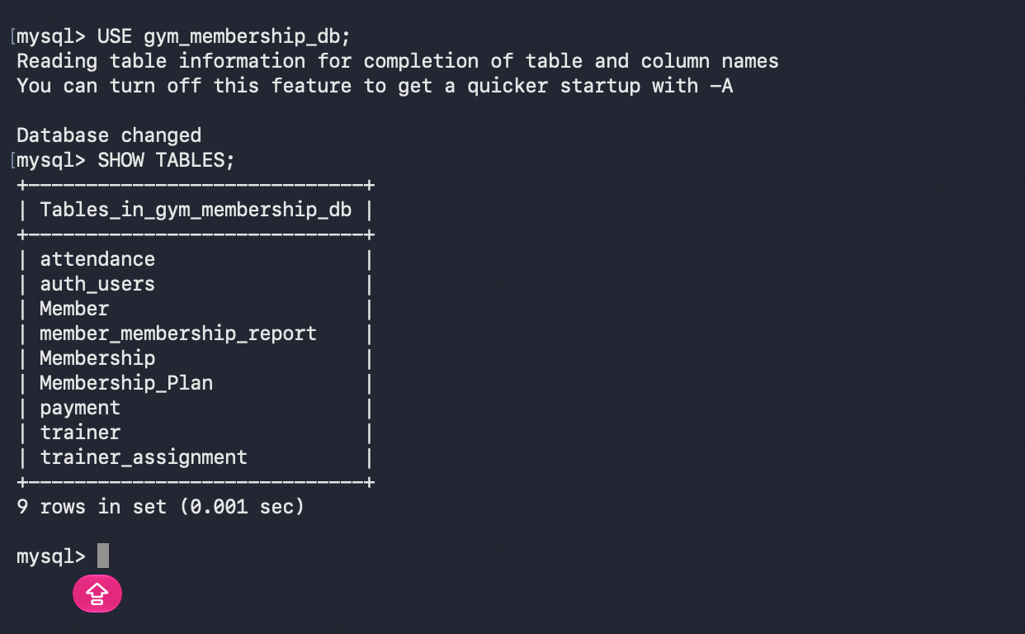
Figure B.1: SHOW TABLES output for gym_membership_db
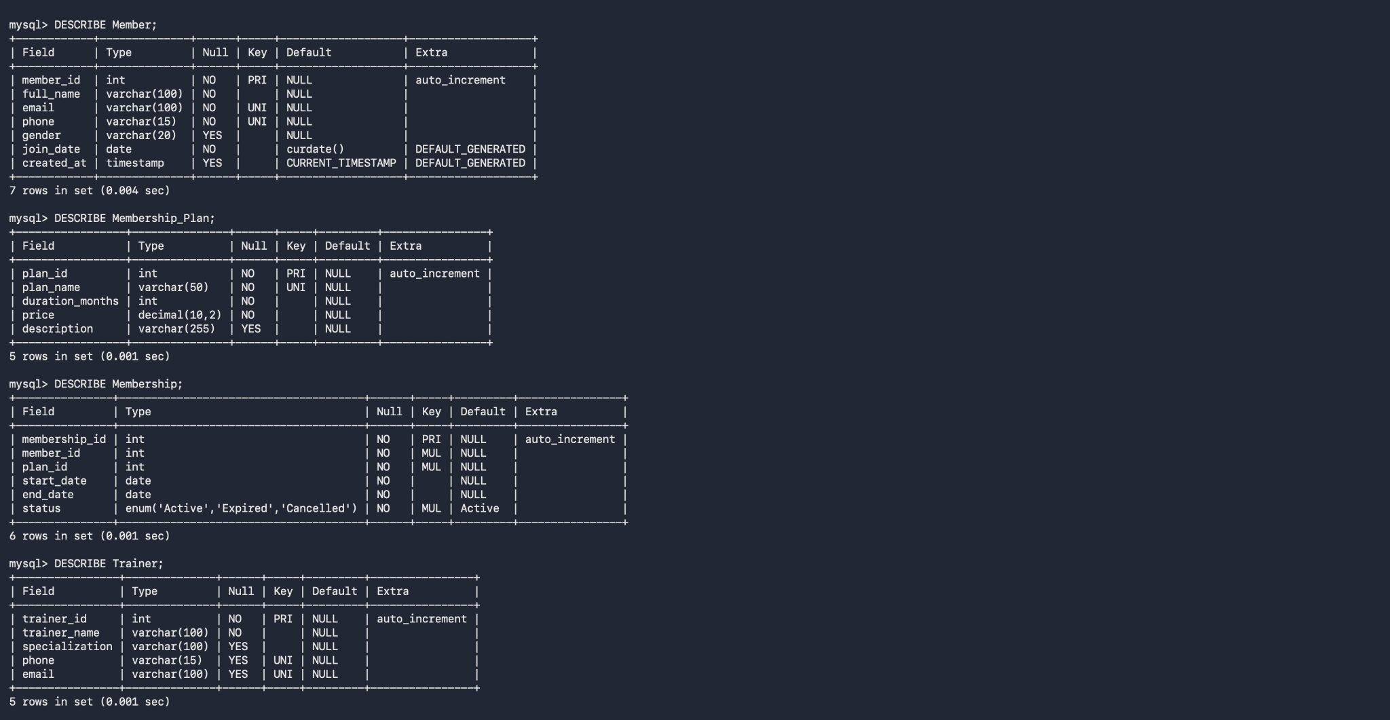
Figure B.2: DESCRIBE output for Member, Membership_Plan, Membership and Trainer

B.2 Diagram Files
The diagrams in this report are also supplied as separate PNG and SVG files: system architecture, authentication flow, Level-1 data flow, application workflow and entity-relationship diagram.

B.3 Test Evidence Summary
Table B.1: Observed evidence and interpretation
Check | Observed result | Interpretation
Admin login | Successful; dashboard opened. | Local administrator authentication verified.
Dashboard modules | Five Member 2 sections and actions tested manually by the contributor. | Manual testing reported; retain a detailed log if required.
MongoDB ping | { ok: 1 } | Local MongoDB reachable.
MongoDB logs | 6 documents; latest attendance event had Attendance ID 14. | Observed count, not forced.
Next.js build | Compile and TypeScript checks passed; 30 static pages generated. | Local build passed.
GitHub Actions | Two successful Build Check runs reported. | CI build passed.
ESLint | Earlier repository-wide run reported remaining issues in other or shared files. | Lint-clean status must not be claimed.
Authentication | Local table and admin configured; teammate uses a separate local database. | Compare schemas and scripts before final integration.

Appendix C: API Route Data-Access Summary
Table C.1 relates each documented route directory to the data stores it is expected to use, based on the module design. It should be verified against the route source files.
Table C.1: Route to data-store summary
Route directory | MySQL objects | MongoDB
app/api/attendance | Attendance (and Member for the member list) | Writes a Check-in document to activity_logs
app/api/assignments | Trainer_Assignment, Trainer, Member | —
app/api/payments | Payment, Membership, Member | —
app/api/activity-logs | — | activity_logs

Appendix D: Pre-Submission Checklist
Table D.1: Items to complete or confirm before submission
Item | Action
Member 1 responsibilities | Add the documented responsibilities of Priyanka B M (modules and tasks).
Shared authentication | Compare auth_users_setup.sql with the teammate’s version.
Payment status column | Confirm whether the column is status or payment_status.
API route details | Add HTTP methods, request fields and responses from the route files.
Reporting views | Confirm daily_attendance_report and payment_report with SHOW FULL TABLES.
Technology versions | Add React, Node.js, MongoDB and library versions from package.json, and confirm whether Tailwind CSS is used.
Open findings | Check the sample email value and the date difference between pages.
Course name | This report uses the course label from the original report (Database Management Systems); change it if required.

