LAB 2 — AGILE BACKLOG CREATION & SPRINT SIMULATION

NAME : Priyanka B M
SRN : PES1UG24AM207
DATE : 31/08/2026 SEC : 5D

Problem Statement: Smart Parking Space Rental & License Validator

- Epics and User Stories
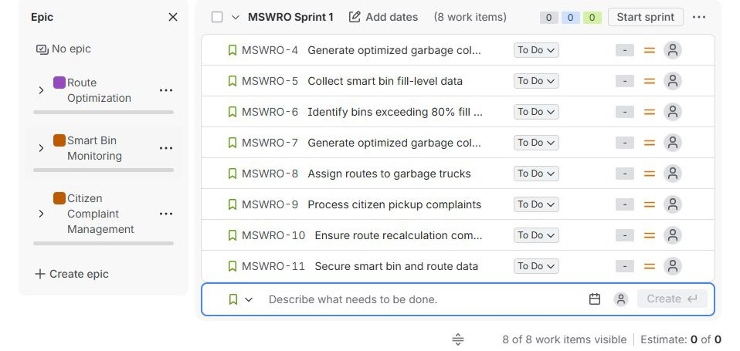

- Sprint board
Evidence for Sprint 1.

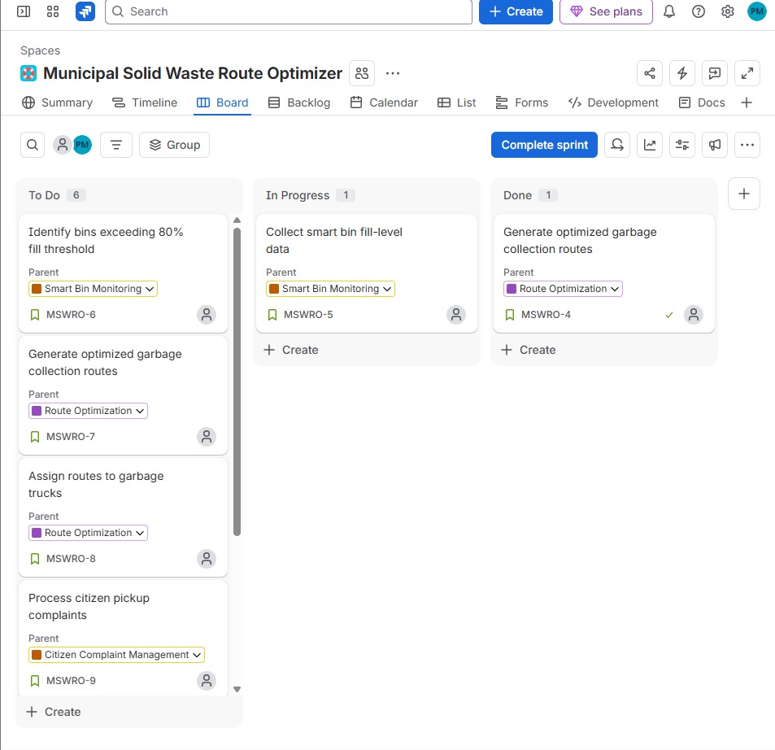
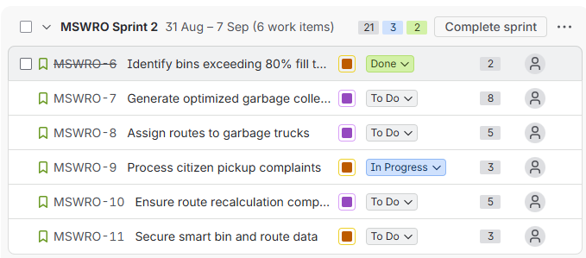
- Sprint 2 , with its duration set to 1 week.

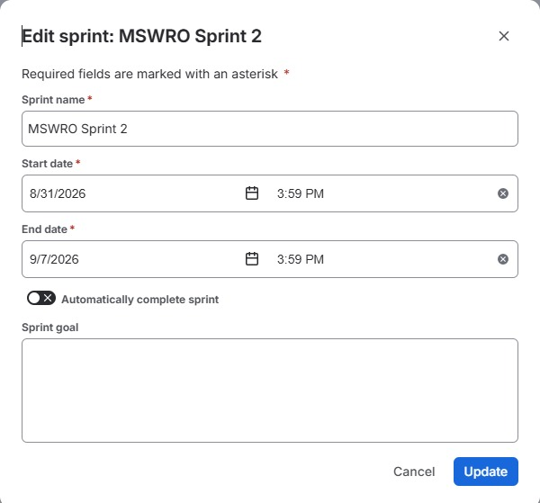

Evidence for Sprint 2.
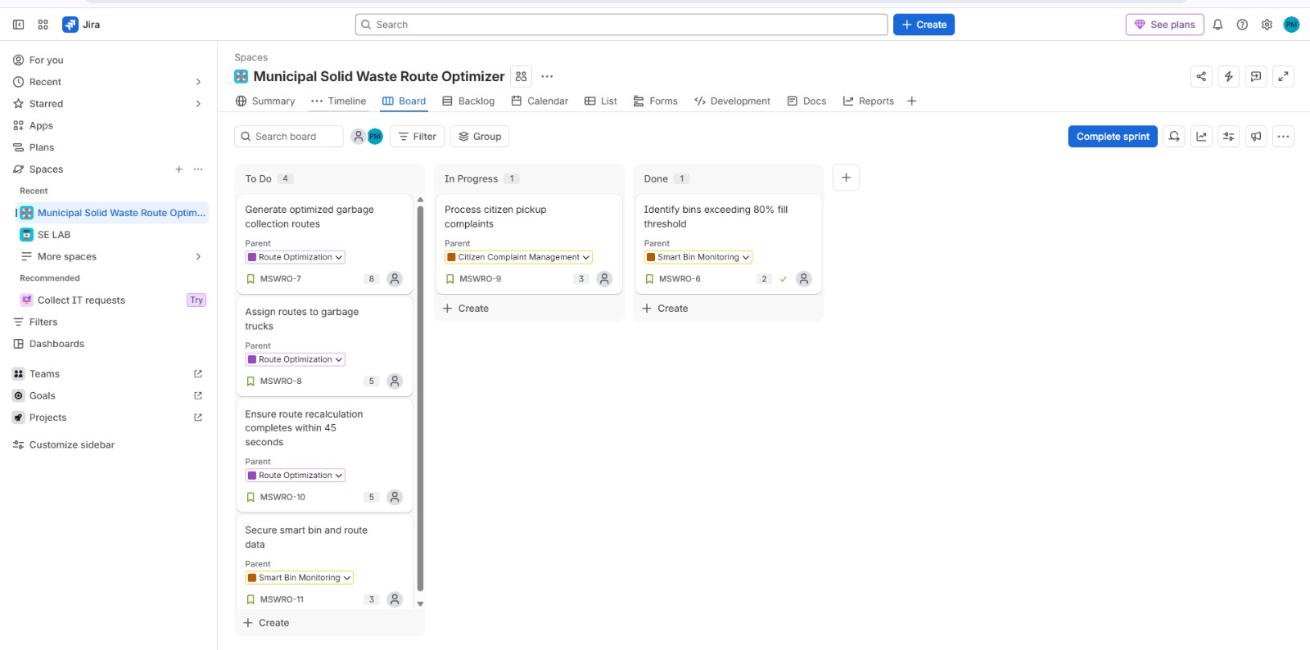

- Sprint 1 Burndown Chart
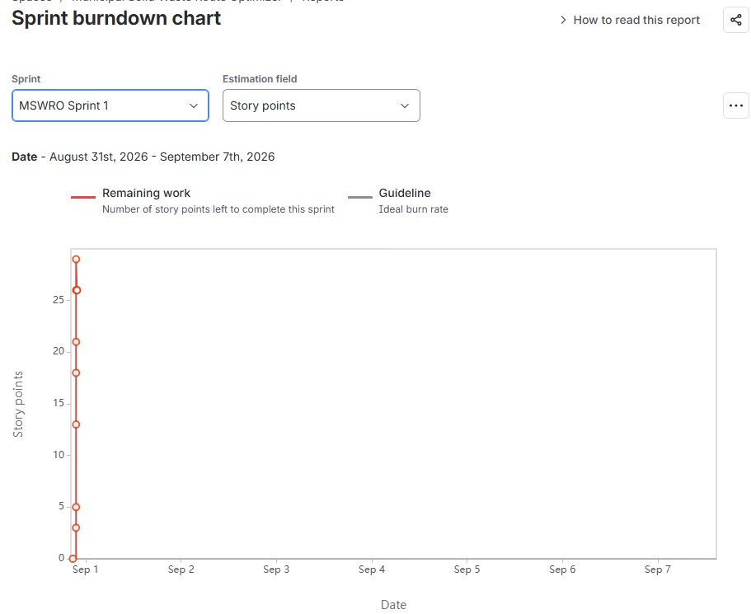

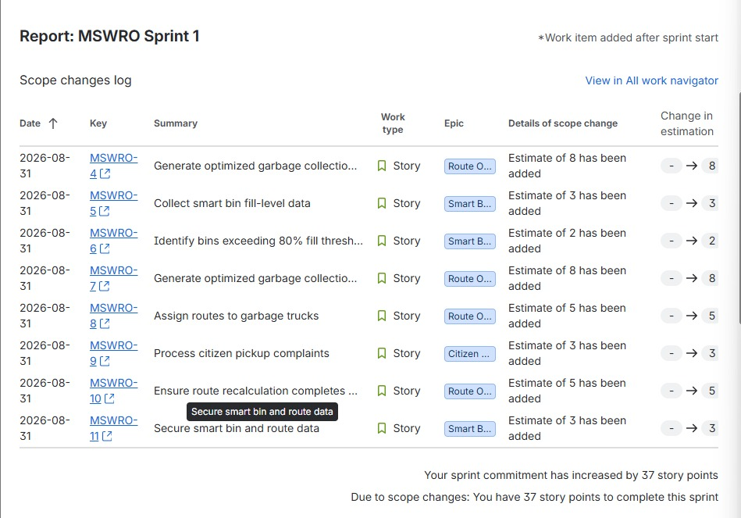
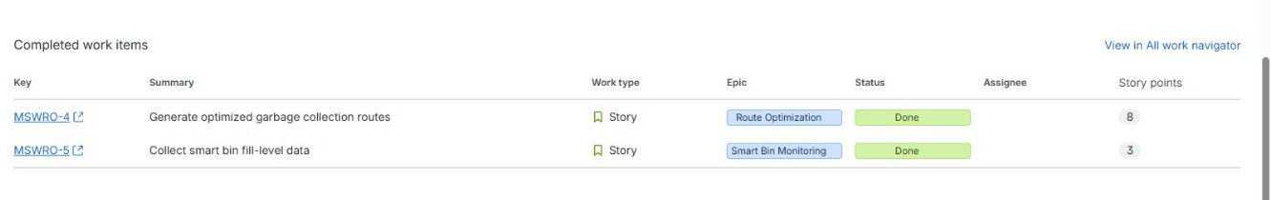
- Sprint 2 Burndown Chart
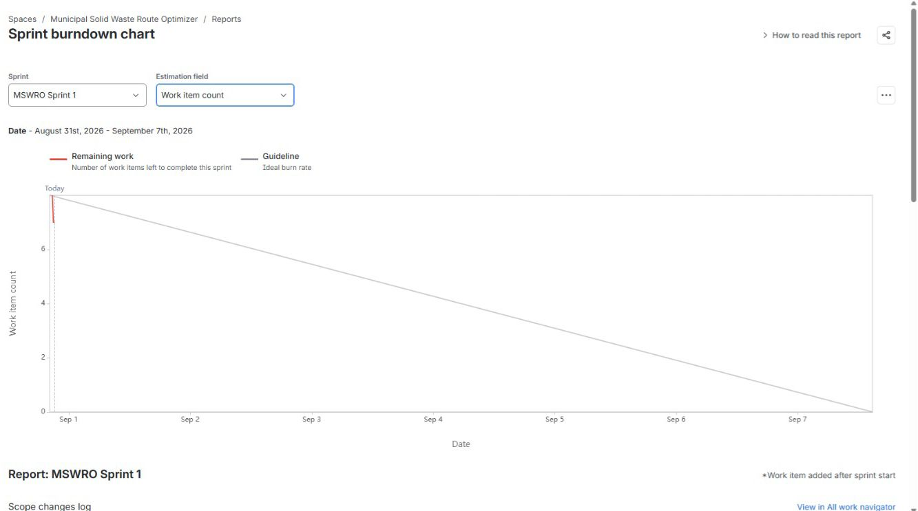

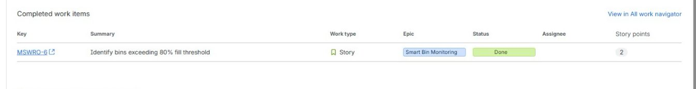

Summary:
The Municipal Solid Waste Route Optimizer was organized in Jira using three epics and eight user stories. The user stories were assigned to the appropriate epics, priorities, and story points and organized into one one-week sprint. The sprint board was used to demonstrate the progress of tasks through To Do, In Progress, and Done. The Burndown Chart was used to track the remaining work and progress throughout the sprint. This Jira-based sprint simulation helped demonstrate Agile backlog management, sprint planning, task tracking, and progress monitoring.

