Lab 1: Requirements Engineering & UML Use-Case Modelling
Problem Statement #25 — Municipal Solid Waste Route Optimizer
NAME: PRIYANKA B M
SRN:PES1UG24AM207

1. Requirements Table

Functional Requirements
ID | Type | Description | Priority | Acceptance Criteria | Rationale
FR-001 | Functional | The system shall generate optimized daily collection routes including only bins that have exceeded an 80% fill threshold. | High | Pass: Route excludes bins below 80% full unless manually tagged. Fail: Overflowing bin is omitted from driver manifest. | Ensures collection resources are focused on bins that require immediate service.
FR-002 | Functional | The system shall collect and display real-time fill-level data received from ultrasonic smart trash bins. | High | Pass: Current fill percentage of registered bins is displayed. Fail: Missing or outdated bin data is shown as current. | Provides accurate information for deciding which bins require collection.
FR-003 | Functional | The system shall assign optimized collection routes to available garbage trucks and their drivers. | High | Pass: Each generated route is assigned to an available truck and driver. Fail: A route is assigned to an unavailable truck or driver. | Ensures that planned routes can be executed by available collection resources.
FR-004 | Functional | The system shall allow truck drivers to view their assigned collection routes and update the pickup status of bins. | High | Pass: Driver can view the assigned route and mark bins as collected. Fail: Driver cannot access the route or update pickup status. | Enables drivers to follow assigned routes and maintain accurate collection records.
FR-005 | Functional | The system shall allow the sanitation supervisor to record and manage missed-pickup complaints from citizens. | Medium | Pass: Supervisor can record, view and update the status of a complaint. Fail: Complaint cannot be recorded or tracked. | Helps ensure missed collections are identified and resolved promptly.

Non-Functional Requirements
ID | Type | Description | Priority | Acceptance Criteria | Rationale
NFR-001 | Performance & Security | The system shall recalculate collection routes for a fleet of 50 trucks across 10,000 bins in under 45 seconds while maintaining required security standards. | High | Pass: Route recalculation completes within 45 seconds and security standards are met under simulated peak load. Fail: Execution exceeds 45 seconds or security requirements are violated. | Ensures the system remains fast and secure when handling large-scale city operations.
NFR-002 | Usability | The system shall provide a clear and easy-to-use interface for sanitation supervisors and truck drivers. | Medium | Pass: Users can access routes, bin information and pickup status with minimal navigation. Fail: Users require excessive steps or cannot locate required information. | Makes the system practical for daily use by supervisors and drivers.

2. UML Use-Case Diagram
Actors:
- Sanitation Supervisor — Primary. Initiates route generation and manually reassigns routes when needed.
- Truck Driver — Primary. Initiates viewing their assigned route and marking bins as collected.
- Citizen — Primary. Initiates missed-pickup complaints.
- Bin Sensor System — Secondary. Supplies ultrasonic fill-level readings; supports “Check Bin Fill Levels” but does not initiate any use case itself.
Use Cases:
- Generate Optimized Route
- Check Bin Fill Levels
- View Assigned Route
- Mark Bin Collected
- Report Missed Pickup
- Reassign Route Manually
Relationships:
- <<include>>: Generate Optimized Route includes Check Bin Fill Levels — every route generation must check current fill levels; this is not optional behavior.
- <<extend>>: Report Missed Pickup extends Mark Bin Collected — a missed-pickup report only occurs as an exceptional branch off the normal collection-marking flow.
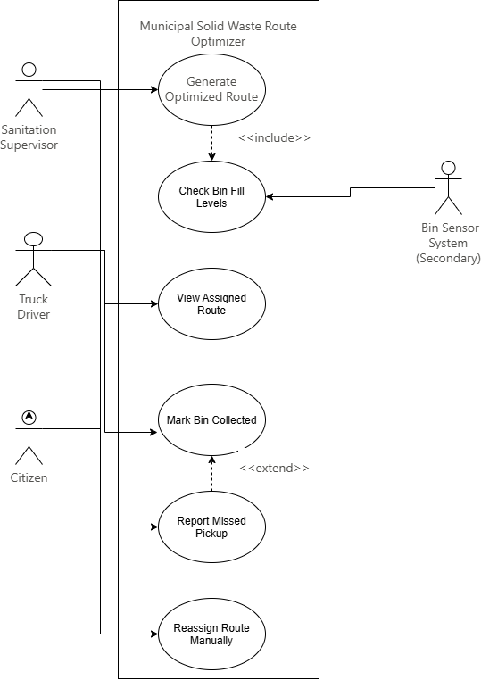

3. Use-Case Flow Specification

Use Case: Generate Optimized Daily Route
Actors: Sanitation Supervisor (primary), Bin Sensor System (secondary)
Related Use Case: Includes “Check Bin Fill Levels”

Preconditions
- The Sanitation Supervisor is logged into the portal with valid credentials.
- Fill-level sensor data from smart trash bins has been received and is up to date (within the last 24 hours).
- The active truck fleet roster (available trucks and drivers for the day) has been configured in the system.
- At least one bin exists in the system with a recorded fill level.

Postconditions
- An optimized route manifest is generated, containing the sequenced list of bins to be collected and the truck/driver assigned to each route.
- The route manifest is saved and made available for driver viewing (see “View Assigned Route”).
- Bins excluded from the route (below the fill threshold) are logged with their current fill percentage for audit purposes.

Main Success Scenario
- The Sanitation Supervisor selects “Generate Daily Route” from the portal dashboard.
- The system triggers the “Check Bin Fill Levels” use case («include») to retrieve the current fill percentage for every registered bin from the Bin Sensor System.
- The system filters bins, including only those at or above the 80% fill threshold, unless a bin has been manually tagged for pickup regardless of fill level.
- The system calculates an optimized route sequence for each available truck, minimizing total travel distance while covering all included bins.
- The system assigns each optimized route to an available truck and driver based on the fleet roster.
- The system generates a route manifest for each truck, listing bin stops in visit order with estimated arrival times.
- The system displays a summary of all generated routes to the Supervisor for review.
- The Supervisor confirms and dispatches the routes.
- The system pushes each route manifest to the corresponding driver’s app/device.

Alternate Flow: No Trucks Available
Trigger: At step 5, the system finds there are no available trucks/drivers in the fleet roster to assign a generated route to.
- The system flags the affected route(s) as “Unassigned” instead of dispatching them.
- The system displays a warning to the Supervisor listing which bins/areas are covered by the unassigned route(s).
- The Supervisor may either manually assign an available truck/driver to the unassigned route (via “Reassign Route Manually”), or defer the route to the next collection cycle with affected bins flagged as high-priority for the following day.
- The system logs the deferral or manual assignment decision.
- The use case resumes at step 8 (Supervisor confirms and dispatches the routes) once all routes are either assigned or explicitly deferred.
Postcondition (Alternate Flow): No route is dispatched without either an assigned truck or an explicit Supervisor decision to defer it, preventing bins from being silently dropped from the schedule.

