
End-to-End Retail Performance
and
Behavioral Analytics


End-to-End Retail Performance and Behavioural Analytics
1.Abstract
This project presents an end-to-end retail performance and behavioural analytics study conducted for Retail Nova Inc., a mid-sized retail and e-commerce company operating through online and physical store channels. The primary objective of this project is to analyse sales performance, customer behaviour, product profitability, store efficiency, and return patterns to support data-driven decision-making.
The analysis was performed using Python for data cleaning and exploratory data analysis, SQL for solving business queries, and Power BI for developing interactive dashboards. Multiple datasets including sales, customers, products, stores, and returns were integrated to generate comprehensive business insights.
The results highlight revenue trends, regional performance differences, high-value customer segments, product return impacts, and store-level profitability variations. The developed dashboards provide a centralized platform for monitoring key performance indicators and support strategic planning and operational improvements.

2.Introduction
In today’s competitive retail industry, organizations must rely on data analytics to improve performance, enhance customer satisfaction, and maintain profitability. Retail companies generate large volumes of data through daily transactions across online and physical store channels. However, without proper analysis, this data cannot be effectively utilized for strategic decision-making.
Retail Nova Inc., a mid-sized retail and e-commerce company, operates through both online platforms and multiple physical stores across different regions. Although the company has experienced growth in sales, it has also faced challenges such as increasing return rates, uneven regional performance, fluctuating profit margins, and rising operating costs in certain stores.
To address these challenges, this project focuses on analysing retail sales data to identify performance trends, customer behaviour patterns, product profitability, and return impacts. By using Python for data processing, SQL for business analysis, and Power BI for dashboard visualization, this project transforms raw data into meaningful insights that support data-driven business decisions.
Retail businesses generate large volumes of transactional and customer data daily. However, without structured analysis, organizations struggle to extract meaningful insights.
Retail Nova Inc., founded in 2016 and headquartered in Chicago, operates 60+ physical stores across 8 regions along with a strong online presence. While the company experienced rapid growth during recent years, it faced challenges including:
- Increased product return rates
- Declining profitability in certain regions
- Higher operational costs in selected stores
- Uneven product category performance
To address these challenges, this project applies a structured analytics approach to evaluate performance and identify optimization opportunities.

3. Problem Statement

Retail Nova Inc. is currently facing multiple operational and performance-related challenges that impact overall business profitability and efficiency. The key issues identified are:

Increasing product return rates, reducing net profit margins.

Uneven sales and profit performance across different regions and stores.

Fluctuating profitability across product categories due to discounts and return behaviour.

Rising operating costs affecting store-level profitability.

Absence of an integrated analytical dashboard for real-time performance monitoring.

Therefore, there is a need for a comprehensive data analysis approach to generate meaningful insights and support data-driven strategic decision-making.

4. Objectives
The major objectives of this project are:
- To calculate total revenue and profit trends
- To identify top-selling and high-return products
- To analyse regional and store-level profitability
- To segment customers based on demographics and value
- To compare Online vs In-Store sales performance
- To measure return rates and their impact on profit
- To design executive-level dashboards for performance monitoring.

5.Data Collection
5.1Dasta Source
The data used in this project was sourced from a structured retail business case study of Retail Nova Inc. The datasets were provided in CSV format and include
- Sales Data
- Customer Data
- Product Data
- Store Data
- Returns Data

5.2 Data Description
The project includes multiple relational tables:
sales_data.csv
- order_id
- order_date
- customer_id
- product_id
- store_id
- sales_channel
- quantity
- unit_price
- discount_pct
- total_amount
customers.csv
- customer_id
- gender
- age
- signup_date
- region
products.csv
- product_name
- category
- brand
- cost_price
- unit_price
- margin_pct
stores.csv
- store_name
- store_type
- region
- operating_cost
These datasets were systematically cleaned, validated, and integrated before being utilized for analysis through Python, SQL, and Power BI.

6. Data Cleaning & Preprocessing
Data cleaning was done by using python in Jupyter Notebook.
Key steps executed:
- Removal of duplicate records to ensure accurate revenue calculations
- Handling of missing values to maintain dataset integrity
- Conversion of date columns into proper datetime format
- Validation and correction of data types
- Creation of derived columns:
  - Profit (Revenue – Cost)
  - Age Groups for segmentation
  - Discount-adjusted revenue
- Cross-validation of foreign key relationships
Cleaned datasets were saved and exported for SQL and Power BI usage.
7.Tools and Technologies
The following tools and technologies were used to complete this project:
- Python – Used for data cleaning, preprocessing, and exploratory data analysis (EDA).
- Pandas & NumPy – For data manipulation and transformation.
- SQL – Used to perform business queries, calculate key metrics, and answer analytical questions.
- Power BI – Used to design interactive dashboards and visualize key performance indicators.
- Jupyter Notebook – For executing Python scripts and documenting analysis steps.
- Microsoft Excel (CSV files) – Used as the data storage format for raw and cleaned datasets.

8. SQL Analysis – Business Question Resolution
SQL queries were written to answer all 10 business questions specified in the project guide.
Advanced SQL operations including JOINs, GROUP BY, aggregate functions, and subqueries were used to calculate:
- Total revenue in the last 12 months
- Top 5 best-selling products by quantity
- Customer count by region
- Most profitable store in the past year
- Return rate by category
- Average revenue per customer by age group
- Channel-wise profitability comparison
- Monthly regional profit trends
- Top 3 high-return products per category
- Top 5 customers contributing highest profit with tenure
9.DASHBOARD DESIGN & ANALYSIS

9.1 SALES OVERVIEW DASHBOARD

Purpose:

The purpose of the Sales Overview dashboard is to provide a quick summary of overall business performance. It helps management understand revenue growth, sales volume, and channel contribution in a single view.

Visuals Included:

KPI Cards (Total Revenue, Total Profit, Total Quantity Sold)

Monthly Revenue Trend

Top 5 Best-Selling Products

Sales by Channel – Online vs In-Store

Slicers (Region, Category, Date)

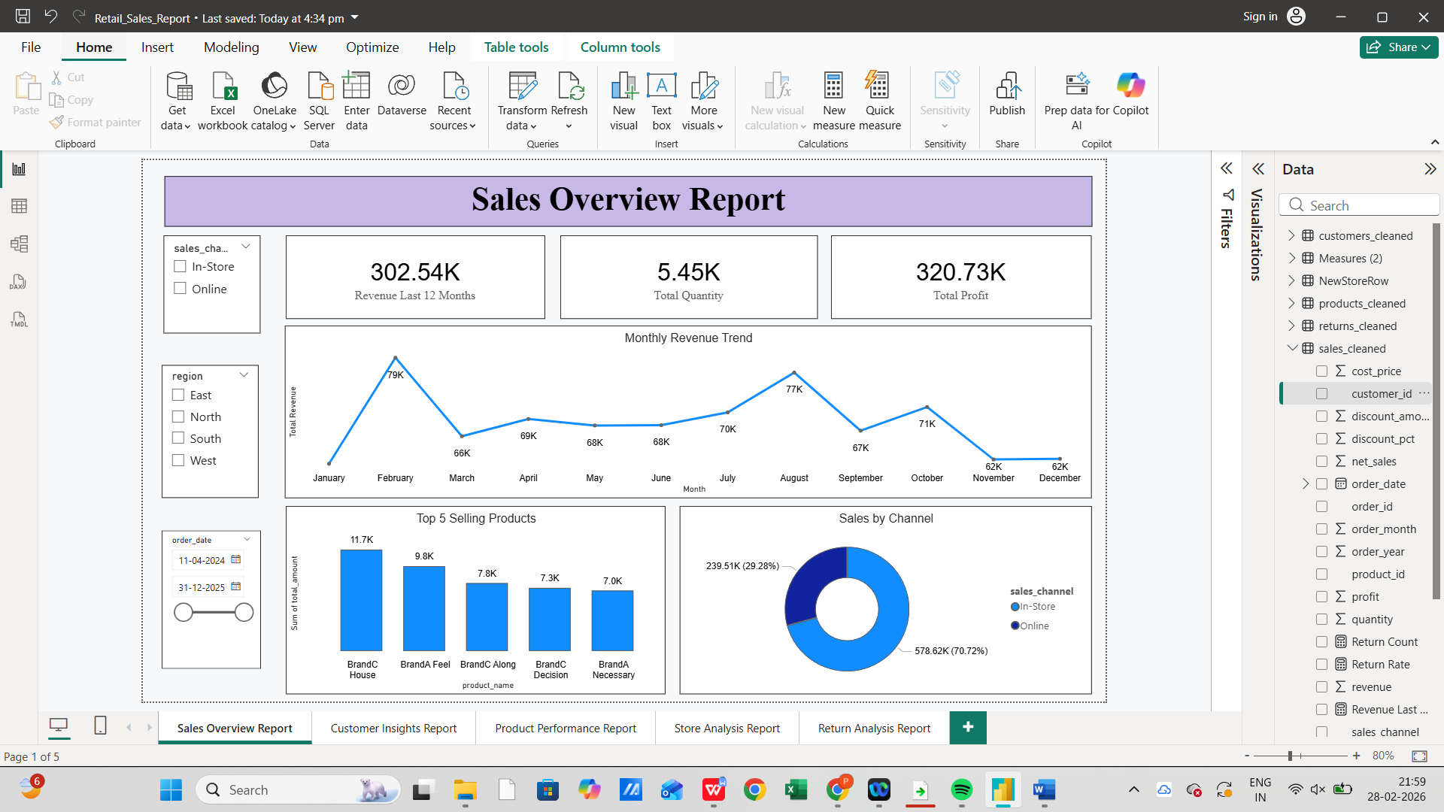

Key Insights:

Revenue shows steady growth with noticeable seasonal peaks.

Online sales contribute significantly to total revenue.

A few top products generate a major share of total sales.

Profit trends vary depending on discounts and returns.

9.2 CUSTOMER INSIGHTS DASHBOARD

Purpose

This dashboard focuses on understanding customer distribution and purchasing behavior. It helps identify valuable customer segments and revenue concentration patterns.

Visuals Included

Customer Count by Region

Age Distribution

Revenue by Age Group

Top 5 High-Value Customers

Slicers (Region, Date)

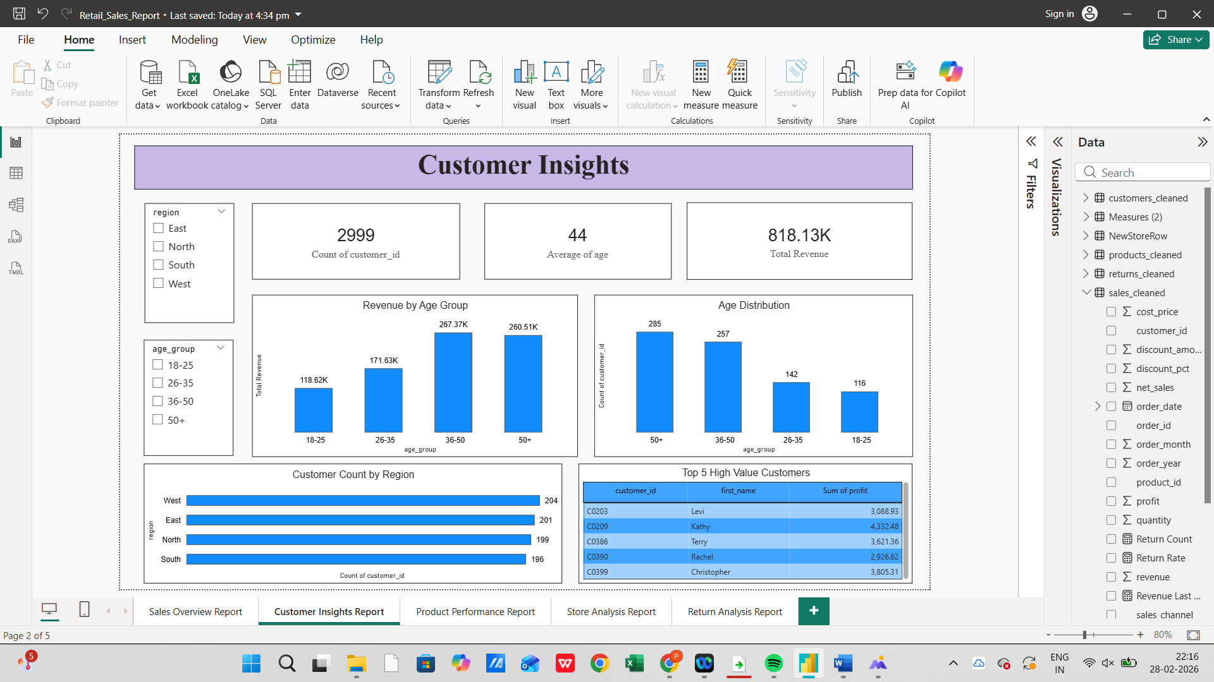

Key Insights:

Certain regions have higher customer concentration.

Specific age groups contribute more to overall revenue.

A small percentage of customers generate a large portion of profit.

Customer segmentation helps in targeted marketing strategies.

9.3 PRODUCT PERFORMANCE DASHBOARD

Purpose

The Product Performance dashboard evaluates category-wise profit, sales contribution, and return behaviour to support product-level decision-making.

Visuals Included

Profit by Category

Return Rate by Category

Product Sales by Region

Top Products by Profit

Slicers (Category, Region)

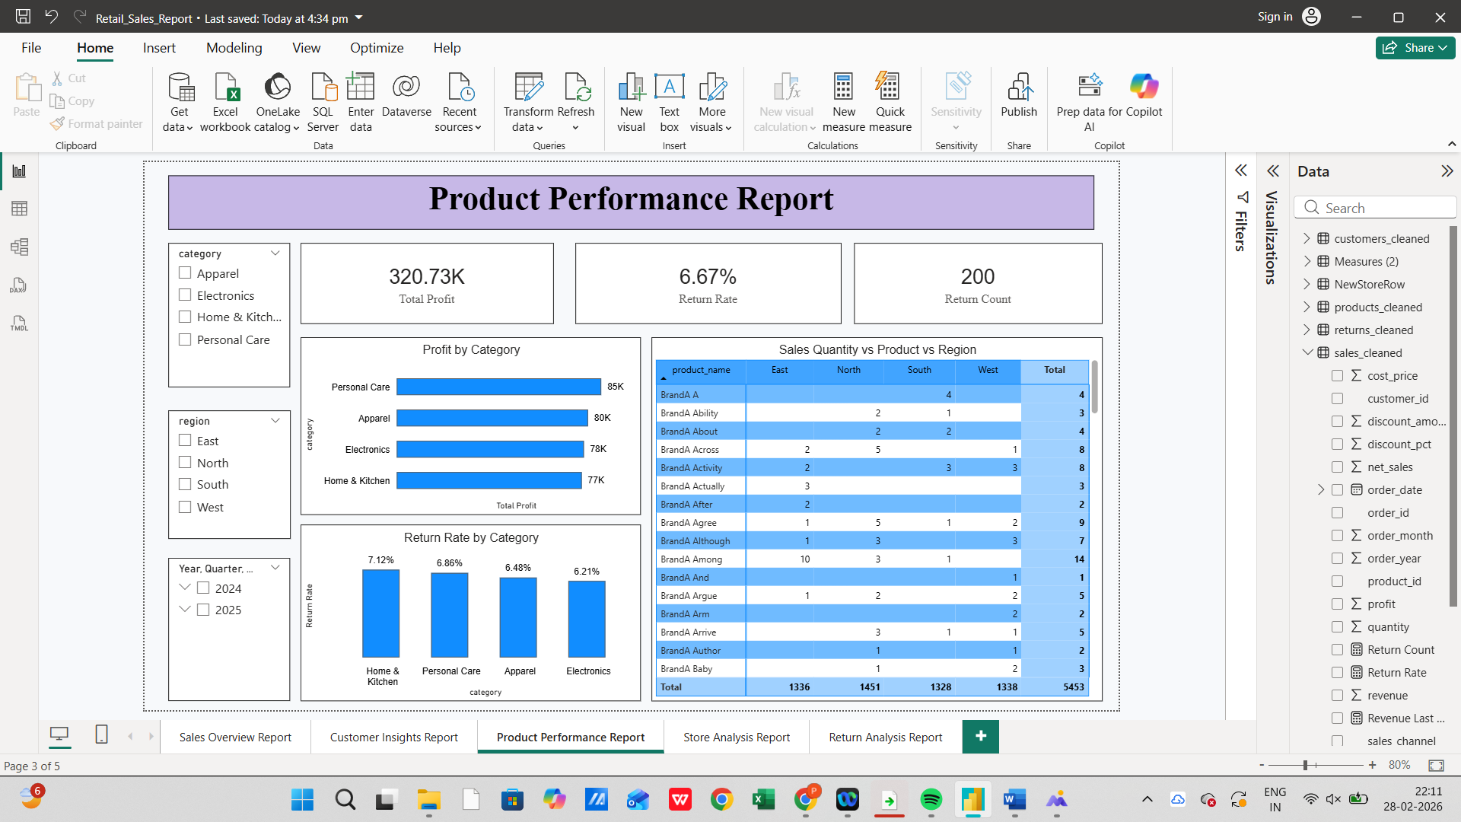

Key Insights:

Some categories generate high revenue but lower profit margins.

High return rates in certain categories impact overall profitability.

Product demand varies across regions.

Profit contribution is concentrated in selected product groups.

9.4 STORE ANALYSIS DASHBOARD

Purpose

This dashboard analyses store-level financial performance and operational efficiency.

Visuals Included

Monthly Profit by Store (Line/Bar Chart)

Store with Highest Sales (Bar Chart)

Store Profit vs Operating Cost (Comparison Chart)

Regional Store Performance (Bar Chart)

Slicers (Region, Date)

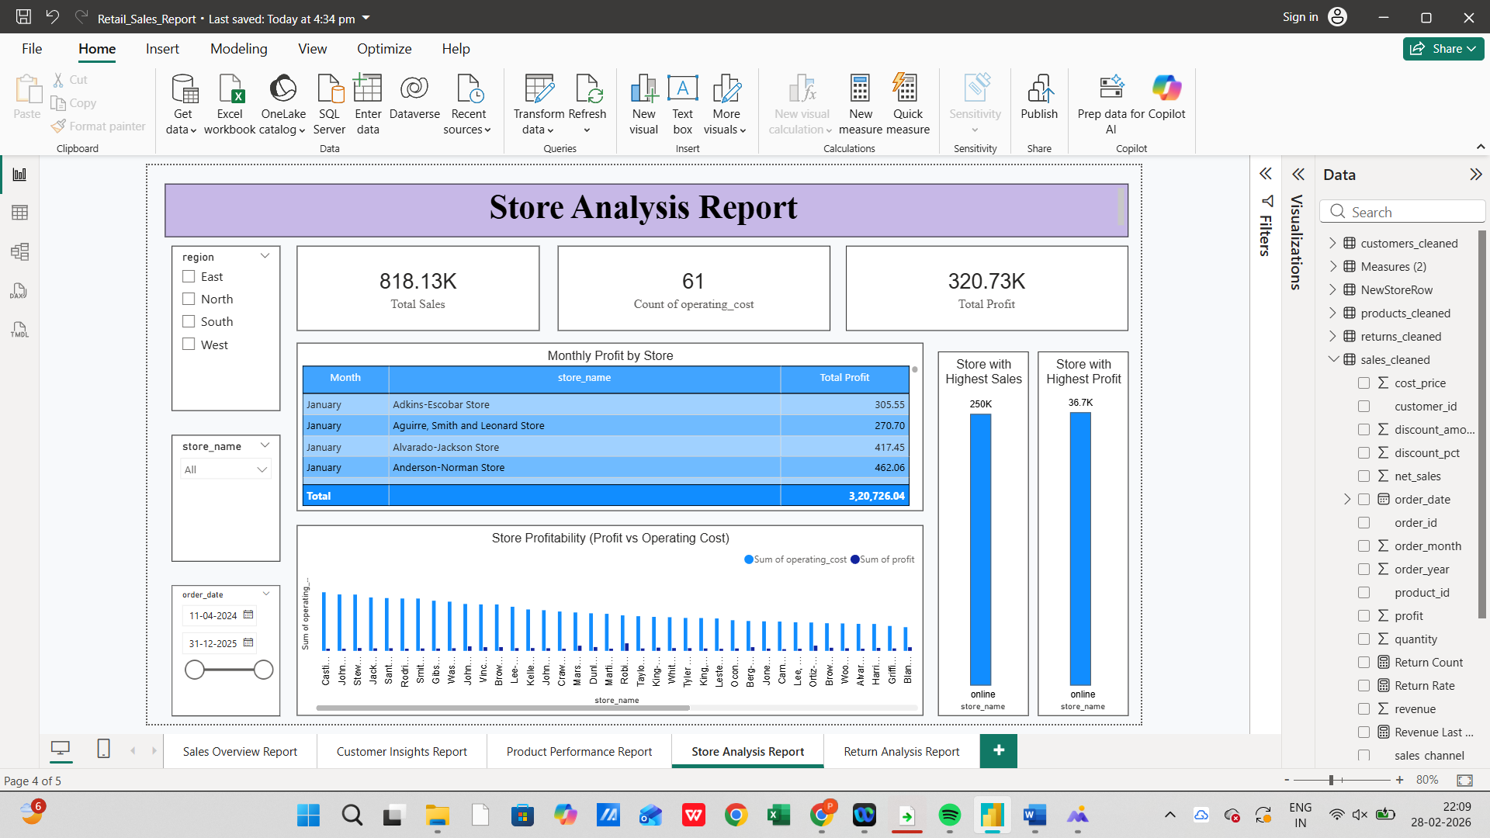

Key Insights:

Some stores consistently perform better than others.

High revenue does not always mean high profit due to operating costs.

Profit stability differs across regions.

Cost optimization may improve underperforming store profitability.

9.5 RETURN ANALYSIS DASHBOARD

Purpose

This dashboard focuses on return behaviour to understand its impact on revenue and profitability.

Visuals Included

Return Rate Trend Over Time (Line Chart)

Return Rate by Category (Bar Chart)

Top Returned Products (Bar Chart)

Returns by Region (Bar Chart)

Slicers (Category, Region, Date)

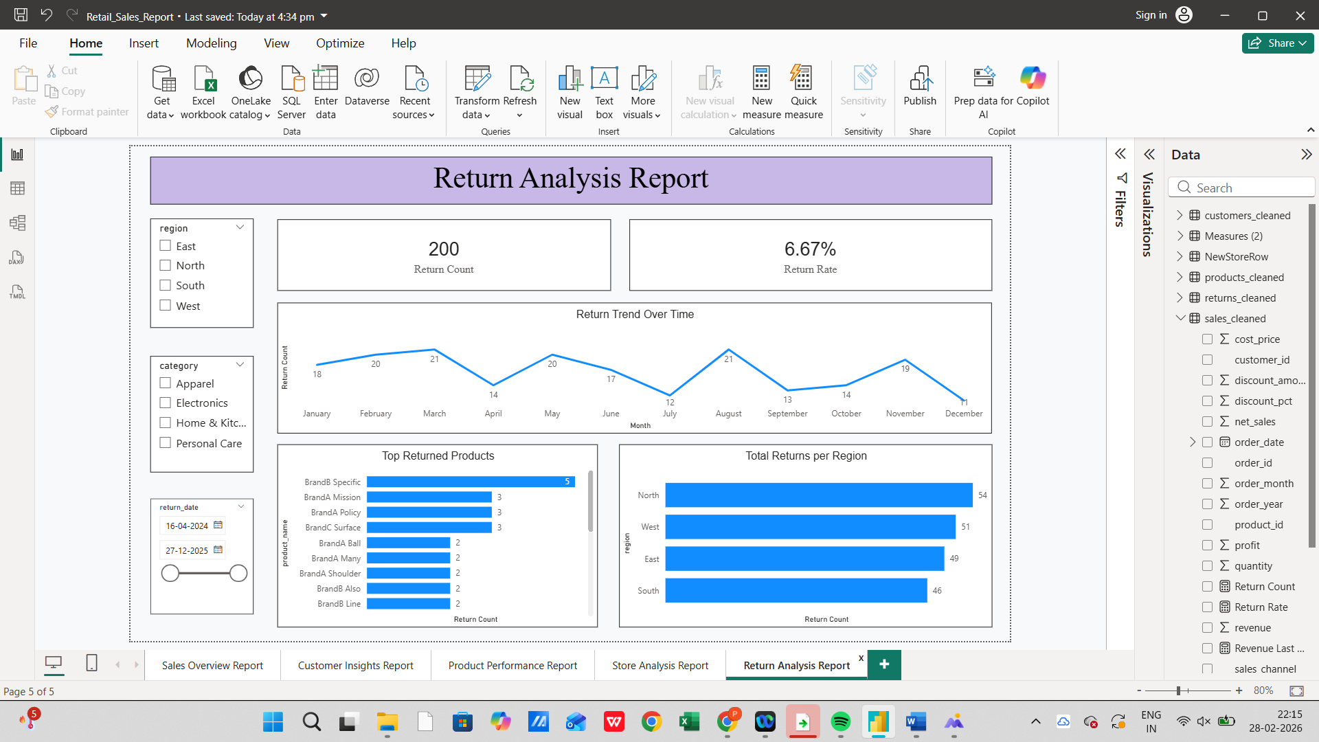

Key Insights:

Return rates directly reduce overall profit margins.

Certain product categories show consistently higher return rates.

Regional differences in returns may indicate logistics or product quality issues.

Monitoring return trends helps improve customer satisfaction and cost control.

10.Key Insights

Revenue growth is strong in certain months, indicating seasonal demand patterns.

Online sales contribute significantly to overall revenue, showing increasing customer preference for digital shopping.

A small group of customers generates a large portion of profit, highlighting the importance of customer retention strategies.

Some product categories show higher return rates, which reduces overall profit margins.

Regional performance differences suggest that marketing and operational strategies should be customized by region.

Some stores generate high revenue but lower profit due to higher operating costs.

Discounts play a major role in influencing revenue and profit levels.

11.Limitations

- The analysis is based only on available historical data.
- External market factors such as competition and economic conditions were not included.
- Profit calculations do not include indirect expenses like marketing or logistics costs.
- Customer satisfaction data beyond return records was not available.
- Real-time data updates were not implemented.
12.Challenges
- Cleaning and merging multiple datasets required careful validation to maintain accuracy.
- Calculating profit correctly required combining cost price, selling price, discount, and quantity accurately.
- Mapping return records with original sales transactions required proper joins and validation.
- Designing dashboards that are simple but still informative was challenging.
- Ensuring consistency between Python analysis, SQL results, and Power BI dashboards required cross-checking.

13.Conclusion

This project successfully transformed raw retail data into meaningful business insights using Python, SQL, and Power BI.

The analysis identified revenue trends, customer behaviour patterns, product performance insights, and return issues affecting profitability.

The interactive dashboards enable management to monitor performance metrics efficiently and support strategic business decisions.

14.Future Scope
- Sales forecasting using Machine Learning
- Customer churn prediction
- Demand forecasting
- Automated real-time dashboard integration
- Advanced profitability modelling

