**PROJECT REPORT ON PRACTICAL ONLINE TEST SYSTEM FOR COLLEGE AUTOMATION SYSTEM**

**Software requirement specification**



**Swami Keshavanand Institute of Technology, Management &Gramothan,**

**Jaipur**

Project Mentor:

**Ms. Nikhar Bhatnagar**

Team Members:

**Priyanka Chandra(12ESKCS738)**

**Shaibya Gupta(12ESKCS747)**

**Sneha Bansal(12ESKCS752)**

**ONLINE TEST SYSTEM FOR COLLEGE AUTOMATION SYSTEM**

**TABLE CONTENTS:**

|  |  |  |
| --- | --- | --- |
| **1.** |  | **INTRODUCTION** |
|  | 1.1 | PURPOSE…………………………………………………………….3 |
|  | 1.2 | SCOPE…………………………………………………………………3 |
|  | 1.3 | TOOLS USED………………………………………………………….3-4 |
|  | 1.4 | REFERENCES………………………………………………………….5 |
|  | 1.5 | OVERVIEW…………………………………………………………..5 |
|  |  |  |
| **2.** |  | **GENERAL DESCRIPTION** |
|  | 2.1 | DESCRIPTION…………………………………………………………5 |
|  | 2.2 | FUNCTIONAL REQUIREMENT……………………………………..5-6 |
|  | 2.3 | NON FUNCTIONAL REQUIREMENT………………………………6 |
|  | 2.4 | ER DIAGRAM…………………………………………………………6-7 |
|  | 2.5 | USE CASE DIAGRAM……………………………………………….8-9 |
| **3.** |  | **SPECIFIC REQUIREMENTS** |
|  | 3.1 | ACTIVITY DIAGRAM……………………………………………..9-10 |
|  | 3.2 | SEQUENCE DIAGRAM…………………………………………..11 |
|  | 3.3 | CLASS DIAGRAM………………………………………………...12-13 |
|  | 3.4 | DFD DIAGRAM……………………………………………………14-15 |
| **4.** |  | **ADVANTAGES ……………………………………………………16** |
| **5.** |  | **DISADVANTAGES………………………………………………...17** |
| **6.** |  | **DATABASE DESIGN………………………………………………18-19** |
| **7.** |  | **FUTURE ENHANCEMENT……………………………………….19-20** |

**1. INTRODUCTION**

**1.1 PURPOSE**

* This web application provides the facility to conduct the online examinations.
* It saves time as it allows multiple students to give their examinations at the same time and they do not need to wait for the results as the result is generated at that time only after the exam gets over.
* It also has the timer facility that means that the timer for the test is set.
* The student will have to complete the test in the given time interval only.
* Administrator has the facility to update create or delete the test questions or the test papers provided to the students during their tests.
* Users or students can login give their tests with his specific id and check their results also.

**1.2 SCOPE**

This system allows the student to give their exams at any time and access the tests from any place where they are comfortable with a definite username and password. No student can login with their wrong username and password. This is for the security purposes. Student will not have to wait for their results. The results will be displayed after the completion of the exam. Results are accessed fast.

**1.3 TOOLS USED**

**Java(Servlet)** - A Java servlet is a Java programming language program that extends the capabilities of a servlet. Although servlets can respond to any types of requests, they most commonly implement applications hosted on Web servers. Such Web servlets are the Java counterpart to other dynamic Web content technologies such as PHP and ASP.NET**.**

**Notepad ++ -** Notepad++ is a [text editor](https://en.wikipedia.org/wiki/Text_editor) and [source code editor](https://en.wikipedia.org/wiki/Source_code_editor) for use with [Microsoft Windows](https://en.wikipedia.org/wiki/Microsoft_Windows). Unlike [Notepad](https://en.wikipedia.org/wiki/Notepad_%28software%29), the built-in Windows text editor, it supports [tabbed](https://en.wikipedia.org/wiki/Tab_%28GUI%29) editing, which allows working with multiple open files in a single window. The project's name comes from the [C](https://en.wikipedia.org/wiki/C_%28programming_language%29) [increment operator](https://en.wikipedia.org/wiki/Increment_operator).

**HTML**  -Hyper Text Markup Language, commonly referred to as HTML, is the standard mark language used to create web pages. Web browsers can read HTML files and render them into visible or audible web pages. HTML describes the structure of a website semantically along with cues for presentation, making it a markup language, rather than a programming language.

**MYSQL** **-** Itis a [relational database management system](https://en.wikipedia.org/wiki/Relational_database_management_system) (RDBMS) in July 2013, it was the world's second mostwidely used RDBMS, and the most widely used [open-source](https://en.wikipedia.org/wiki/Open-source) RDBMS. It is named after co-founder [Michael Widenius](https://en.wikipedia.org/wiki/Michael_Widenius)'s daughter. The [SQL](https://en.wikipedia.org/wiki/SQL) acronym stands for [Structured Query Language](https://en.wikipedia.org/wiki/Structured_Query_Language). The MySQL development project has made its [source code](https://en.wikipedia.org/wiki/Source_code) available under the terms of the [GNU General Public License](https://en.wikipedia.org/wiki/GNU_General_Public_License), as well as under a variety of [proprietary](https://en.wikipedia.org/wiki/Proprietary_software) agreements. MySQL was owned and sponsored by a single [for-profit](https://en.wikipedia.org/wiki/Business) firm, the [Swedish](https://en.wikipedia.org/wiki/Sweden) company [MySQL AB](https://en.wikipedia.org/wiki/MySQL_AB), now owned by [Oracle Corporation](https://en.wikipedia.org/wiki/Oracle_Corporation).

**Rational software architect(RSA)-** Rational Software Architect is a modeling and development environment that uses the [Unified Modeling Language](https://en.wikipedia.org/wiki/Unified_Modeling_Language) (UML) for designing architecture for [C++](https://en.wikipedia.org/wiki/C%2B%2B) and [Java EE](https://en.wikipedia.org/wiki/Java_EE) (JEE) applications and web services. Rational Software Architect is built on the [Eclipse](https://en.wikipedia.org/wiki/Eclipse_%28software%29) [open-source](https://en.wikipedia.org/wiki/Open_source_software) [software framework](https://en.wikipedia.org/wiki/Software_framework) and includes capabilities focused on architectural code analysis, C++, and [model-driven development](https://en.wikipedia.org/wiki/Model-driven_development) (MDD) with the UML for creating applications and web services.

**Java Script –** is a [high level](https://en.wikipedia.org/wiki/High-level_programming_language), [dynamic](https://en.wikipedia.org/wiki/Dynamic_programming_language), [untyped](https://en.wikipedia.org/wiki/Programming_language#Type_system), and [interpreted](https://en.wikipedia.org/wiki/Interpreted_language) programming language.[[6]](https://en.wikipedia.org/wiki/JavaScript#cite_note-FOOTNOTEFlanagan20111-6) It has been standardized in the [ECMA Script](https://en.wikipedia.org/wiki/ECMAScript) language specification.[[7]](https://en.wikipedia.org/wiki/JavaScript#cite_note-FOOTNOTEFlanagan20112-7) Alongside [HTML](https://en.wikipedia.org/wiki/HTML) and [CSS](https://en.wikipedia.org/wiki/CSS), it is one of the three essential technologies of [World Wide Web](https://en.wikipedia.org/wiki/World_Wide_Web) content production; the majority of [websites](https://en.wikipedia.org/wiki/Website) employ it and it is supported by all modern [web browsers](https://en.wikipedia.org/wiki/Web_browser) without [plug-ins](https://en.wikipedia.org/wiki/Browser_extension).[[6]](https://en.wikipedia.org/wiki/JavaScript#cite_note-FOOTNOTEFlanagan20111-6) JavaScript is [prototype-based](https://en.wikipedia.org/wiki/Prototype-based_programming) with [first-class functions](https://en.wikipedia.org/wiki/First-class_functions), making it a [multi-paradigm](https://en.wikipedia.org/wiki/Multi-paradigm) language, supporting [object-oriented](https://en.wikipedia.org/wiki/Object-oriented_programming),[[8]](https://en.wikipedia.org/wiki/JavaScript#cite_note-ECMA-262-8) [imperative](https://en.wikipedia.org/wiki/Imperative_programming), and [functional](https://en.wikipedia.org/wiki/Functional_programming) programming styles.[[6]](https://en.wikipedia.org/wiki/JavaScript#cite_note-FOOTNOTEFlanagan20111-6) It has an [API](https://en.wikipedia.org/wiki/Application_programming_interface) for working with text, [arrays](https://en.wikipedia.org/wiki/Array_data_type), dates and [regular expressions](https://en.wikipedia.org/wiki/Regular_expression), but does not include any [I/O](https://en.wikipedia.org/wiki/Input/output), such as networking, storage or graphics facilities, relying for these upon the host environment in which it is embedded.

**1.4 REFERENCES**

* <http://www.indiabix.com>
  1. **OVERVIEW**

This project is aimed at developing a web based system, which manages the activity related to student’s curriculum vita and online testing. This system will manage the database and maintain a list of all the students group that have registered on this site, conduct their online test and shortlist those students who have passed the eligibility criteria given by the professor. Students can chose more than one programming language and give their tests corresponding to that selected programming language. This project also containsa timer in which their test will be finished. Students will get their results with their percentile after finishing of the tests.

Students need to register only for the first visit of their site. For the first time he/she only have to login their corresponding id and password. Admin manage the functionality of new user, add new questions, resetting password etc.

**2. GENERAL DESCRIPTION**

**2.1 DESCRIPTION**

This web application provides the facility to conduct the online examinations. It saves time as it allows multiple students to give their examinations at the same time and they do not need to wait for the results as the result is generated at that time only after the exam gets over. It also has the timer facility that means that the timer for the test is set.

The student will have to complete the test in the given time interval only. Administrator has the facility to update create or delete the test questions or the test papers provided o the students during their tests. Users or students can login give their tests with his specific id and check results also.

**2.2 FUNCTIONAL REQUIREMENTS**

* Legal / Regulatory requirement
* Authentication
* Administration
* Timer
* OTP(One Time Password)
* User details
* User id and password

**2.3 NON FUNCTIONAL REQUIREMENTS**

* External Interfaces(Mouse , keyboard**)**
* Enabled navigations across the screen
* Mozilla Firefox
* testability
* Good Response Time and throughput

2.4 ER DIAGRAM

An entity–relationship model (ER model) is a [data model](https://en.wikipedia.org/wiki/Data_modeling) for describing the data or information aspects of a business domain or its process requirements, in an abstract way that lends itself to ultimately being implemented in a [database](https://en.wikipedia.org/wiki/Database) such as a [relational database](https://en.wikipedia.org/wiki/Relational_database). The main components of ER models are [entities](https://en.wikipedia.org/wiki/Entities) (things) and the relationships that can exist among them.

While useful for organizing [data](http://searchdatamanagement.techtarget.com/definition/data) that can be represented by a relational structure, an entity-relationship diagram can't sufficiently represent semi-structured or [unstructured data](http://searchbusinessanalytics.techtarget.com/definition/unstructured-data), and an ERD is unlikely to be helpful on its own in integrating data into a pre-existing information system.

Three main components of an ERD are the [entities](http://whatis.techtarget.com/definition/entity), which are objects or concepts that can have data stored about them, the relationship between those entities, and the [cardinality](http://whatis.techtarget.com/definition/cardinality), which defines that relationship in terms of numbers.

The three main cardinal relationships are:

* **One-to-one (1:1).** For example, if each customer in a database is associated with one mailing address.
* **One-to-many (1:M).** For example, a single customer might place an order for multiple products. The customer is associated with multiple entities, but all those entities have a single connection back to the same customer.
* **Many-to-many (M:N).** For example,at a company where all call center agents work with multiple customers, each agent is associated with multiple customers, and multiple customers might also be associated with multiple agents.

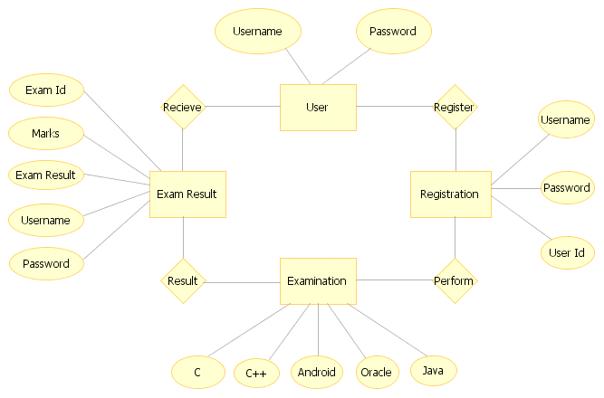

Figure 1 ER-diagram

**2.5 USE CASE DIAGRAM**

A use case diagram at its simplest is a representation of a user's interaction with the system that shows the relationship between the user and the different [use cases](https://en.wikipedia.org/wiki/Use_Case) in which the user is involved. A use case diagram can identify the different types of users of a system and the different use cases and will often be accompanied by other types of diagrams as well.

Use case diagrams depict:

* **Use cases**: A use case describes a sequence of actions that provide something of measurable value to an actor and is drawn as a horizontal ellipse.
* **Actors**: An actor is a person, organization, or external system that plays a role in one or more interactions with your system.
* **Associations**: Associations between actors and use cases are indicated in use case diagrams by solid lines. Associations are modeled as lines connecting use cases and actors to one another, with an optional arrowhead on one end of the line. The arrowhead is often used to indicating the direction of the initial invocation of the relationship or to indicate the primary actor within the use case.

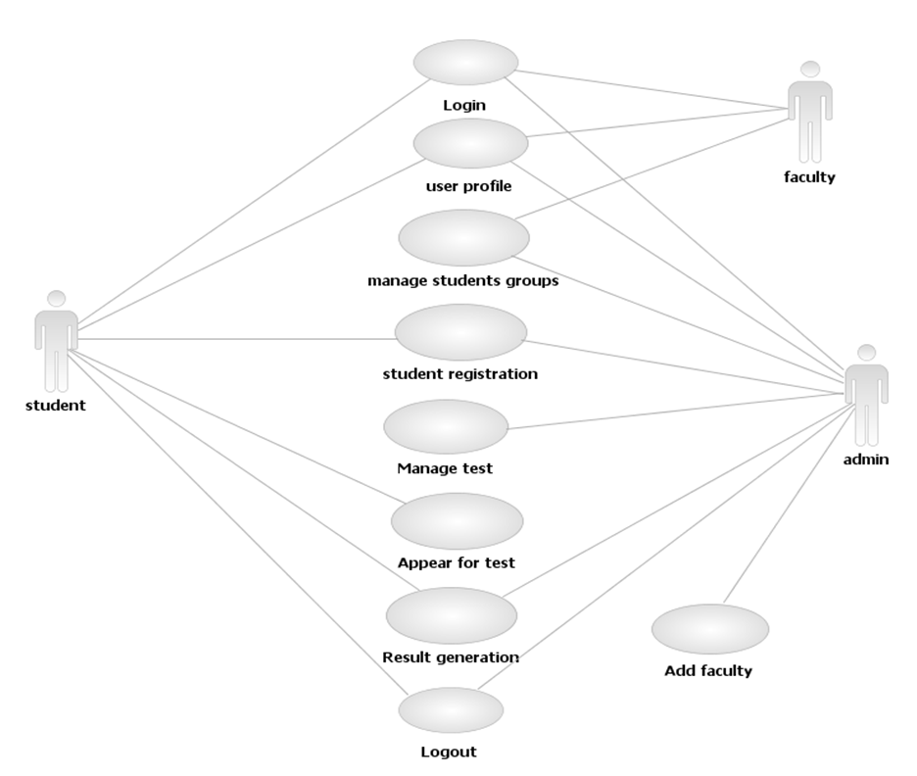

Figure USE_CASE-diagram

**3. SPECIFIC REQUIREMENTS**

**3.1 ACTIVITY DIAGRAM**

Activity diagrams are graphical representations of [workflows](https://en.wikipedia.org/wiki/Workflow) of stepwise activities and actionswith support for choice, iteration and concurrency. In the [Unified Modeling Language](https://en.wikipedia.org/wiki/Unified_Modeling_Language), activity diagrams are intended to model both computational and organizational processes (i.e. workflows). Activity diagrams show the overall flow of control.

Activity diagrams are constructed from a limited number of shapes, connected with arrows.[[4]](https://en.wikipedia.org/wiki/Activity_diagram#cite_note-4) The most important shape types:

* rounded rectangles represent actions;
* diamonds represent decisions;
* bars represent the start (split) or end (join) of concurrent activities;
* a black circle represents the start (initial state) of the workflow;
* an encircled black circle represents the end (final state).

Arrows run from the start towards the end and represent the order in which activities happen.

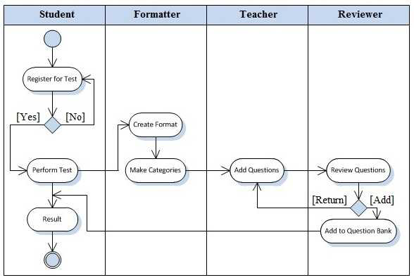

Figure 5 ACTIVITY DIAGRAM

**3.2 SEQUENCE DIAGRAM**

A sequence diagram shows object interactions arranged in time sequence. It depicts the objects and classes involved in the scenario and the sequence of messages exchanged between the objects needed to carry out the functionality of the scenario. Sequence diagrams are typically associated with use case realizations in the Logical View of the system under development. Sequence diagrams are sometimes called event diagrams or event scenarios.

A sequence diagram shows, as parallel vertical lines (lifelines), different processes or objects that live simultaneously, and, as horizontal arrows, the messages exchanged between them, in the order in which they occur. This allows the specification of simple runtime scenarios in a graphical manner.

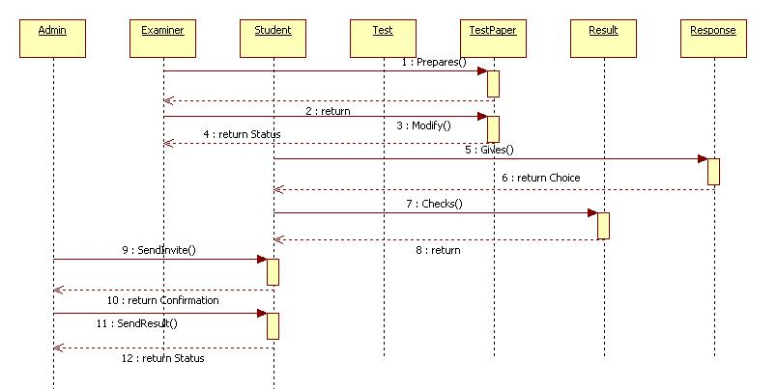

Figure 6 SEQUENCE DIAGRAM

**3.3 CLASS DIAGRAM**

A class diagram in the [Unified Modeling Language](https://en.wikipedia.org/wiki/Unified_Modeling_Language) (UML) is a type of static structure diagram that describes the structure of a system by showing the system's [classes](https://en.wikipedia.org/wiki/Class_%28computer_science%29), their attributes, operations (or methods), and the relationships among objects.

In the diagram, classes are represented with boxes which contain three parts:

* The top part contains the name of the class. It is printed in bold and centered, and the first letter is capitalized.
* The middle part contains the attributes of the class. They are left-aligned and the first letter is lowercase.
* The bottom part contains the methods the class can execute. They are also left-aligned and the first letter is lowercase.

In the design of a system, a number of classes are identified and grouped together in a class diagram which helps to determine the static relations between those objects. With detailed modelling, the classes of the conceptual design are often split into a number of subclasses.

In order to further describe the behaviour of systems, these class diagrams can be complemented by a [state diagram](https://en.wikipedia.org/wiki/State_diagram).

#### Dependency

A Dependency is the basic relationship among objects.

#### Association

An [association](https://en.wikipedia.org/wiki/Association_%28object-oriented_programming%29) represents a family of links. A binary association (with two ends) is normally represented as a line. An association can link any number of classes. An association with three links is called a ternary association.   
There are four different types of association: bi-directional, uni-directional, Aggregation (includes Composition aggregation).

#### Aggregation

[Aggregation](https://en.wikipedia.org/wiki/Aggregation_%28object-oriented_programming%29) is a variant of the "has a" association relationship; aggregation is more specific than association. It is an association that represents a part-whole or part-of relationship.

In [UML](https://en.wikipedia.org/wiki/Unified_Modeling_Language), it is graphically represented as a hollow [diamond shape](https://en.wikipedia.org/wiki/Rhombus) on the containing class with a single line that connects it to the contained class.

#### Composition

[Composition](https://en.wikipedia.org/wiki/Object_composition) is a stronger variant of the "has a" association relationship; composition is more specific than aggregation.

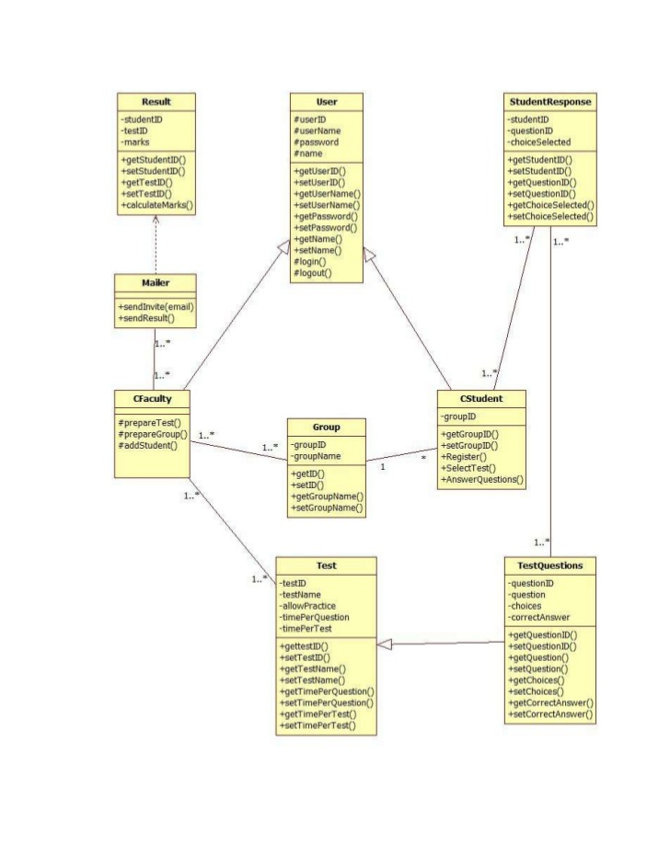

Figure CLASS DIAGRAM

**3.4 DFD DIAGRAM**

A Data Flow Diagram (DFD) is a graphical representation of the "flow" of data through an [information system](https://en.wikipedia.org/wiki/Information_system), modelling its process aspects. A DFD is often used as a preliminary step to create an overview of the system, which can later be elaborated. DFDs can also be used for the [visualization](https://en.wikipedia.org/wiki/Data_visualization) of [data processing](https://en.wikipedia.org/wiki/Data_processing) (structured design).

A DFD shows what kind of information will be input to and output from the system, where the data will come from and go to, and where the data will be stored. It does not show information about the timing of process or information about whether processes will operate in sequence or in parallel (which is shown on a [flowchart](https://en.wikipedia.org/wiki/Flowchart)).

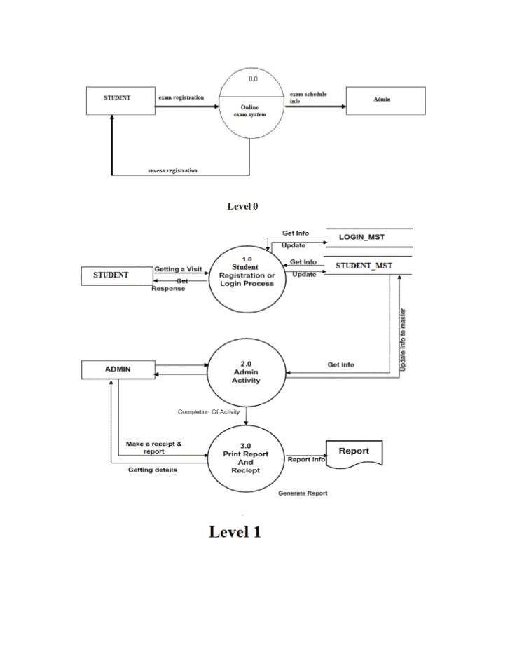 Figure 3 DFD Diagram

**5. ADVANTAGES**

* Can be easily accessed 24/7 over the open test period from anywhere across the world having internet connection. Users can access their accounts with their given login id and registered password chosen by the user.
* Will be given Y minutes to answer X number of question provided in the question paper.

Students will be given a time slot under which the students will have to complete their respective exams. They have to complete the test having X questions and Y minutes.

* Immediate test feedback when a test is submitted, i.e. the results will be displayed on the screen after the completion of the test.
* It contains a combination of true/false, multiple choice, questions and in some cases essay questions related to any topics which could ask questions based on that particular topic.
* Good Response Time and throughput will be achieved throughout the test.
* It is cost effective. No printing or distribution expenses for question paper as well as no transport and logistics expenses while conducting exams across several geographically scattered locations.
* It is totally secured as it maintains confidentiality and avoid paper leaks or the change of question paper at the last minute by pooling question papers from the question bank. It has randomized sequence of questions for each examinee. No data loss even in situation of power and internal failure.
* It has an expanded scope .Students can create exams on multiple subjects.
* Users can take their exams as per their convenience.
* It is based on the principle of “GO GREEN” . Users will be saving a substantial amount of paper by using this online mode of exams . It prevents the use of paper and save the planet.

**6. DISADVANTAGES**

* Highly dependent on honor system; hard to catch cheating. A group of students can take turns taking test first to share answer with others in the group raising their overall grade.

Like for around 100 students , they can be assigned shifts for their conduction in the tests.

* Hard or difficult to ask question or contest answers.
* Can be slow responding due to connection speed ( i.e dial- up would limit the use of graphics or media files) as it depends on the connection network speed if it is slow then it will be difficult for students to give answers .Online tests requires good internet speed.
* In the case of any type of verification problem of the students, no functionality is defined in the system to correct it or inter-connection among the users are also not available. If the students or users enter wrong information in case for the first time. No updations are possible afterwards .
* The fees is taken manually as there is not any module for the online payment.

**7. DATABASE DESIGN**

 Table 1 Registration

|  |  |  |
| --- | --- | --- |
| Field Name | Data Type | Len |
| Q_No | varchar | 30 |
| Question | varchar | 60 |
| Option1 | varchar | 30 |
| Option2 | varchar | 30 |
| Option3 | varchar | 30 |
| Option4 | varchar | 30 |
| Correct_ans | varchar | 30 |

Table 2 core_ java

|  |  |  |
| --- | --- | --- |
| Field Name | Data Type | Len |
| Q_No | varchar | 30 |
| Question | varchar | 60 |
| Option1 | varchar | 30 |
| Option2 | varchar | 30 |
| Option3 | varchar | 30 |
| Option4 | varchar | 30 |
| Correct_ans | varchar | 30 |

**Table 3 Adv_java**

**7. FUTURE ENHANCEMENT**

The main aim of our project is to create the good interaction between the students and the teachers. We are trying to do the project at best label to satisfy all the end users that are students and faculty. In our future we are decided to provide more security to our website which may not be had. And we give the choice to add their name under the faculty who they wish and get advice for their betterment. It will be more empowering. Next we are aiming to provide some online classes to the users.

In future, we will enhance the project by adding the authentication for the users to be registered by providing the facility of OTP (One time password) by sending the message on their respective mobile numbers or by sending the emails to their respective email ids. This will make the users authenticated to access the website and to be able to give their presence in the conduction of their exams.

Further , users do not have this facility of correcting their data or information entered wrongly during the completion of the registration form, they will be asked if they entered I wrong, will be corrected .