**NATIONAL INSTITUTE OF TECHNOLOGY CALICUT**

**DEPARTMENT OF ELECTRONICS AND COMMUNICATION ENGINEERING**



**DIGITAL COMMUNICATION LABORATORY**

**Submitted by:**

B.Veda Sree - B150734EC

B.Sravani - B150783EC

Ch.Priyanka - B150837EC

Ch.Vamsi Narayana Reddy - B150530EC

**Aim:**

To get familiarised with Manchester Encoding and clock recovery from it and experiment it.

**Theory:**

Manchester encoding is a data-modulation technique that can be used in many situations but which is particularly helpful in binary data transfer based on analog, RF, optical, high speed digital, or long-distance-digital signals.

In [telecommunication](https://en.wikipedia.org/wiki/Telecommunication) and [data storage](https://en.wikipedia.org/wiki/Computer_data_storage), Manchester code (also known as phase encoding, or PE) is a [line code](https://en.wikipedia.org/wiki/Line_code) in which the encoding of each data [bit](https://en.wikipedia.org/wiki/Bit) is either low then high, or high then low, for equal time. It is a [self-clocking signal](https://en.wikipedia.org/wiki/Self-clocking_signal) with no [DC component](https://en.wikipedia.org/wiki/DC_component).

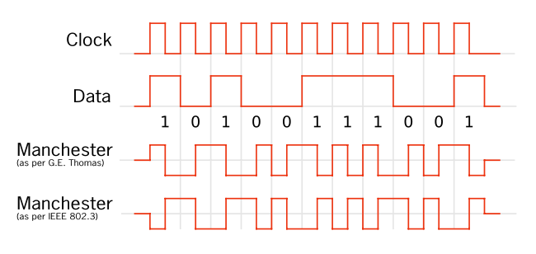

**Components Required:**

1. 7486(XOR gate)

2. 7404(NOT gate)

3. 7474(D flip flop)

4. 555 timer

5. 741 op-amp

6. Resistors

7. Capacitors

**Data Generation:**

Data is generated using a D-FlipFlop configured as a frequency divider (fclock /2).

**Manchester Encoding:**

Manchester data encoding is typically described as the process of a logical combining of the serial data to be encoded and the clock used to establish the bit rate.

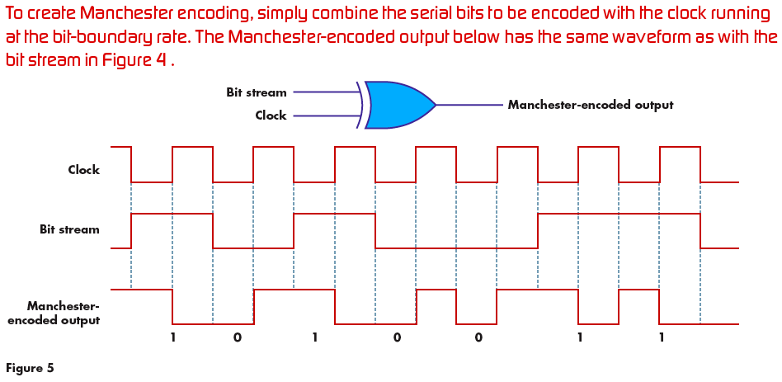

**Procedure:**

1. Data generated through D flip-flops is XORed with Clock signal.

2. Manchester encoded data for the generated data signal is observed on oscilloscope.

**Clock Recovery:**

Clock recovery circuit has three stages. First the encoded data is given to a RC high pass filter which acts like a differentiator and outputs positive and negative voltage spike signals. Then full wave rectifier circuit is used to convert positive to negative spikes and then it is given to a monostable multivibrator to generate clock signal.

**Procedure:**

1. Encoded signal is inputted to high pass filter and then given to full wave rectifier.

2. Output rectified signal is observed on oscilloscope.

3. Rectified signal is given as interrupt signal monostable multivibrator and clock frequency is obtained.

**Clock and the Input data generated :**

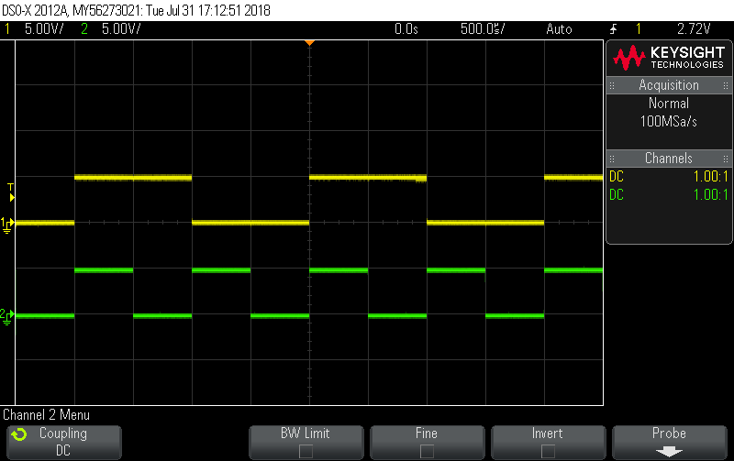

1. Signal corresponding to channel 1 is sequence generated from D flip flop.

2. Signal corresponding to channel 2 is the clock signal.

**Input data stream and the Manchester encoded data stream:**

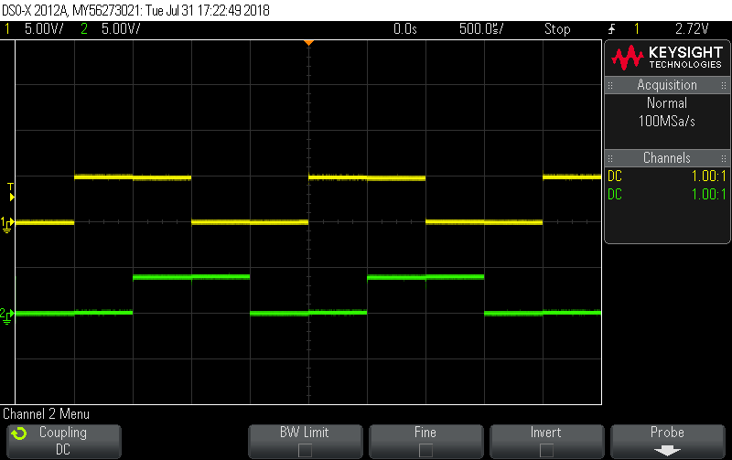

1. Signal corresponding to channel 1 is sequence generated from D flip flop.

2. Signal corresponding to channel 2 is generated Manchester code.

**Output of the Differentiator:**

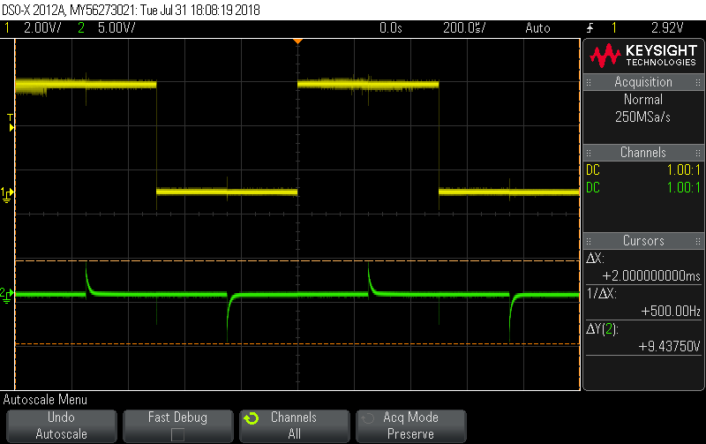

1. Signal corresponding to channel 1 is sequence generated from D flip flop.

2. Signal corresponding to channel 2 is generated differentiated output.

**Output of the full wave rectifier:**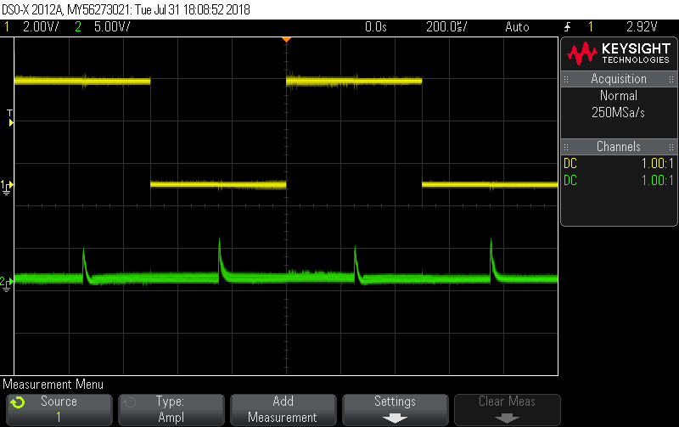

1. Signal corresponding to channel 1 is sequence generated from D flip flop.

2. Signal corresponding to channel 2 is full wave rectified output.

**Output of the NOT gate:**

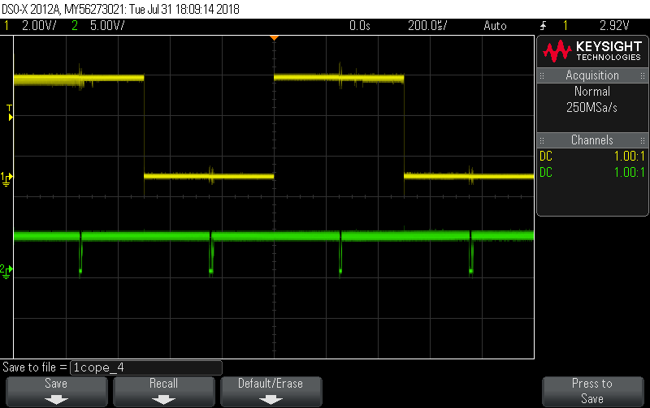

1. Signal corresponding to channel 1 is sequence generated from D flip flop.

2. Signal corresponding to channel 2 is the output of NOT gate.

**Output of the 555 timer:**

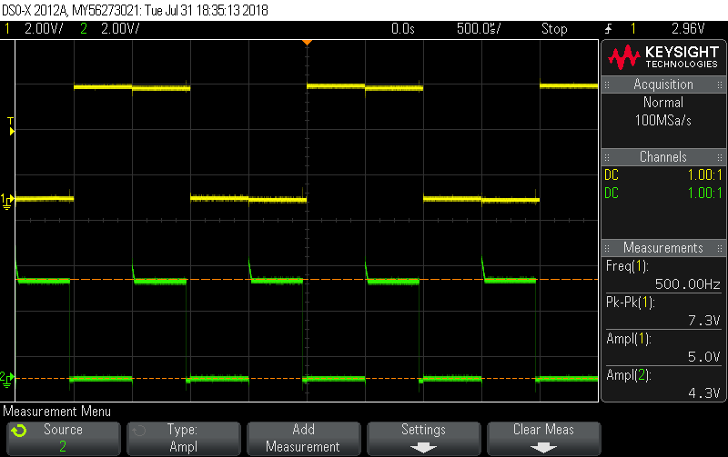

1. Signal corresponding to channel 1 is sequence generated from D flip flop.

2. Signal corresponding to channel 2 is the 555 timer output i.e the clock recovered.

**Inference:**

Input data can be generated using D-flip flops. Manchester encoding can be done with XORing of data and clock signal. Since every transition in encoded signal occurs at the mid of clock signal encoded data is differentiated to get the transitions and recover clock. So,even if the input data contains continuous 1s and 0s , the clock can be recovered if it is Manchester encoded.

**Result:**

Manchester Encoding is studied and realised using circuits. Clock recovery is also done from Manchester encoded signal.