- INTRODUCTION

The purpose of Pharmacy management system is to automate the existing manual system with the help of computerized equipments and the software, fulfilling their requirements, so that their valuable information/data can be stored for a longer period with easy accessing and manipulating the same accordingly. Pharmacy management system as mentioned above, can lead to error-free, secure, reliable and fast management. People who are suffering with any health issues, can use this website and can buy medicines according to their will. .This also helps the organization in better utilization of resources, and maintaining computerized records.The main aim is to make it user friendly for the people in buying medicines, by giving complete details of those medicines,if they are looking for anyparticular diagnosis.

1.1 Scope

This system can be used as an application for the Pharmacy Management System to manage the college information and student’s information. The system is an online application that can be accessed throughout the organization and customers as well with proper login provided, which will give them better service . This system can be used as research and online shopping / drug dealing website that seeks to protect the privacy of its customers and their personal details, and thus, endeavors to safeguard the use of information in its custody. To that end, the customers and administrator provides constituent information to requestors only under the conditions. Overall description consists of background of the entire specific requirement. It also gives explanation about actor and function which is used. It gives explanation about architecture diagram and it also gives what we are assumed and dependencies. It also support specific requirement and also it support functional requirement, supplementary requirement other than actor which is used. It also gives index and appendices. It also gives explanation about any doubt and queries. This project can be used as a research or a online shopping website so that the customers can get to know about the medicines and share knowledge innovative ideas.

1.2 Existing System
The existing system is paper-based involving high amount of paper work and manpower requirement. Even though computerized systems are used in some places, they are not web-based and are very insecure and improperly managed. So, the current pharmacy management procedure is very uneconomical and inflexible to meet user demands
The following are the drawbacks of the existing manual System:
- Scope for redundancy
- Time Delay
- More manual work
- Illiteracy about the components
1.3 Proposed System

The proposed system, being web-based, is very efficient and effective from the point of view of work productivity and time. It is less tedious to manage operations in a medical store or pharmacy with such a system. It has all the required modules and is developed with the aim of managing staffs, schedule, inventories, and relevant things in the medical store.
With this system, the entire operations in medical store is fully automated. Unlike the traditional system where records were maintained manually, this system maintains records in a database. Typical example of these records include purchases, counter sales, recorder levels, staffs, suppliers, customers, monetary transactions, etc.
MERITS-
- Using centralized database.

- Accessing of information becomes very easy

- Information sharing is easy.

- Data accessing is easy

2. SYSTEM ANALYSIS

This System Analysis is closely related to requirements analysis. It is also "an explicit formal inquiry carried out to help someone (referred to as the decision maker) identify a better course of action and make a better decision than he might otherwise have made." This step involves breaking down the system in different pieces to analyze the situation, analyzing project goals, breaking down what needs to be created and attempting to engage users so that definite requirements can be defined.

2.1 Functional Requirement Specification

The System after careful analysis has been identified to be present with the following modules.

2.1.1 Administrator Module:

The administrator is responsible for adding the customers. When any customer submits the registration form, it is to be verified, after all the details are approved by the administrator, the customer will be added into the site. The administrator maintains the passwords of customers and that of himself.

2.1.2 Customer Module:

The Customer can register themselves and after the approval from the administrator they can login into their account and can research about the drugs or buy them online after checking their components

2.2 Performance Requirements

Performance is measured in terms of the output provided by the application. Requirement specification plays an important part in the analysis of a system. Only when the requirement specifications are properly given, it is possible to design a system, which will fit into required environment. It rests largely with the users of the existing system to give the requirement specifications because they are the people who finally use the system. This is because the requirements have to be known during the initial stages so that the system can be designed according to those requirements. It is very difficult to change the system once it has been designed and on the other hand designing a system, which does not cater to the requirements of the user, is of no use.
The requirement specification for any system can be broadly stated as given below:
- The system should be able to interface with the existing system
- The system should be accurate
- The system should be better than the existing system
The existing system is completely dependent on the user to perform all the duties.

2.3 Software Requirements:
- Operating System: Microsoft Windows 10
- Technology: Servlets.
- Front-End: HTML,CSS
- Back-End: ORACLE 10g-express, MySQL, Xml.
- Web-Server: Apache-Tomcat 7.0.32
- Platform: Advanced Java Concepts (J2EE).

2.4 Hardware Requirements:
Processor : Intel P-IV based system
RAM : Min. 512 MB

3.SYSTEM DESIGN

Systems design is the process of defining the architecture, components, modules, interfaces, and data for a system to satisfy specified requirements. One could see it as the application of systems theory to product development. Object-oriented analysis and design methods are becoming the most widely used methods for computer systems design.

3.1 Architectural Design

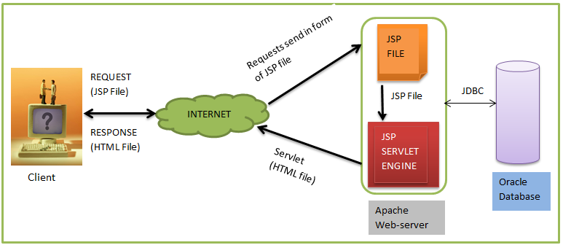
Fig 3.1 Architectural Design
As with a normal page, your browser sends an HTTP request to the web server.The web server recognizes that the HTTP request is for a JSP page and forwards it to a JSP engine. This is done by using the URL or JSP page which ends with .jsp instead of .html. The JSP engine loads the JSP page from disk and converts it into a servlet content. This conversion is very simple in which all template text is converted to println( ) statements and all JSP elements are converted to Java code that implements the corresponding dynamic behavior of the page. The JSP engine compiles the servlet into an executable class and forwards the original request to a servlet engine.A part of the web server called the servlet engine loads the Servlet class and executes it. During execution, the servlet produces an output in HTML format, which the servlet engine passes to the web server inside an HTTP response. The web server forwards the HTTP response to your browser in terms of static HTML content. Finally web browser handles the dynamically generated HTML page inside the HTTP response exactly as if it were a static page.

  - Modules
3.2.1Administrator Module:
The administrator is responsible for adding the customers and the medicines . When any customer submits the registration form, it is to be verified, after all the details are approved by the administrator, the customer will be added into the site. The administrator maintains the passwords of customers and that of himself.
Sub modules of Administrator are:
  - Manage Requests
  - Change Passwords
- Administrator’s Password
3.2.2.Customer module:
The customer can browse catalogue, research for all types of medication/ drugs, add items to the cart make the payment and get through confirmation message and get the ordered drugs.

3.3 UML Diagrams
UML Diagrams for our application are as follows:

3.3.1 Use Case Diagram
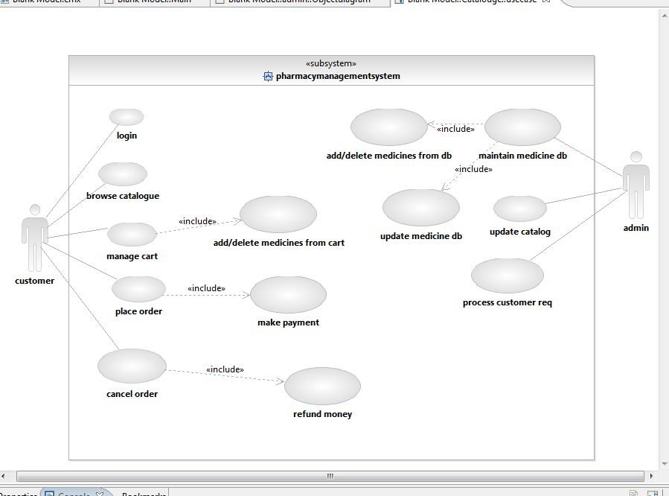 Fig 3.2 Usecase Diagram of Pharmacy Management System

- Usecase Diagrams give a pictorial view of how the actual product works in real time environment.
- The customer can login, browse the catalogue, manage his cart, place the order and even cancel the order.
- On the other side, the admin can monitor the database, update the catalogue, and process the customer’s request.

3.3.2 Class Diagrams

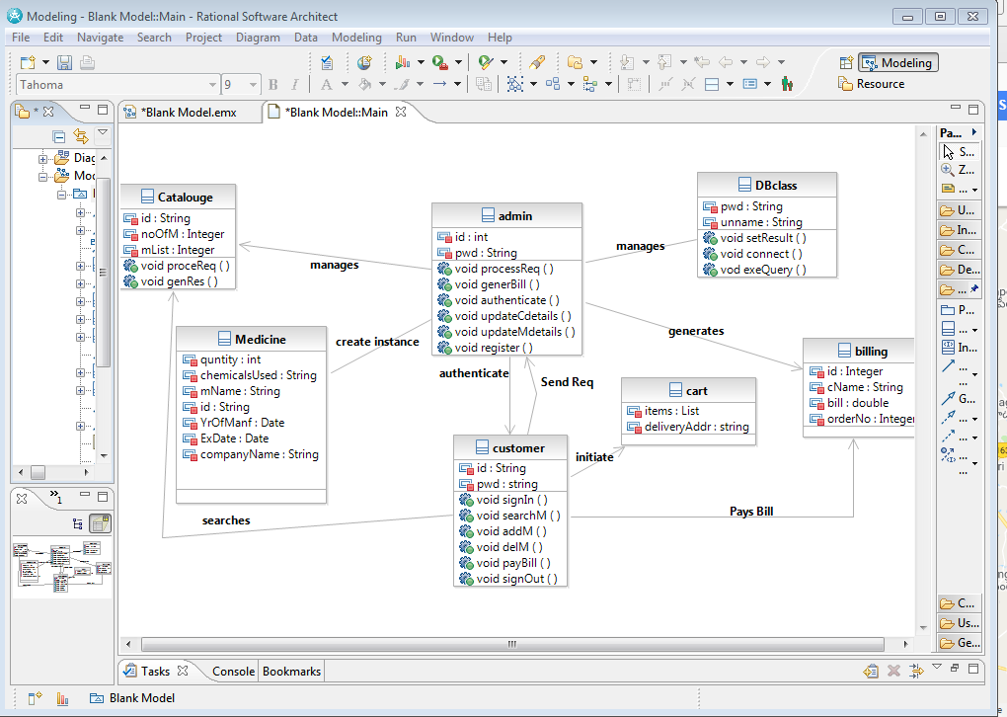

Fig 3.3 Class Diagram for Pharmacy Management System

The above class diagram contains six classes namely admin, dbclass, customer, catalogue, medicine, cart, and bill.
These are connected through relationships like association, directed association.
admin class used for processing and generating response of customer, manages db class and catalog, generates bill.
Db class used for executing query and to set results
Customer class contains information about customer’s ends request to admin, searches required medicine from catalog and to cart ,pays bill.

4.PROJECT IMPLEMENTATION

The implementation stage of any project is a true display of the defining moments that make a project a success or a failure. The implementation stage is defined as the system or system modifications being installed and made operational in a production environment. The phase is initiated after the system has been tested and accepted by the user. This phase continues until the system is operating in production in accordance with the defined user requirements.

4.1 Algorithm
Algorithm Pharmacy management system{
1.Enter Portal number of the website in the web browser //Home Page is displayed;
2.If(Customer)
Goto Customer()
3.Else if (Administrator)
a.Goto Administrator ()
4.Else
a. The rest of the viewers have the visibility of only the following Pages
- Home page
- About pharmacy
- Catalogue
- Contact us
}

Algorithm customer
{
1.If (Already registered Customer) {
a. Enter Username and password;
b. Click Login
}
2.Else {
a. Click Signup to get registered.
b. Fill registration form and submit;
c. Display “You Have Registered Successfully...Validation will be done...if yours is an valid account...you can Login with your Registration Number as user name after 1 day.....!”
d. Wait(for approval from the administrator)
}
3.If(valid credentials) {
a. welcome message
b. can browse catalogue
c. add items to cart
d. wait for processing
e. can get confirmation message
}
4.else{
a. invalid user
}//end of customer

Algorithm Administrator
{
1.Click Administrator tab in home page
2.Enter user name, password and click Login button
3.Validate with the database
a. If(Username and password valid){
Display Welcome Admin page
Can manipulate the database
Save the changes
- Else
{
Display “Invalid Username…Please verify your user name“
}
}//end of administrator algorithm

5. OUTPUT SCREENS

Output Screens of various functionalities in our application are shown over here along with the description.
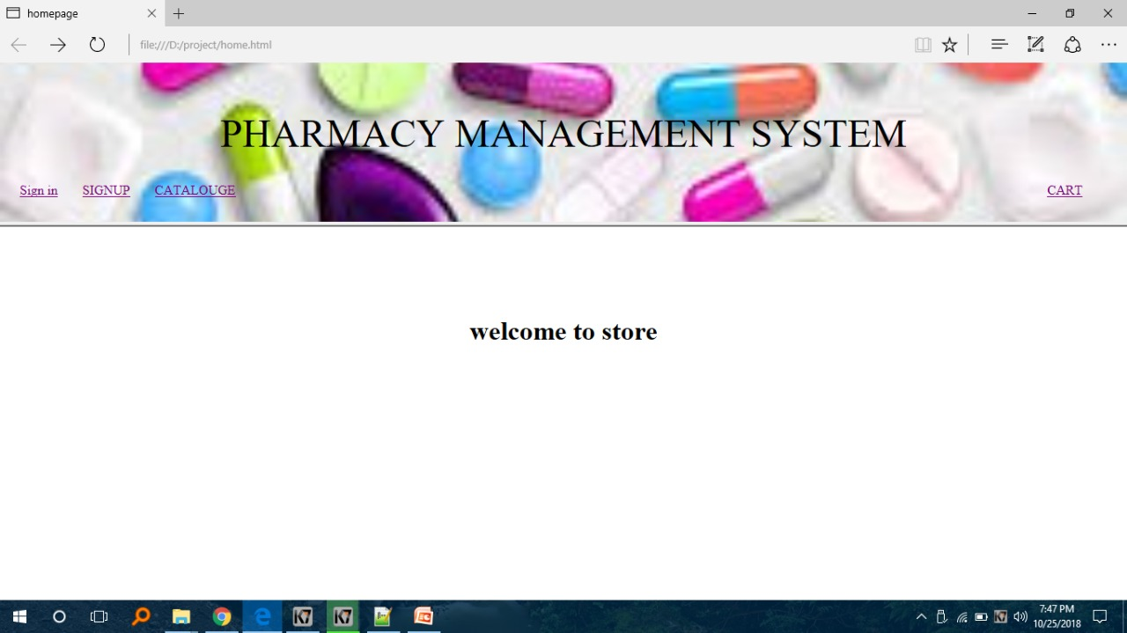

Fig 5.1 Home Page of Pharmacy Management System

This is the Home page for Pharmacy Management System.This page mainly consists of a brief Description of our web-site .This page has got several tabs named as Home, Sign in, Sign up, Catalogue, Cart. We have a Log in facility for the Administration/Customer in the right side of the web site. Through home page one can reach to any of the feature he wants to use .Catalogue helps the person to search for a drug/medicine and add to cart. Cart helps him to buy the medicines after their research.

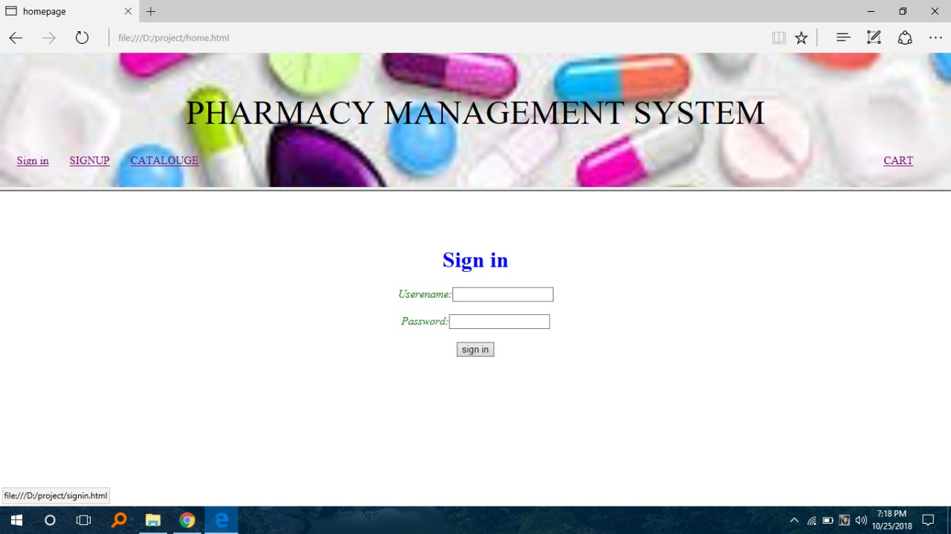

Fig 5.2 Sign-in page of Pharmacy Management System

Using the Sign in tab in the home screen of the website , the administrator or the customer can sign in into the web page, where the page shows email-id and the password areas and submit button so that the person can login.

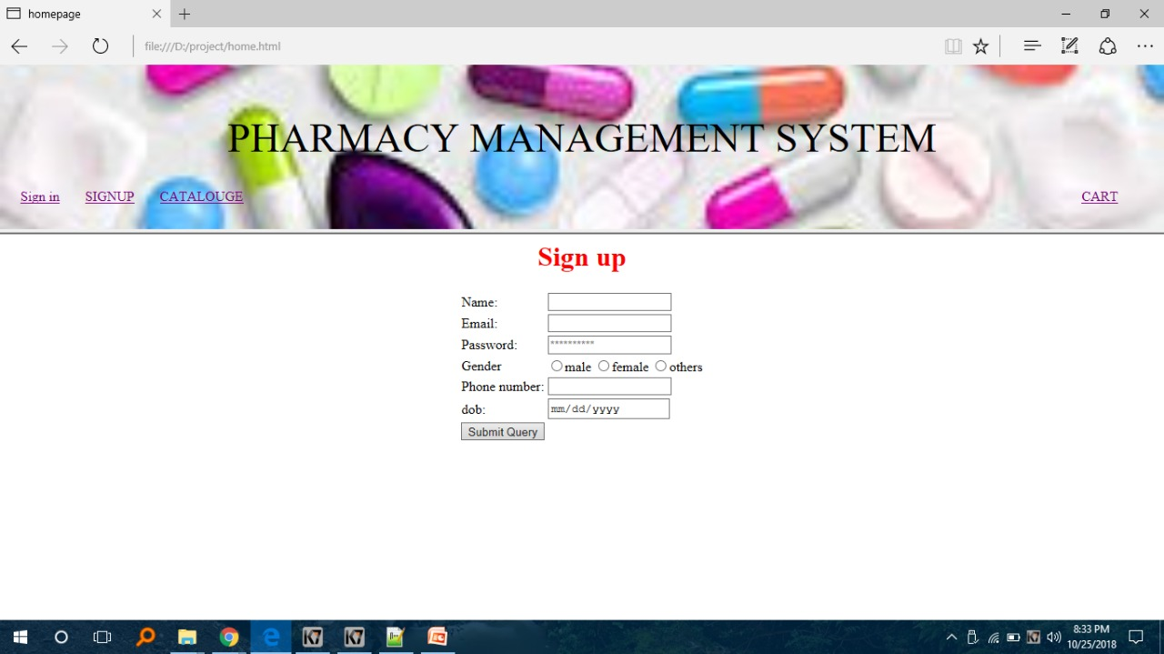

Fig 5.3 Sign-up Page for Pharmacy Management System

If a person enters into the website the person has to login into his account, or if he is
a new user to our website then he has to sign-up into our website and then continue his shopping or research. In the Sign-up page we have Name, Email(which has to be verified by Google), Password, Gender( which has to be selected), phone number, and Date of Birth text fields, which are to be filled by a new user.

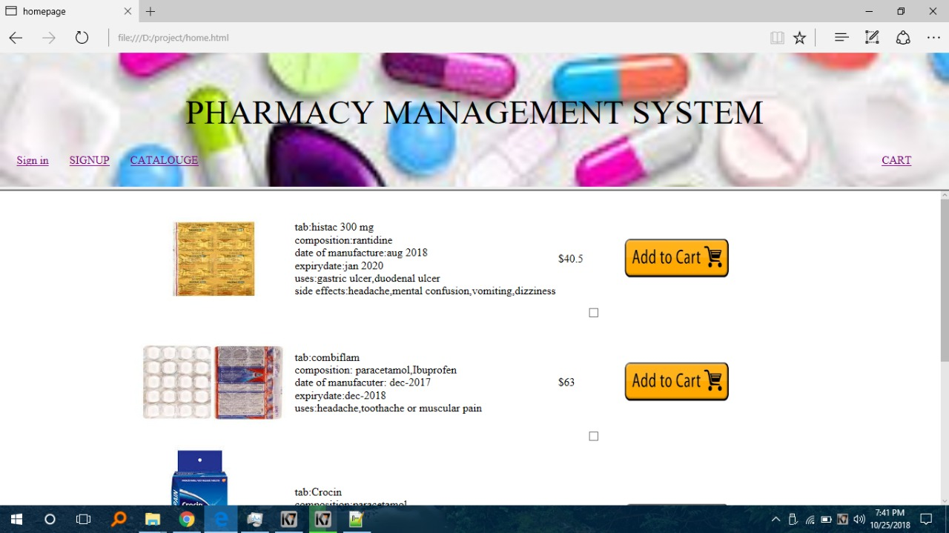

Fig 5.4 Catalogue page of Pharmacy Management System

In the catalogue page, the person/ customer can search for the required medicine or thedrugs he /she wants. He an also check the amount of mixtures of components being used in any particular type of medicine. The customer can ad theat medicine to cart if he wants.
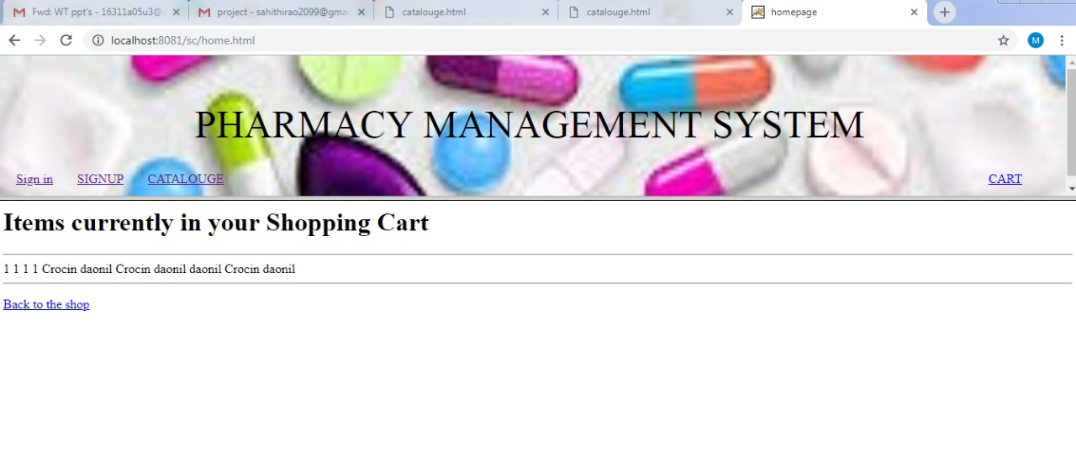Fig 5.5 Shopping cart of Pharmacy Management System

In the Catalogue page, when the customer clicks add to cart button, the medicine or thee item selected will be moved to cart. Even if the customer logs out and sign in into his account on the website, the items will be there in his cart until he/ she removes or deletes that particular item out of the cart.

If the customer logs in into his account after a long time or he opens the website from google he can click CART option on the home page which is to the right corner of home page , and directly go buy the products in the cart.

The customer can add newer products into his cart when ever possible, its upto the customers wish.

6. CONCLUSION AND FUTURE SCOPE

Conclusion:

- This project has made us aware of immense capabilities of HTML,CSS,MYSQL, Apache TOMCAT server both individually and combined. We have raised one step further in terms of designing and developing a combined management system of both Stock Managing and Billing Automation which can be used for any other related stores.

- Pharmacy management system is very much needed for patient compliance. Patient counseling, proper dispensing of drugs and other patient oriented issues can be managed properly if the hospital pharmacy is developed.

- By ensuring a quality management system of hospital pharmacy, it is possible to enrich the health sector.

Future Scope:

It is not possible to develop a system that makes all the requirements of the user. User requirements keep changing as the system is being used.
Some of the future enhancements that can be done to this system are:
- Based on the future security issues, security can be improved using emerging technologies.
- Department wise Pocket Pharmacy System (DPPS)
- Automatic Prescription and Review Manager (APRM)
- Automated Inventory Storage and Dispensing System (AISDS):

BIBLIOGRAPHY

[1] Herbert Schildt, The Complete Reference Java Tenth Edition, Tata McGraw-Hill Edition 2017

[2] Grady Booch, James Rumbaugh, Ivar Jacobson. The Unified Modeling Language User
Guide. Addison-Wesley, Reading, Mass., 1999.

[3] www.w3schools.com

[4] www.wikipedia.org

APPENDIX-A:JAVA TECHNOLOGY

About Java:
Initially the language was called as “oak” but it was renamed as “java” in 1995.The primary motivation of this language was the need for a platform-independent(i.e. architecture neutral)language that could be used to create software to be embedded in various consumer electronic devices.
- Java is a programmer’s language
- Java is cohesive and consistent
- Except for those constraint imposed by the Internet environment. Java gives the programmer, full control
Servlets/JSP
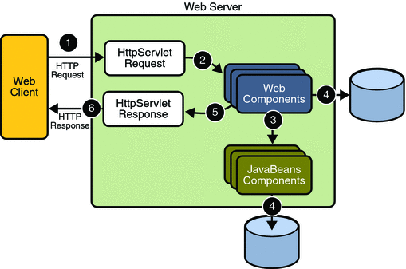
Fig : Life cycle of Servlet

A Servlet Is a generic server extension. a Java class that can be loaded dynamically to expand the functionality of a server. Servlets are commonly used with web servers. Where they can take the place CGI scripts.A servlet is similar to proprietary server extension, except that it runs inside a Java Virtual Machine (JVM) on the server, so it is safe and portable .Servlets operate solely within the domain of the server.

Features of Servlets:
- Servlets are persistent. Servlet are loaded only by the web server and can maintain services between requests.
- Servlets are fast. Since servlets only need to be loaded once, they offer much better performance over their CGI counterparts.
- Servlets are platform independent.
- Servlets are extensible Java is a robust, object-oriented programming language, which easily can be extended to suit your needs.
- Servlets are secure
- Servlets are used with a variety of client.

Invoking Servlets
A servlet invoker is a servlet that invokes the “server” method on a named servlet.If the servlet is not loaded in the server,then the invoker first loades the servlet(either form local disk or from the network) and the then invokes the “service” method.Also like applets,local servlets in the server can be identified by just the class name.In other words, if a servlet name is not absolute.it is treated as local.
A Client can Invoke Servlets in the Following Ways:
- The client can ask for a document that is served by the servlet.
- The client(browser) can invoke the servlet directly using a URL, once it has been mapped using the SERVLET ALIASES Section of the admin GUI
- The servlet can be invoked through server side include tags.
- The servlet can be invoked by placing it in the servlets/directory

The Servlet Life Cycle:-
The Servlet life cycle is one of the most exciting features of Servlets.This life cycle is a powerful hybrid of the life cycles used in CGI programming and lower-level NSAPI and ISAPI programming.
The servlet life cycle allows servlet engines to address both the performance and resource problems of CGI and the security concents of low level server API programming.
Servlet life cycle is highly flexible Servers hava significant leeway in how they choose to
support servlets. The only hard and fast rule is that a servlet engine must confor to the
following life cycle contact:

- Create and initialize the servlets
- Handle zero or more service from clients
- Destroy the servlet and then garbage Collects it.
It’s perfectly legal for a servlet to be loaded, created and initialzed in its own JVM,only to be destroyed and garbage collected without handling any client request or after handling just one request

Init and Destroy:-
Just like Applets servlets can define init() and destroy() methods, A servlets init(ServiceConfig) method is called by the server immediately after the server constructs the servlet’s instance. Depending on the server and its configuration, this can be at any of these times

- When the server states
- When the servlet is first requested, just before the service() method is invoked
- At the request of the server administrator

In any case, init() is guaranteed to be called before the servlet handles its first request.
The init() method is typically used to perform servlet initialization creating or loading objects that are used by the servlet in handling of its request. In order to providing a new servlet any information about itself and its environment, a server has to call a servelts init() method and pass an object that implement the ServletConfig interface.

This ServletConfig object supplies a servlet with information about its initialization parameters. These parameters are given to the servlets and are not associated with any single request. They can specify initial values, such as where a counter should begin counting, or default values, perhaps a template to use when not specified by the request,

The server calls a servlet’s destroy() method when the servlet is about to be unloaded. In the destroy() method, a servlet should free any resources it has acquired that will not be garbage collected. The destroy() method also gives a servlet a chance to write out its unsaved. cached information or any persistent information that should be read during the next call to init().

Session Tracking:
HTTP is a stateless protocol, it provides no way for a server to recognize that a sequence
of requests is all from the same client.
The solution for this is for client to introduce itself as it makes each request, Each clients
needs to provide a unique identifier that lets the server identify it, or it needs to give some
information that the server can use to properly handle the request, There are several ways to
send this introductory information with each request such as:

- User Authentication:
One way to perform session tracking is to leverage the information that comes with user authorization. When a web server restricts access to some of its resources to only those clients that log in using a recognized username and password. After the client logs in, the username is available to a servlet through getRemoteUser()
The biggest advantage of using user authorization to perform session tracking is that it’s easy to implement and easy to identify each client.Another advantage is that the technique works even when the user accesses your site form or exists her browser before coming back.

- Hidden Form Fields:
One way to support anonymous session tracking is to use hidden from fields. As the name implies, these are fields added to an HTML, form that are not displayed in the client’s browser, They are sent back to the server when the form that contains them is submitted.
In a sense, hidden form fields define constant variables for a form. To a servlet receiving a submitted form, there is no difference between a hidden fields and a visible filed.
As more and more information is associated with a clients session . It can become burdensome to pass it all using hidden form fields. In these situations it’s possible to pass on just a unique session ID that identifies as particular clients session.
That session ID can be associated with complete information about its session that is stored on the server.
The advantage of hidden form fields is their ubiquity and support for anonymity. Hidden fields are supported in all the popular browsers, they demand on special server requirements, and they can be used with clients that haven’t registered or logged in.
The major disadvantage with this technique, however is that works only for a sequence of
dynamically generated forms, The technique breaks down immediately with static
documents ,emailed documents book marked documents and browser shutdowns.
- URL Rewriting:
URL rewriting is another way to support anonymous session tracking, With URL rewriting every local URL the user might click on is dynamically modified. or rewritten, to include extra, information. The extra information can be in the deform of extra path information, added parameters, or some custom, server-specific.URL change. Due to the limited space available in rewriting a URL, the extra information is usually limited to a unique session.
Each rewriting technique has its own advantage and disadvantage
Using extra path information works on all servers, and it works as a target for forms that use both the Get and Post methods. It does not work well if the servlet has to use the extra path information as true path information
The advantages and disadvantages of URL.rewriting closely match those of hidden form fileds, The major difference is that URL rewriting works for all dynamically created documents, such as the Help servlet, not just forms. With the right server support, custom URL rewriting can even work for static documents.
- Persistent Cookies:
A fourth technique to perform session tracking involves persistent cookies. A cookie is a bit of information sent by a web server to a browser that can later be read back form that browser. When a browser receives a cookie, it saves the cookie and there after sends the cookie back to the server each time it accesses a page on that server, subject to certain rules. Because a cookie’s value can uniquely identify a client, cookies are often used for session tracking.
Persistent cookies offer an elegant, efficient easy way to implement session tracking. Cookies provide as automatic an introduction for each request as we could hope for. For each request, a cookie can automatically provide a client’s session ID or perhaps a list of clients performance. The ability to customize cookies gives them extra power and versatility.
JDBC:
What is JDBC?
JDBC is a Java API for executing SQL,Statements.As a point of interest JDBC is trademarked name and is not an acronym; nevertheless,Jdbc is often thought of as standing for Java Database Connectivity. It consists of a set of classes and interfaces written in the Java Programming language.JDBC provides a standard API for tool/database developers and makes it possible to write database applications using a pure Java API
Using JDBC, it is easy to send SQL statements to virtually program will be able to send SQL statements to the appropriate database. The Combination of Java and JDBC lets a programmer write it once and run it anywhere.

What Does JDBC Do?
- Establish a connection with a database
- Send SQL statements
- Process the results.

JDBC Driver Types
An individual database system is accessed via a specific JDBC driver that implements the java.sql.Driver interface. Drivers exist for nearly all-popular RDBMS systems, through few are available for free. Sun bundles a free JDBC-ODBC bridge driver with the JDK to allow access to a standard ODBC,data sources, such as a Microsoft Access database, Sun advises against using the bridge driver for anything other than development and very limited development.
JDBC drivers are available for most database platforms, from a number of vendors and
in a number of different flavours. There are four driver categories
- Type 01-JDBC-ODBC Bridge Driver
Type 01 drivers use a bridge technology to connect a java client to an ODBC database service. Sun’s JDBC-ODBC bridge is the most common type 01 driver. These drivers implemented using native code.
- Type 02-Native-API party-java Driver
Type 02 drivers wrap a thin layer of java around database-specific native code libraries for Oracle databases, the native code libraries might be based on the OCI(Oracle call Interface) libraries, which were originally designed for c/c++ programmers, Because type-02 drivers are implemented using native code, in some cases they have better performance than their all-java counter parts. They add an element of risk, however, because a defect in a driver’s native code section can crash the entire server
- Type 03-Net-Protocol All-Java Driver
Type 03 drivers communicate via a generic network protocol to a piece of custom
middleware.The middleware component might use any type of driver to provide the actual
database access. These drivers are all java, which makes them useful for applet deployment
and safe for servlet deployment
- Type-04-native-protocol All-java Driver
Type 04 drivers are the most direct of the lot. Written entirely in java, Type 04 drivers understand database-specific networking. protocols and can access the database directly without any additional software
Oracle:
Oracle is a relational database management system, which organizes data in the form of tables. Oracle is one of many database servers based on RDBMS model, which manages a seer of data that attends three specific things-data structures, data integrity and data manipulation.
With oracle cooperative server technology we can realize the benefits of open, relational systems for all the applications. Oracle makes efficient use of all systems resources, on all hardware architecture; to deliver unmatched performance, price performance and scalability. Any DBMS to be called as RDBMS has to satisfy Dr.E.F.Codd’s rules.
Features of Oracle:
Portable
The Oracle RDBMS is available on wide range of platforms ranging from PCs to super computers and as a multi user loadable module for Novel NetWare, if you develop application on system you can run the same application on other systems without any modifications.
Compatible
Oracle commands can be used for communicating with IBM DB2 mainframe RDBMS that is different from Oracle, which is Oracle compatible with DB2. Oracle RDBMS is a high performance fault tolerant DBMS, which is specially designed for online transaction processing and for handling large database applications.
Multithreaded Server Architecture
Oracle adaptable multithreaded server architecture delivers scalable high performance for very large number of users on all hardware architecture including symmetric multiprocessors (sumps) and loosely coupled multiprocessors. Performance is achieved by eliminating CPU, I/O, memory and operating system bottlenecks and by optimizing the Oracle DBMS server code to eliminate all internal bottlenecks.

Oracle has become the most popular RDBMS in the market because of its ease of use
- Client/server architecture.
- Data independence.
- Ensuring data integrity and data security.
- Managing data concurrency.
- Parallel processing support for speed up data entry and online transaction processing used for applications.
- DB procedures, functions and packages.

HTML:
Hypertext Markup Language(HTML), the languages of the world wide web(WWW), allows
users to produces web pages that included text, graphics and pointer to other web pages
(Hyperlinks).
HTML is not a programming language but it is an application of ISO Standard 8879,SGML(Standard Generalized Markup Language),but specialized to hypertext and adapted to the Web. We can navigate through the information based on out interest and preference. A markup language is simply a series of items enclosed within the elements should be displayed.
Hyperlinks are underlined or emphasized works that load to other documents or some portions of the same document.
Html can be used to display any type of document on the host computer, which can be geographically at a different location. It is a versatile language and can be used on any platform or desktop.
HTML provides tags(special codes) to make the document look attractive.
HTML provides are not case-sensitive. Using graphics,fonts,different sizes, color, etc.. can enhance the presentation of the document. Anything that is not a tag is part of the document itself.

Basic Html Tags:

<!-- --> Specific Comments.
<A>………</A> Creates Hypertext links.
<B>………</B> Text is changed to bold
<Body>…….</Body> Contains all tags and text in the Html-document
<DD>………..</DD> Definition of a term.
<TABLE>……</TABLE> Creates table
<Td>………..</Td> Indicates table data in a table.
<Tr>………..</Tr> Designates a table row
<Th>……….</Th> Creates a heading in a table.

Advantages:

  - A HTML document is small and hence easy to send over the net.It is small because it does not include formatted information.
  - HTML is platform independent.
  - HTML tags are not case-sensitive.

JAVA SCRIPT

JavaScript is a compact , object-based scripting language for developing client and server internet applications. Netscape Navigator 2.0 interprets JavaScript statements embedded directly in an HTML page. and Livewire enables you to create server-based applications similar to common gateway interface(cgi) programs.In a client application for Navigator, JavaScript statements embedded in an HTML page can recognize and respond to user events such as mouse clicks form Input, and page navigation.For example, you can write a JavaScript function to verify that users enter valid information into a form requesting a telephone number or zip code . Without any network transmission, an Html page with embedded Java Script can interpret the entered text and alert the user with a message dialog if the input is invalid or you can use JavaScript to perform an action (such as play an audio file, execute an applet, or communicate with a plug-in) in response to the user opening or exiting a page.

HTML:



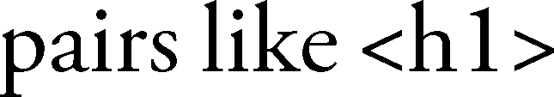

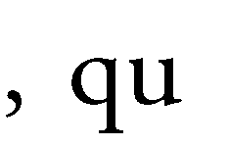

ELEMENTS



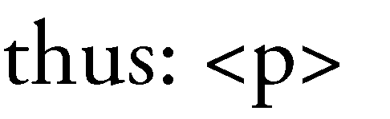






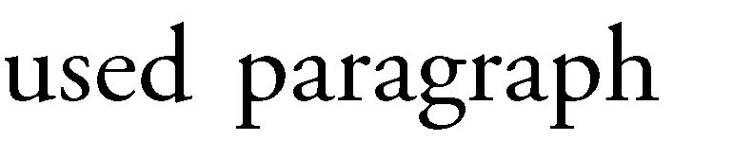
APPENDIX-B:UNIFIED MODELING LANGUAGE

The Unified Modeling Language (UML) is a general-purpose visual modeling language that is used to specify, visualize, construct, and document the artifacts of a software system. It captures decisions and understanding about systems that must be constructed. It is used to understand, design, browse, configure, maintain, and control information about such systems. It is intended for use with all development methods, lifecycle stages, application domains, and media. The modeling language is intended to unify past experience about modeling techniques and to incorporate current software best practices into a standard approach. UML includes semantic concepts, notation, and guidelines. It has static, dynamic, environmental, and organizational parts. It is intended to be supported by interactive visual modeling tools that have code generators and report writers. The UML specification does not define a standard process but is intended to be useful with an iterative development process. It is intended to support most existing object oriented development processes.

The UML captures information about the static structure and dynamic behavior of a system. A system is modeled as a collection of discrete objects that interact to perform work that ultimately benefits an outside user. The static structure defines the kinds of objects important to a system and to its implementation, as well as the relationships among the objects. The dynamic behavior defines the history of objects over time and the communications among objects to accomplish goals.

Modeling a system from several separate but related viewpoints permits it to be understood for different purposes.

The UML also contains organizational constructs for arranging models into packages that permit software teams to partition large systems into workable pieces, to understand and control dependencies among the packages, and to manage the versioning of model units in a complex development environment. It contains constructs for representing implementation decisions and for organizing run-time elements into components.

UML is not a programming language. Tools can provide code generators from UML into a variety of programming languages, as well as construct reverseengineered models from existing programs. The UML is not a highly formal language intended for theorem proving. There are a number of such languages, but they are not easy to understand or to use for most purposes. The UML is a general-purpose modeling language. For specialized domains, such as GUI layout, VLSI circuit design, or rule-based artificial intelligence, a more specialized tool with a special language might be appropriate. UML is a discrete modeling language.

It is not intended to model continuous systems such as those found in engineering and physics. UML is intended to be a universal general-purpose modeling language for discrete systems such as those made of software, firmware, or digital logic.

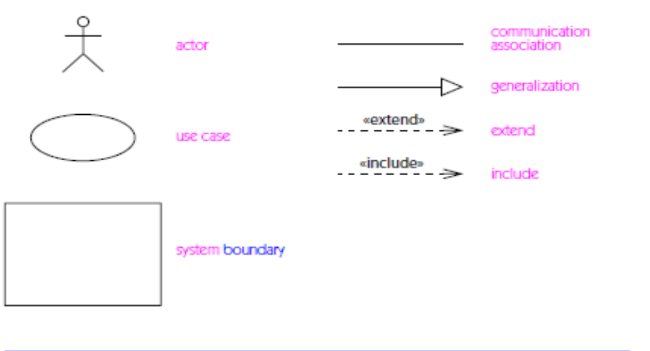
Fig : Icons on use case diagrams

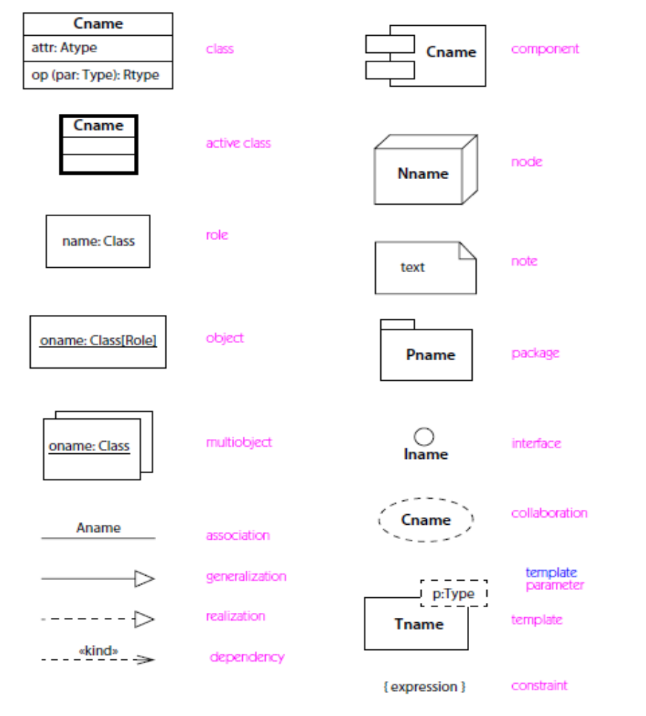
Fig : Icons on class, component, deployment, and collaboration diagrams

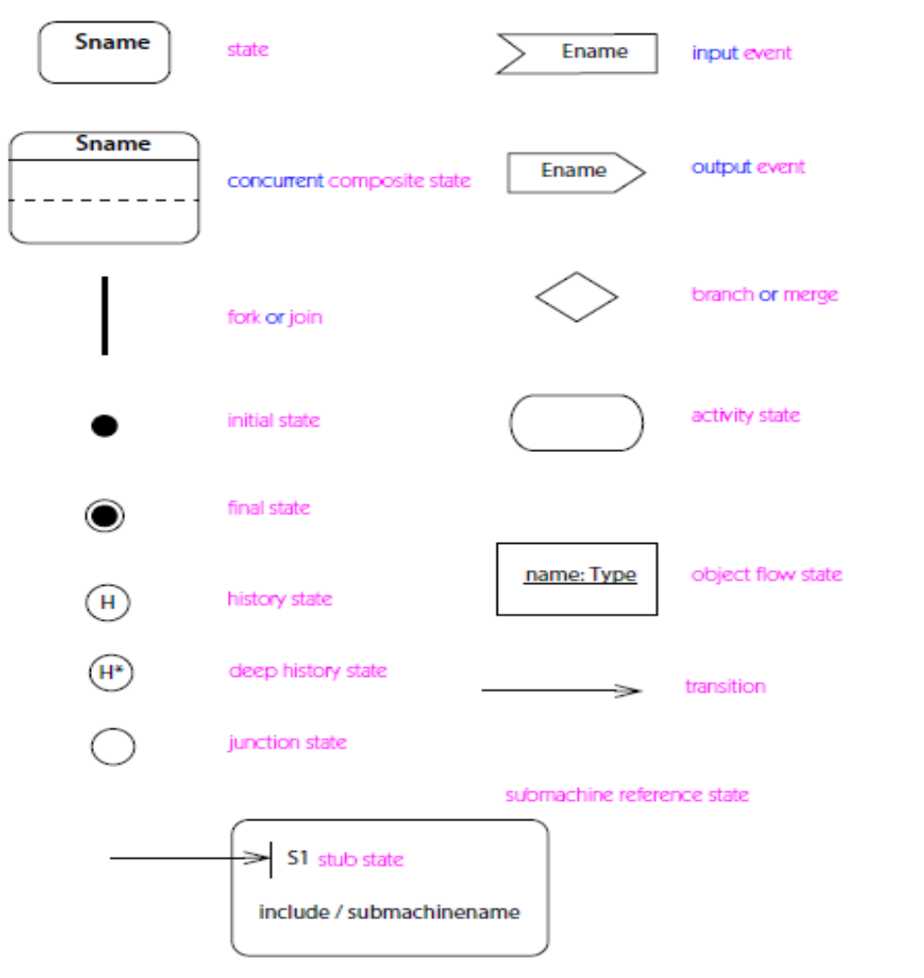
Fig :Icons on state chart and activity diagrams

