TASK 2
HANDS-ON DATA LAB IMPLEMENTATION
Food Delivery Data Analysis Using Python
YuvaIntern – Data Analyst Internship
Submitted by: Priyanka Das
Task 2

1. Introduction
Food delivery platforms generate large amounts of data related to orders, food items, restaurants, customers, payments, delivery operations, traffic conditions, and drivers. Analyzing this information helps identify ordering patterns and understand different aspects of delivery operations.
In this task, Python was used to analyze a food delivery dataset containing 100,000 order records and 23 columns. The analysis covers data exploration, data quality checking, data manipulation, basic statistical analysis, and data visualization. The project examines food items, order values, cities, payment methods, delivery duration, delivery distance, traffic levels, driver vehicles, driver availability, and order timing.

2. Objective
- To understand and explore the food delivery dataset.
- To perform basic data manipulation using Python and Pandas.
- To check the dataset for missing values and duplicate records.
- To analyze order values, quantities, food items, cities, and payment methods.
- To study delivery duration and delivery distance.
- To examine traffic levels, driver vehicles, and driver availability.
- To create meaningful visualizations for the analyzed data.
- To identify useful patterns and observations from the dataset.

3. Dataset Description
The dataset used for this project is a Food Delivery Data Analysis dataset containing 100,000 records and 23 columns. It contains information about orders, users, restaurants, drivers, food items, quantities, prices, order and delivery times, cities, payment methods, order status, vehicle type, geographic coordinates, delivery distance, traffic level, and driver availability.
The order timestamps in the dataset cover the period from June 1, 2025 to June 16, 2025.

4. Dataset Columns
Column | Description
Order_ID | Unique identification number of an order.
User_ID | Identification of the customer/user.
Restaurant_ID | Identification of the restaurant.
Driver_ID | Identification of the delivery driver.
Item_Name | Name of the food item ordered.
Quantity | Quantity of food items ordered.
Total_Price | Total price of the order.
Order_Time | Date and time when the order was placed.
Delivery_Time | Date and time associated with delivery.
Delivery_Duration_Minutes | Delivery duration in minutes.
City | City associated with the order.
Payment_Method | Payment method used for the order.
Order_Status | Status of the order.
Driver_Vehicle | Vehicle used by the delivery driver.
Restaurant_Lat | Restaurant latitude.
Restaurant_Lon | Restaurant longitude.
Customer_Lat | Customer latitude.
Customer_Lon | Customer longitude.
Driver_Lat | Driver latitude.
Driver_Lon | Driver longitude.
Delivery_Distance_km | Delivery distance in kilometres.
Traffic_Level | Traffic level during delivery.
Driver_Availability | Availability status of the driver.

5. Tools and Technologies Used
- Python – used for data analysis and manipulation.
- Jupyter Notebook – used to execute and document the analysis.
- Pandas – used for loading, cleaning, grouping, filtering, and analyzing data.
- NumPy – used for numerical operations.
- Matplotlib – used for creating charts and visualizations.

6. Data Loading and Initial Exploration
The CSV file was loaded into a Pandas DataFrame. The first few records were viewed to understand the structure of the data. The shape, column names, data types, descriptive statistics, and number of unique values were then examined.
The dataset contains 100,000 rows and 23 columns.
The analysis used functions such as head(), shape, info(), columns, describe(), and nunique().

7. Data Quality Checking
Missing values were checked for all columns. The dataset contains 0 missing values. Duplicate rows were also checked, and the dataset contains 0 duplicate rows. Therefore, no missing-value treatment or duplicate-row removal was required for this dataset.
Quality Check | Result
Number of Records | 100,000
Number of Columns | 23
Missing Values | 0
Duplicate Rows | 0

8. Date and Time Data Preparation
The Order_Time and Delivery_Time columns were converted to datetime format using Pandas. Additional time-based columns were created from Order_Time, including Order_Date, Order_Hour, and Order_Day. These derived fields make it possible to perform time-based analysis of order activity.

9. Data Manipulation
Data manipulation was performed using Pandas operations such as column selection, filtering, sorting, value counting, grouping, and aggregation. Grouped calculations were used to compare order counts and total order values across food items, cities, traffic levels, vehicle types, and quantities.
The analysis also created useful time-based columns and calculated totals and averages for quantity, order value, delivery duration, and delivery distance.

10. Basic Statistical Analysis
Metric | Result
Total Orders | 100,000
Total Quantity Ordered | 299,111
Total Order Value | 26,892,573.36
Average Order Value | 268.93
Average Quantity per Order | 2.99
Average Delivery Duration | 37.52 minutes
Average Delivery Distance | 2.17 km

11. Order Status Analysis
The Order_Status column was analyzed using value counts and percentage calculations. The dataset contains three order statuses: Delivered, Cancelled, and In Transit.
Delivered: 85,197 orders (85.197%).
Cancelled: 9,812 orders (9.812%).
In Transit: 4,991 orders (4.991%).
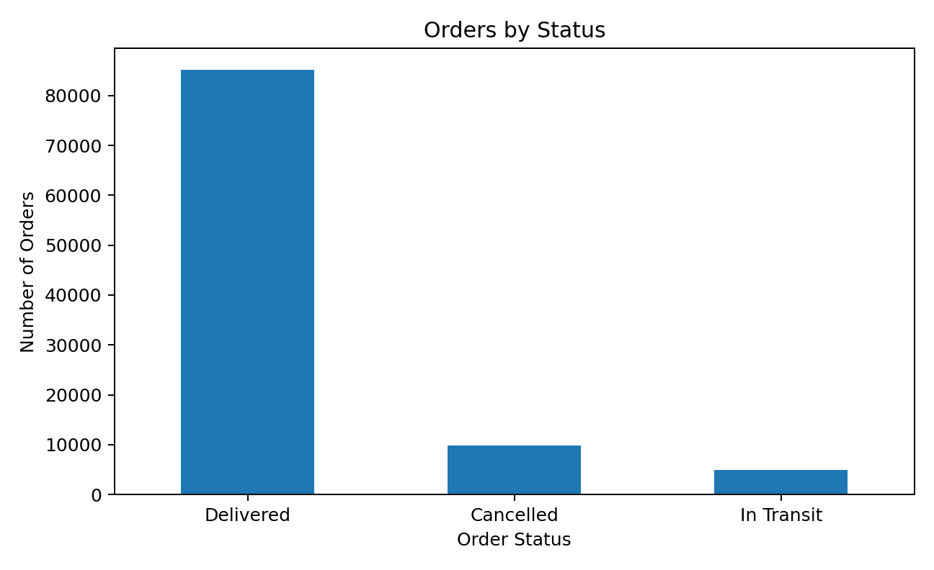
Figure 1. Orders by Status

12. Food Item Analysis
The number of orders was calculated for each food item. Shawarma recorded the highest number of orders.
Shawarma recorded 11,320 orders, followed by Pizza with 11,229 orders.
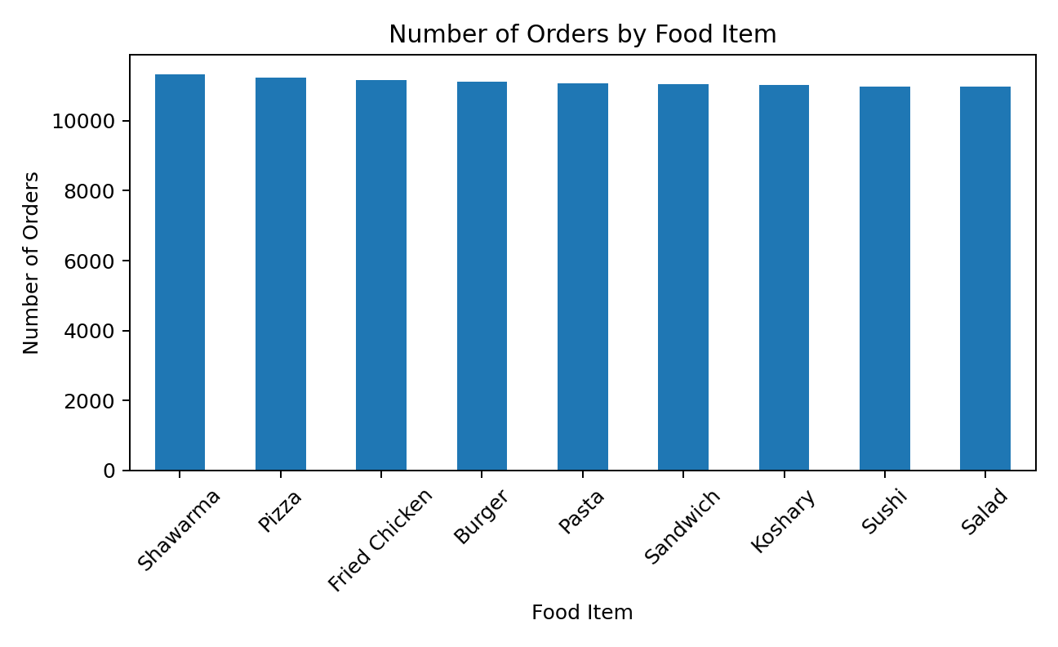
Figure 2. Number of Orders by Food Item

13. Total Order Value by Food Item
Total order value was grouped by food item. Shawarma generated the highest total order value of 3,060,271.73, while Sushi recorded the lowest among the listed food items at 2,933,665.72.
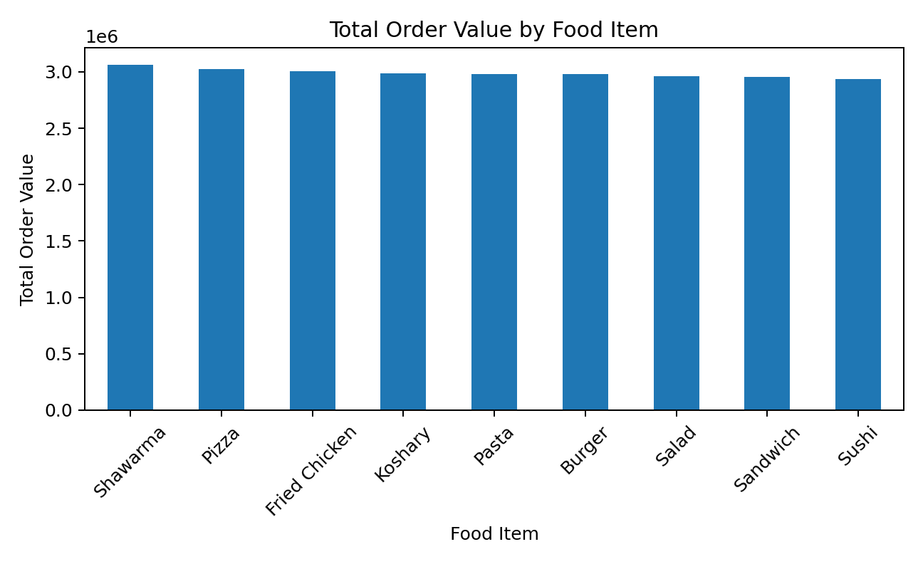
Figure 3. Total Order Value by Food Item

14. City-wise Order Analysis
Orders were grouped by city to compare order activity. Zagazig recorded the highest number of orders with 14,538 orders, while Mansoura recorded the lowest with 14,044 orders.
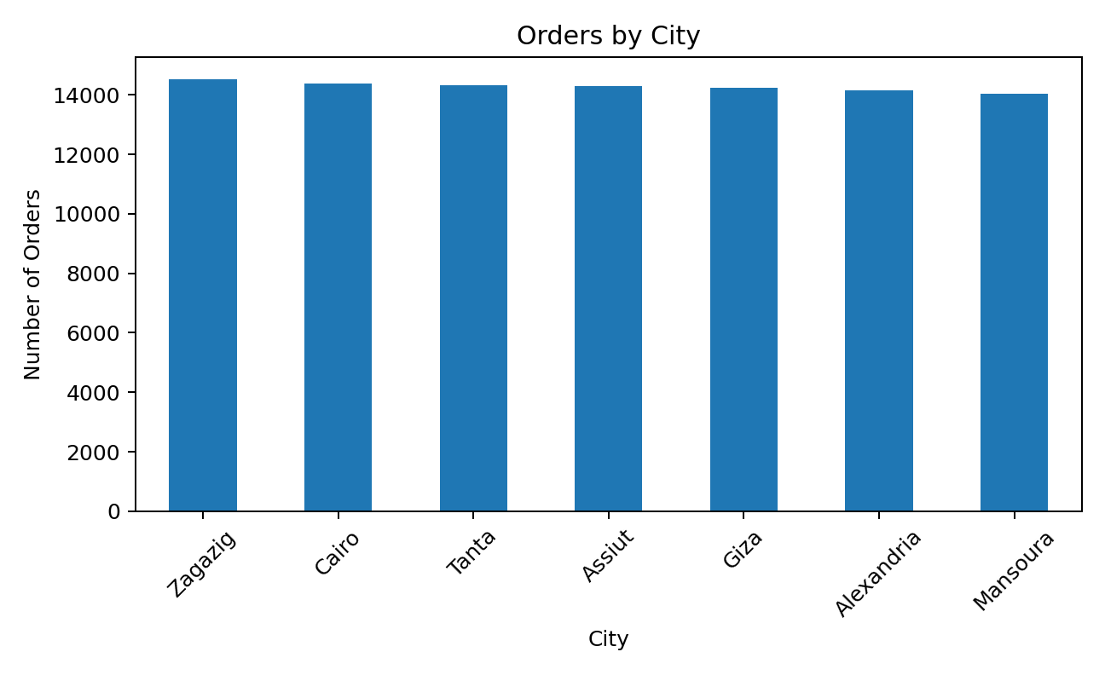
Figure 4. Orders by City

15. City-wise Total Order Value
Total order value was calculated for each city. Zagazig recorded the highest total order value of 3,905,102.65, while Mansoura recorded the lowest total order value of 3,755,348.05.
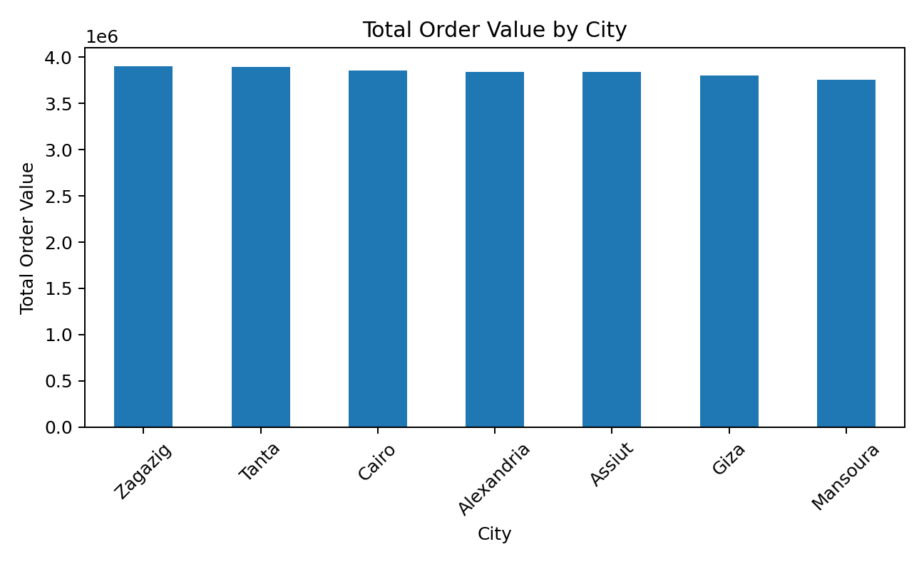
Figure 5. Total Order Value by City

16. Payment Method Analysis
Cash was the most frequently used payment method with 33,528 orders. Wallet was used for 33,250 orders and Credit Card for 33,222 orders.
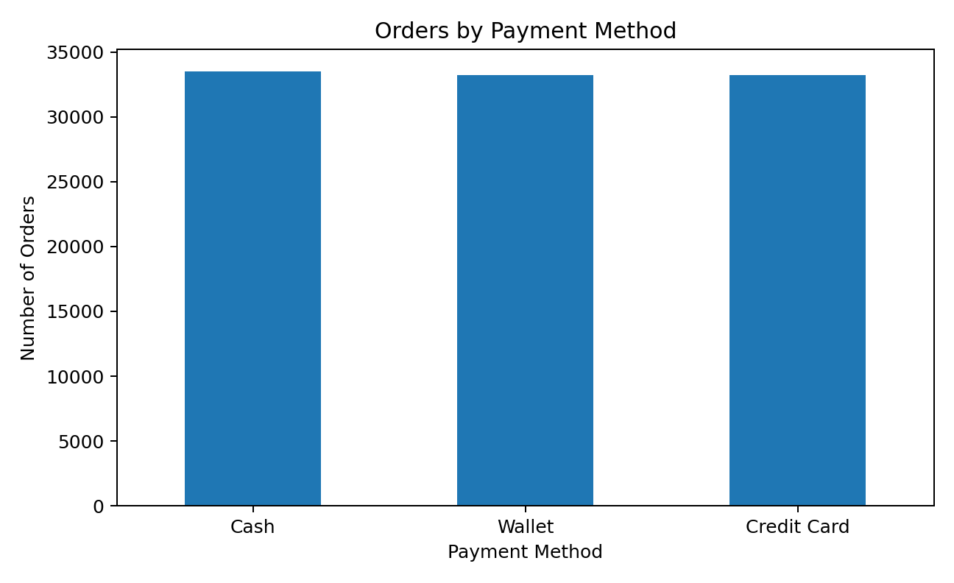
Figure 6. Orders by Payment Method

17. Delivery Duration Analysis
Delivery duration ranged from 15 to 60 minutes. The average delivery duration was 37.52 minutes, with a median of 38 minutes.
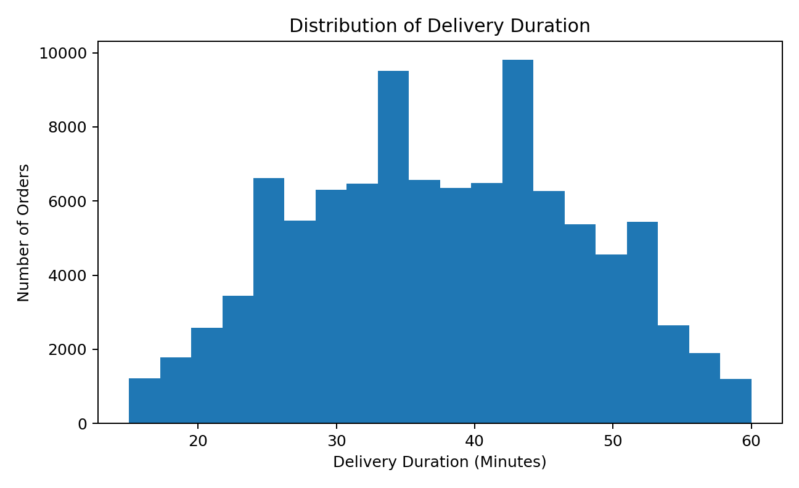
Figure 7. Distribution of Delivery Duration

18. Delivery Distance Analysis
Delivery distance ranged from 0.009 km to 5.598 km. The average delivery distance was 2.17 km.
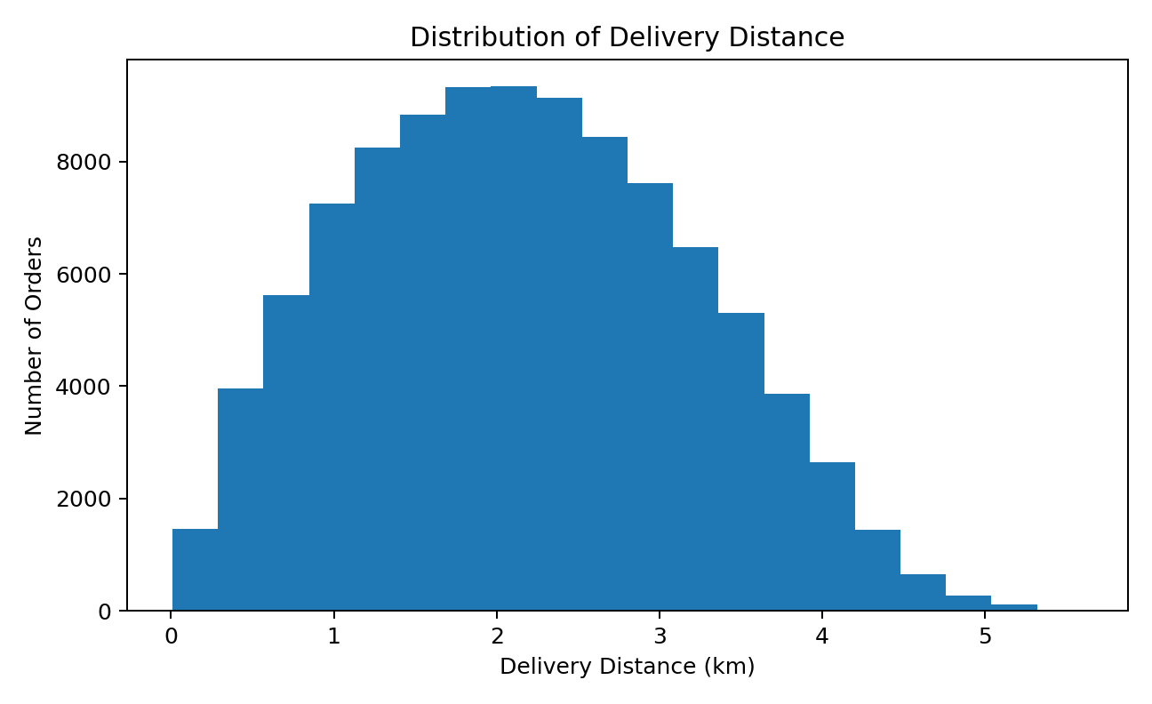
Figure 8. Distribution of Delivery Distance

19. Traffic Level Analysis
The dataset contains 45,826 orders with Low traffic, 29,220 with High traffic, and 24,954 with Medium traffic.
Average delivery duration was also compared across traffic levels. In this dataset, Low traffic had the highest average delivery duration at 37.58 minutes, followed by Medium at 37.49 minutes and High at 37.45 minutes.
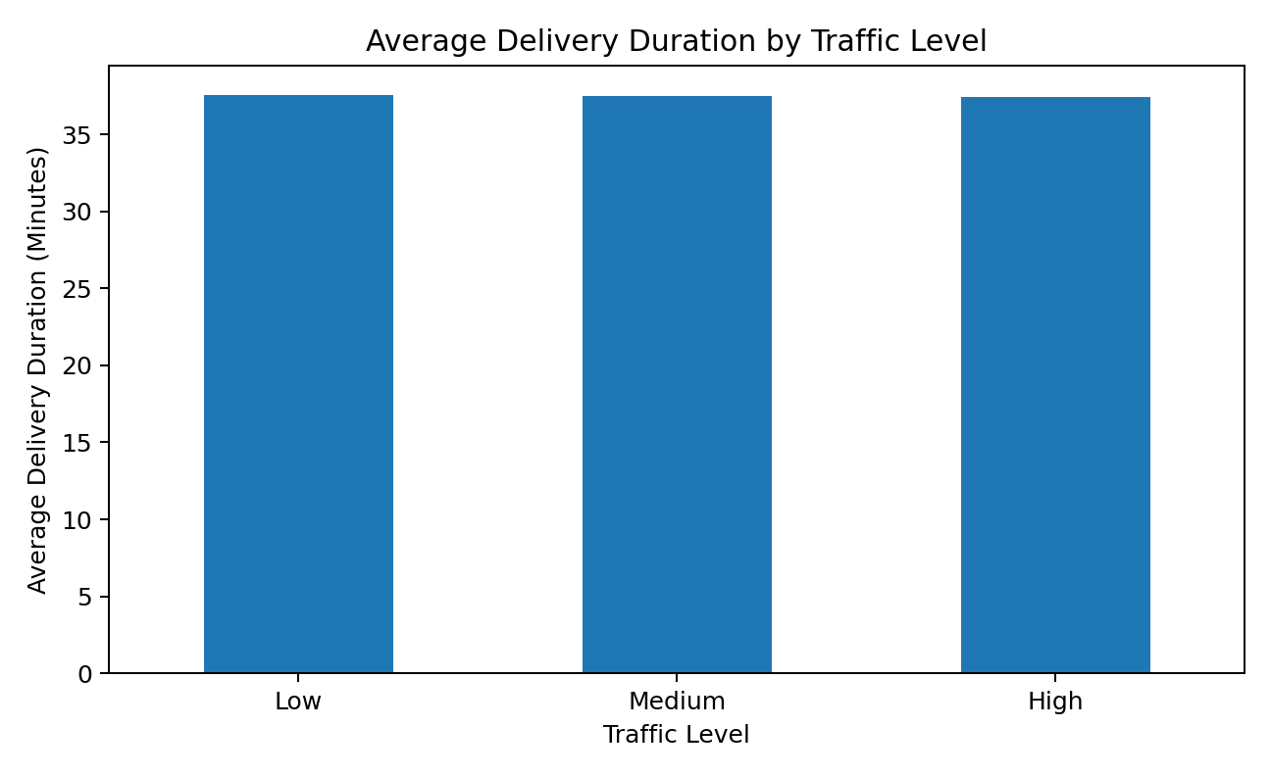
Figure 9. Average Delivery Duration by Traffic Level

20. Driver Vehicle Analysis
The dataset contains 33,393 Bicycle records, 33,362 Car records, and 33,245 Motorbike records. The average delivery duration was 37.55 minutes for Car, 37.53 minutes for Bicycle, and 37.48 minutes for Motorbike.

21. Driver Availability Analysis
The dataset contains 90,111 records where the driver was Online and 9,889 records where the driver was Offline.
- Online driver records: 90,111
- Offline driver records: 9,889

22. Order Quantity and Average Order Value
The relationship between quantity and average order value was examined by grouping orders according to quantity. The average order value increased as the quantity increased in this dataset.
Quantity 1: average order value = 89.98.
Quantity 2: average order value = 180.09.
Quantity 3: average order value = 270.03.
Quantity 4: average order value = 361.41.
Quantity 5: average order value = 447.08.
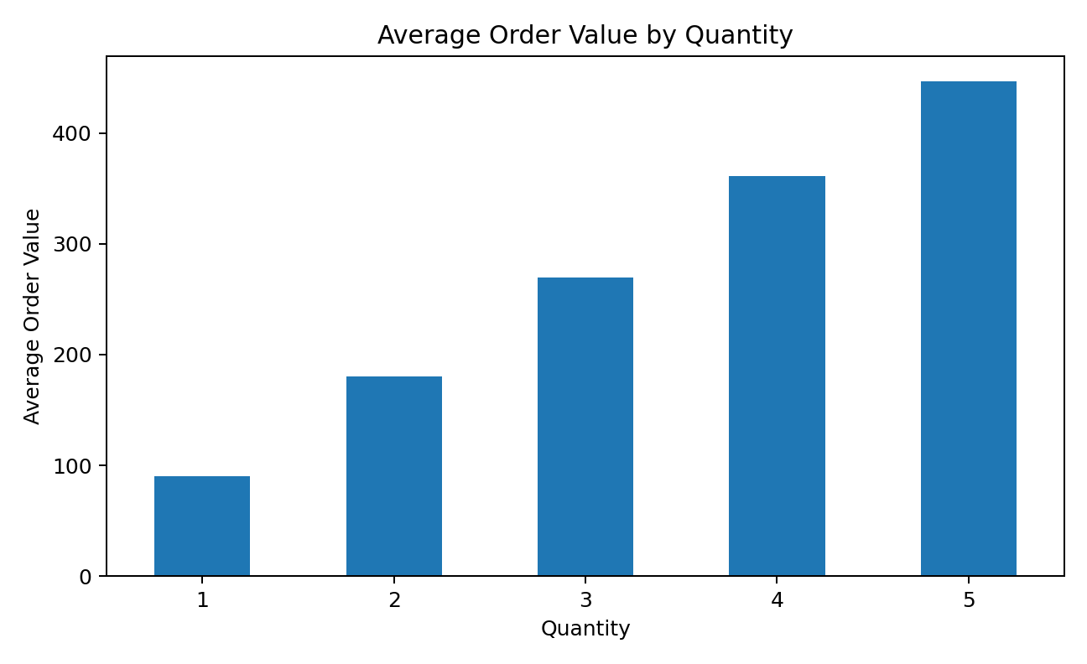
Figure 10. Average Order Value by Quantity

23. Restaurant Analysis
Restaurant_ID 277 recorded the highest number of orders among restaurants, with 133 orders. Restaurant_ID 86 recorded the highest total order value among restaurants, with 37,230.68.
Restaurant IDs were used for this analysis because the dataset provides restaurant identifiers rather than restaurant names.

24. Key Findings
- The dataset contains 100,000 food delivery records across 23 columns.
- The dataset contains no missing values and no duplicate records.
- Total order value across the dataset is 26,892,573.36, with an average order value of 268.93.
- Shawarma was the most frequently ordered food item with 11,320 orders.
- Shawarma also recorded the highest total order value among food items at 3,060,271.73.
- Zagazig had the highest number of orders with 14,538 and the highest city-level total order value at 3,905,102.65.
- Cash was the most commonly used payment method with 33,528 orders.
- 85,197 orders were marked Delivered, representing 85.197% of the records.
- The average delivery duration was 37.52 minutes and the average delivery distance was 2.17 km.
- Low traffic had the highest average delivery duration in this dataset at 37.58 minutes; therefore, the data does not show a simple pattern where higher traffic always corresponds to longer average delivery duration.
- Online driver records numbered 90,111, compared with 9,889 offline records.

25. Conclusion
This project provided practical experience in analyzing food delivery data using Python. The dataset was explored and checked for data quality before performing data manipulation and analysis. Pandas was used to filter, group, aggregate, and summarize the data, while Matplotlib was used to create visualizations.
The analysis examined food items, cities, order values, payment methods, order status, delivery duration, delivery distance, traffic levels, driver vehicles, driver availability, quantities, and restaurant identifiers. The visualizations helped present the results clearly and identify patterns in the dataset.
Overall, the task strengthened practical understanding of data loading, data quality checking, data manipulation, basic statistical analysis, and data visualization using Python.

26. GitHub Repository
GitHub Repository: https://github.com/priyankadas-star/YuvaIntern-Data-Analyst-Internship/tree/main
The repository should contain the Jupyter Notebook, the dataset used for the analysis, and a README file describing the project.

27. Final Submission Checklist
- Jupyter Notebook completed with the actual analysis and outputs.
- Food delivery dataset included in the project repository, if permitted by the internship instructions.
- Relevant charts included in the notebook and report.
- Word report completed and checked for consistency with the notebook.
- GitHub repository URL added to the YuvaIntern submission form.
- No fabricated results or observations included.

