MARKETING CAMPAIGN ANALYSIS
Task 3 – Real-World Dataset Analysis Project
Name:Priyanka Das
Task 3-Marketing campaign analysis

1. Abstract
This project analyses a marketing campaign sales dataset containing 548 records and 7 variables. The dataset records sales across 10 markets, 137 locations, three promotion categories and four weeks. The analysis examines data structure, data quality, sales distribution, market-size performance, promotion performance, weekly trends, store age and correlations among numerical variables. The total recorded sales are 29,299.48 in the dataset's SalesInThousands unit. Exploratory analysis and visualizations are used to identify patterns and present evidence-based findings. A Power BI dashboard is used to communicate the results.

2. Introduction
Marketing campaign analysis helps an organization understand how sales vary across market segments, promotions, locations and time periods. This project uses a structured sales dataset to explore these patterns. The analysis focuses on descriptive insights and comparisons; it does not claim that a promotion caused a change in sales.

3. Problem Statement
Sales records across multiple markets, locations, promotions and weeks can be difficult to interpret without structured analysis. The project aims to summarize the dataset, check its quality, compare sales categories and present findings through visualizations and a dashboard.

4. Objectives
- Understand the dataset structure and variables.
- Check missing values, duplicate records and data types.
- Summarize sales using descriptive statistics.
- Compare sales across market sizes and promotions.
- Examine weekly sales and store-age patterns.
- Explore relationships among numerical variables using correlation.
- Present findings through charts and a Power BI dashboard.

5. Dataset Description
File used: Marketing-Campaign_raw.csv (the raw dataset supplied for this analysis). The file contains the following columns:
Column | Data type | Description
MarketID | Integer | Identifier for the market.
MarketSize | Text/category | Market category: Small, Medium or Large.
LocationID | Integer | Identifier for the location.
AgeOfStore | Integer | Store age value recorded in the dataset.
Promotion | Integer/category | Promotion category (1, 2 or 3).
week | Integer/category | Week number (1 to 4).
SalesInThousands | Decimal | Sales value recorded in thousands.
Dataset dimensions: 548 rows × 7 columns. Unique values: 10 markets, 137 locations, 3 market-size categories, 3 promotions and 4 weeks. Each of the 137 locations has exactly four weekly records.

6. Tools and Technologies
The raw file was inspected and analysed using Python with Pandas and NumPy; Matplotlib was used to generate the report charts. Power BI is used for the project dashboard. Include Excel or SQL in the final submission only if you actually used them in this project and can provide supporting evidence.

7. Data Exploration
Exploration check | Verified result
Rows and columns | 548 rows and 7 columns
Missing values | 0 across all columns
Duplicate rows | 0
Market IDs | 10
Locations | 137
Market sizes | Large, Medium, Small
Promotion categories | 1, 2, 3
Weeks | 1, 2, 3, 4
Sales range | 17.34 to 99.65
Average sales | 53.47
Median sales | 50.20
The dataset contains no null values and no exact duplicate rows. The integer identifier and category columns are stored as integers in the CSV; for analysis, MarketID, LocationID, Promotion and week should be treated as categorical identifiers/categories rather than continuous measurements. MarketSize is a text category, and SalesInThousands is a decimal numerical measure.

8. Data Cleaning and Preprocessing
The raw CSV was loaded and checked before analysis. The verified checks found zero missing values and zero duplicate rows, so no row deletion or missing-value imputation was required for these checks. The column data types were inspected. For meaningful analysis, identifier/category columns (MarketID, LocationID, Promotion and week) were treated as categories, while SalesInThousands remained numerical. No values were silently removed.
An IQR-based outlier check was performed on SalesInThousands. Q1 = 42.545, Q3 = 60.477, IQR = 17.932; the 1.5×IQR lower and upper fences are 15.646 and 87.376. The check flags 33 records above the upper fence and none below the lower fence. These are potential high-value observations, not automatically errors; they should be investigated and retained unless a data-entry issue is confirmed.

9. Descriptive Statistics
Statistic | SalesInThousands
Count | 548
Total | 29,299.48
Mean | 53.47
Median | 50.20
Standard deviation | 16.76
Minimum | 17.34
Maximum | 99.65

10. Exploratory Data Analysis

10.1 Sales by Market Size
Market size | Records | Total sales | Average sales
Large | 168 | 11779.61 | 70.12
Medium | 320 | 14075.31 | 43.99
Small | 60 | 3444.56 | 57.41
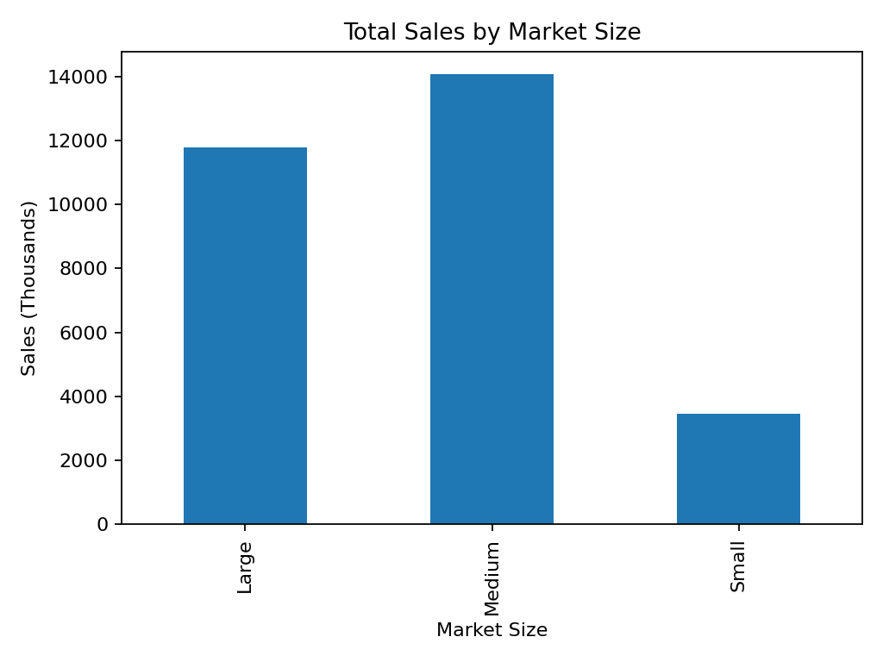
Figure 1. Total sales by market size.
Medium markets contribute the largest total sales (14075.31), approximately 48.04% of total sales. Large markets contribute 11779.61 (40.20%), and Small markets contribute 3444.56 (11.76%). Large markets have the highest average sales per record (70.12), while Medium markets have the highest aggregate sales because they have more records.

10.2 Promotion-wise Sales
Promotion | Records | Total sales | Average sales
Promotion 1 | 172 | 9993.03 | 58.10
Promotion 2 | 188 | 8897.93 | 47.33
Promotion 3 | 188 | 10408.52 | 55.36
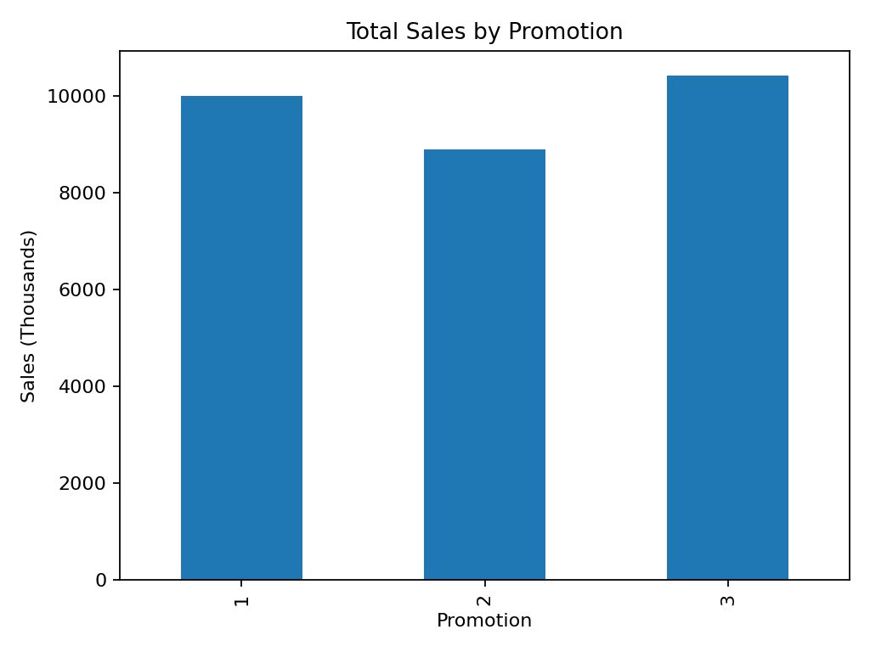
Figure 2. Total sales by promotion.
Promotion 3 has the highest total sales (10408.52) and Promotion 2 has the lowest total sales (8897.93). Promotion 3 contributes 35.52% of total recorded sales. These are descriptive comparisons; they do not establish that the promotion itself caused the difference.

10.3 Weekly Sales Trend
Week | Records | Total sales | Average sales
Week 1 | 137 | 7369.31 | 53.79
Week 2 | 137 | 7313.96 | 53.39
Week 3 | 137 | 7326.02 | 53.47
Week 4 | 137 | 7290.19 | 53.21
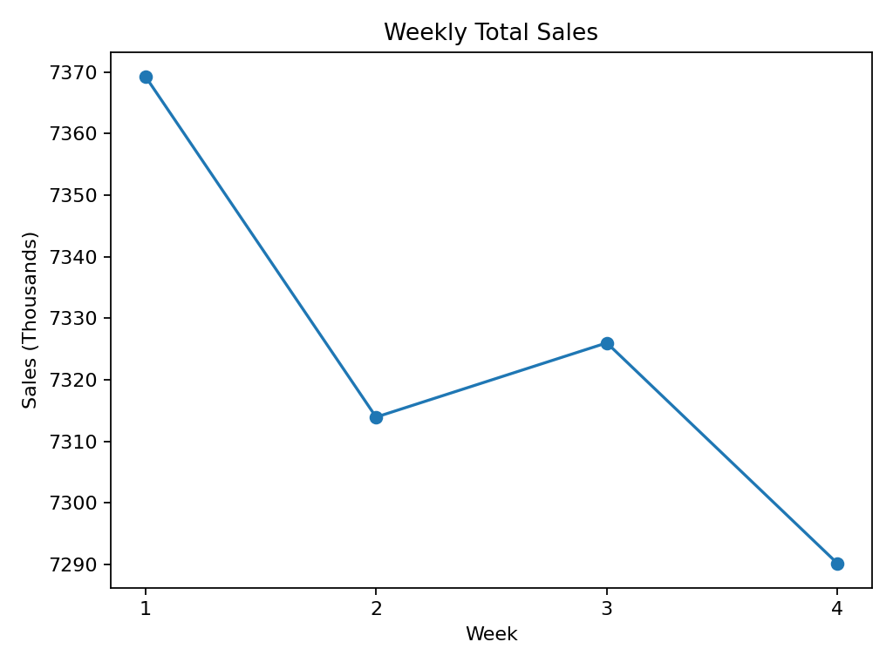
Figure 3. Weekly total sales.
Week 1 has the highest total sales (7369.31), while Week 4 has the lowest (7290.19). The weekly totals are close, ranging from 7290.19 to 7369.31, indicating relatively stable total sales across the four weeks.

10.4 Store Age Analysis
Store ages in the dataset range from 1 to 28. Average sales vary across age values. The highest observed average is for store age 23 (65.10); this group has 8 records. Some age groups contain very few records, so comparisons should be interpreted carefully.

10.5 Location Performance
Location ID | Total sales
209 | 380.36
218 | 364.50
220 | 361.37
210 | 357.05
208 | 354.31
202 | 349.66
214 | 349.50
205 | 348.27
222 | 347.68
207 | 344.65
Location totals are calculated by summing the four weekly records for each location. The table above lists the ten locations with the highest total sales in this dataset.

11. Correlation Analysis
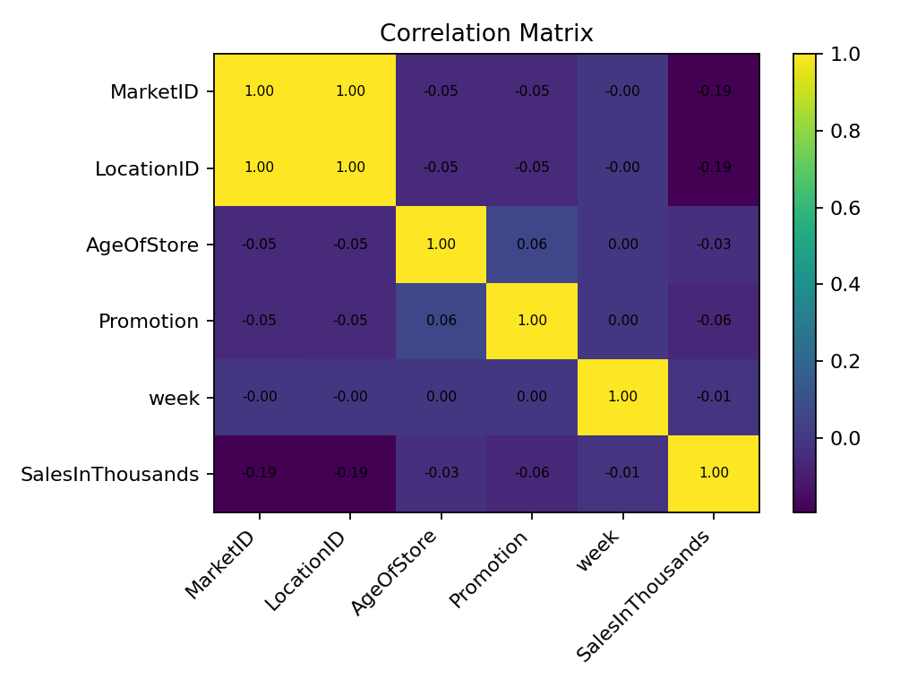
Figure 4. Pearson correlation matrix for numerical columns.
Pearson correlation measures linear association and ranges from -1 to +1. In this dataset, the correlation between SalesInThousands and AgeOfStore is -0.029, between SalesInThousands and Promotion is -0.059, and between SalesInThousands and week is -0.011. These values indicate weak linear relationships in this dataset. MarketID and LocationID have a correlation of 1.000, largely because the IDs are linked in the data structure; identifiers are not meaningful continuous measurements. Therefore, correlations involving ID columns should not be interpreted as business relationships. Promotion numbers 1, 2 and 3 are category labels, so treating them as numeric in Pearson correlation is also limited; grouped comparisons are more appropriate.

12. Outlier Analysis
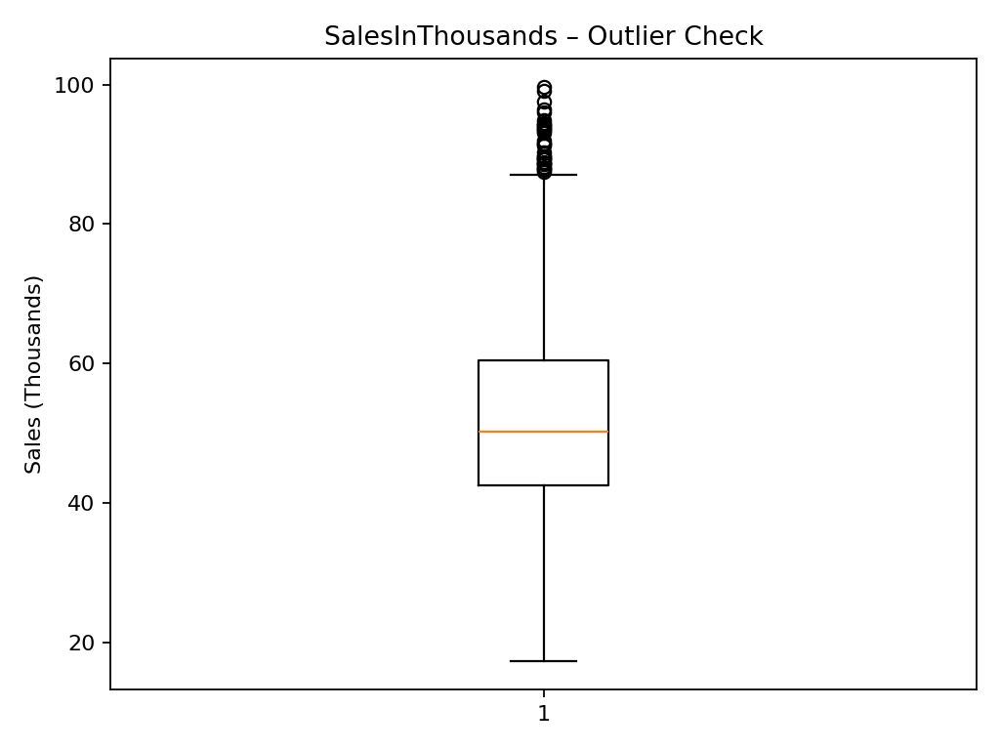
Figure 5. Boxplot of sales values.
The IQR rule flags 33 high-side observations above 87.38. The minimum sales value is 17.34 and maximum is 99.65. The flagged observations should be checked against source records. They were not removed from the descriptive analysis because an unusual sales value is not necessarily an error.

13. Dashboard and Visualization
The Power BI dashboard summarizes total sales, number of markets and locations, sales by market size, promotion-wise sales, weekly sales trends, top locations and store-age comparisons. Insert the actual screenshots exported from Power BI in this section. Each screenshot should have a figure number and a short explanation. The charts in this report are independently generated from the uploaded raw CSV for reproducible evidence.

14. Key Findings
- The raw dataset contains 548 rows and 7 columns, representing 10 markets and 137 locations.
- Total recorded sales are 29,299.48 and average sales per record are 53.47.
- Medium markets have the highest aggregate sales (14075.31; 48.04% share).
- Large markets have the highest average sales per record (70.12).
- Promotion 3 has the highest total sales (10408.52).
- Week 1 has the highest weekly total, while Week 4 has the lowest.
- The data contains no missing values or exact duplicate rows.
- The IQR rule flags 33 potential high-side sales outliers; they require source-level review rather than automatic deletion.

15. Recommendations
- Investigate the reasons behind higher average sales in Large markets and higher aggregate sales in Medium markets; consider the number of records in each group.
- Review Promotion 3 performance alongside campaign cost, profit and customer response before deciding whether to expand it.
- Continue monitoring weekly sales; the four weekly totals are close, so use a longer time period to identify seasonality.
- Review high-sales outlier records against original business records before deciding whether they are valid.
- Use location-level comparisons to identify strong and weak locations, while considering differences in market size.
- Do not use identifier correlations as business insights; focus on meaningful measures and properly encoded categories.

16. Conclusion
The analysis of the uploaded marketing campaign dataset provides a structured view of sales across markets, locations, promotions and weeks. The dataset contains 548 records and has no missing values or duplicate rows. Medium markets contribute the highest aggregate sales, Large markets have the highest average sales per record, and Promotion 3 has the highest total sales among the three promotion categories. Weekly totals are relatively stable. The analysis combines data-quality checks, descriptive statistics, grouped comparisons, correlation analysis and visualizations to support evidence-based interpretation.

17. Limitations and Future Scope
The dataset covers four weeks and does not include campaign costs, profit, customer-level information or other variables needed to measure return on investment or establish causal effects. Future work can include a longer time period, profitability measures, customer segmentation, statistical significance testing and predictive analysis when suitable data is available.

18. Appendix – Reproducible Python Code
import pandas as pd
import numpy as np

df = pd.read_csv("Marketing-Campaign_raw.csv")

print(df.shape)
print(df.info())
print(df.isnull().sum())
print("Duplicate rows:", df.duplicated().sum())
print(df.describe())

print(df.groupby("MarketSize")["SalesInThousands"].agg(
["count", "sum", "mean"]))
print(df.groupby("Promotion")["SalesInThousands"].agg(
["count", "sum", "mean"]))
print(df.groupby("week")["SalesInThousands"].agg(
["count", "sum", "mean"]))

print(df.corr(numeric_only=True))

q1 = df["SalesInThousands"].quantile(0.25)
q3 = df["SalesInThousands"].quantile(0.75)
iqr = q3 - q1
lower = q1 - 1.5 * iqr
upper = q3 + 1.5 * iqr

outliers = df[
(df["SalesInThousands"] < lower) |
(df["SalesInThousands"] > upper)
]
print("Potential outliers:", len(outliers))

19. References
1. Original raw dataset supplied for this project: Marketing-Campaign_raw.csv.
2. Pandas documentation: https://pandas.pydata.org/docs/
3. NumPy documentation: https://numpy.org/doc/
4. Matplotlib documentation: https://matplotlib.org/stable/
5. Microsoft Power BI documentation: https://learn.microsoft.com/power-bi/

