

**Outlier Treatments**

**Instructions**:

Please share your answers filled inline in the word document. Submit code files wherever applicable.

Please ensure you update all the details:

**Name: _________________________**

**Batch Id: _______________________**

**Topic: Data Pre-Processing**

**Problem Statement:**

Most of the datasets have extreme values or exceptions in their observations. These values affect the predictions (Accuracy) of the model in one way or the other, removing these values is not a very good option. For these types of scenarios, we have various techniques to treat such values.

Refer: <https://360digitmg.com/mindmap-data-science>

1. Prepare the dataset by performing the preprocessing techniques, to treat the outliers.

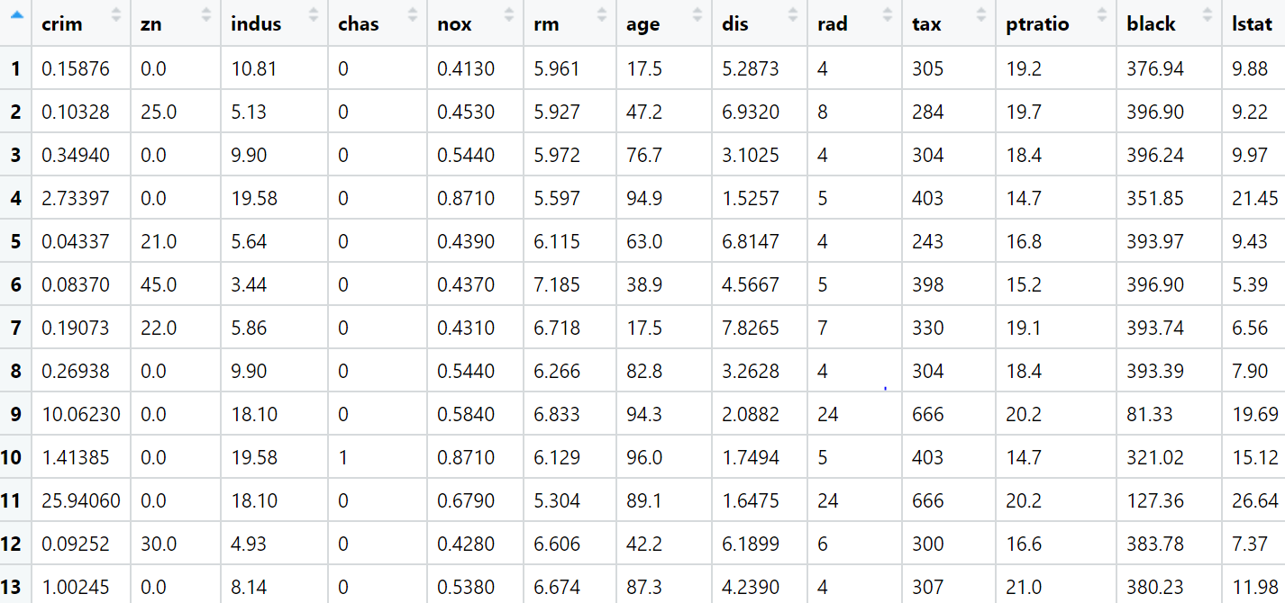

**Hints:**

For each assignment, the solution should be submitted in the below format

1. Work on each feature to create a data dictionary as displayed in the image displayed below: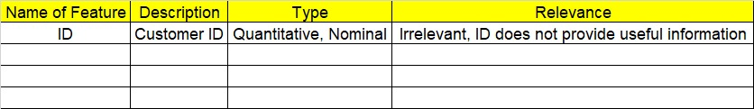
2. Hint: Boston dataset is publicly available. Refer to the Boston.csv file.
3. Research and perform all possible steps for obtaining the solutions.
4. All the codes (executable programs) should execute without errors.
5. Code modularization should be followed.
6. Each line of code should have comments explaining the logic and why you are using that function
7. Detailed explanation of your approach is mandatory.