**Imputation**

Instructions:

Please share your answers filled inline in the word document. Submit code files wherever applicable.

Please ensure you update all the details:

**Name: _________________________**

**Batch Id: _______________________**

**Topic: Data Pre-Processing**

**Problem Statement:**

Majority of the datasets have missing values, that might be because the data collected were not at regular intervals or the breakdown of instruments and so on. It is nearly impossible to build the proper model or in other words, get accurate results. The common techniques are either removing those records completely or substitute those missing values with the logical ones, there are various techniques to treat these types of problems.

1. Prepare the dataset using various techniques to solve the problem, explore all the techniques available and use them to see which gives the best result.

**Hint:**  Go through this link: <https://360digitmg.com/mindmap-data-science>

**Hints:**

For each assignment, the solution should be submitted in the below format.

1. Work on every feature of the dataset and create a data dictionary as an example displayed in the image below:

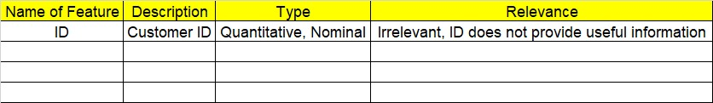

1. Hint: Refer to the file Claimants.csv.
2. The data is vehicle Insurance data. Research the Data fields and perform preliminary analysis.
3. Research and perform all possible steps for obtaining the solution.
4. All the codes (executable programs) should execute without errors.
5. Code modularization should be followed.
6. Each line of code should have comments explaining the logic and why you are using that function.