# Gibbs Update:

Iterations – Error Rates

16.4924225025

0 5.65685424949

5 5.65685424949

10 5.65685424949

15 5.65685424949

20 5.65685424949

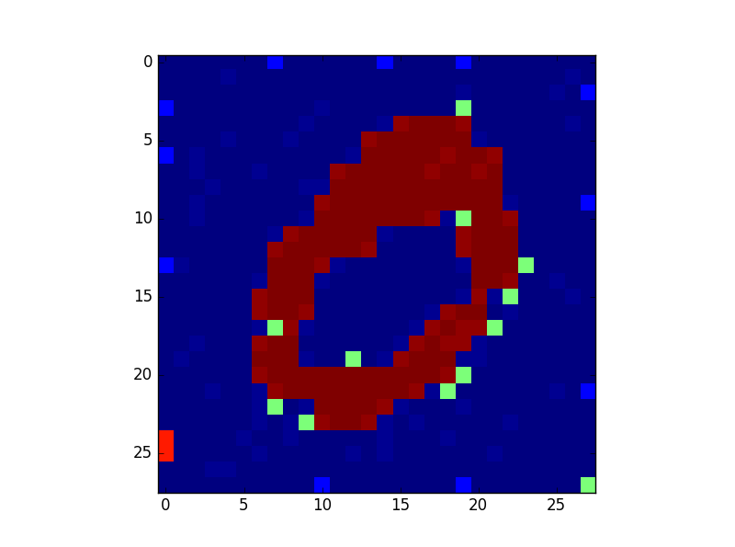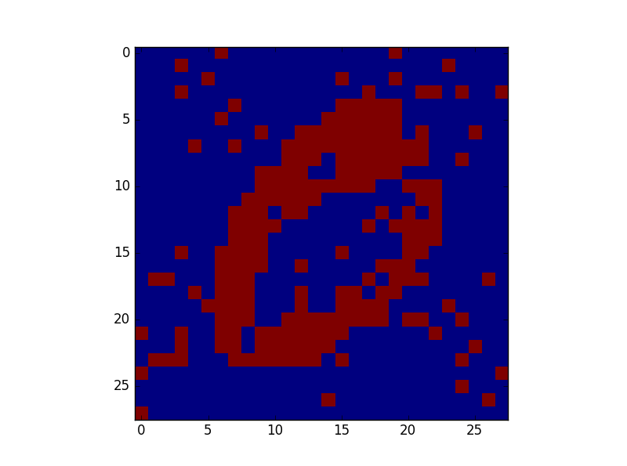

# Mean Field Value:

Error Rate:

17.2046505341

0 8.07110581592

5 5.74162183401

10 5.66303424273

15 5.62830854582

20 5.60838876522

25 5.59555938969

