# Homework 4

**Problem 1:**



$L\left(w\right)= \sum_{i=1}^{n}{{(y^{(i)}-w.x^{(i)})}^{2}}$

$\frac{∂L}{{∂w}_{j}}=-\sum_{i=1}^{n}{2* \left(y^{\left(i\right)}-w.x^{\left(i\right)}\right)x_{j}^{\left(i\right)}}$

$\frac{∂2L}{{∂w}_{j}{∂w}_{k}}=H_{jk}= \sum_{i=1}^{n}{2* x_{j}^{\left(i\right)}} x_{k}^{\left(i\right)}$

If $v_{ji}= \sqrt{2}* x_{j}^{\left(i\right)}$, we can write Hjk as a product of 2 vectors.

$H_{jk}= v_{j}∙v_{k }-(Eq.1)$ Therefore,

$H= \left(\begin{matrix}… & v_{1} & … \\ … & ⋮ & … \\ … & v_{p} & …\end{matrix}\right)\left(\begin{matrix}⋮ & ⋮ & ⋮ \\ v_{1} & … & v_{p} \\ ⋮ & ⋮ & ⋮\end{matrix}\right)= V^{T}V-(Eq. 2)$

For convexity, we have to prove that H is positive semidefinite.

$We can see that, H_{jk}= H_{kj}$ from Eq. 1.

From Eq. 2, $H=V^{T}V$.

Let z be any vector. Multiplying the equation by $z^{T} and z as follows:$

${z^{T}V}^{T}Vz= {{(z}^{T}V}^{T})\left(Vz\right)= {\left(Vz\right)}^{T}\left(Vz\right)= {|\left|Vz\right||}^{2}≥0$

Hence proved that H is a PSD and L(w) is a convex function.



$w_{t+1}= w_{t}- η_{t} \frac{∂L}{∂w}= w_{t}+2η_{t} \sum_{i=1}^{n}{\left(y^{\left(i\right)}-w.x^{\left(i\right)}\right)x_{j}^{\left(i\right)}}$

$w_{t+1}= w_{t}- H^{-1} \frac{∂L}{∂w}= w_{t}+2H^{-1} \sum_{i=1}^{n}{\left(y^{\left(i\right)}-w.x^{\left(i\right)}\right)x_{j}^{\left(i\right)}}$

**Problem 2:**

$f\left(x\right)= z^{T}Mz≥0= \sum_{i,j}{M_{ij}x_{i}x_{j}}\left(Since M is PSD\right)$

$\frac{∂f}{{∂x}_{i}}=2M_{ii}x_{i}+ \sum_{j !=i }{M_{ij}x_{j} }+ \sum_{j !=i }{M_{ji}x_{j}}$

Since M is symmetric $M_{ij}= M_{ji}$

$\frac{∂f}{{∂x}_{i}}= 2*\sum_{ji }{M_{ij}x_{j} }$

$\frac{∂2f}{{∂x}_{i}{∂x}_{j}}=H_{ij}= 2* M_{ij}$

Since M is PSD, H is also PSD. Therefor, f(x) is convex

$f\left(x\right)= e^{u∙x}$

$\frac{∂f}{{∂x}_{i}}= u_{i}e^{u∙x}$

$\frac{∂2f}{{∂x}_{i}{∂x}_{j}}=H_{ij}= u_{i}u_{j}e^{u∙x}-(Eq. 1)$

$H can be written as H=VV^{T} where V=U∙ e^{(u∙x)/2}$

${z^{T}VV}^{T}z= {{(z}^{T}V)(V}^{T}z)= {\left(V^{T}z\right)}^{T}\left(V^{T}z\right)= {|\left|V^{T}z\right||}^{2}≥0$

1. For f to be convex, prove that: $f(θx+\left(1-θ\right)y)≤ θf(x)+\left(1-θ\right)f(y)$

$Let z= θx+\left(1-θ\right)y$

$f\left(z\right)=\max\left(g\left(z\right), h\left(z\right)\right)$***– Eq1***

From the above equations, we can say that

$g\left(z\right)≤ θf\left(x\right)+\left(1-θ\right)f\left(y\right) and h(z)≤ θf(x)+\left(1-θ\right)f(y)$

Since both g(x) and h(x) are convex,

$g\left(z\right)≤ θg\left(x\right)+\left(1-θ\right)g\left(y\right)$**– *Eq-2***

From Equation 1 and 2:

$g\left(z\right)≤ θg\left(x\right)+\left(1-θ\right)g\left(y\right)≤ f\left(x\right)+\left(1-θ\right)f\left(y\right)$**– *Eq-3***

Similarly, we can say this about h(z)

$h\left(z\right)≤ θh\left(x\right)+\left(1-θ\right)h\left(y\right)≤ f\left(x\right)+\left(1-θ\right)f\left(y\right)$**– *Eq-4***

Thus from equation 1, 3, 4 we can say that f(x) is convex

**Problem 3:**

$η_{t} is obtained by using the backtracking line search algorithm with.$

$Limiting condition :L^{'}\left(w\right)<0$.0001

$Update η_{t}= 0.8η_{t} while the below condition is true:$

$$L(w - ∇L(w)) > L(w) - \frac{t}{2}{|\left|∇L\left(w\right)|\right|}^{2} ,$$

1. Number of iterations to get a good decision boundary = 22164

Intermediate Graph (t=10)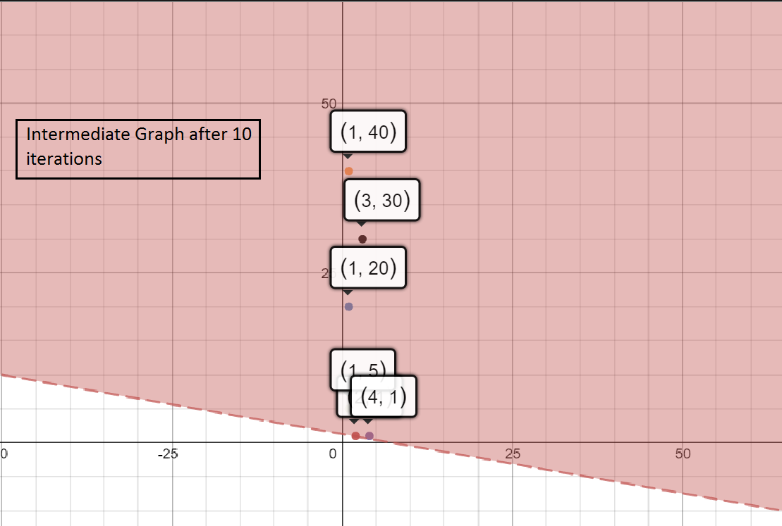

Intermediate Graph: (t=1000)

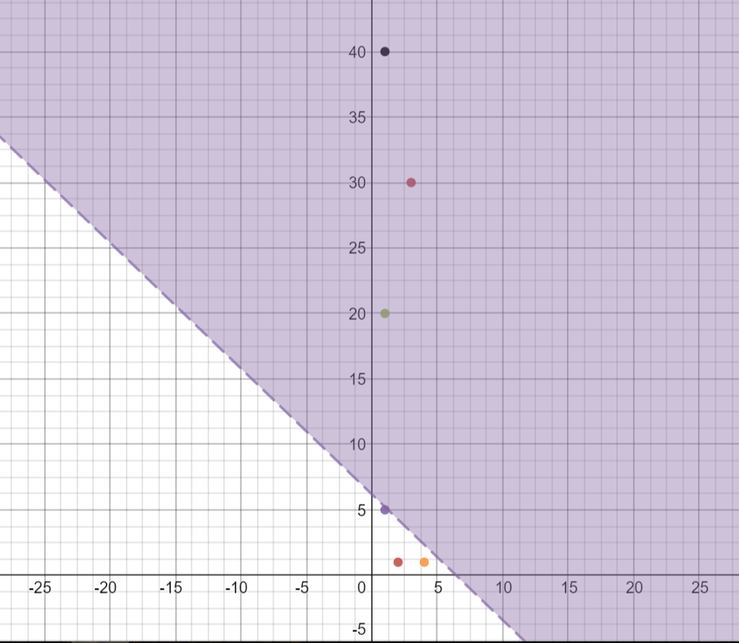

Intermediate Graph (t=15000)

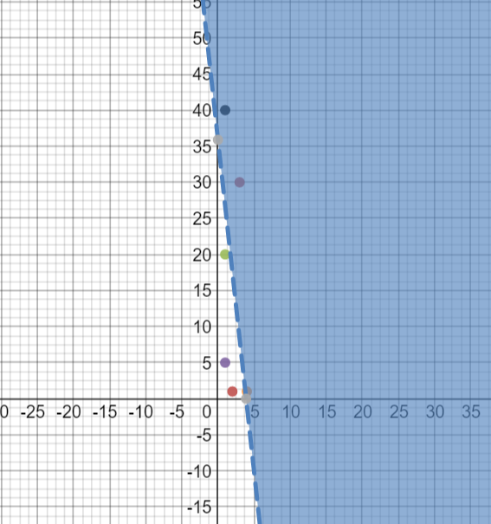

Graph of Final Decision Boundary (iter=22164)  
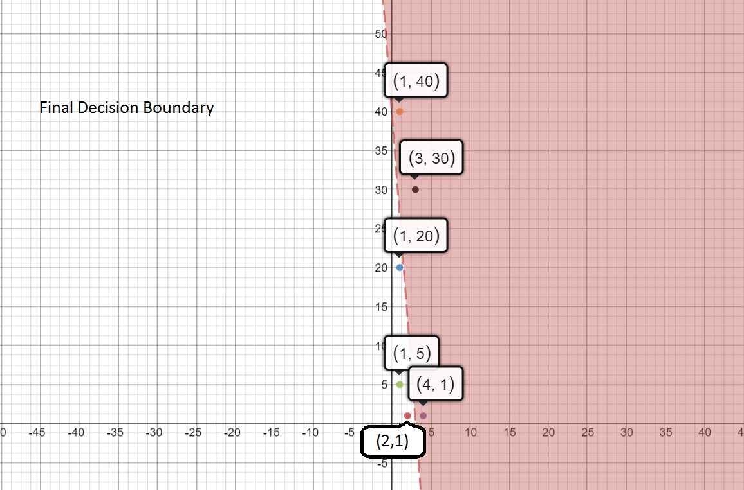

Final Graph by feature scaling:

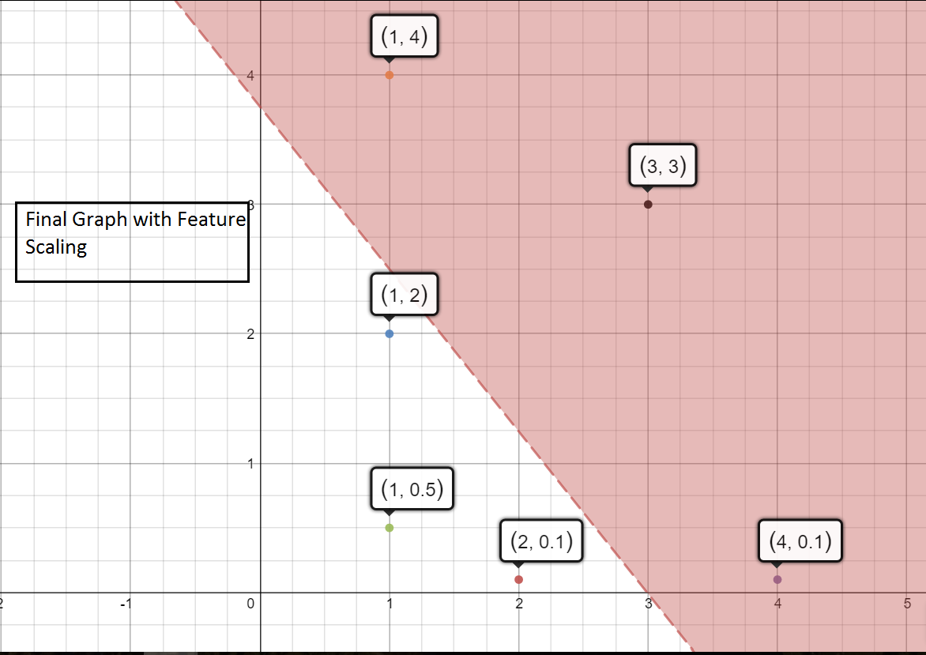

1. Yes, the number of iterations to get a good decision boundary reduces to 4632
2. Graph with random bivariate gaussians:

Overlapping boundaries: **(iter = 82)**

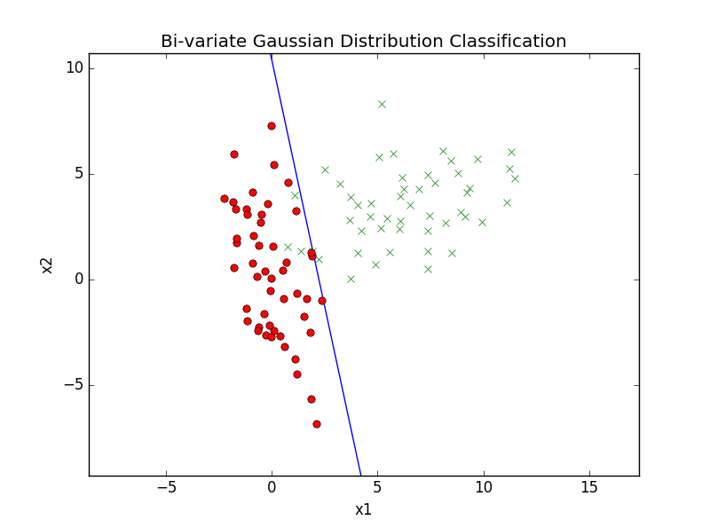

Non-overlapping boundaries: **(iter = 78)**

