# Homework 5

**Problem 1:**

1. The decision boundary for a voted perceptron algorithm is as follows (T=10):

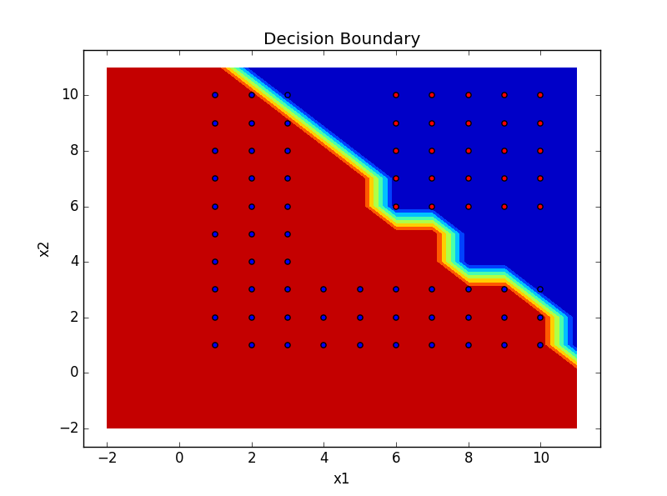

The final decision boundary is non linear

1. Pseudocode for voted perceptron with down-sampling:

$l=0, c_{l}=0, w_{l}=0$

* Repeat T times:
  + Randomly permute the data points
  + for i = 1 to n:

- If l + 1 > L:

// Remove the (c, w) with the most minimum c

$minI=argmin\left( c \right)$

del c[minI], del w[minI]

decrement l

$w_{l+1}= w_{l}+y^{(i)}x^{(i)}$

$c_{l+1}=1, l=l+1$

* Else:

$c_{l}= c_{l}+1$

The decision boundary using down sampling is as follows (T=100, L=100):

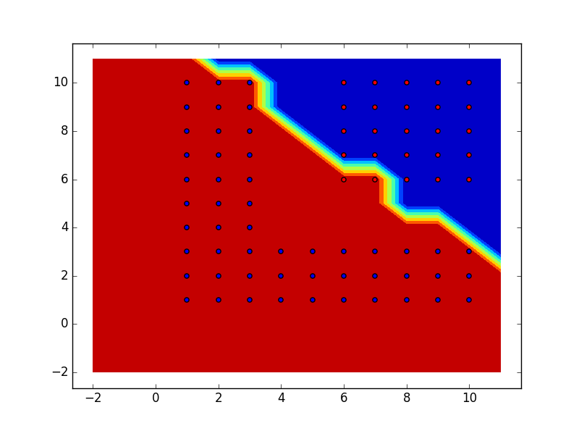

1. Pseudocode for averaged perceptron tracking at most 2 w’s is as follows:

$l=0, =0, w_{final}=w_{update}= 0$

* Repeat T times:
  + Randomly permute the data points
  + for i = 1 to n:

$If \left(x^{(i)},y^{(i)}\right)is missclassified by w_{l}:$

$w_{final}=w_{update}*c$

$w_{update}= w_{update}+y^{(i)}x^{(i)}$

$c=1$

* Else: c = c + 1

The decision boundary is as follows:

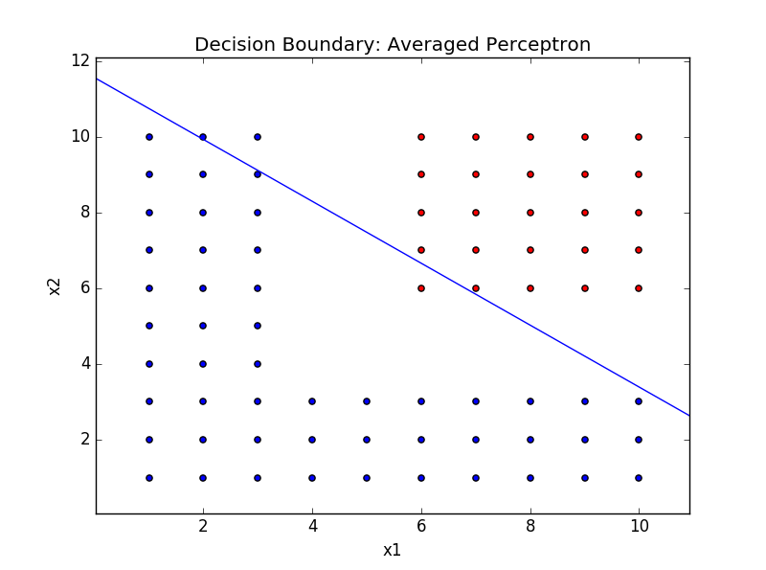

**Problem 2:**

Decision boundary obtained by quadratic kernels:

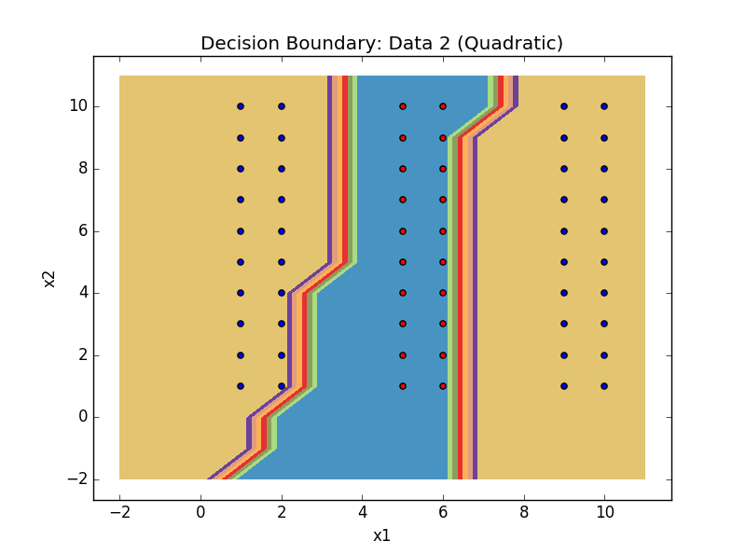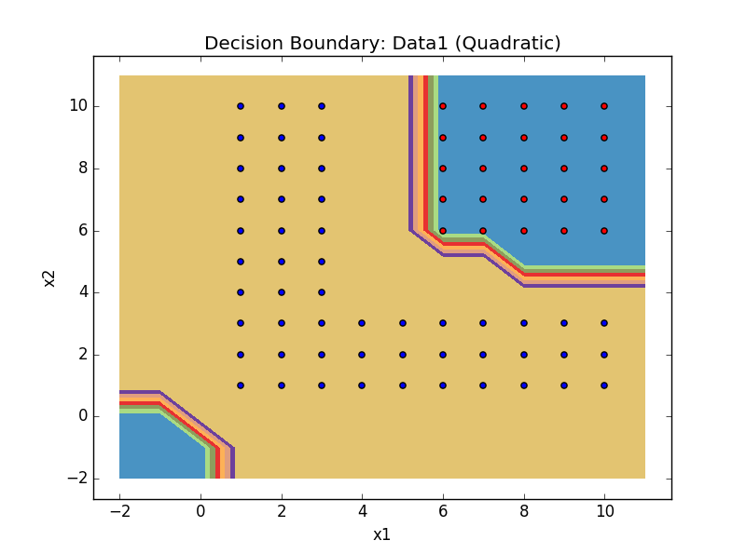

Decision boundary obtained by RBF kernels:

