# Homework 7

**Problem 1:**

$Mv_{i}= σ_{i}u_{i}$

$M^{T}u_{i}= σ_{i}v_{i}$

$M^{T}Mv_{i}= σ_{i}{M^{T}u}_{i} \left(from a.\right)= σ_{i}^{2}v_{i} (from b.)$

${MM}^{T}u_{i}= σ_{i}{Mv}_{i} \left(from b.\right)= σ_{i}^{2}u_{i} (from a.)$

1. ${MM}^{T}=UΛV^{T} VΛU^{T}=UΛ^{2}U^{T}σ_{1}^{2}, σ_{2}^{2}, … σ_{p}^{2}$ are the eigenvalues of ${MM}^{T}$ and $u_{1}, u_{2}, …u_{p}$ are the corresponding p eigenvectors
2. The matrix $M^{T}M$ can be written as: $M^{T}M= \sum_{i=1}^{p}{σ_{i}^{2}{v_{i}.v}_{i}^{T} }$. From this equation and from part c., we can see that $M^{T}M$ has p eigenvalues $σ_{1}^{2}, σ_{2}^{2}, … σ_{p}^{2}$ and corresponding eigenvectors ${ v}_{1, } v_{2}, …v_{p}$. The rest of the eigenvalues are 0.

Thus $M^{T}M$ and ${MM}^{T}$ have the same p eigenvalues

1. If M has rank k, then $σ_{k+1}= σ_{k+2}…=σ_{p}=0$

**Problem 2:**

1. The best rank-1 approximation to M is: $\left(\begin{matrix}1.57454629 & 2.08011388 & 2.58568148 \\ 3.75936076 & 4.96644562 & 6.17353048\end{matrix}\right)$
2. The decomposition is not unique. We can find orthonormal vectors *a* and *b* such that

$uv^{T}=ab^{T}$. This is when $a= -u and b= -v$

1. Best k-rank approximation of M can be written as:

$\hat{M}= σ_{1}u_{1}v_{1}^{T}+ σ_{2}u_{2}v_{2}^{T}+…+σ_{k}u_{k}v_{k}^{T}$

**Problem 3:**

The Gram matrix for the given data points is as follows: $\left(\begin{matrix}\begin{matrix}1 & 1 \\ 1 & 2\end{matrix} & \begin{matrix}1 & 1 \\ 1 & 2\end{matrix} \\ \begin{matrix}1 & 1 \\ 1 & 2\end{matrix} & \begin{matrix}2 & 2 \\ 2 & 3\end{matrix}\end{matrix}\right)$

The other set of points with exactly the same Gram matrix are:

(-1, 0, 0), (-1, 0, -1), (-1, -1, 0), (-1, -1, -1). This is because, the Gram matrix B can be written as $B_{ij }=y_{i} . y_{j}$ and $y_{i} . y_{j}= {-y}_{i} . {-y}_{j}$

Thus the second solution is negative of the first solution.

**Problem 4:**

The plot of the cities was inverted with respect to the actual map of U.S cities. This was fixed by multiplying the 2D points by (-1). Thus we plot (-x, -y) instead of (x, y).

The two set of points have the same Gram matrix, since we can decompose the matrix B to get two solutions for calculating the square root of the Eigen value matrix ($Λ)$: $Λ^{1/2} and {-Λ}^{1/2}$

The following is the corrected plot of U.S. cities:

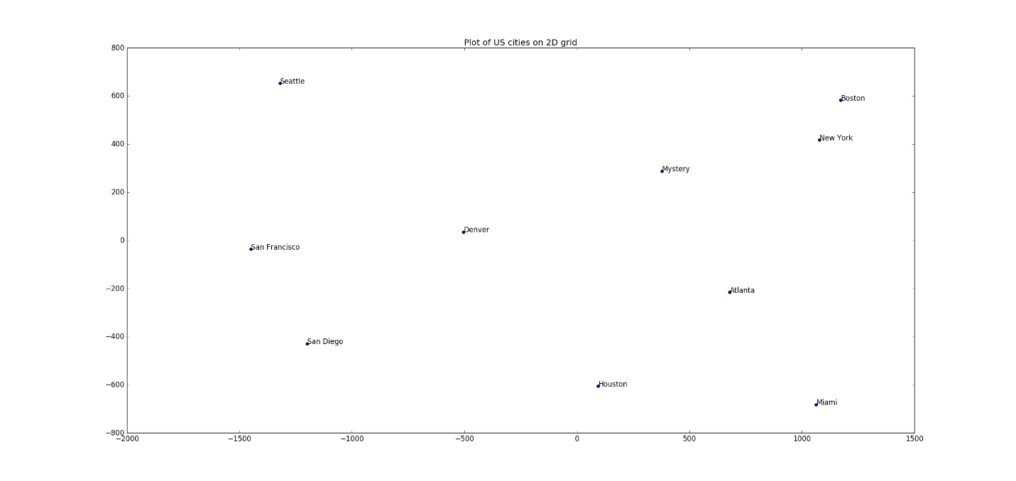

The mystery city appears to be **Chicago**.