* How to copy Folder from Source to Destination

1. Read and Understand mail properly to understand the requirement.
2. Find Source DB name and Destination (Target) DB name from that request and read Folder name that we have to copy.
3. Make sure , you are connected to VPN.
4. Firstly, take backup and then restore the DB (both source and target).
5. After restoring all DB successfully. Choose Source DB. And run queries for finding source folders details.
6. To Find Folder from source that you have to move to target environment ,

you can use query :

* **select * from fldr.folder where name = ‘Folder_Name’**

1. You can add condition in this query as per requirement .
2. For example, given folders can be package, portfolio, Foundation template,etc.

Let’s take below example.

If we have to move 3 folders from Source to Target which are ***Foundation Template***.

So we will use condition -  ***Isportfolio =1 and isfoundation =1***

* **Select * From fldr.Folder Where isportfolio=1 and isfoundation=1 and**

**Name IN('FT AZ Individual','FT NC Individual','FT CO Individual')**

9) First , we will execute the script for Type Creation .

i.e.

CREATE TYPE FolderCopy AS TABLE

(

Foldername nvarchar(200) Null

)

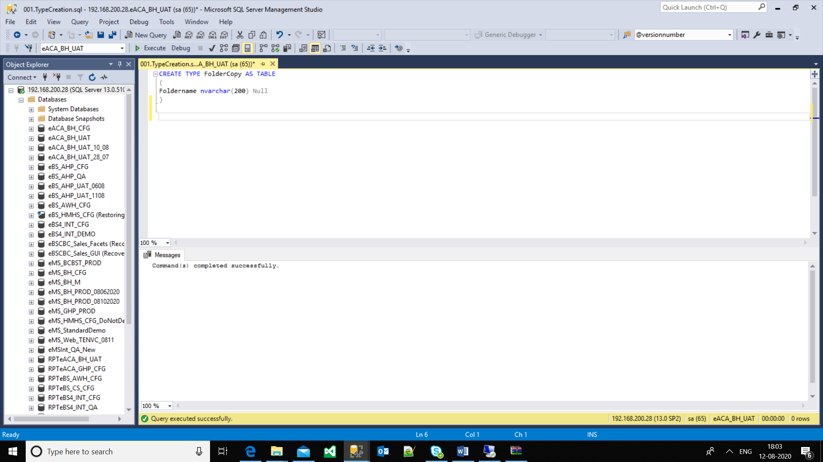

Fig .1

10) Once this script get executed successfully, we have to execute Folder copy script.

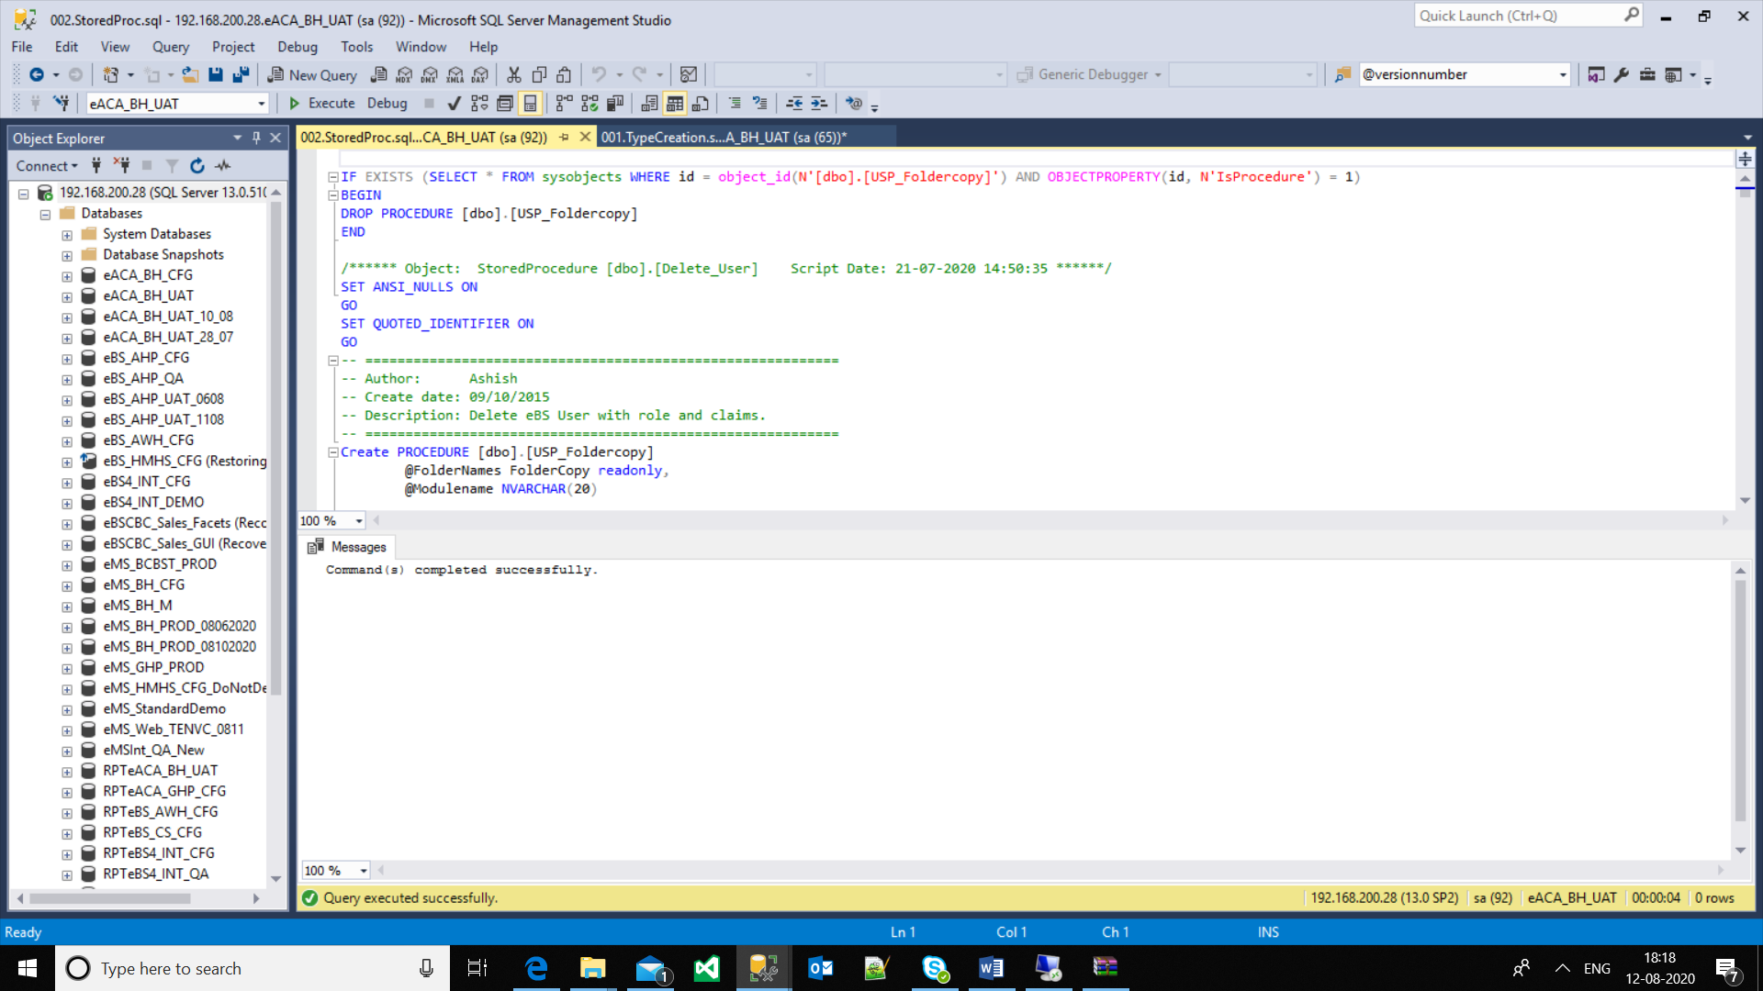

Fig. 2

Here, we are using **Stored** **Procedure** in this script , We have created stored procedure for copy the folder .

Now, we have to execute below query.

10) Here we have to add name of the folders that we have to copy and Module name (i.e. It may be Package,portfolio,Account ,masterlist,foundation) as per requirement.

Declare @Foldernames FolderCopy

Insert into @Foldernames

Select Name From fldr.Folder Where isportfolio=1 and isfoundation=1 and

Name IN('FT AZ Individual','FT NC Individual','FT CO Individual')

Exec [dbo].[USP_Foldercopy] @Foldernames=@Foldernames,@Modulename='Foundation'

In above example, Folders are Foundation Template, hence we add Modulename as Foundation.

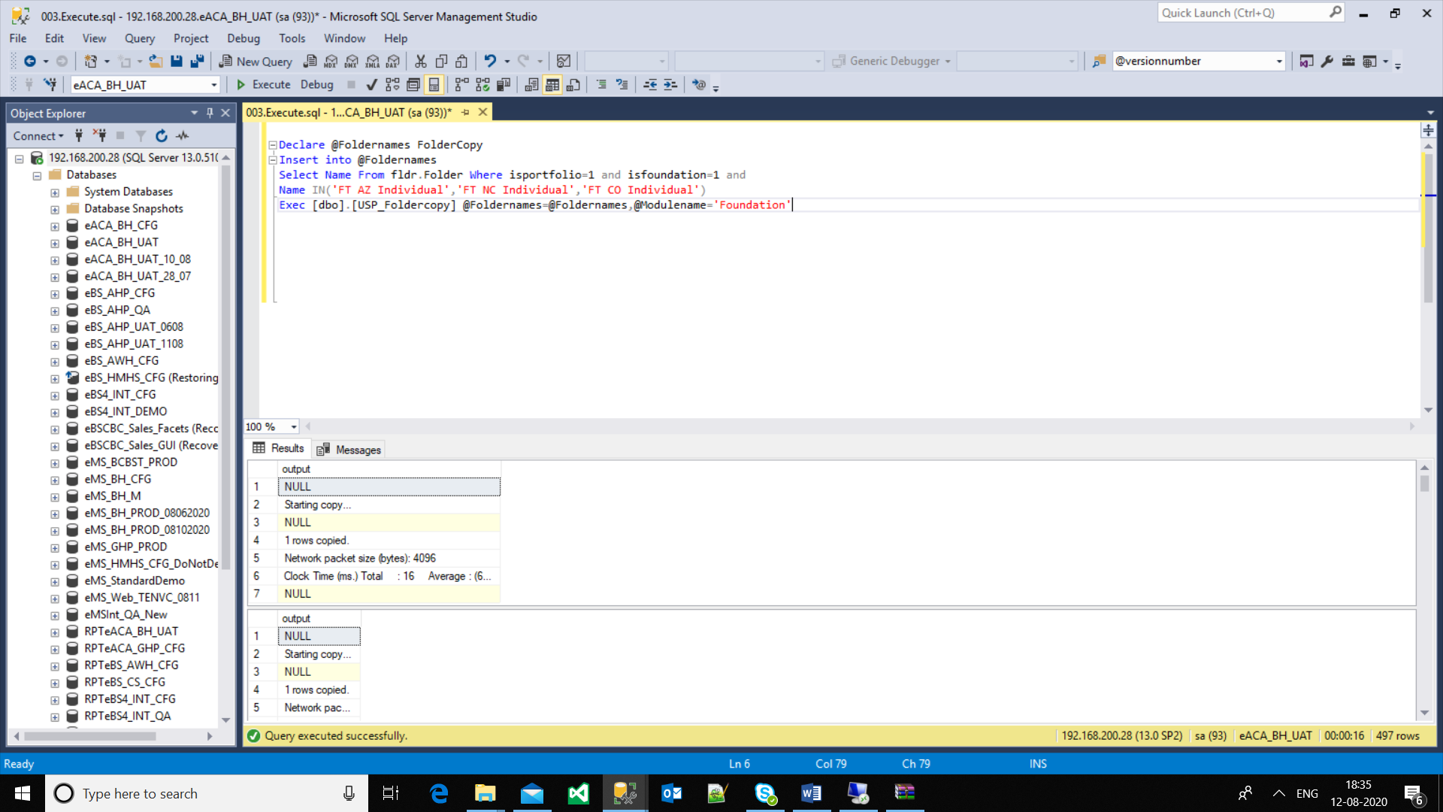

Fig.3

11) After executing this above script , Text files and Datascript will get generated in D:Import of Remote desktop .

1. Connect to Remote desktop with respective server (for ex. 192.168.200.28)

13)Here, you can see generated Text files and Datascript.

14)Select Destination DB on SSMS. And Execute that generated Datascript .

1. After successful execution, You will get an output and required folder will get copy on Destination.
2. Now, we can check and verifiy ,whether folder is copied on target or not.