Assignment 1 - AWS Identity

1)Created User Groups with respective policies attached to them.

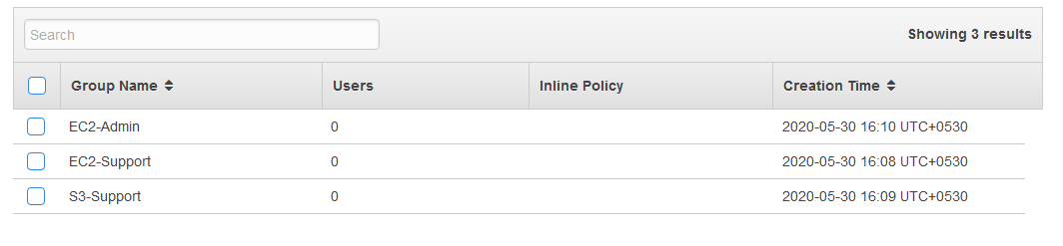

- Created User in IAM and added user to group - EC2-Admin

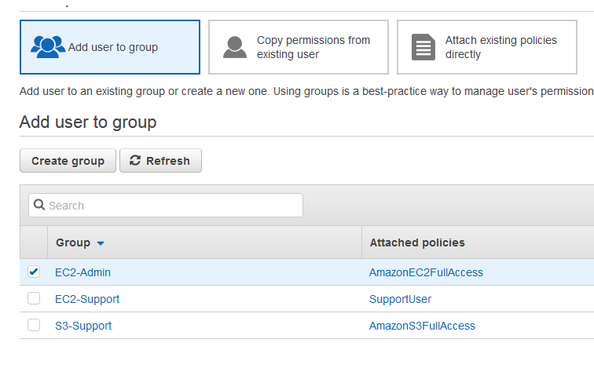

- Logged in using newly created user
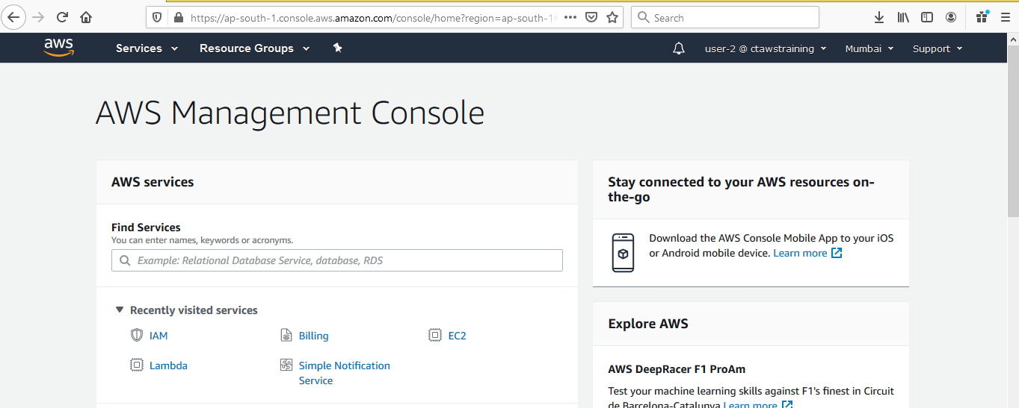

Assignment -2
Create your own EC2 workstation in the AWS console. Sign into it with an SSH key. Use that
instance to create an S3 Bucket in our AWS account and used the instance to have the Simple
Notification Service send us a text message.

Assignment-6
Create a custom AMI and launch index.html or php

Assignment-7
You will configure an S3 bucket to trigger AWS Simple Notification Service notifications
whenever an object is added to an S3 bucket.

[Assignment -2 , Assignment-6 and Assignment-7 clubbed together.]

Assignment-6
Steps:
- Launched an EC2 instance with free tier Linux AMI with user data as shown

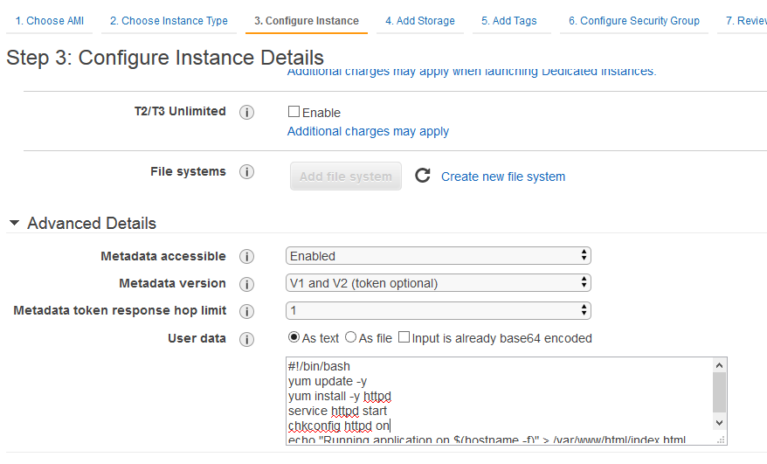

- Added security group configuration with SSH(22) and HTTP(80) access so that we can install Apache server and launch index.html

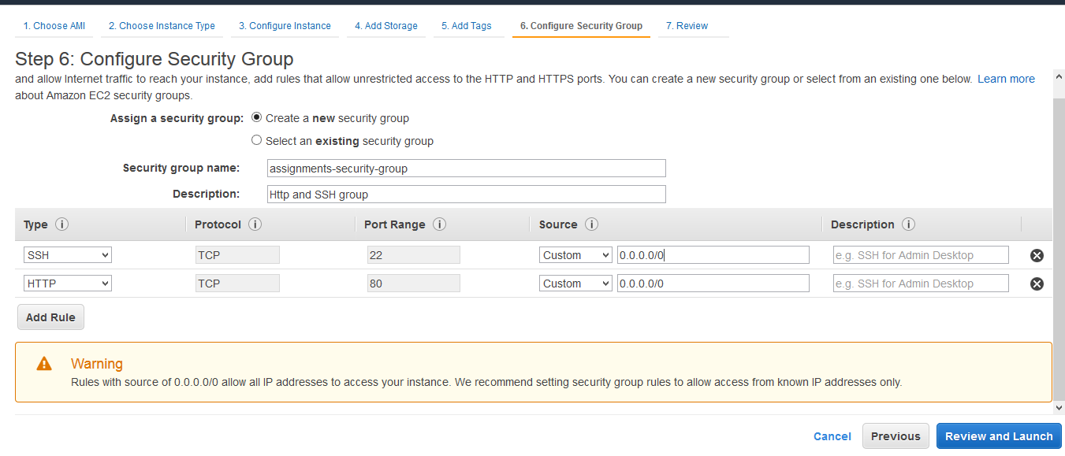
- After machine started, launched instance using public IP.

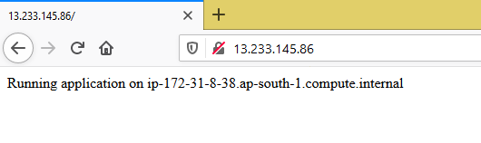

- Created Image from above EC2 Instance

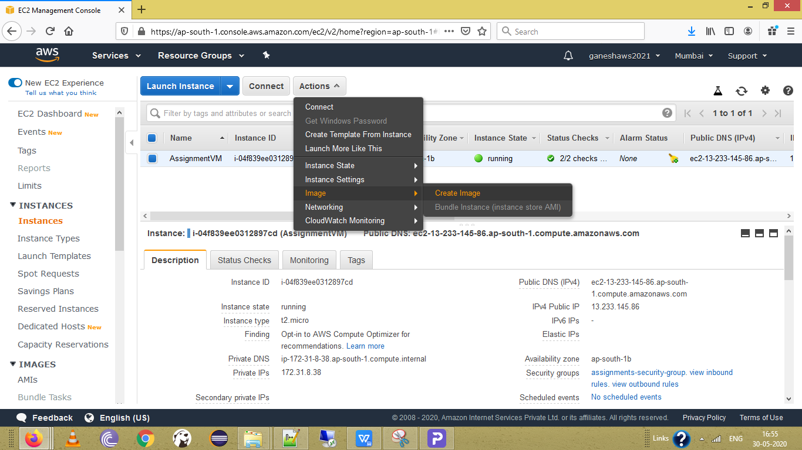

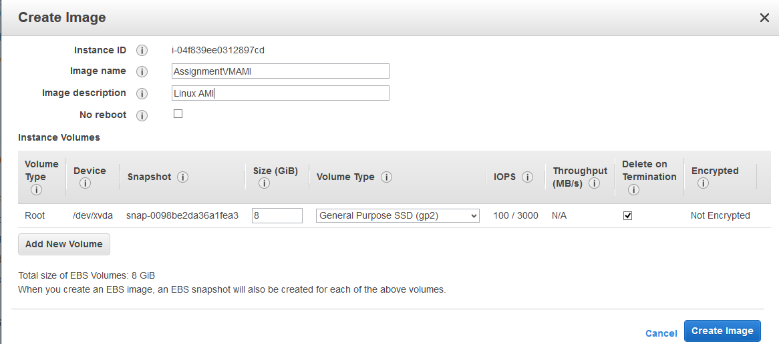

5)Image Saved and available under AMI
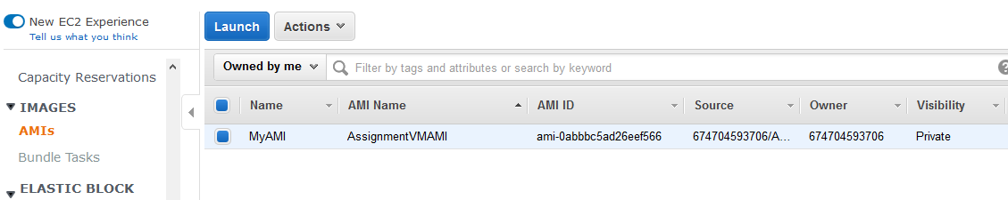

6)Launched new instance from AMI.
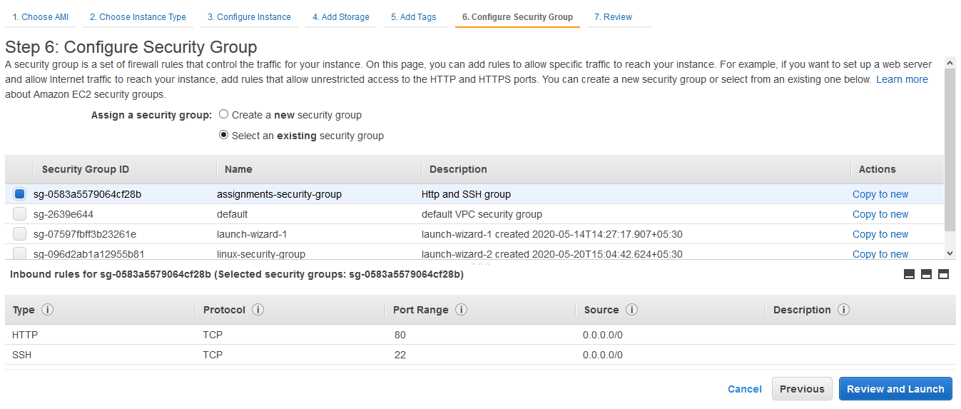

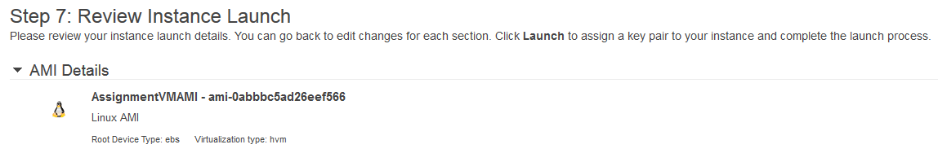

- Instance Started and running.
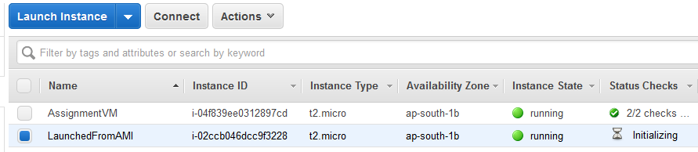

- Launched second instance in browser.

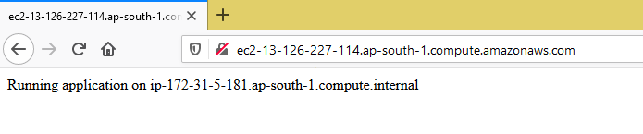

(-----------------------------------------------End of Assignment 6----------------------------------------------------------)

Assignment 2- Create Bucket and Send SMS using SNS

- Used same EC2 instance we created above.
- For creating a bucket from AWS CLI, first installed AWS CLI on EC2 instance using below commands

curl "https://awscli.amazonaws.com/awscli-exe-linux-x86_64.zip" -o "awscliv2.zip"
unzip awscliv2.zip
sudo ./aws/install

- In order to create S3 bucket , first need to have IAM User and S3 full access policy added to user group. (Got below error when user was not having access to S3)

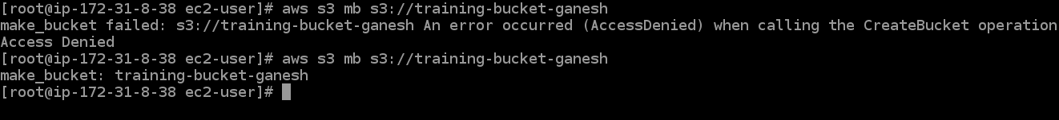

- Added S3 full access policy to user group

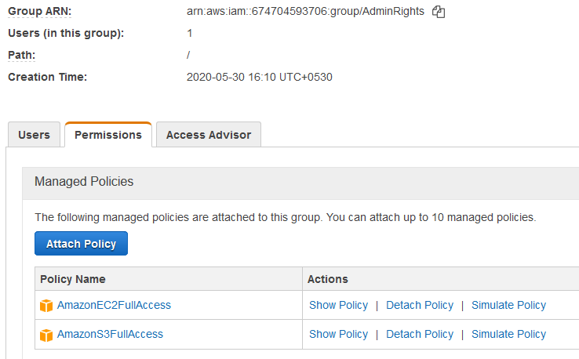

- Before using any commands, since environment variable were not set, had to add user configuration first as below.

aws configure
AWS Access Key ID [None]: <access key for IAM user>
AWS Secret Access Key [None]: <Secret Access key for IAM user>
Default region name [None]: ap-south-1
Default output format [None]: json

- Then used mb (make bucket ) command to create a S3 bucket.

Command : aws s3 mb s3://training-bucket-ganesh

- S3 part completed, now need to send SMS from this EC2 instance.
For this, I had to add SNS full access policy to user group.
Basically I created only one user group - ‘AdminRights’ and have added policies as per
requirements for each assignment.

- Used below command to send simple text message to my mobile .

Command: aws sns publish --message "Hello Ganesh" --phone-number +91<phone number>
(-----------------------------------------------End of Assignment 2----------------------------------------------------------)

Assignment 3 - Configure S3 bucket to send SNS notification when object added to bucket.

- Used same EC2 instance and S3 bucket we created in above 2 assignments.
2) We need a topic and a subscriber of type Email so that we can send email to that subscriber when object is added to S3 bucket - *’training-bucket-ganesh’*

- First created topic using command

Command : aws sns create-topic --name CTTraining_S3-Notification

- Added subscriber from admin console.
Confirmation email was received on my email, did the confirmation activity.
Tried creating subscriber from CLI as well.

Command:
aws sns subscribe --topic-arn arn:aws:sns:ap-south-1:674704593706:CTTraining_S3-Notification --protocol email --notification-endpoint <my personal email>

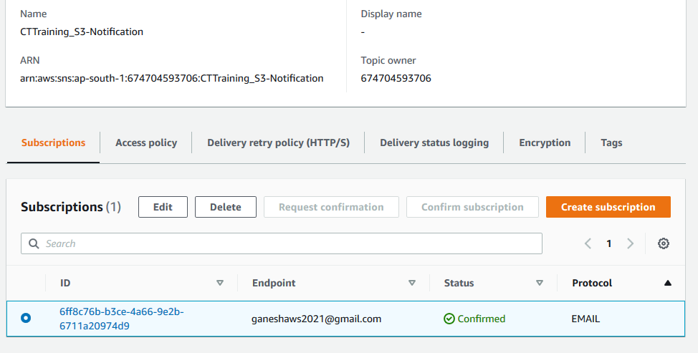

- Now for SNS to send notification when object added to s3 bucket, I had to add some changes in access policy of topic. ( SNS side configuration )

Added below condition to policy of Topic.
"Condition": {
"ArnLike": {
"aws:SourceArn": "arn:aws:s3:*:*:training-bucket-ganesh"
}
}

- Now on S3 bucket side, added event configuration and mapped to my SNS topic.
(S3 bucket side Configuration)

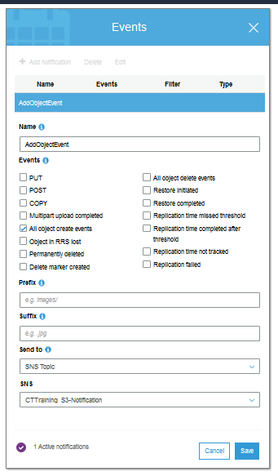

- Done, when I uploaded one json file to my bucket, got notification event email on my subscribed email address. Below shown is my JSON file.

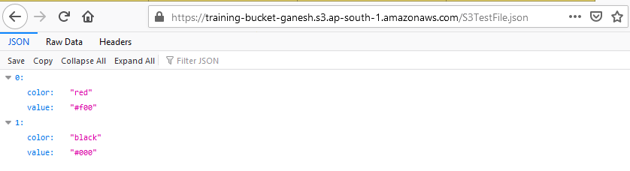

Assignment 4 - Working with S3

- Used above created bucket- ‘training-bucket-ganesh’ for pushing a json file as shown - ‘S3TestFile.json’.

- Uploaded a file from aws console, and used option Make Public to make it publicly accessible.

- Versioning was enabled for the bucket.

